Table S1. Antepartum and pregnancy outcomes in original cohort between Aspirin and No-aspirin group
Variable | Aspirin group (n=83) | No aspirin group (n=147) | P-value
Primary outcome
sPTB at <28 wk | 7(8.43%) | 28(19.05%) | 0.03*
PTB at＜28 wk | 7(8.43%) | 28(19.05%) | 0.03*
Secondary maternal outcomes
GA at delivery, wk | 36 (32, 38) | 36(29, 38) | 0.66
sPTB at <32 wk | 17(20.48%) | 42(28.57%) | 0.18
PTB at＜32 wk | 17(20.48%) | 43(29.25%) | 0.15
sPTB at <34 wk | 26(31.33%) | 50(34.01%) | 0.68
PTB at＜34 wk | 26(31.33%) | 54(36.73%) | 0.41
sPTB at <37 wk | 34(40.96%) | 74(50.34%) | 0.17
PTB at＜37 wk | 46(55.42%) | 80(54.42%) | 0.88
Hypertension disorder, n(%) | 16(19.28%) | 16(10.88%) | 0.08
IUGR, n(%) | 5(6.02%) | 4(2.72%) | 0.22
Antepartum hemorrhage, n(%) | 9(10.84%) | 24(16.33%) | 0.26
Mode of delivery |  |  | 0.14
Vaginal, n(%) | 39(46.99%) | 84(57.14%)
Cesarean, n(%) | 44(53.01%) | 63(42.86%)
Postpartum hemorrhage, n(%) | 7(8.43%) | 12(8.16%) | 0.94
Blood loss VD, ml | 96(60, 112) | 88(47, 105) | 0.12
Blood loss CD, ml | 78(93.98%) | 120(81.63%) | <0.01**
Cerclage to delivery interval, d | 73(87.95%) | 111(75.51%) | 0.02*
More than 28 d, n(%) | 39(46.99%) | 84(57.14%)
More than 56 d, n(%) | 44(53.01%) | 63(42.86%)
Secondary fetal outcomes
Overall perinatal mortality, n(%) | 2(2.41%) | 18(12.24%) | 0.01*
Neonatal survival rate, n(%) | 81(97.59%) | 126(85.71%) | <0.01**
Data are presented as median (interquartile range) or as number (percentage).
*p<0·05, **p<0·01
RR, relative risk; CI, confidence interval; PTB, preterm birth; sPTB, spontaneous preterm birth; GA, gestational age; NICU, neonatal intensive care unit; GDM, gestational diabetes mellitus; IUGR, intra-uterine growth retardation; VD, vaginal delivery; CD, cesarean delivery

Table S2. Outcome of neonates born alive in original cohort
Variable | Aspirin group  (n=81) | No aspirin group  (n=126) | P-value
Birthweight, g | 2840(1850, 3275) | 2845(2197.5, 3340) | 0.56
Birthweight＜1500g, n(%) | 11(13.58%) | 17(13.49%) | 0.99
5-min Apgar score< 7 | 0 | 1(0.79%) | 0.82#
NICU admission, n(%) | 45(55.56%) | 61(48.41%) | 0.32
Neonatal mortality, n(%) | 0 | 3(2.38%) | 0.42#
NICU LOS, d | 19.5(5.75, 49) | 21(5, 46) | 0.90
Composite neonatal outcome, n(%) | 28(34.57%) | 36(28.57%) | 0.36
RDS, n(%) | 15(18.52%) | 25(19.84%) | 0.79
IVH, n(%) | 14(17.28%) | 20(15.87%) | 0.81
NEC, n(%) | 2(2.47%) | 0 | 0.15#
Sepsis, n(%) | 17(20.99%) | 19(15.08%) | 0.29
ROP, n(%) | 5(6.17%) | 8(6.35%) | 0.95
Data are presented as median (interquartile range) or as number (percentage).
# was calculated by Fisher’s exact test.
RR, relative risk; CI, confidence interval; GA, gestational age; NICU, neonatal intensive care unit; LOS, length of stay in the hospital; RDS, respiratory distress syndrome; IVH, intraventricular hemorrhage; NEC, necrotizing enterocolitis; ROP, retinopathy of prematurity.

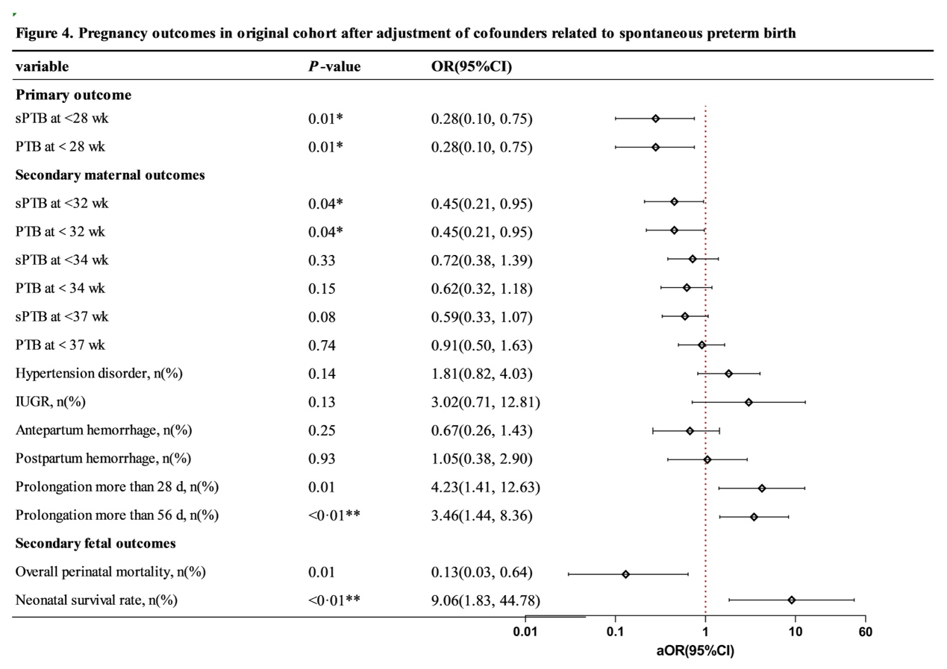
Figure S1. Pregnancy outcomes in original cohort after adjustment of cofounders related to spontaneous preterm birth. sPTB, spontaneous preterm birth; IUGR, intrauterine growth retardation. *p<0.05, **p<0.01

