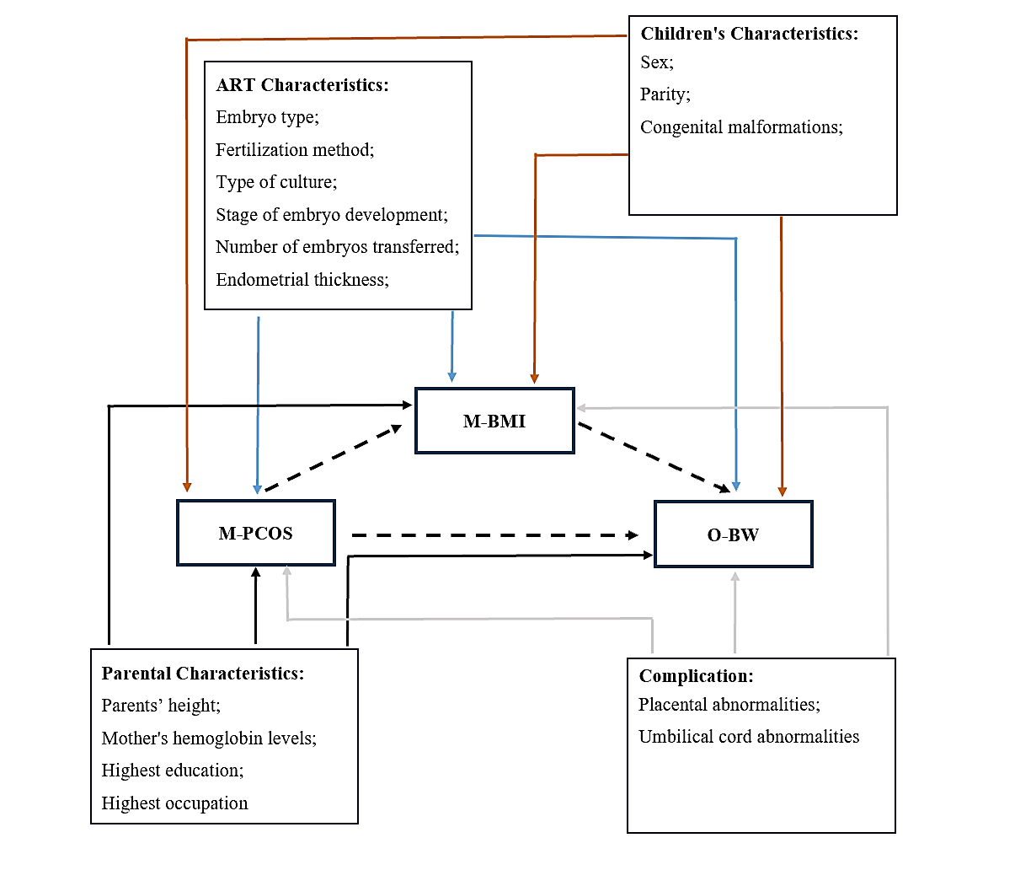
Supplemental Figure 2: Direct Acyclic Graph for the Models.
Models of offspring’s birth weight were estimated.
The dotted lines present the research question and the full lines the covariates adjusted for.
Abbreviations: M-PCOS, mothers who suffers from PCOS; M-BMI, Mother's pre-pregnancy body mass index; O-BW：offspring’s birth weight

