Table S1. Likelihood ratio test for the exposure-mediator interaction
Interaction term | LBW |  |  |  |  | Preterm birth
Interaction term | χ^{2ǂ} | χ^{2†} | Δχ² | P |  | χ^{2ǂ} | χ^{2†} | Δχ² | P
1SD-increase*GDM | 46.50 | 46.99 | 0.49 | 0.48 |  | 54.64 | 55.38 | 0.74 | 0.39
1SD-increase*Gestational hypertension | 62.48 | 64.54 | 2.06 | 0.15 |  | 48.19 | 49.10 | 0.91 | 0.34
1SD-increase*Preeclampsia | 102.34 | 103.75 | 1.41 | 0.24 |  | 97.15 | 97.78 | 0.63 | 0.43
1SD-increase*Preterm birth | 848.66 | 849.15 | 0.49 | 0.48 |  | / |  | / | /
Quartile*GDM | 47.63 | 47.71 | 0.08 | 0.78 |  | 57.63 | 58.97 | 1.34 | 0.25
Quartile*Gestational hypertension | 63.59 | 64.72 | 1.13 | 0.29 |  | 51.06 | 51.26 | 0.20 | 0.65
Quartile*Preeclampsia | 103.40 | 104.11 | 0.71 | 0.40 |  | 99.74 | 99.86 | 0.12 | 0.73
Quartile* Preterm birth | 848.71 | 848.89 | 0.18 | 0.67 |  | / |  | / | /
Notes: ǂ：Models without interaction term. †: Models with interaction term.

Table S2. E-value analysis to quantify sensitivity of mediation effect into unmeasured confounders
TyG | Mediator | LBW |  |  |  | Preterm birth
TyG | Mediator | NIE | E-value for NIE | E-value for CI |  | NIE | E-value for NIE | E-value for CI
1SD-increase | Individual mediator
1SD-increase | 1. GDM | 1.02 (1.01-1.03) ** | 1.16 | 1.11 |  | 1.02 (1.01-1.04) ** | 1.16 | 1.11
1SD-increase | 2. Gestational hypertension | 1.01 (1.00-1.02) * | 1.11 | 1.00 |  | 1.01 (1.00-1.01) # | 1.11 | 1.00
1SD-increase | 3. Preeclampsia | 1.02 (1.00-1.04) ** | 1.16 | 1.00 |  | 1.02 (1.00-1.03) * | 1.16 | 1.00
1SD-increase | 4. Preterm birth | 1.10 (1.04-1.16) *** | 1.43 | 1.24 |  | /
1SD-increase | Multiple mediators ª | 1.04 (1.02-1.06) *** | 1.24 | 1.16 |  | 1.04 (1.02-1.07) *** | 1.24 | 1.16
1SD-increase | Multiple mediators ^{b} | 1.12 (1.05-1.18) *** | 1.49 | 1.28 |  | /
4th vs. 1st  Quartile | Individual mediator
4th vs. 1st  Quartile | 1. GDM | 1.37 (1.01-1.08) ** | 2.08 | 1.11 |  | 1.06 (1.02-1.09) ** | 1.31 | 1.16
4th vs. 1st  Quartile | 2. Gestational hypertension | 1.03 (1.00-1.06) * | 1.21 | 1.00 |  | 1.01 (1.00-1.03) # | 1.11 | 1.00
4th vs. 1st  Quartile | 3. Preeclampsia | 1.05 (1.01-1.09) * | 1.28 | 1.11 |  | 1.04 (1.00-1.08) * | 1.24 | 1.00
4th vs. 1st  Quartile | 4. Preterm birth | 1.30 (1.12-1.51) *** | 1.92 | 1.49 |  | /
4th vs. 1st  Quartile | Multiple mediators ª | 1.10 (1.04-1.16) *** | 1.43 | 1.24 |  | 1.10 (1.04-1.16) *** | 1.43 | 1.24
4th vs. 1st  Quartile | Multiple mediators ^{b} | 1.34 (1.15-1.60) *** | 2.01 | 1.57 |  | / | / | /
Notes: NIE: nature indirect effect. a: mediators including GDM, gestational hypertension and preeclampsia. b: mediators in a and preterm birth. ***: P<.001, **: P<.01, *: P<.05, #: P<0.10.

Table S3. Estimates from causal mediation analysis for the associations of TyG index with low birth weight and preterm birth among pre-pregnancy underweight women
TyG | Mediator | LBW |  |  |  | Preterm birth
TyG | Mediator | NDE | NIE | PM (%) |  | NDE | NIE | PM (%)
1SD-increase | Individual mediator
1SD-increase | 1. GDM | 0.97 (0.75 - 1.27) | 1.00 (0.98 - 1.02) | n.s |  | 1.25 (0.94 - 1.65)* | 0.99 (0.97 - 1.01) | n.s
1SD-increase | 2. Gestational hypertension | 0.97 (0.75 - 1.27) | 1.00 (0.99 - 1.02) | n.s |  | 1.23 (0.93 - 1.64) | 1.00 (0.99 - 1.01) | n.s
1SD-increase | 3. Preeclampsia | 0.98 (0.75 - 1.27) | 1.00 (0.98 - 1.02) | n.s |  | 1.24 (0.93 - 1.66) | 1.00 (0.96 - 1.03) | n.s
1SD-increase | 4. Preterm birth | 0.90 (0.70 - 1.16) | 1.08 (0.97 - 1.20) | n.s |  | / | / | /
1SD-increase | Multiple mediators ª | 0.98 (0.75 - 1.26) | 1.08 (0.97 - 1.20) | n.s |  | 1.26 (0.95 - 1.66) | 0.98 (0.93 - 1.02) | n.s
1SD-increase | Multiple mediators ^{b} | 0.91 (0.71 - 1.18) | 1.07 (0.96 - 1.21) | n.s |  | / | / | /
4th vs. 1st  Quartile | Individual mediator
4th vs. 1st  Quartile | 1. GDM | 0.86 (0.39 - 1.97) | 1.00 (0.97 - 1.04) | n.s |  | 1.62 (0.78 - 3.58) | 0.98 (0.94 - 1.03) | n.s
4th vs. 1st  Quartile | 2. Gestational hypertension | 0.85 (0.40 - 1.94) | 1.01 (0.97 - 1.06) | n.s |  | 1.59 (0.79 - 3.41) | 1.00 (0.97 - 1.04) | n.s
4th vs. 1st  Quartile | 3. Preeclampsia | 0.87 (0.42 - 1.91) | 0.98 (0.92 - 1.06) | n.s |  | 1.62 (0.78 - 3.37) | 0.98 (0.89 - 1.10) | n.s
4th vs. 1st  Quartile | 4. Preterm birth | 0.72 (0.33 - 1.59) | 1.17 (0.86 - 1.71) | n.s |  | / | / | /
4th vs. 1st  Quartile | Multiple mediators ª | 0.88 (0.43 - 1.99) | 0.97 (0.88 - 1.08) | n.s |  | 1.69 (0.83 - 3.50) | 0.93 (0.84 - 1.03) | n.s
4th vs. 1st  Quartile | Multiple mediators ^{b} | 0.70 (0.34 - 1.55) | 1.20 (0.86 - 1.70) | n.s |  | / | / | /
Notes: NDE: nature direct effect. NIE: nature indirect effect. PM: proportion of mediation. a: mediators including GDM, gestational hypertension and preeclampsia. b: mediators in a and preterm birth. n.s: non-significant.

Table S4. Estimates from causal mediation analysis for the associations of TyG index with low birth weight and preterm birth among pre-pregnancy normal weight women
TyG | Mediator | LBW |  |  |  | Preterm birth
TyG | Mediator | NDE | NIE | PM (%) |  | NDE | NIE | PM (%)
1SD-increase | Individual mediator
1SD-increase | 1. GDM | 1.15 (1.00 - 1.32) # | 1.03 (1.01 - 1.05) ** | 19.5 |  | 1.20 (1.04 - 1.39) * | 1.04 (1.02 - 1.06) *** | 18.8
1SD-increase | 2. Gestational hypertension | 1.17 (1.02 - 1.36) * | 1.01 (1.00 - 1.02) # | 6.4 |  | 1.23 (1.06 - 1.42) ** | 1.01 (1.00 - 1.02) | n.s
1SD-increase | 3. Preeclampsia | 1.15 (1.00 - 1.34) # | 1.02 (1.00 - 1.04) * | 15.1 |  | 1.21 (1.04 - 1.40) * | 1.02 (1.01 - 1.05) * | 12.4
1SD-increase | 4. Preterm birth | 1.07 (0.93 - 1.22) | 1.11 (1.03 - 1.20) ** | 63.9 |  | / | / | /
1SD-increase | Multiple mediators ª | 1.11 (0.95 - 1.28) | 1.07 (1.04 - 1.11) *** | 41.6 |  | 1.16 (1.00 - 1.35) * | 1.07 (1.03 - 1.11) *** | 33.1
1SD-increase | Multiple mediators ^{b} | 1.04 (0.90 - 1.21) | 1.14 (1.06 - 1.23) ** | 78.0 |  | / | / | /
4th vs. 1st  Quartile | Individual mediator
4th vs. 1st  Quartile | 1. GDM | 1.55 (1.02 - 2.28) * | 1.08 (1.03 - 1.14) *** | 19.1 |  | 1.58 (1.06 - 2.35) * | 1.10 (1.04 - 1.16) *** | 21.6
4th vs. 1st  Quartile | 2. Gestational hypertension | 1.63 (1.07 - 2.46) * | 1.03 (1.00 - 1.06) # | 6.3 |  | 1.71 (1.15 - 2.52) ** | 1.02 (0.99 - 1.04) | n.s
4th vs. 1st  Quartile | 3. Preeclampsia | 1.58 (1.04 - 2.42) * | 1.06 (1.01 - 1.11) * | 13.6 |  | 1.65 (1.10 - 2.42) * | 1.06 (1.01 - 1.11) * | 12.9
4th vs. 1st  Quartile | 4. Preterm birth | 1.28 (0.88 - 1.87) | 1.31 (1.06 - 1.59) ** | 58.2 |  | / | / | /
4th vs. 1st  Quartile | Multiple mediators ª | 1.42 (0.91 - 2.17) | 1.18 (1.10 - 1.29) *** | 37.5 |  | 1.48 (1.00 - 2.21) # | 1.18 (1.08 - 1.29) *** | 35.5
4th vs. 1st  Quartile | Multiple mediators ^{b} | 1.21 (0.83 - 1.72) | 1.38 (1.14 - 1.72) ** | 68.1 |  | / | / | /
Notes: NDE: nature direct effect. NIE: nature indirect effect. PM: proportion of mediation. a: mediators including GDM, gestational hypertension and preeclampsia. b: mediators in a and preterm birth. ***: P<.001, **: P<.01, *: P<.05, #: P<0.10. n.s: non-significant.

Table S5. Estimates from causal mediation analysis for the associations of TyG index with low birth weight and preterm birth among pre-pregnancy overweight/obese women
TyG | Mediator | LBW |  |  |  | Preterm birth
TyG | Mediator | NDE | NIE | PM (%) |  | NDE | NIE | PM (%)
1SD-increase | Individual mediator
1SD-increase | 1. GDM | 0.96 (0.75 - 1.21) | 1.01 (0.97 - 1.05) | n.s |  | 1.10 (0.92 - 1.30) | 1.02 (0.98 - 1.06) | n.s
1SD-increase | 2. Gestational hypertension | 0.94 (0.76 - 1.18) | 1.03 (0.99 - 1.06) | n.s |  | 1.11 (0.93 - 1.33) | 1.01 (0.99 - 1.03) | n.s
1SD-increase | 3. Preeclampsia | 0.95 (0.76 - 1.18) | 1.02 (0.97 - 1.07) | n.s |  | 1.11 (0.92 - 1.33) | 1.01 (0.98 - 1.05) | n.s
1SD-increase | 4. Preterm birth | 0.89 (0.72 - 1.09) | 1.08 (0.95 - 1.21) | n.s |  | / | / | /
1SD-increase | Multiple mediators ª | 0.95 (0.76 - 1.18) | 1.02 (0.95 - 1.09) | n.s |  | 1.09 (0.91 - 1.30) | 1.03 (0.98 - 1.08) | n.s
1SD-increase | Multiple mediators ^{b} | 0.88 (0.71 - 1.08) | 1.09 (0.95 - 1.25) | n.s |  | / | / | /
4th vs. 1st  Quartile | Individual mediator
4th vs. 1st  Quartile | 1. GDM | 1.03 (0.25 - 3.62) | 1.01 (0.94 - 1.09) | n.s |  | 2.53 (0.02 - 118.37) | 1.04 (0.96 - 1.11) | n.s
4th vs. 1st  Quartile | 2. Gestational hypertension | 0.98 (0.38 - 2.29) | 1.06 (0.96 - 1.17) | n.s |  | 2.52 (0.06 - 59.32) | 1.04 (0.97 - 1.10) | n.s
4th vs. 1st  Quartile | 3. Preeclampsia | 1.05 (0.40 - 2.46) | 0.99 (0.82 - 1.19) | n.s |  | 2.58 (0.07 - 55.90) | 1.01 (0.89 - 1.15) | n.s
4th vs. 1st  Quartile | 4. Preterm birth | 0.67 (0.34 - 1.22) | 1.66 (1.00 - 2.65) * | N.A |  | / | / | /
4th vs. 1st  Quartile | Multiple mediators ª | 1.08 (0.19 - 5.45) | 0.96 (0.75 - 1.20) | n.s |  | 2.59 (0.01 - 178.46) | 1.01 (0.85 - 1.19) | n.s
4th vs. 1st  Quartile | Multiple mediators ^{b} | 0.70 (0.14 - 3.14) | 1.57 (0.90 - 2.62) # | N.A |  | / | / | /
Notes: NDE: nature direct effect. NIE: nature indirect effect. PM: proportion of mediation. a: mediators including GDM, gestational hypertension and preeclampsia. b: mediators in a and preterm birth. *: P<.05. #: P<0.10. n.s: non-significant. N.A: not applicable due to the opposite direction between NDE and NIE.

Notes: P value: P value for interaction. GDM: gestational diabetes mellitus.
Figure S1. Subgroup analysis for the association between TyG index and gestational complications.
Notes: P value: P value for interaction
Figure S2. Subgroup analysis for the association of TyG index with preterm birth, low birth weight and macrosomia.

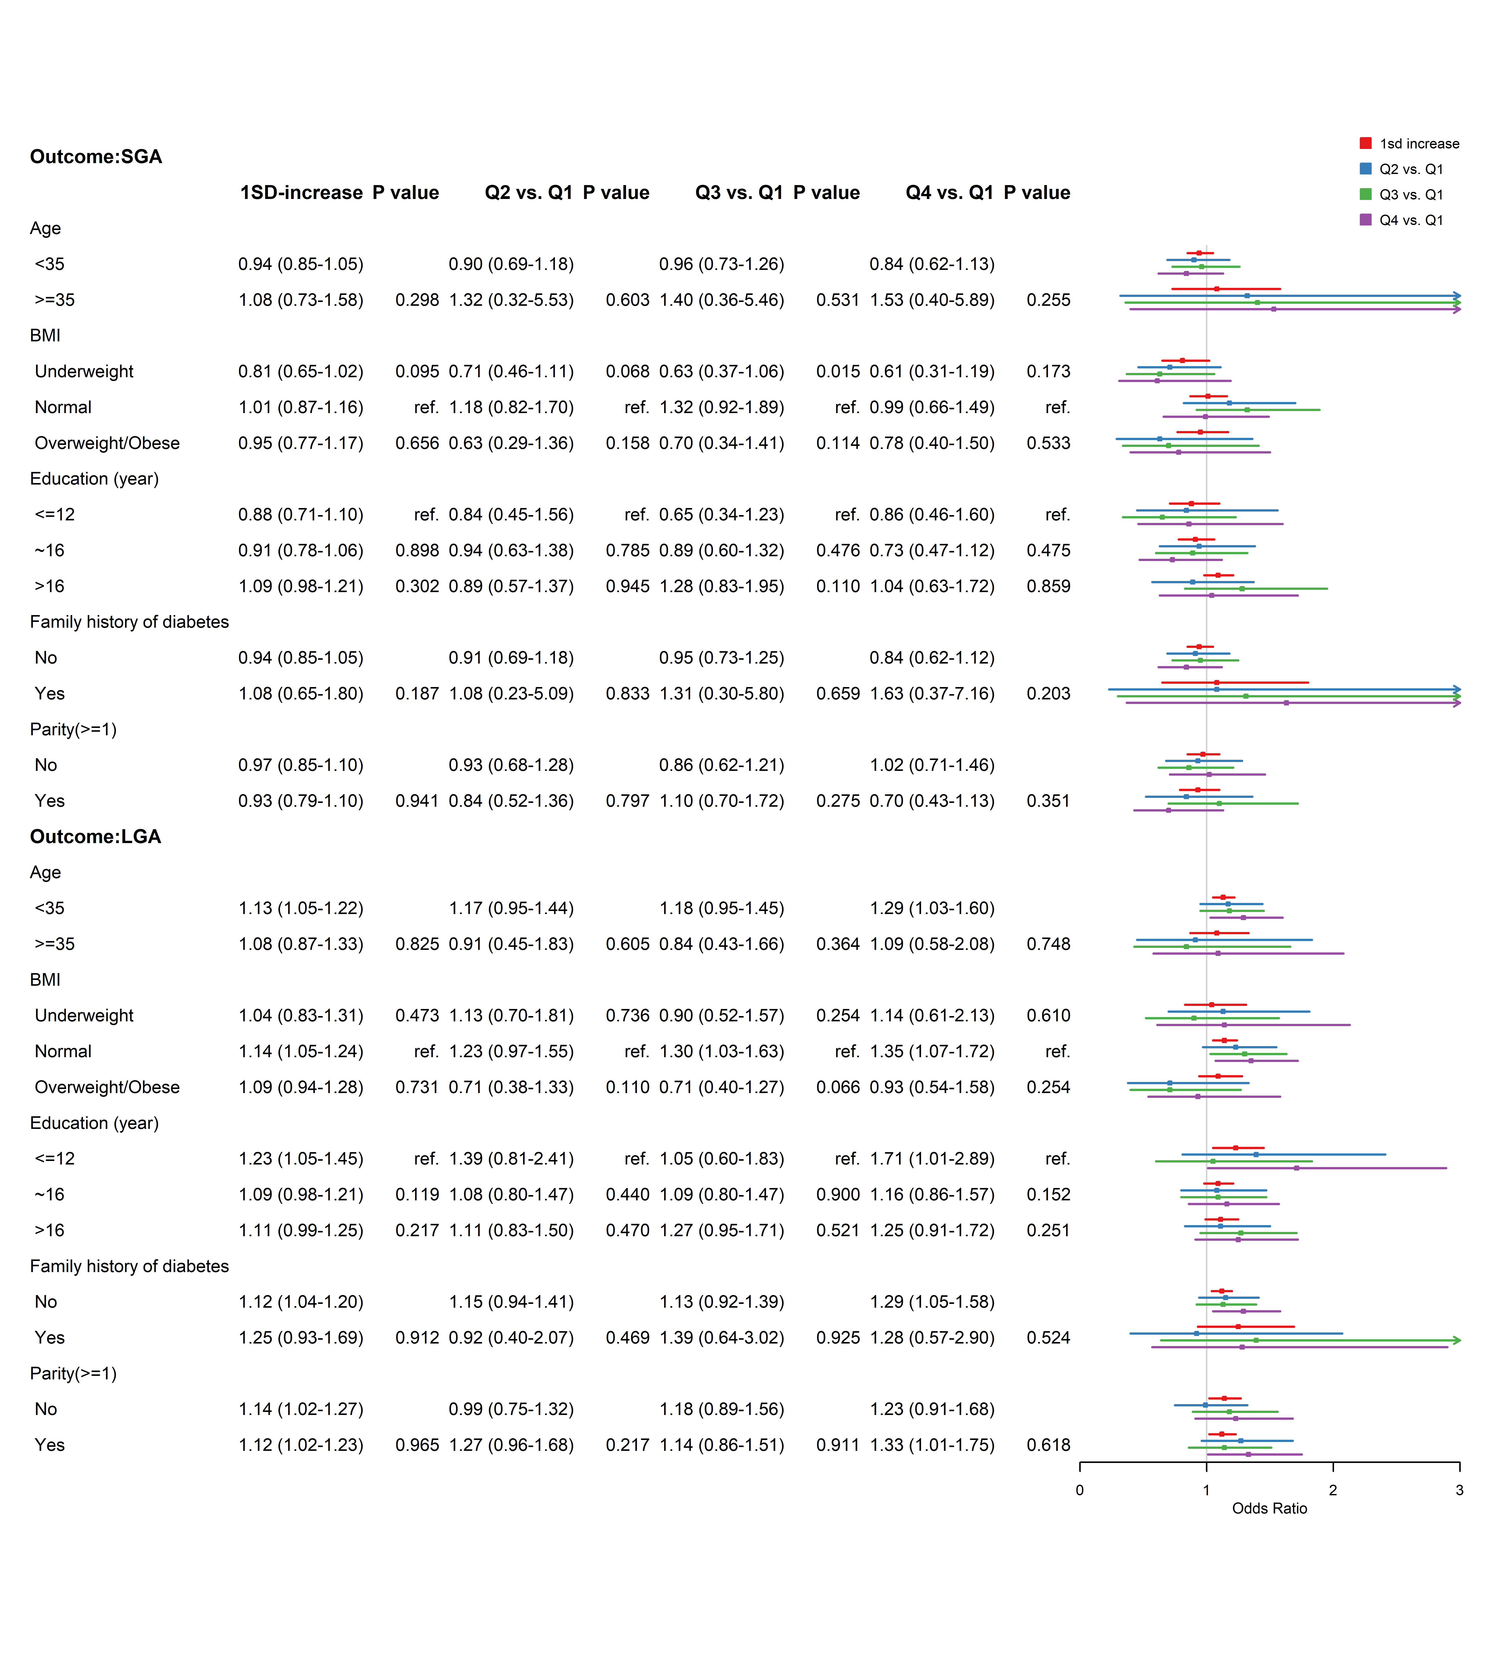
Notes: P value: P value for interaction. SGA: small for gestational age. LGA: large for gestational age.
Figure S3. Subgroup analysis for the association of TyG index with SGA and LGA.

Notes: P value: P value for interaction. GDM: gestational diabetes mellitus. n.a: not applicable due to no case in the subgroup.
Figure S4. Subgroup analysis for the association of gestational complications with preterm birth, low birth weight and macrosomia.
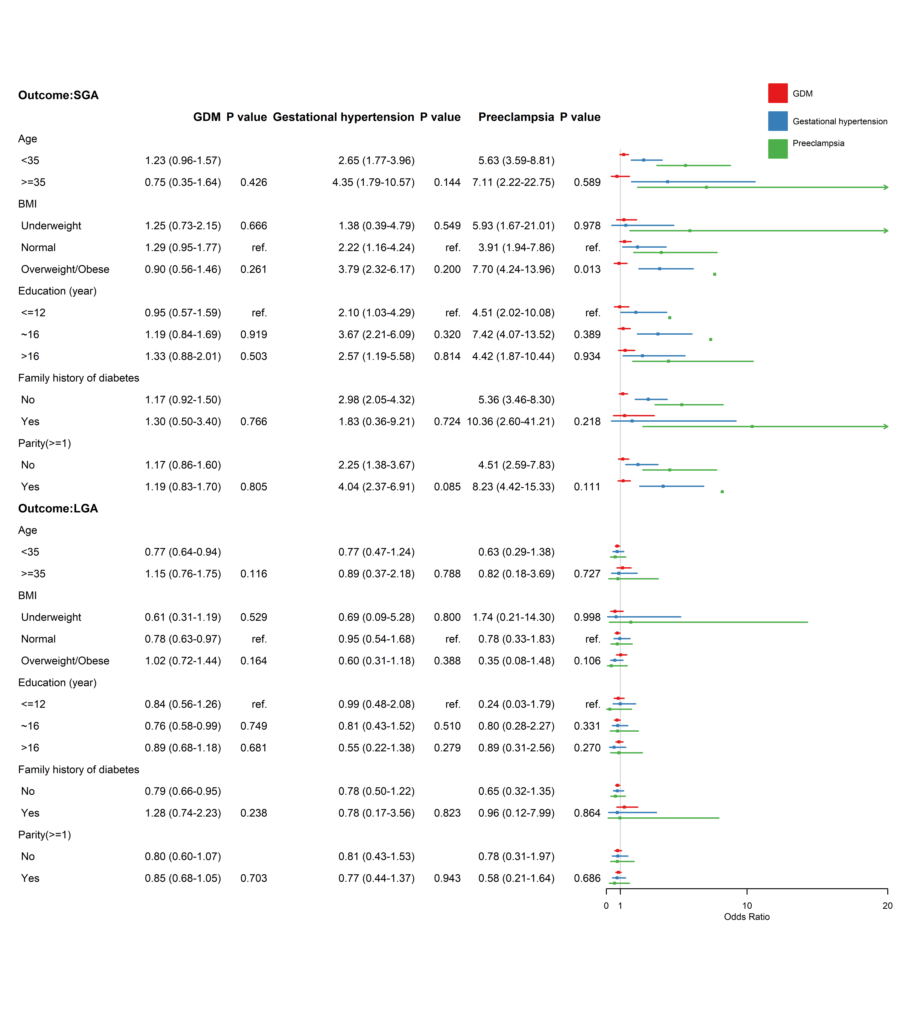
Notes: P value: P value for interaction. GDM: gestational diabetes mellitus. SGA: small for gestational age. LGA: large for gestational age.
Figure S5. Subgroup analysis for the association of gestational complications with SGA and LGA.

