Subgroup and Sensitivity Analyses
AFC
1.1 AFC Subgroup Analysis Results
Stratification group | Number of studies | OR | 95% CI | I² (%) | P for heterogeneity
Validation Methods
Internal validation | 4 | 1.058 | (0.984-1.138) | 98.2 | < 0.001
Verification method not specified | 2 | 2.092 | (0.531-8.248) | 97.0 | < 0.001
Study Design
Cohort study | 3 | 1.032 | (0.940-1.133) | 98.7 | < 0.001
Non cohort study | 3 | 1.338 | (1.082-1.655) | 95.8 | < 0.001
Population
Average age≥29 | 2 | 1.993 | (0.459-8.660) | 97.4 | < 0.001
Average age＜29 | 4 | 1.081 | (1.042-1.120) | 82.5 | 0.001

1.2 Sensitivity Analysis of AFC
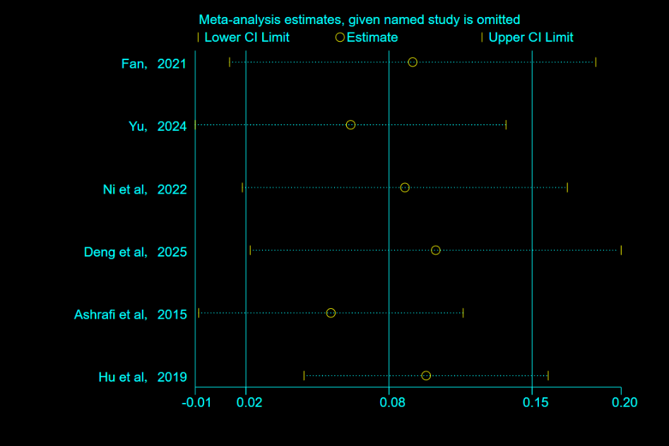

Age
2.1 Age Subgroup Analysis Results
Stratification group | Number of studies | OR | 95% CI | I² (%) | P for heterogeneity
Validation Methods
Internal validation | 3 | 0.956 | (0.878-1.041) | 96.5 | < 0.001
Verification method not specified | 3 | 0.796 | (0.627-1.010) | 92.5 | < 0.001
Study Design
Cohort study | 4 | 0.949 | (0.881-1.002) | 94.9 | < 0.001
Non cohort study | 2 | 0.737 | (0.495-1.097) | 95.2 | < 0.001
Population
Average age＞30 | 2 | 0.595 | (0.522-0.677) | 0.0 | 0.762
Average age≤30 | 4 | 0.960 | (0.901-1.022) | 94.0 | < 0.001
2.2 Sensitivity Analysis of Age
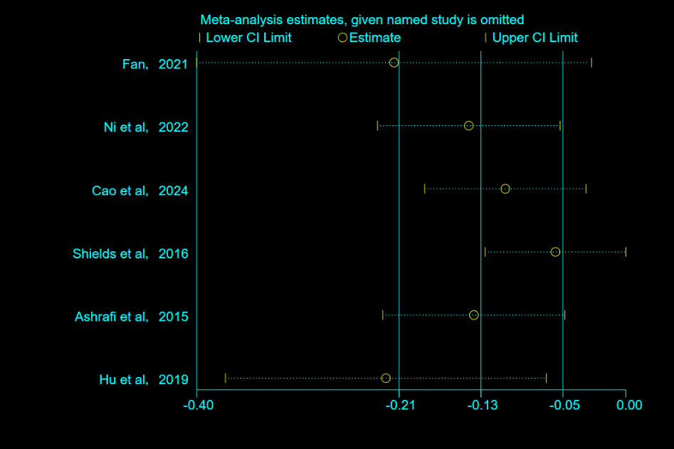

AMH
3.1 AMH Subgroup Analysis Results
Stratification group | Number of studies | OR | 95% CI | I² (%) | P for heterogeneity
Validation Methods
Internal validation | 4 | 1.096 | (0.986-1.217) | 98.5 | < 0.001
External validation | 2 | 1.641 | (1.041-2.588) | 91.0 | 0.001
Study Design
Cohort study | 4 | 1.412 | (1.016-1.285) | 98.4 | < 0.001
Non cohort study | 2 | 1.268 | (1.219-1.320) | 0.0 | 0.401
Population
Average age＞30 | 2 | 1.468 | (0.744-2.899) | 96.5 | < 0.001
Average age≤30 | 4 | 1.156 | (1.015-1.317) | 98.5 | < 0.001

3.2 Sensitivity Analysis of AMH
