Additional file 1: Spatial variation in maternal care indicators (ANC4 and postanal visits), from health system data. Annualized per capita utilization out of expected pregnant women, estimated as the fokontany average from data of all health centers. A) ANC4, and B) Postnatanal care.
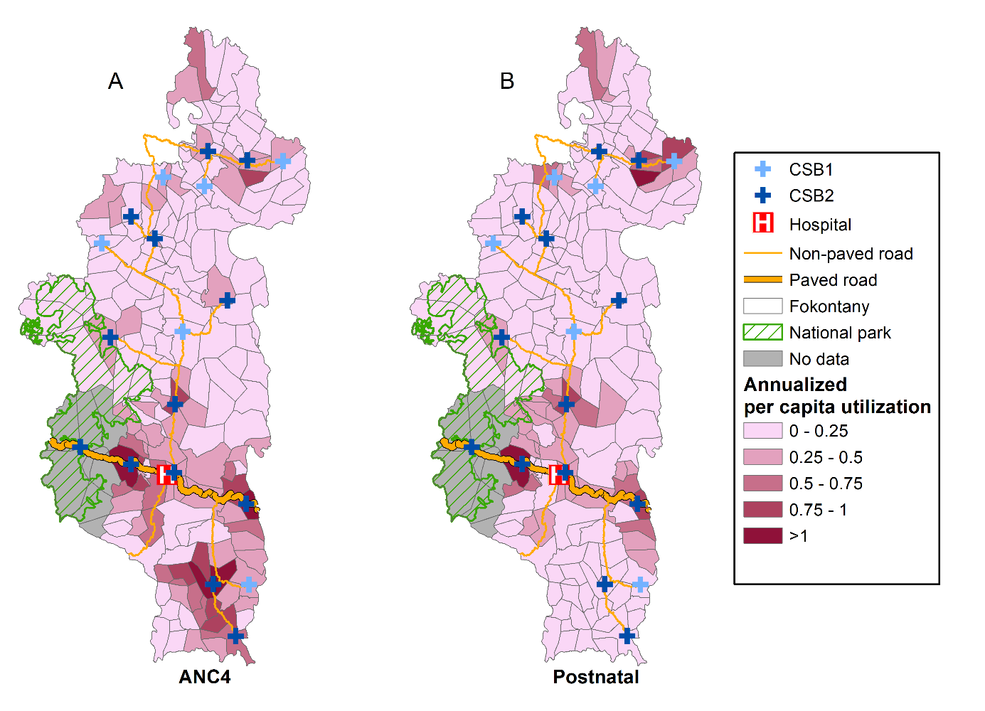

Additional file 2: Spatial variation in maternal care indicators (ANC4 and postanal visits), from cohort data. Percentage of pregnant women included in each of 80 clusters in cohort surveys (black circle) who accessed each maternal care service, with values interpolated using inverse distance weighted interpolation. A) ANC4, and B) Postnatal care.
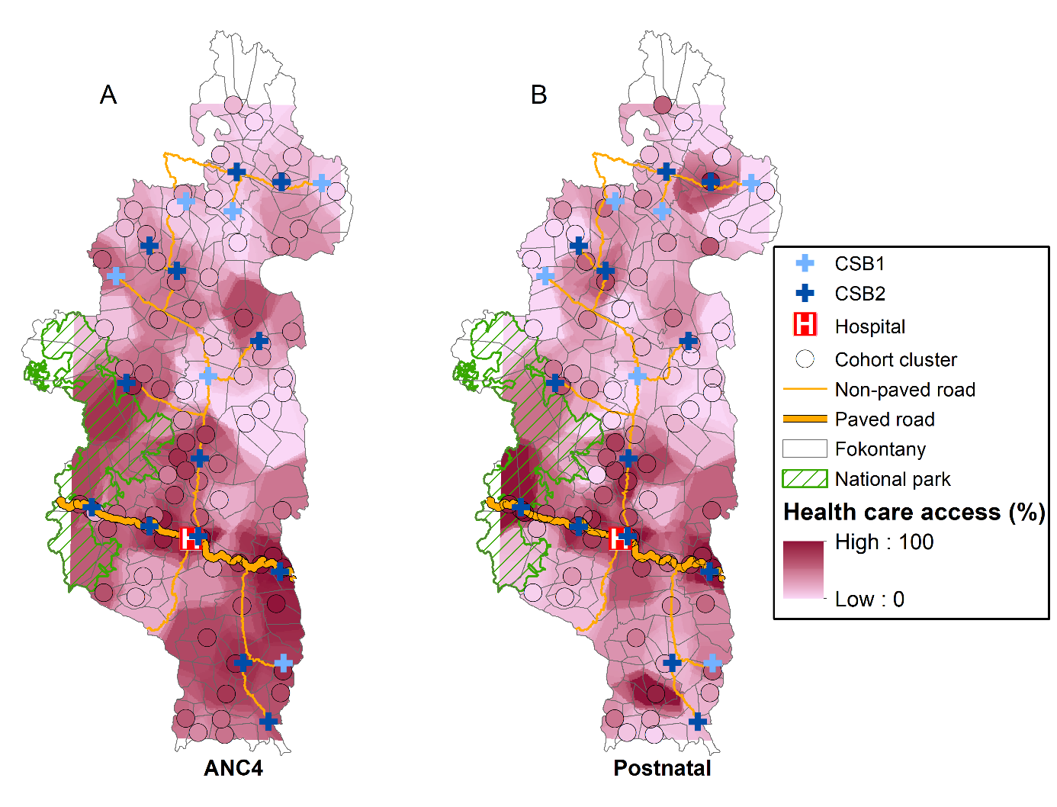

Additional file 3: Multivariate analyses of health system data using density of health staff (generalized linear mixed model, negative binomial distribution)
Variables | ANC1 | ANC4 | Deliveries | Postnatal
Variables | Relative change (95% CI) | Relative change (95% CI) | Relative change (95% CI) | Relative change (95% CI)
Geographic factors
Travel time (ref. less than 1h)
1- 2 hr | 0.85 (0.79-0.92) *** | 0.78 (0.68-0.89) *** | 0.60 (0.53-0.68) *** | 0.67 (0.58-0.78) ***
More than 2 hr | 0.74 (0.69- 0.79) *** | 0.55 (0.48- 0.62) *** | 0.40 (0.36-0.45) *** | 0.48 (0.41-0.56) ***
Health system factors
Density of health staff | 1.07 (0.99-1.17) | 0.94 (0.81-1.09) | 1.06 (0.96-1.17) | 1.09 (0.91-1.31)
PHC level (CSB2 vs. CSB1) | 1.58 (1.10-2.28) * | 2.09 (1.15-3.82) * | 1.35 (0.98-1.84) | 1.49 (0.62-3.58)
HSS catchment (RoD vs. HSS catchment) | 0.82 (0.69-0.99) * | 0.91 (0.63-1.32) | 0.97 (0.74-1.28) | 0.66 (0.43-1.00)
Temporal trends
Annual linear trend | 0.94 (0.91-0.97) *** | 1.01 (0.95-1.08) | 0.92 (0.88-0.98) ** | 0.94 (0.88-1.01)
Lag (1-month) | 1.35 (1.33-1.38) *** | 1.88 (1.76-2.01) *** | 1.58 (1.49-1.66) *** | 2.02 (1.87-2.18) ***
*p <0.05; ***p <0.001
PHC, primary health center; HSS, health system strengthening; RoD, rest of the district.

