Supplementary material
Methods
MMR estimation
Using the following search string[1]:
( ( ( ( "Postpartum Hemorrhage" OR "Uterine Hemorrhage" ) OR ( maternal[Title/Abstract] OR pregnan*[Title/Abstract] OR mothers ) AND ( haemorrhag*[Title/Abstract] OR hemorrhag*[Title/Abstract] ) NOT "case report"[All fields] ) OR ( ( "induced abortion" OR "Therapeutic abortion" OR "legal Abortion" OR "medical abortion" OR "miscarriage" OR "Abortion, Induced"[Mesh] OR "Abortion, Therapeutic"[Mesh] OR "Abortion, Legal"[Mesh] OR "ectopic Pregnancy" ) NOT ( "case report"[Title/Abstract] OR "birth defect"[Title/Abstract] OR congenital[Title/Abstract] ) ) OR ( "obstructed labour" OR "obstructed labor" OR "labour dystocia" OR "labor dystocia" OR dystocia OR "cephalopelvic disproportion" OR "cephalo-pelvic disproportion" ) OR ( ( "obstetric fistula" OR "vesicovaginal fistula" ) OR "rectovaginal fistula" ) OR ( ( "Puerperal Infection"[Mesh] OR "Puerperal Infection" OR ( (maternal[Title/Abstract] OR pregnan*[Title/Abstract] ) AND ( Sepsis OR infection[Title/Abstract] ) ) ) NOT "case report" ) OR ( ( pre-eclampsia[Title/Abstract] OR preeclampsia[Title/Abstract] OR eclampsia[Title/Abstract] OR PreEclampsia[Mesh] OR Eclampsia[Mesh] OR "Hypertension, Pregnancy-Induced"[Mesh] OR "pregnancy induced hypertension"[Title/Abstract] OR "gestational hypertension"[Title/Abstract] OR "Hypertensive disorders of pregnancy"[Title/Abstract] ) NOT ( "case report" OR "kidney donor"[Title/Abstract] OR "kidney donors"[Title/Abstract] OR polymorphism*[Title/Abstract] OR endotheli*[Title/Abstract] ) ) ) OR ( ( ( "maternal mortality"[Title/Abstract] OR "maternal death"[Title/Abstract] OR "maternal deaths"[Title/Abstract] OR "MM"[Title/Abstract] OR "confidential enquiry"[Title/Abstract] OR "confidential inquiry"[Title/Abstract] OR ( ( obstetric[Title/Abstract] OR pregnan*[Title/Abstract] ) AND (etiology[Title/Abstract] OR cause[Title/Abstract] OR pattern[Title/Abstract]) AND ( death[Title/Abstract] OR mortality[Title/Abstract] ) ) ) NOT ( fetal[Title/Abstract] OR newborn*[Title/Abstract] OR neonatal[Title/Abstract] OR "case report" [Title/Abstract] OR "case study" [Title/Abstract] OR pathogenesis[Title/Abstract] OR thromboprophylaxis[Title/Abstract] ) ) OR ( ( ( "maternal mortality"[Title/Abstract] OR "maternal death"[Title/Abstract] OR "maternal deaths"[Title/Abstract] OR "MMR"[Title/Abstract] ) AND ( "Afghanistan"[Title/Abstract] OR "Albania"[Title/Abstract] OR "Algeria"[Title/Abstract] OR "Andorra"[Title/Abstract] OR "Angola"[Title/Abstract] OR "Antigua and Barbuda"[Title/Abstract] OR "Argentina"[Title/Abstract] OR "Armenia"[Title/Abstract] OR "Azerbaijan"[Title/Abstract] OR "Bahrain"[Title/Abstract] OR "Bangladesh"[Title/Abstract] OR "Barbados"[Title/Abstract] OR "Belarus"[Title/Abstract] OR "Belize"[Title/Abstract] OR "Benin"[Title/Abstract] OR "Bhutan"[Title/Abstract] OR "Bolivia"[Title/Abstract] OR "Bosnia and Herzegovina"[Title/Abstract] OR "Botswana"[Title/Abstract] OR "Brazil"[Title/Abstract] OR "Brunei"[Title/Abstract] OR "Bulgaria"[Title/Abstract] OR "Burkina Faso"[Title/Abstract] OR "Burundi"[Title/Abstract] OR "Cambodia"[Title/Abstract] OR "Cameroon"[Title/Abstract] OR "Cape Verde"[Title/Abstract] OR "Central African Republic"[Title/Abstract] OR "Chad"[Title/Abstract] OR "China"[Title/Abstract] OR "Colombia"[Title/Abstract] OR "Comoros"[Title/Abstract] OR "Congo"[Title/Abstract] OR "Costa Rica"[Title/Abstract] OR "Croatia"[Title/Abstract] OR "Cuba"[Title/Abstract] OR "Cyprus"[Title/Abstract] OR "Côte d’Ivoire"[Title/Abstract] OR "Democratic Republic of the Congo"[Title/Abstract] OR "Djibouti"[Title/Abstract] OR "Dominica"[Title/Abstract] OR "Dominican Republic"[Title/Abstract] OR "Ecuador"[Title/Abstract] OR "Egypt"[Title/Abstract] OR "El Salvador"[Title/Abstract] OR "Equatorial Guinea"[Title/Abstract] OR "Eritrea"[Title/Abstract] OR "Ethiopia"[Title/Abstract] OR "Federated States of Micronesia"[Title/Abstract] OR "Fiji"[Title/Abstract] OR "Gabon"[Title/Abstract] OR "Georgia"[Title/Abstract] OR "Ghana"[Title/Abstract] OR "Grenada"[Title/Abstract] OR "Guatemala"[Title/Abstract] OR "Guinea"[Title/Abstract] OR "Guinea-Bissau"[Title/Abstract] OR "Guyana"[Title/Abstract] OR "Haiti"[Title/Abstract] OR "Honduras"[Title/Abstract] OR "India"[Title/Abstract] OR "Indonesia"[Title/Abstract] OR "Iran"[Title/Abstract] OR "Iraq"[Title/Abstract] OR "Jamaica"[Title/Abstract] OR "Jordan"[Title/Abstract] OR "Kazakhstan"[Title/Abstract] OR "Kenya"[Title/Abstract] OR "Kiribati"[Title/Abstract] OR "Kuwait"[Title/Abstract] OR "Kyrgyzstan"[Title/Abstract] OR "Laos"[Title/Abstract] OR "Latvia"[Title/Abstract] OR "Lebanon"[Title/Abstract] OR "Lesotho"[Title/Abstract] OR "Liberia"[Title/Abstract] OR "Libya"[Title/Abstract] OR "Lithuania"[Title/Abstract] OR "Macedonia"[Title/Abstract] OR "Madagascar"[Title/Abstract] OR "Malawi"[Title/Abstract] OR "Malaysia"[Title/Abstract] OR "Maldives"[Title/Abstract] OR "Mali"[Title/Abstract] OR "Malta"[Title/Abstract] OR "Marshall Islands"[Title/Abstract] OR "Mauritania"[Title/Abstract] OR "Mauritius"[Title/Abstract] OR "Moldova"[Title/Abstract] OR "Mongolia"[Title/Abstract] OR "Montenegro"[Title/Abstract] OR "Morocco"[Title/Abstract] OR "Mozambique"[Title/Abstract] OR "Myanmar"[Title/Abstract] OR "Namibia"[Title/Abstract] OR "Nepal"[Title/Abstract] OR "Nicaragua"[Title/Abstract] OR "Niger"[Title/Abstract] OR "Nigeria"[Title/Abstract] OR "North Korea"[Title/Abstract] OR "Oman"[Title/Abstract] OR "Pakistan"[Title/Abstract] OR "Palestine"[Title/Abstract] OR "Panama"[Title/Abstract] OR "Papua New Guinea"[Title/Abstract] OR "Paraguay"[Title/Abstract] OR "Peru"[Title/Abstract] OR "Philippines"[Title/Abstract] OR "Qatar"[Title/Abstract] OR "Romania"[Title/Abstract] OR "Russia"[Title/Abstract] OR "Rwanda"[Title/Abstract] OR "Saint Lucia"[Title/Abstract] OR "Saint Vincent and the Grenadines"[Title/Abstract] OR "Samoa"[Title/Abstract] OR "Saudi Arabia"[Title/Abstract] OR "Senegal"[Title/Abstract] OR "Serbia"[Title/Abstract] OR "Seychelles"[Title/Abstract] OR "Sierra Leone"[Title/Abstract] OR "Singapore"[Title/Abstract] OR "Solomon Islands"[Title/Abstract] OR "Somalia"[Title/Abstract] OR "South Africa"[Title/Abstract] OR "South Sudan"[Title/Abstract] OR "Sri Lanka"[Title/Abstract] OR "Sudan"[Title/Abstract] OR "Suriname"[Title/Abstract] OR "Swaziland"[Title/Abstract] OR "Syria"[Title/Abstract] OR "São Tomé and Principe"[Title/Abstract] OR "Taiwan"[Title/Abstract] OR "Tajikistan"[Title/Abstract] OR "Tanzania"[Title/Abstract] OR "Thailand"[Title/Abstract] OR "The Bahamas"[Title/Abstract] OR "The Gambia"[Title/Abstract] OR "Timor-Leste"[Title/Abstract] OR "Togo"[Title/Abstract] OR "Tonga"[Title/Abstract] OR "Trinidad and Tobago"[Title/Abstract] OR "Tunisia"[Title/Abstract] OR "Turkmenistan"[Title/Abstract] OR "Uganda"[Title/Abstract] OR "Ukraine"[Title/Abstract] OR "United Arab Emirates"[Title/Abstract] OR "Uruguay"[Title/Abstract] OR "Uzbekistan"[Title/Abstract] OR "Vanuatu"[Title/Abstract] OR "Venezuela"[Title/Abstract] OR "Vietnam"[Title/Abstract] OR "Yemen"[Title/Abstract] OR "Zambia"[Title/Abstract] OR "Zimbabwe"[Title/Abstract] ) ) NOT ("demographic and health survey"[Title/Abstract] OR "demographic and health surveys "[Title/Abstract] OR DHS[Title/Abstract] OR "reproductive health survey"[Title/Abstract] OR "reproductive health surveys"[Title/Abstract] OR RHS[Title/Abstract] ) ) OR ( ( HIV[Title/Abstract] OR "Acquired Immunodeficiency Syndrome"[Title/Abstract] OR AIDS[Title/Abstract] ) AND ( pregnan*[Title/Abstract] OR "postpartum"[Title/Abstract] OR "post partum"[Title/Abstract] ) AND ("mortality"[Title/Abstract] OR "death"[Title/Abstract] ) NOT "case report" ) ) AND ( 2019/05/10[PDat] : 3000[PDat] ) NOT ( animals[MeSH] NOT humans[MeSH] ) )
During the GBD 2021 cycle, a total of 5563 newly published literature titles and abstracts were identified and reviewed; among these, 235 underwent full-text assessment, and ultimately 66 met the inclusion criteria and could be used for one or more maternal disease burden indicators.
PRISMA 2020 Flow Diagram[2]
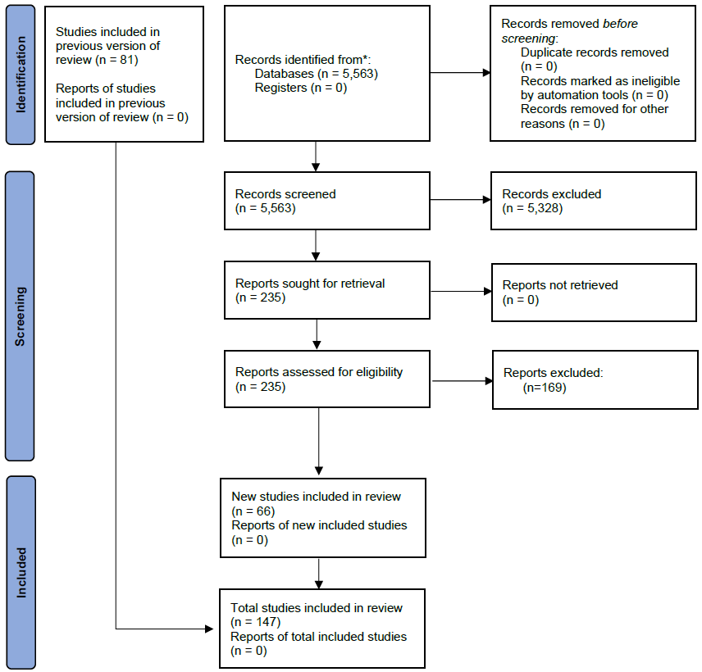
Modelling strategy
Overall maternal mortality
Overall maternal mortality was estimated with CODEm. Covariates included in this model, their level, and directionality are show in the Table1 below:
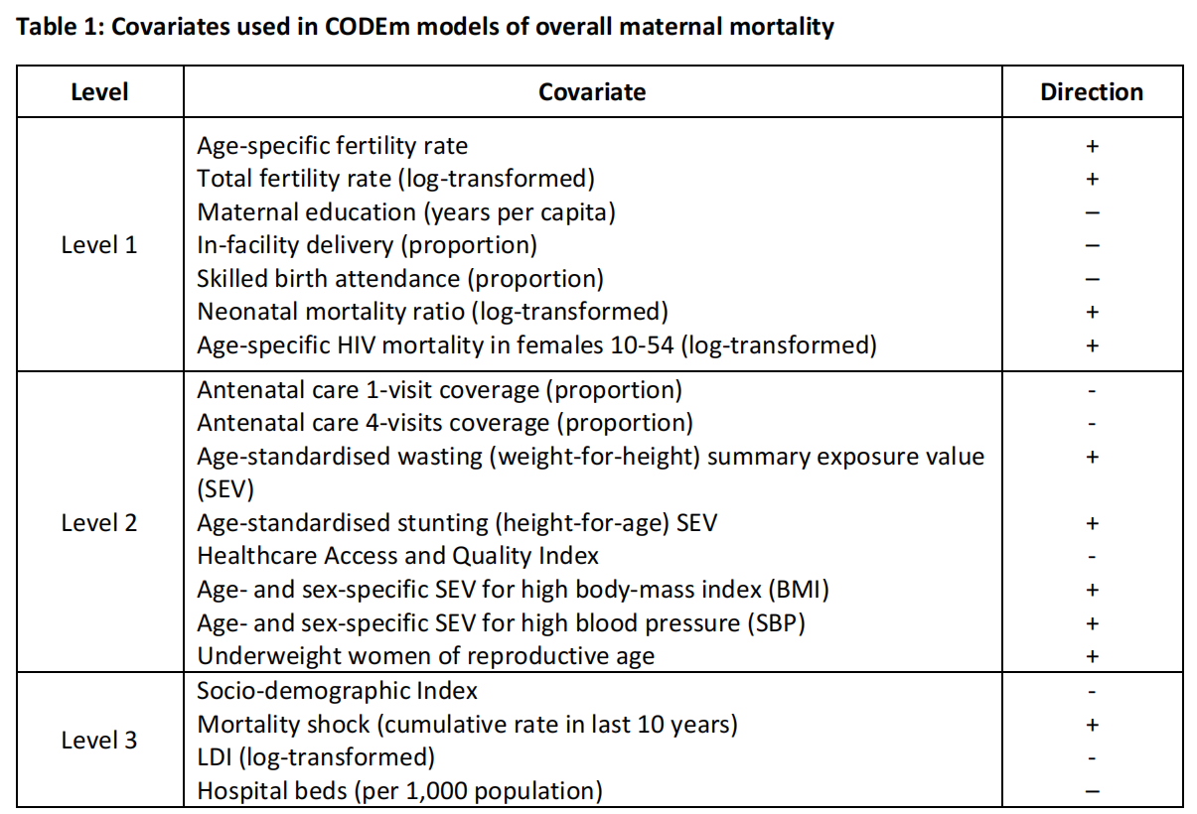
Cause-specific maternal mortality
In GBD 2021, the spatiotemporal Gaussian process regression (ST-GPR) was employed to estimate maternal mortality ratios for subcategories of maternal causes of death. This modeling strategy requires that data conform to the standard age groups defined by the Global Burden of Disease Study (GBD). To achieve this, GBD 2021 utilized global age patterns for each cause of death from Cause of Death (COD) data and extrapolated these to all non-standard age groups. ST-GPR also requires a variance estimate for each data point: this was obtained by running a Lowess regression on an annual basis and using the variance of the residuals between observed and predicted values as the variance for that data point. Previously, the first step consistently involved a mixed-effects ordinary least squares regression, fitting the target metric against a predefined set of country-level covariates. GBD subsequently revised this approach: the first step was changed to a "regression ensemble" method, where the weights of each constituent model were determined based on their out-of-sample predictive performance regarding coverage rates. This strategy not only allows for testing a larger number of covariates but also enables the pre-specification of directional relationships between country-level covariates and the outcome variable. The country-specific covariates used in each subcause model are detailed in the Table2 below[2].
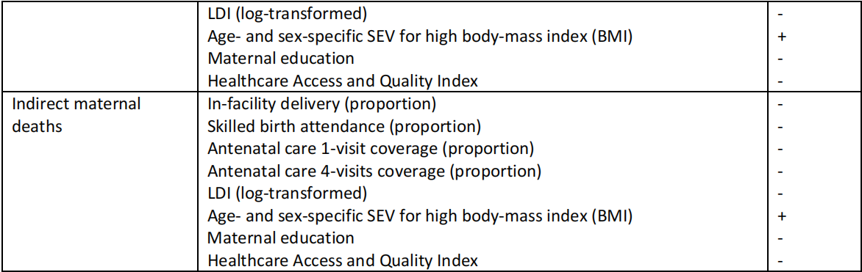
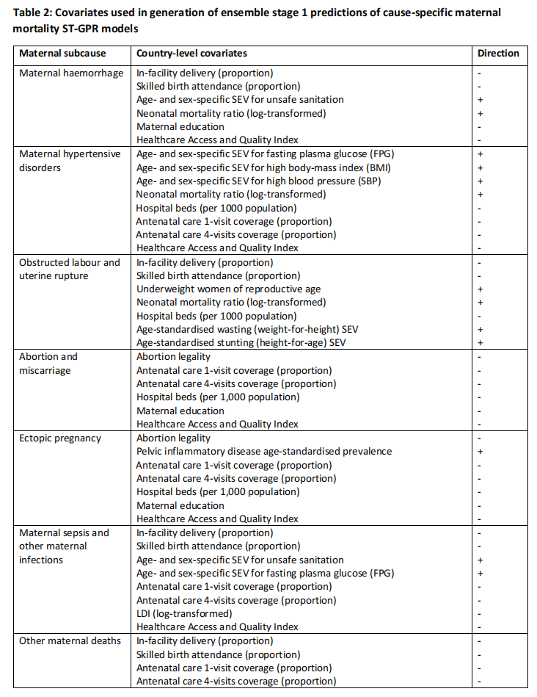
Case Definition of Maternal Disorders[1]
Maternal disorders refer to complications occurring during pregnancy, childbirth, and the postpartum period. The Global Burden of Disease Study (GBD) 2021estimated nine statistical models across maternal subcauses, defined as follows:
- ​​Abortion and Miscarriage​​: Abortion is defined as an elective or medically-indicated termination of pregnancy at any gestational age. Miscarriage refers to the spontaneous loss of pregnancy before 24 weeks of gestation, requiring medical care due to complications.
- ​​Ectopic Pregnancy​​: This is defined as any pregnancy occurring outside the uterine cavity.
- ​​Maternal Haemorrhage (including placental disorders)​​: This includes both postpartum haemorrhage (blood loss >500 ml for vaginal delivery and >1,000 ml for cesarean delivery) and antepartum haemorrhage (vaginal bleeding from any cause at or beyond 20 weeks of gestation and prior to the onset of labour). It also encompasses placental disorders accompanied by haemorrhage, regardless of the volume of blood lost or the timing of the bleeding event. Placental disorders without haemorrhage are categorized under 'other direct maternal disorders'.
- ​​Maternal Sepsis and Other Maternal Infections​​:
  - ​​Maternal Sepsis​​: Defined by a body temperature <36°C or >38°C accompanied by clinical signs of shock, including systolic blood pressure <90 mmHg and tachycardia >120 bpm.
  - ​​Other Maternal Infections​​: These are defined as any maternal infections excluding HIV, sexually-transmitted infections, or those not believed to have an epidemiological relationship with pregnancy. Examples include urinary tract infections, mastitis, candidiasis, and bacterial vaginosis during pregnancy.
- ​​Hypertensive Disorders of Pregnancy​​: This overall category is defined as blood pressure (BP) >140/90 mmHg, based on multiple measurements, in individuals who were not hypertensive prior to pregnancy. It includes several subcategories:
  - ​​Severe Pre-eclampsia​​: Characterized by severe hypertension (>160/100 mmHg), proteinuria (≥0.3 g/l), and additional signs of end-organ damage (e.g., low platelets, elevated liver enzymes, coagulation issues for liver; elevated creatinine for kidney; headaches or visual disturbances for CNS). This includes HELLP syndrome (Hypertension, Elevated Liver enzymes, Low Platelets).
  - ​​Eclampsia​​: Defined by hypertension (with or without proteinuria) and the occurrence of seizures.
  - ​​Other Hypertensive Disorders​​: This includes gestational hypertension (BP >140/90 without proteinuria or other symptoms) and pre-eclampsia (hypertension and proteinuria without signs of end-organ damage).
- ​Other Direct Maternal Disorders​​: This category includes a variety of other obstetric complications. The most common causes of death from ICD-10 coded vital registration sources include O88 (Obstetric embolism), O26 (Maternal care for other conditions predominantly related to pregnancy), O90 (Complications of the puerperium, not elsewhere classified), O75 (Other complications of labor and delivery, not elsewhere classified), C58 (Malignant neoplasm of placenta), and O36 (Maternal care for other fetal problems).
Age-sex splitting[1]
Different data sources often report mortality using varying age intervals. For cause of death (CoD) analysis, the Global Burden of Disease Study 2021 (GBD 2021) maps these intervals to standard GBD age groups. During the integration and harmonization of population databases, the aggregation of age groups was identified as the most prominent source of inconsistency. Conventionally, data are often published in broad age groups (e.g., 0–4 years, 5–14 years, 15–49 years) or aggregated by sex. When compiling the GBD CoD database, comparability issues across age-sex groups became particularly pronounced. To address this, GBD 2021 developed an "age-sex splitting" tool. This tool disaggregates combined age groups and "both sexes combined" groups into their theoretical component age-sex groups, based on cause-specific and country-specific age distributions. The GBD analytical framework defines three infant age segments—early neonatal (0–6 days), late neonatal (7–27 days), and post-neonatal (28–364 days)—along with 20 non-infant age groups: 1–4 years, 5–9 years, and so forth in 5-year intervals up to a terminal group of 95 years and older. The processing pathways for unknown age and unknown sex are the same as those for the "all-age combined" and "both sexes combined" categories, thereby enabling homogeneous comparison across all data sources.
The age-splitting methodology is based on the following formula. Its core assumption is that the relative risk of death across age groups, compared to a reference age group, remains constant across different populations. Although this assumption might be violated in specific instances, the age-specific relative risks of death for most causes exhibit distinct biological patterns. The fundamental formula is as follows
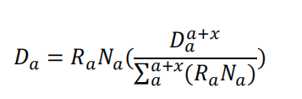
Where: 𝐷_{α}= the number of deaths from a cause in age group α; 𝑅_{α}= global cause-specific mortality rate of age group α; 𝑁_{α}= the country-year-sex-specific population in age group α; 𝐷α+𝑥 α= the number of deaths in the age group α to α+𝑥.
Under the assumption that the relative risk of mortality for each age group compared to the reference age group remains constant, the total number of deaths in the age interval "α to α+𝑥 " can be decomposed into specific death counts for each constituent age group within that interval by incorporating the population age structure.
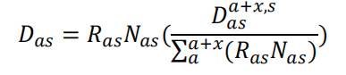
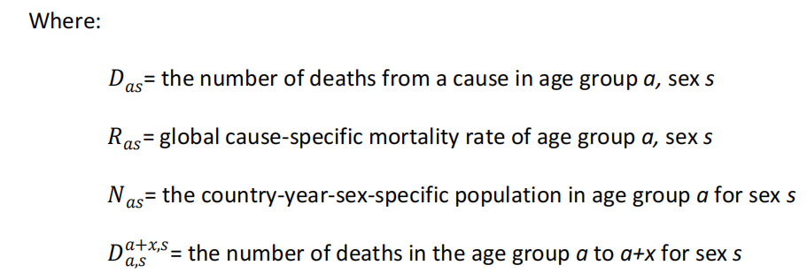
In certain instances, mortality data are reported only in an aggregated form by "age group and combined for both sexes." In such cases, the task of disaggregation becomes more complex, yet the same underlying principles can be applied. GBD 2021 operates under the assumption that the relative risks of death across age groups and sexes remain constant. This assumption allows for the splitting of the combined data. However, the postulate of invariant relative risks across age and sex is a strong one; fortunately, the pooling of data across sexes is relatively uncommon in both published and unpublished cause-of-death (CoD) data. The age- and sex-specific relative risks of mortality are derived from the cause-specific mortality distributions found in global Vital Registration (VR) data that possess the necessary age and sex detail. After data aggregation, they are mapped to GBD causes of death and aggregated to the Level 3 hierarchy. The disaggregation is performed at this level—any sub-cause within a Level 3 cause of death is split according to the age distribution of its parent Level 3 cause (for instance, chronic kidney disease due to diabetes mellitus would be disaggregated using the age pattern of chronic kidney disease). Subsequently, GBD 2021 aggregates the death counts and population figures across all region-years for each "age-sex-cause" combination to compute cause-specific mortality rates by age and sex. These rates are then used to determine the mortality risk for any given age group relative to a reference age group, as specified in the equations mentioned previously.

References:
1. Global burden of 369 diseases and injuries in 204 countries and territories, 1990-2019: a systematic analysis for the Global Burden of Disease Study 2019. Lancet (London, England) 2020, 396(10258):1204-1222.http://dx.doi.org/10.1016/s0140-6736(20)30925-9.
2. Global burden of 288 causes of death and life expectancy decomposition in 204 countries and territories and 811 subnational locations, 1990-2021: a systematic analysis for the Global Burden of Disease Study 2021. Lancet (London, England) 2024, 403(10440):2100-2132.http://dx.doi.org/10.1016/s0140-6736(24)00367-2.

