Supplementary Materials

Supplementary Material 1
The allocation of imaging sequences, scanners, and orientations followed a completely randomized block design. The data from different sequences, scanners, and orientations were balanced, with no statistically significant differences, as shown in the following table (all P-values＞0.05).
Groups  Categories | Training group  (n = 1386) | Validation group  (n = 462) | Test group  (n = 462) | χ² values | P values
Sequences  Sequences(Haste) | 1293(93.29%) | 433(93.74%) | 432(93.50%) | 0.486 | 0.975
Sequences(Fiesta) | 89(6.42%) | 28(6.06%) | 28(6.06%)
Sequences(SSFSE) | 4(0.29%) | 1(0.2%) | 2(0.44%)
Scanners |  |  |  | 0.113 | 0.945
Scanners(Siemens)  Scanners(GE) | 1293(93.29%)  93(6.71%) | 433(93.74%)  29(6.26%) | 432(93.50%)  30(6.50%)
Orientations  Axial view  Coronal view  Sagittal view | 1022(73.7%)  193(13.9%)  171(12.4%) | 336(72.7%)  66(14.3%)  60(13.0%) | 342(74.0%)  78(16.9%)  42(9.1%) | 5.936 | 0.204

Supplementary Material 2
In supplementary material 2, the blue color represents the axial scans, the orange color represents the coronal scans, and the green color represents the sagittal scans. The data from different orientations were balanced, with no statistically significant differences among these different groups (P-values > 0.05), as detailed in supplementary material 2.
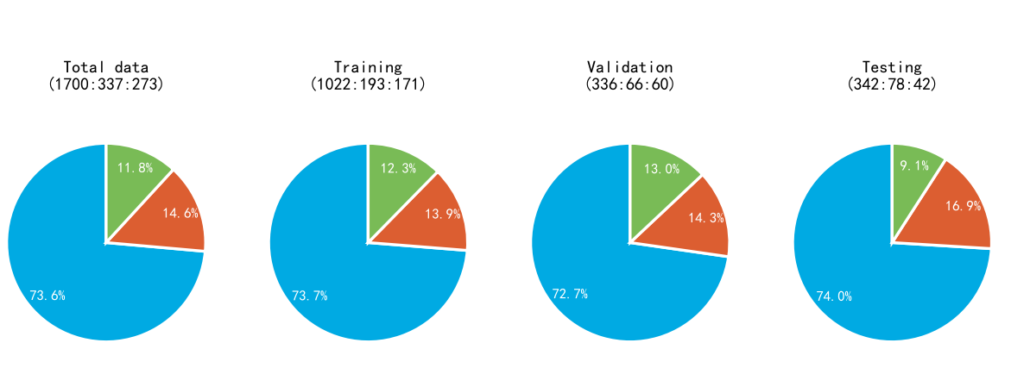

Supplementary Material 3
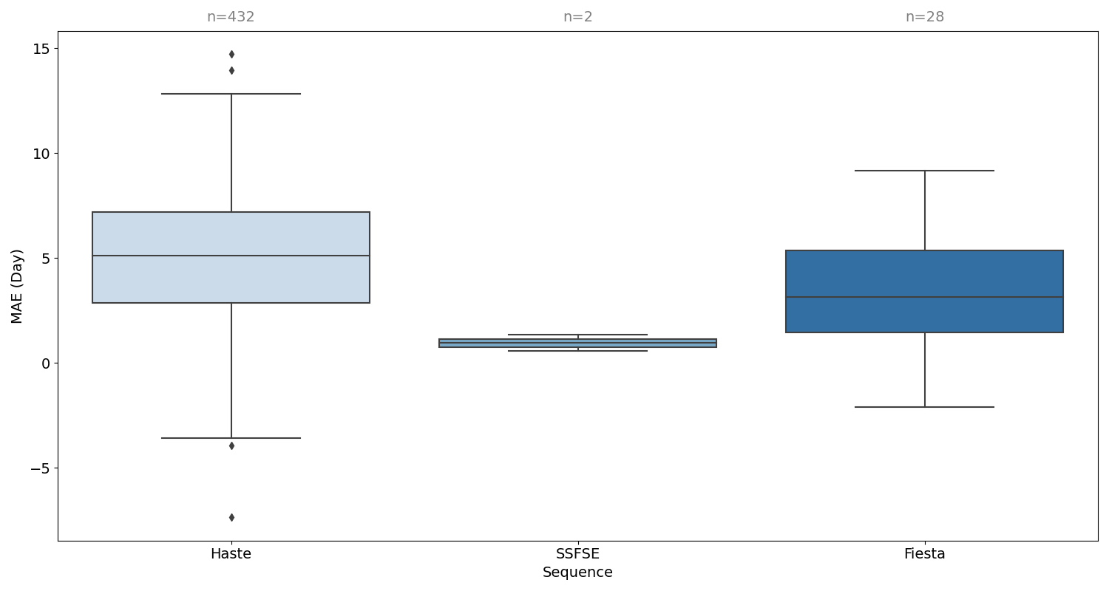
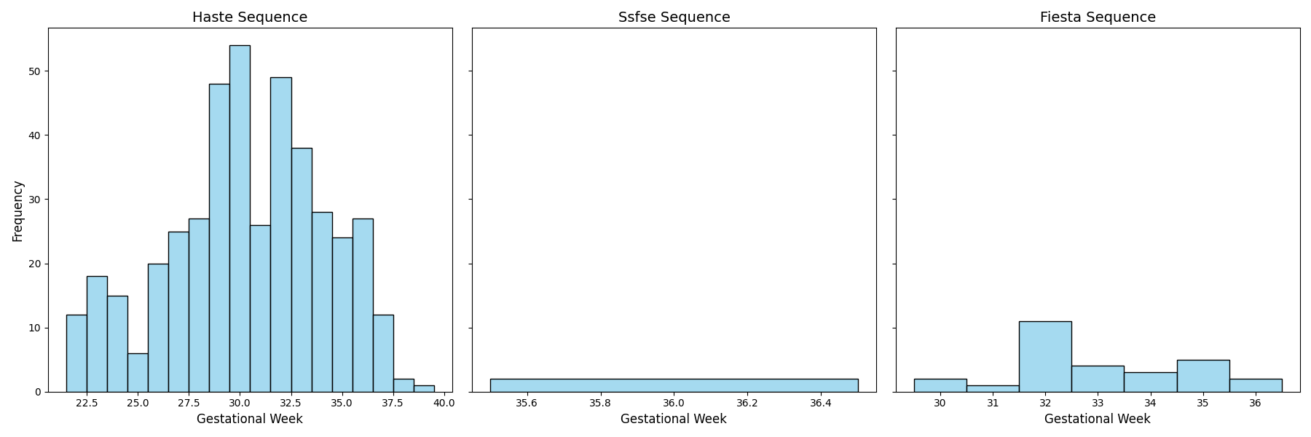
This study encompassed samples from three distinct T2-weighted sequences. Although the sample sizes and gestational age distribution for each sequence were not balanced, no significant differences in predictive performance were observed.

Supplementary Material 4
The specific distribution of fetal MRI scans, which encompass the full range of gestational ages in the study, is detailed in supplementary material 4. Supplementary material 4 shows that all gestational ages were adequately represented across the training, validation, and test sets.
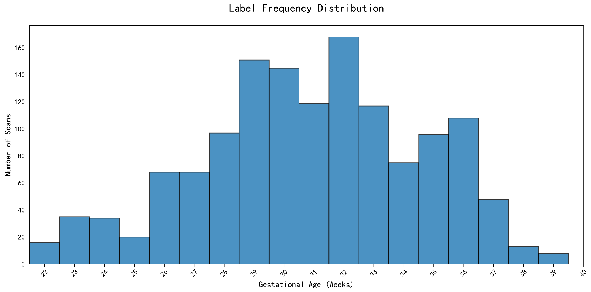
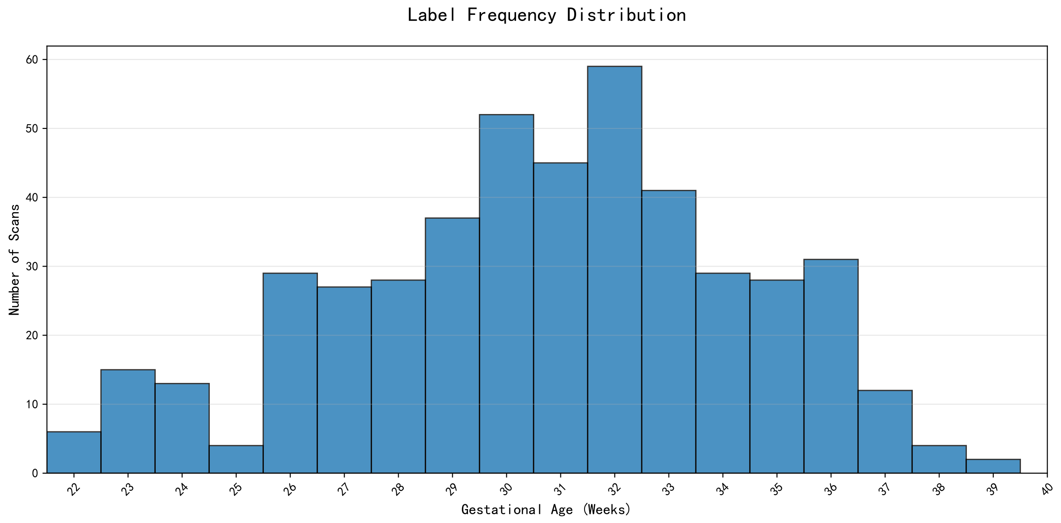
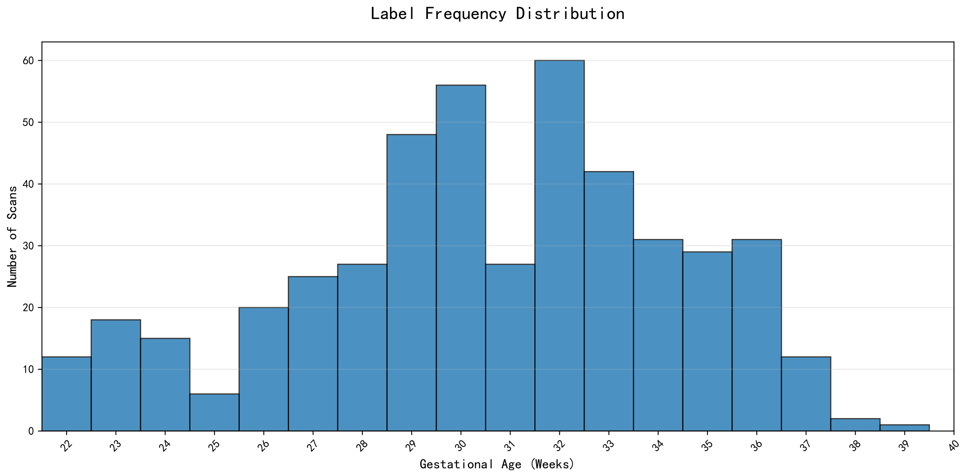

Supplementary Material 5
To further evaluate whether the prior pooling mechanism enhances performance, we conducted additional analyses as shown in supplementary material 5. The full method with the prior pooling mechanism yields a MAE of 4.62 ± 3.31 days for predicting fetal brain age. After eliminating the prior pooling mechanism, the MAE is 4.85 ± 3.60 days for predicting fetal brain age. Consequently, it can be concluded that the inclusion of the prior pooling mechanism can enhance the model's predictive accuracy for gestational age estimation.
Comparison of MAE and R² generated by different methods
Methods | Menstrual cycle-based gestational week | Scan prior | MAE (Days) | R² | P-value
ResNet-50 | × | × | 20.5612±14.8430 | 0.2356 | <0.001
Ours (Prior-1) | $$√$$ | × | 4.8540±3.5994 | 0.946 | <0.001
Ours (Full) | $$√$$ | $$√$$ | 4.6210±3.3151 | 0.9532 | /
Notes: √= used, × = not used.

Supplementary Material 6
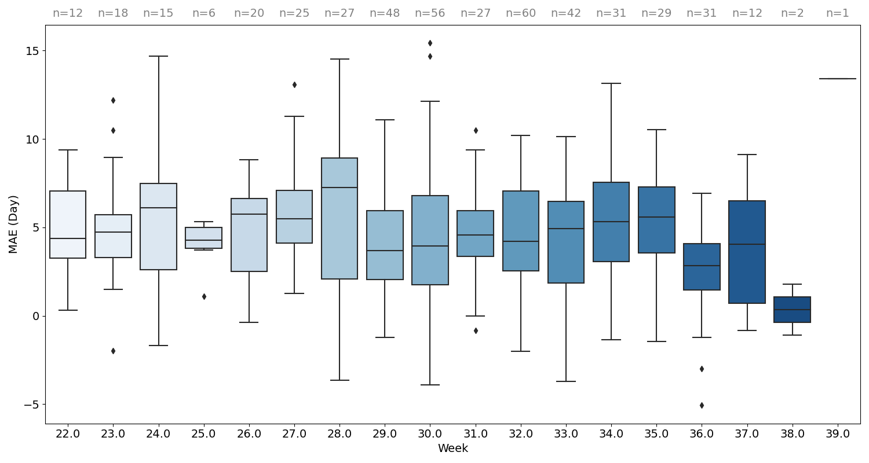
Our gestational age-stratified analysis reveals statistically consistent prediction errors across all weeks, demonstrating robust performance stability throughout the second and third trimesters.

Supplementary Material 7
The clear illustration of the attention maps overlay with original images has been attached as supplementary material 7. The attention map demonstrates that the model is capable of extracting features that are highly correlated with fetal central brain regions, as highlighted by deep red coloration.
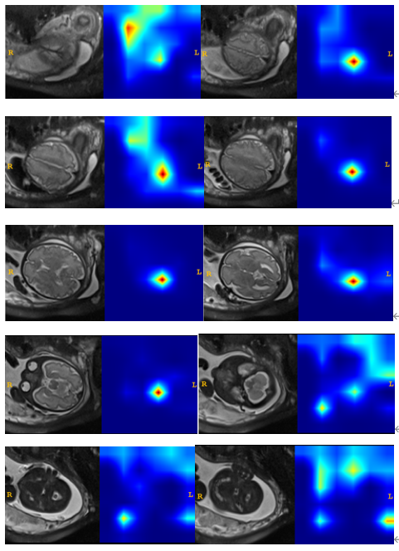
0
1
Slice index increase
(Low attention)
(High attention)

