Appendix
Table S1 Assignment of independent variables
Independent variables | Assignment
Gestational stage | 1=First trimester; 2=Second trimester; 3=Third trimester; 4=Postpartum
Education | 1=Primary school and below; 2=Junior high school; 3=High school/Technical secondary school; 4=College degree; 5=Undergraduate degree; 6=Postgraduate degree and above
Parity | 1=1 time; 2=2 times; 3=＞2 times
Prior VTE learning | 1=Yes; 2=No
Proactive learning (self) | 1=Yes; 2=No
Proactive learning (spouse) | 1=Yes; 2=No
Prenatal visit frequency | 1=Yes; 2=No
Pregnancy hospitalization | 1=Yes; 2=No

Supplementary Table S2: Knowledge model (HC3 robust SEs)
term | Estimate | Std Error | t value | P value
(Intercept) | 31.52 | 0.99 | 31.72 | 5.684
Gestational stage
First trimester (REF)
Second trimester | 4.58 | 0.32 | 14.22 | 6.378
Third trimester | 0.20 | 0.39 | 0.51 | 0.609
Postpartum | -0.34 | 0.43 | -0.78 | 0.436
Education level
Primary school and below | -0.03 | 2.324 | -0.01 | 0.989
Junior high school | -0.55 | 1.72 | -0.32 | 0.749
High school/Technical secondary school（REF）
Undergraduate degree | 2.69 | 0.75 | 3.58 | ＜0.001
Postgraduate degree and above | 2.74 | 0.79 | 3.48 | ＜0.001
Parity
1 time (REF)
2 times | 0.17 | 0.31 | 0.54 | 0.586
＞2 times | -2.68 | 1.88 | -1.43 | 0.153
Prior VTE learning
YES（REF）
NO | -2.09 | 0.32 | -6.43 | 1.810
Proactive learning (self)
YSE（REF）
NO | 0.83 | 0.37 | 2.21 | 0.027
Proactive learning (spouse)
YSE(REF)
NO | 1.05 | 0.47 | 2.25 | 0.0247
Prenatal visit frequency
YSE(REF)
NO | -0.68 | 1.68 | -0.41 | 0.684
Pregnancy hospitalization
YES(REF)
NO | -0.11 | 0.50 | -0.22 | 0.827

Supplementary Table S3: Attitudes model (HC3 robust SEs)
term | Estimate | Std Error | t value | P value
(Intercept) | 47.71 | 0.99 | 48.065 | 4.127
Gestational stage
First trimester (REF)
Second trimester | -0.36 | 0.389 | -0.93 | 0.351
Third trimester | -1.34 | 0.36 | -3.73 | ＜0.001
Postpartum | -1.14 | 0.42 | -2.73 | 0.006
Education level
Primary school and below | 5.76 | 8.66 | 0.66 | 0.506
Junior high school | 0.44 | 1.47 | 0.30 | 0.762
High school/Technical secondary school (REF)
Undergraduate degree | 1.40 | 0.79 | 1.77 | 0.077
Postgraduate degree and above | 1.21 | 0.82 | 1.47 | 0.142
Parity
1 time (REF)
2 times | 0.74 | 0.34 | 2.18 | 0.030
＞2 times | -0.28 | 1.31 | -0.21 | 0.832
Prior VTE learning
YES(REF)
NO | -0.99 | 0.41 | -2.45 | 0.014
Proactive learning (self)
YES(REF)
NO | 1.423 | 0.46 | 3.08 | 0.002
Proactive learning (spouse)
YES(REF)
NO | -0.34 | 0.57 | -0.60 | 0.549
Prenatal visit frequency
YES(REF)
NO | -3.43 | 3.29 | -1.04 | 0.297
Pregnancy hospitalization
YES(REF)
NO | -0.84 | 0.47 | -1.78 | 0.0749

Supplementary Table S4: Practices model (HC3 robust SEs)
term | Estimate | Std Error | t value | P value
(Intercept) | 33.72 | 1.43 | 23.60 | 1.323
Gestational stage
First trimester (REF)
Second trimester | -0.11 | 0.48 | -0.223 | 0.821
Third trimester | -2.46 | 0.48 | -5.15 | 3.027
Postpartum | -1.33 | 0.532 | -2.50 | 0.013
Education level
Primary school and below | -0.28 | 5.23 | -0.05 | 0.958
Junior high school | -2.38 | 2.23 | -1.07 | 0.285
High school/Technical secondary school (REF)
Undergraduate degree | 2.32 | 1.09 | 2.13 | 0.033
Postgraduate degree and above | 2.26 | 1.12 | 2.02 | 0.044
Parity
1 time (REF)
2 times | 0.74 | 0.44 | 1.68 | 0.093
＞2 times | -0.71 | 1.98 | -0.36 | 0.722
Prior VTE learning
YES(REF)
NO | -1.48 | 0.47 | -3.14 | 0.001
Proactive learning (self)
YES(REF)
NO | 2.48 | 0.53 | 4.65 | 3.668
Proactive learning (spouse)
YES(REF)
NO | 0.58 | 0.60 | 0.96 | 0.335
Prenatal visit frequency
YES(REF)
NO | -2.05 | 2.99 | -0.68 | 0.494
Pregnancy hospitalization
YES(REF)
NO | -1.48 | 0.64 | -2.29 | 0.022

Supplementary Figure S1: Knowledge model diagnostics
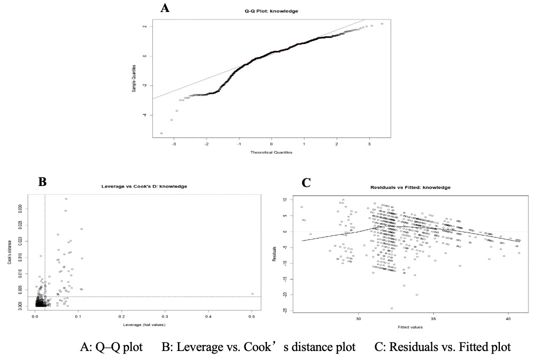

Supplementary Figure S2: Attitudes model diagnostics
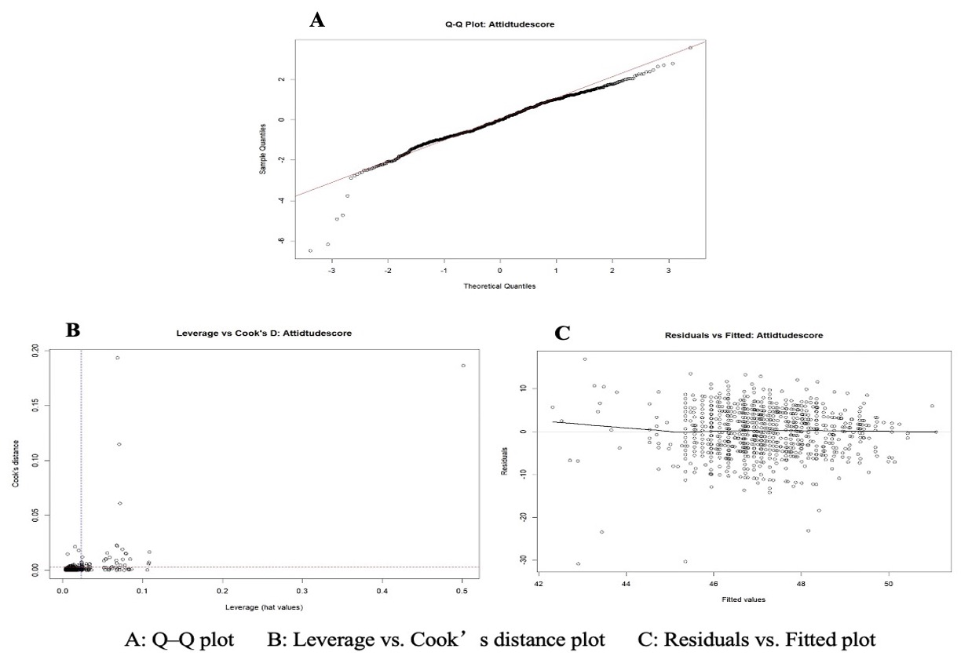
Supplementary Figure S3: Practices model diagnostics
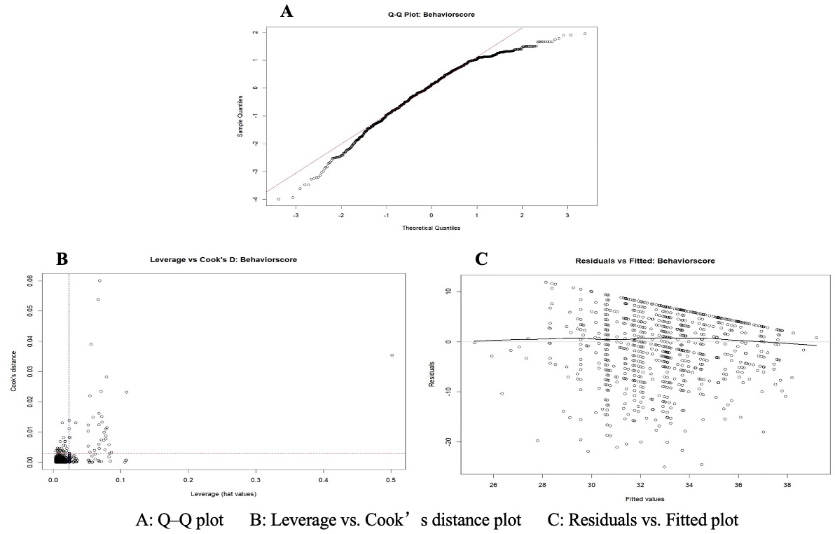

Supplementary Table S5: Variance inflation factors（VIF） for predictors in the three models
Dependent variable | Independent variable | VIF
knowledge | Gestational stage | 1.45
 | First trimester (REF)
 | Second trimester | 1.48
 | Late pregnancy | 1.47
 | Postpartum | 1.39
 | Education level | 2.25
 | Primary school and below | 1.16
 | Junior high school | 1.17
 | High school or Technical secondary school (REF)
 | College degree | 2.60
 | Undergraduate | 3.52
 | Postgraduate degree and above | 2.76
 | Parity | 1.10
 | 1 time (REF)
 | 2 times | 1.00
 | ＞2 times | 1.19
 | Prior VTE learning | 1.11
 | YES(REF)
 | NO | 1.11
 | Proactive learning (self) | 1.56
 | YES(REF)
 | NO | 1.56
 | Proactive learning (spouse) | 1.36
 | YES(REF)
 | NO | 1.36
 | Prenatal visit frequency | 1.02
 | YES(REF)
 | NO | 1.02
 | Pregnancy hospitalization | 0.81
 | YES(REF)
 | NO | 0.80
Attitude | Gestational stage | 1.45
 | First trimester (REF)
 | Second trimester | 1.48
 | Late pregnancy | 1.47
 | Postpartum | 1.39
 | Education level | 2.25
 | Primary school and below | 1.18
 | Junior high school | 1.17
 | High school or Technical secondary school (REF)
 | College degree | 2.60
 | Undergraduate | 3.52
 | Postgraduate degree and above | 2.76
 | Parity | 1.10
 | 1 time (REF)
 | 2 times | 1.00
 | ＞2 times | 1.19
 | Prior VTE learning | 1.11
 | YES(REF)
 | NO | 1.11
 | Proactive learning (self) | 1.56
 | YES(REF)
 | NO | 1.56
 | Proactive learning (spouse) | 1.45
 | YES(REF)
 | NO | 1.36
 | Prenatal visit frequency | 1.02
 | YES(REF)
 | NO | 1.02
 | Pregnancy hospitalization | 0.81
 | YES(REF)
 | NO | 0.81
Practice | Gestational stage | 1.45
 | First trimester (REF)
 | Second trimester | 1.48
 | Late pregnancy | 1.47
 | Postpartum | 1.39
 | Education level | 2.25
 | Primary school and below | 1.18
 | Junior high school | 1.17
 | High school or Technical secondary school (REF)
 | College degree | 2.60
 | Undergraduate | 3.52
 | Postgraduate degree and above | 2.76
 | Parity | 1.10
 | 1 time (REF)
 | 2 times | 1.00
 | ＞2 times | 1.19
 | Prior VTE learning | 1.11
 | YES(REF)
 | NO | 1.11
 | Proactive learning (self) | 1.56
 | YES(REF)
 | NO | 1.56
 | Proactive learning (spouse) | 1.45
 | YES(REF)
 | NO | 1.36
 | Prenatal visit frequency | 1.02
 | YES(REF)
 | NO | 1.02
 | Pregnancy hospitalization | 0.81
 | YES(REF)
 | NO | 0.81

Supplementary Table S6. Summary of Delphi process for questionnaire development
Component | Description
Expert panel | 7 experts: 2 in obstetric nursing, 2 in vascular nursing, 3 in nursing education; all with postgraduate qualifications; median 25 years of experience
Rounds | Two rounds conducted, both with 100% response rate
Consensus criteria | Item mean score > 3.5 (4-point scale) and coefficient of variation < 0.25
Authority coefficient (Cr) | Average 0.87, indicating high authority
Coordination (Kendall’s W) | Round 1: W = 0.406, p < 0.001; Round 2: W = 0.513, p < 0.001
Psychometric results from pretest (n = 138) | Cronbach’s α: total = 0.943; knowledge = 0.889; attitudes = 0.856; practices = 0.846. Test–retest reliability: 0.80–0.90 across domains

Supplementary Table S7. MANOVA for the three models
Knowledge | term | Df effect | Df error | F value | P value | η² partial
Knowledge | Gestational stage | 3 | 1368 | 83.59 | 0.000 | 0.15
Knowledge | Education level | 5 | 1368 | 5.52 | 0.000 | 0.02
Knowledge | Parity | 2 | 1368 | 2.43 | 0.089 | 0.00
Knowledge | Prior VTE learning | 1 | 1368 | 31.80 | 0.000 | 0.02
Knowledge | Lack of proactive learning (self) | 1 | 1368 | 3.90 | 0.049 | 0.00
Knowledge | Lack of proactive learning (spouse) | 1 | 1368 | 3.82 | 0.051 | 0.00
Knowledge | prenatal visit frequency | 1 | 1368 | 0.34 | 0.562 | 0.00
Knowledge | Pregnancy hospitalization | 1 | 1368 | 0.06 | 0.813 | 0.00
Attitude | Gestational stage | 3 | 1368 | 5.67 | 0.001 | 0.01
Attitude | Education level | 5 | 1368 | 1.54 | 0.176 | 0.01
Attitude | Parity | 2 | 1368 | 2.55 | 0.079 | 0.00
Attitude | Prior VTE learning | 1 | 1368 | 6.39 | 0.012 | 0.00
Attitude | Lack of proactive learning (self) | 1 | 1368 | 10.22 | 0.001 | 0.01
Attitude | Lack of proactive learning (spouse) | 1 | 1368 | 0.36 | 0.548 | 0.00
Attitude | prenatal visit frequency | 1 | 1368 | 7.48 | 0.006 | 0.01
Attitude | Pregnancy hospitalization | 1 | 1368 | 2.87 | 0.091 | 0.00
Practice | Gestational stage | 3 | 1368 | 12.37 | 0.000 | 0.03
Practice | Education level | 5 | 1368 | 4.15 | 0.001 | 0.01
Practice | Parity | 2 | 1368 | 1.67 | 0.188 | 0.00
Practice | Prior VTE learning | 1 | 1368 | 8.73 | 0.003 | 0.01
Practice | Lack of proactive learning (self) | 1 | 1368 | 19.30 | 0.000 | 0.01
Practice | Lack of proactive learning (spouse) | 1 | 1368 | 0.64 | 0.424 | 0.00
Practice | prenatal visit frequency | 1 | 1368 | 1.65 | 0.199 | 0.00
Practice | Pregnancy hospitalization | 1 | 1368 | 5.49 | 0.019 | 0.00

