Supplementary Table
Table S1: Summary statistics of delivery, stillbirth and max temperature across district of Bihar, 2009-19
District | Mean Total Delivery | Mean Stillbirth | Mean Max Temperature
Araria | 5043 | 79 | 27.6
Arwal | 913 | 14 | 31.8
Aurangabad | 3763 | 47 | 31.8
Banka | 3102 | 62 | 31.6
Begusarai | 5685 | 66 | 31.5
Bhagalpur | 4431 | 87 | 31.2
Bhojpur | 3386 | 55 | 31.8
Buxar | 2032 | 26 | 31.7
Darbhanga | 5509 | 78 | 31.0
Gaya | 5707 | 98 | 31.7
Gopalganj | 3581 | 58 | 31.3
Jamui | 2939 | 48 | 31.6
Jehanabad | 1506 | 28 | 31.7
Kaimur (Bhabua) | 2097 | 28 | 32.1
Katihar | 5316 | 90 | 31.0
Khagaria | 3314 | 42 | 31.5
Kishanganj | 2994 | 72 | 27.1
Lakhisarai | 1559 | 23 | 31.6
Madhepura | 3944 | 61 | 30.3
Madhubani | 6173 | 80 | 31.1
Munger | 2053 | 39 | 31.6
Muzaffarpur | 6934 | 93 | 31.4
Nalanda | 4056 | 72 | 31.6
Nawada | 2794 | 47 | 31.6
Pashchim Champaran | 6761 | 82 | 31.4
Patna | 5310 | 80 | 31.7
Purba Champaran | 6808 | 66 | 31.4
Purnia | 6860 | 131 | 30.0
Rohtas | 2947 | 38 | 32.0
Saharsa | 3432 | 62 | 31.4
Samastipur | 7694 | 95 | 31.6
Saran | 5347 | 57 | 31.6
Sheikhpura | 1244 | 21 | 31.7
Sheohar | 998 | 16 | 31.2
Sitamarhi | 4253 | 60 | 31.3
Siwan | 4002 | 65 | 31.5
Supaul | 4214 | 65 | 29.5
Vaishali | 5360 | 54 | 31.6
Source: Author
Table S2 Result of basic panel regression model for still birth rate
Predictor | Coefficient (β) | Std. Error | t-value | p-value
Max Temperature (°C) | 0.125 | 0.021 | 6.02 | <0.001
Source: Author
Table S3. Fixed-effects panel regression results for stillbirth rate (robust clustered SE)
Variable | Estimate | Std. Error | t-value | p-value
Max Temperature (°C) | −1.385 | 0.459 | −3.02 | 0.002 **
Max Temperature² | 0.0198 | 0.0069 | 2.87 | 0.004 **
February | 1.076 | 0.597 | 1.8 | 0.072
March | 3.119 | 1.045 | 2.98 | 0.003 **
April | 3.9 | 1.071 | 3.64 | <0.001 ***
May | 4.242 | 1.216 | 3.49 | <0.001 ***
June | 4.558 | 1.157 | 3.94 | <0.001 ***
July | 5.422 | 1.081 | 5.01 | <0.001 ***
August | 4.151 | 1.108 | 3.75 | <0.001 ***
September | 3.349 | 1.022 | 3.28 | 0.001 **
October | 3.157 | 0.917 | 3.44 | <0.001 ***
November | 2.551 | 0.782 | 3.26 | 0.001 **
December | −0.022 | 0.324 | −0.07 | 0.945
Year 2010 | 3.62 | 1.099 | 3.29 | 0.001 ***
Year 2011 | 1.696 | 0.948 | 1.79 | 0.074
Year 2012 | 0.86 | 0.984 | 0.87 | 0.382
Year 2013 | −0.520 | 1.224 | −0.43 | 0.671
Year 2014 | −1.384 | 1.295 | −1.07 | 0.285
Year 2015 | −2.895 | 1.081 | −2.68 | 0.007 **
Year 2016 | −4.331 | 1.034 | −4.19 | <0.001 ***
Year 2017 | −4.748 | 0.997 | −4.76 | <0.001 ***
Year 2018 | −5.516 | 1.08 | −5.11 | <0.001 ***
Year 2019 | −6.282 | 1.039 | −6.04 | <0.001 ***
Source: Author

Supplementary Figure
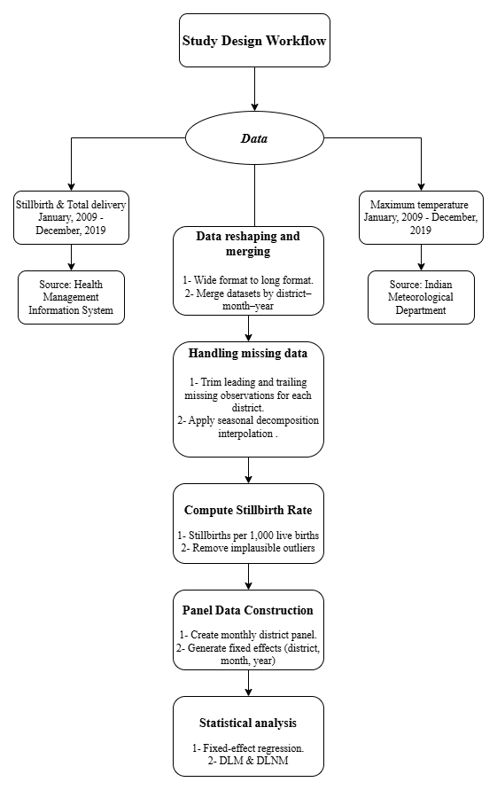
Figure S1: Flowchart of the study design.

