Table S1. Search strategy

Database | Search query | Search result
Cochrane | "Continuous glucose monitoring" in Title Abstract Keyword OR CGM in Title Abstract Keyword AND "gestational diabetes mellitus" in Title Abstract Keyword OR GDM in Title Abstract Keyword | 650
Scopus | ( TITLE-ABS-KEY ( continuous glucose monitoring ) OR TITLE-ABS-KEY ( cgm ) AND TITLE-ABS-KEY ( gestational diabetes mellitus ) OR TITLE-ABS-KEY ( gdm ) ) AND PUBYEAR > 1999 AND PUBYEAR < 2024 | 1204
Embase | #1. (('continuous glucose monitoring'/exp OR 'continuous glucose monitoring' OR 'cgm') AND ('gestational diabetes mellitus'/exp OR 'gestational diabetes mellitus') OR 'gdm') AND  ('randomized controlled trial'/exp OR 'randomized controlled trial')  #2. #1 AND (2000:py OR 2001:py OR 2002:py OR 2003:py OR 2004:py OR 2005:py OR 2006:py OR 2007:py OR 2008:py OR  2009:py OR 2010:py OR 2011:py OR 2012:py OR 2013:py OR 2014:py OR 2015:py OR 2016:py OR 2017:py OR 2018:py OR 2019:py OR 2020:py OR 2021:py OR 2022:py OR 2023:py OR 2024:py)  #3. #2 AND 'Article'/it | 849
PubMed | (((("continuous glucose monitoring"[MeSH Terms] OR ("continuous"[All Fields] AND "glucose"[All Fields] AND "monitoring"[All Fields]) OR "continuous glucose monitoring"[All Fields] OR "CGM"[All Fields]) AND ("diabetes, gestational"[MeSH Terms] OR ("diabetes"[All Fields] AND "gestational"[All Fields]) OR "gestational diabetes"[All Fields] OR ("gestational"[All Fields] AND "diabetes"[All Fields] AND "mellitus"[All Fields]) OR "gestational diabetes mellitus"[All Fields])) OR "GDM"[All Fields]) AND ("randomized controlled trial"[Publication Type] OR "randomized controlled trials as topic"[MeSH Terms] OR "randomized controlled trial"[All Fields] OR "randomised controlled trial"[All Fields])) AND ((clinicaltrial[Filter] OR randomizedcontrolledtrial[Filter] OR systematicreview[Filter]) AND (2000:2024[pdat])) | 672

Table S2. Summary table of diagnostic criteria used in included studies
Study | Diagnostic criteria / Glucose Load | Gestational weeks  for OGTT | Diagnosis Rule | Thresholds
 |  |  |  | FBG | 1-hour PPBS | 2-hour PPBS
Alfadhli et al., 2016 | IADPSG criteria – 75 g OGTT | 22 - 34 | At least two abnormal high plasma glucose values out of three measurements. | ≥ 5.1 mmol/L | ≥ 10.0 mmol/L | ≥ 8.5 mmol/L
Kestilä et al., 2007 | Criteria applied to a high-risk group according to the evaluation system used in Finland - 75 g OGTT | 22 - 34 | At least two abnormal high plasma glucose values out of three measurements. | > 5.1 mmol/l. | > 10.0 mmol/l | > 8.7 mmol/l.
Lai et al., 2023 | IADPSG criteria - 75 g OGTT | 24 - 28 | If one or more plasma glucose values out of three measurements. | ≥ 5.1 mmol/L | ≥ 10.0 mmol/L | ≥ 8.5 mmol/L
Paramasivam et al., 2018 | Local guidelines -75 g OGTT | - | If OGTT reveals a fasting plasma glucose or a 2-h post-load plasma glucose higher than the threshold. This study specifically enrolled women with confirmed GDM using these criteria. | ≥ 5.1 mmol/L | - | ≥ 7.8 mmol/L
Wei et al., 2016 | ADA criteria - 75 g OGTT | 24 - 28 | At least one abnormally high plasma glucose value out of the three measurements. | > 92 mg/dL (5.1 mmol/L) | > 180 mg/dL (10.0 mmol/L) | > 153 mg/dL (8.5 mmol/L).
Note: OGTT - Oral Glucose Tolerance Test, ADA - American Diabetes Association, IADPSG - International Association of the Diabetes and Pregnancy Study Groups.

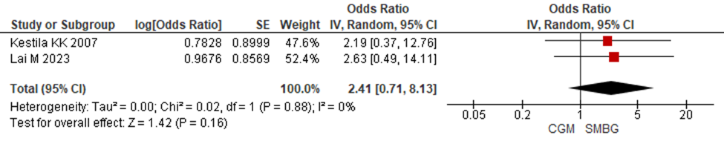
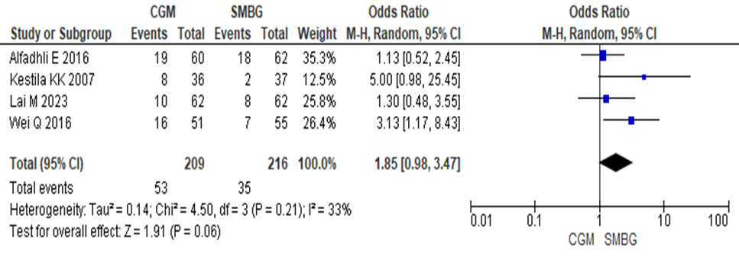
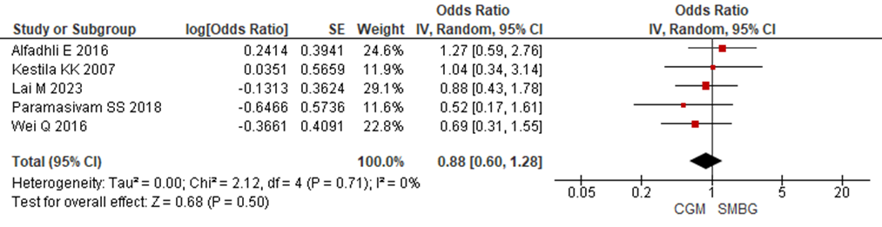

Figure S1. Forest Plot for maternal outcomes (A. Gestational hypertension, B. patient requiring insulin therapy and C. Caesarean section) between the CGM and SMBG Groups.

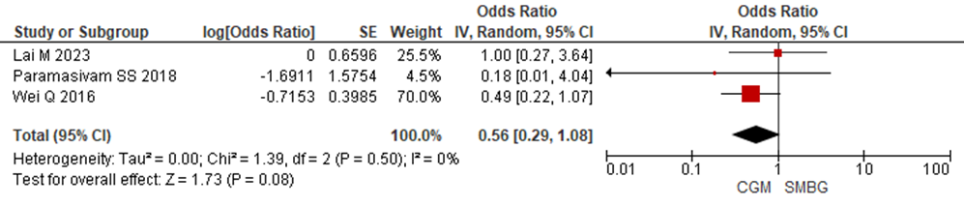
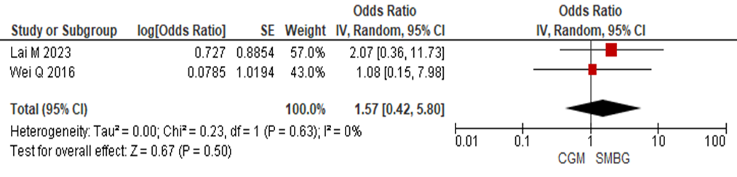
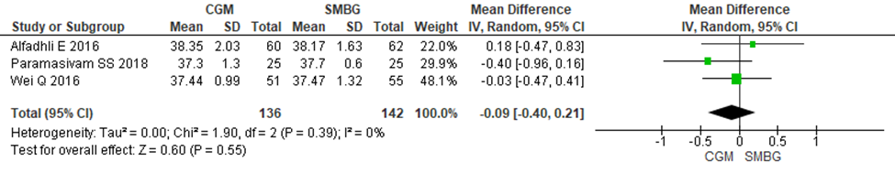
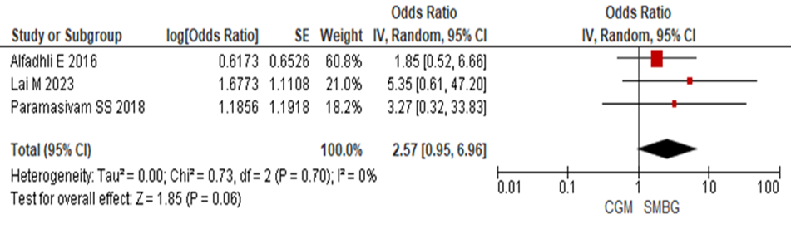

Figure S2. Forest Plot for neonatal outcomes (A. LGA, B. SGA, C. GA at delivery and D. Preterm delivery) between the CGM and SMBG Groups.

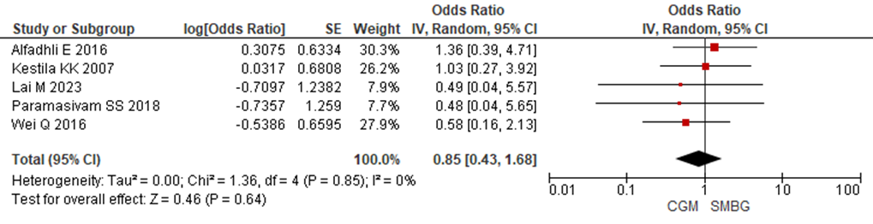
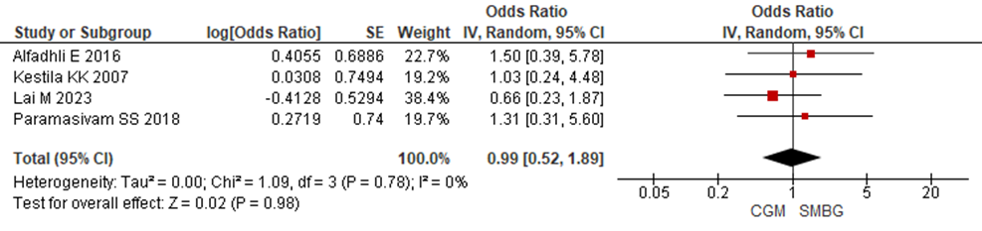
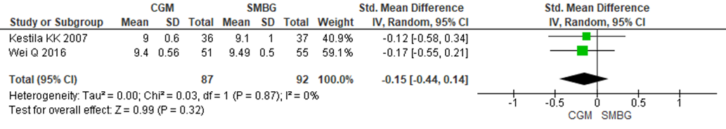
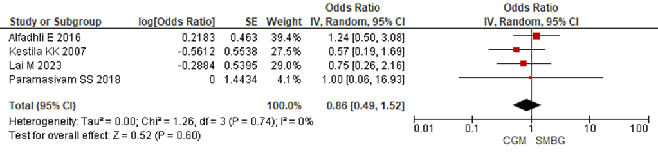
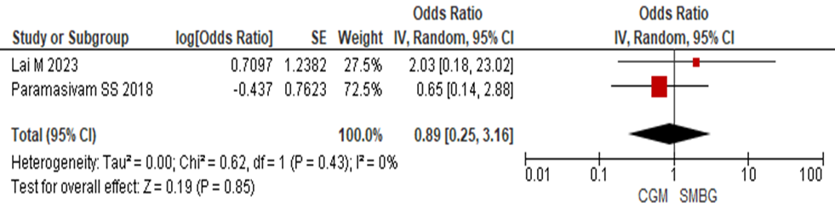
Figure S3. Forest Plot for neonatal outcomes (A. neonatal hypoglycemia, B. neonatal hyperbilirubinemia, C. Apgar score, D. NICU admission and E. RDS) between the CGM and SMBG Groups.
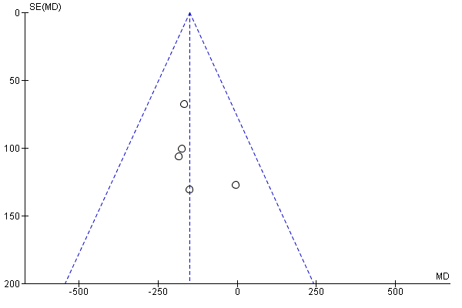
Figure S4. Funnel plot of included studies.

HbA1c
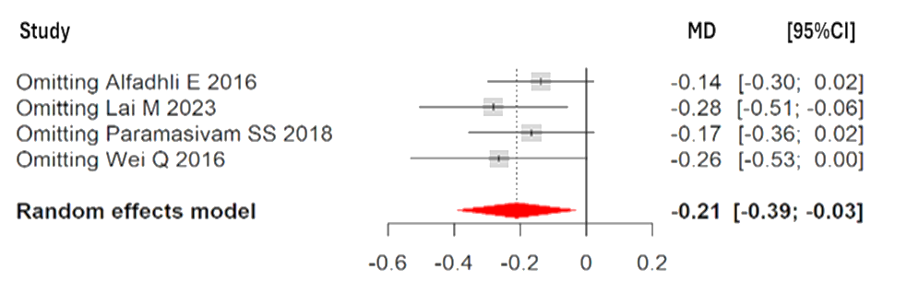
Macrosomia
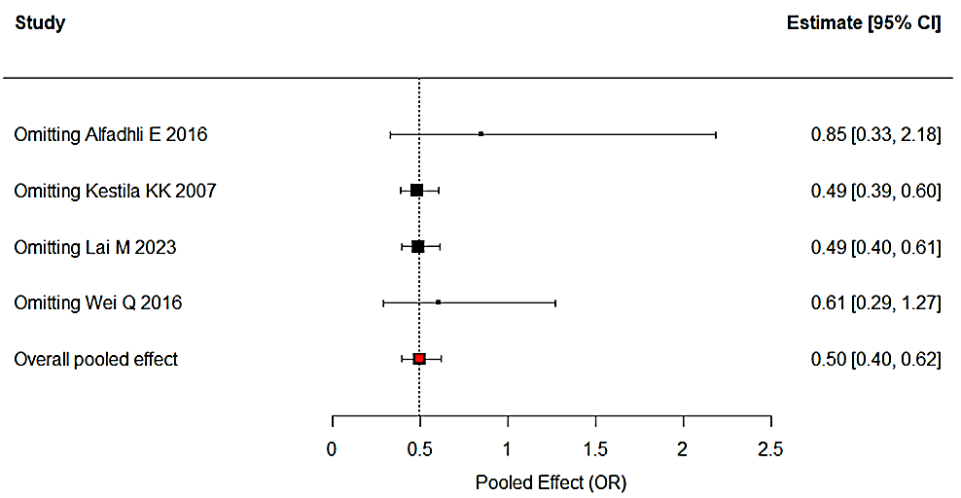
Birth weight
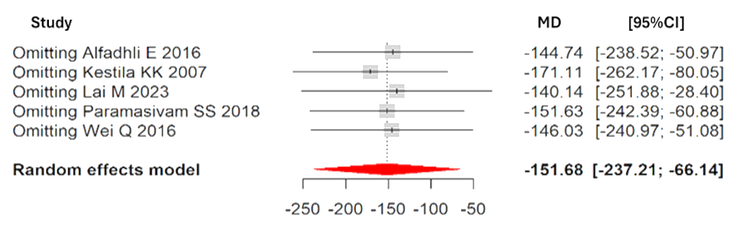
Patient requiring insulin therapy
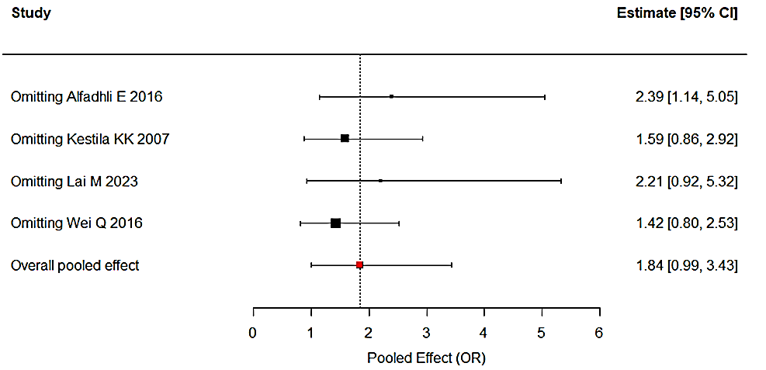
Caesarean section
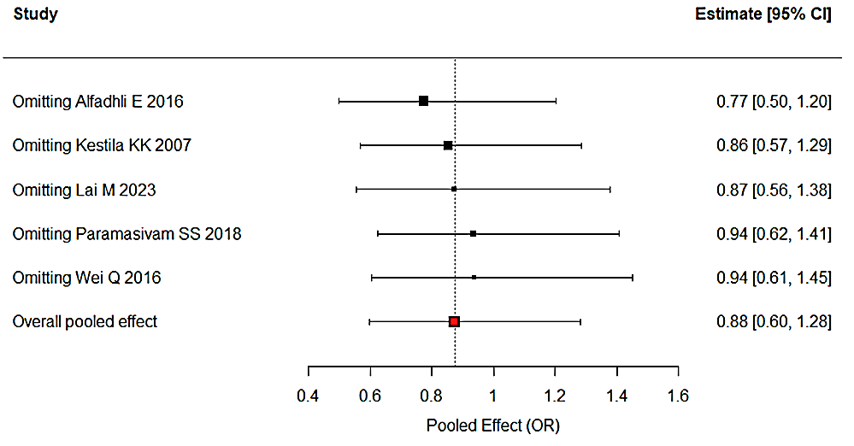
GA at delivery
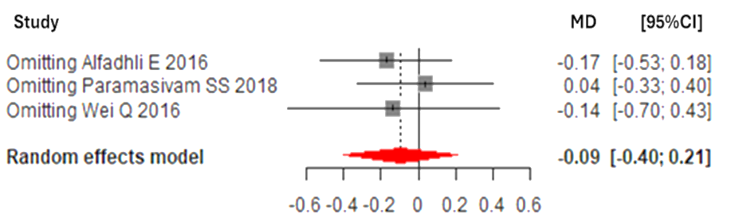

Figure S5. Sensitivity analysis forest plot. Note: GA - Gestational Age, HbA1c - Glycated Hemoglobin, OR - Odds Ratio

Large for gestational age
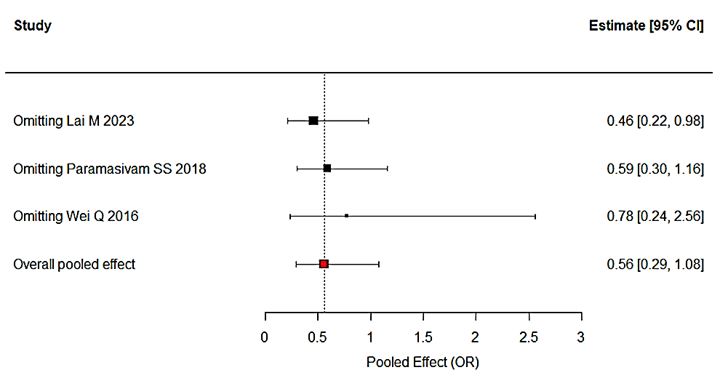
Preterm delivery
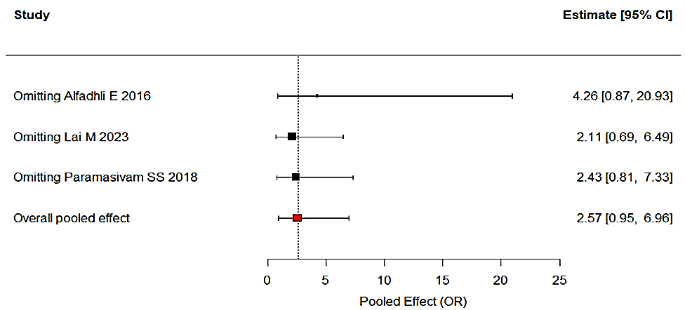
Neonatal hypoglycemia
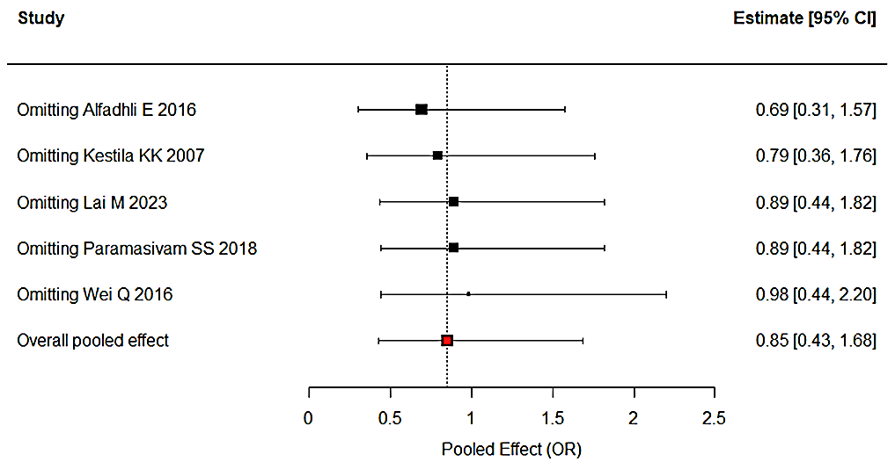
Neonatal hyperbilirubinemia
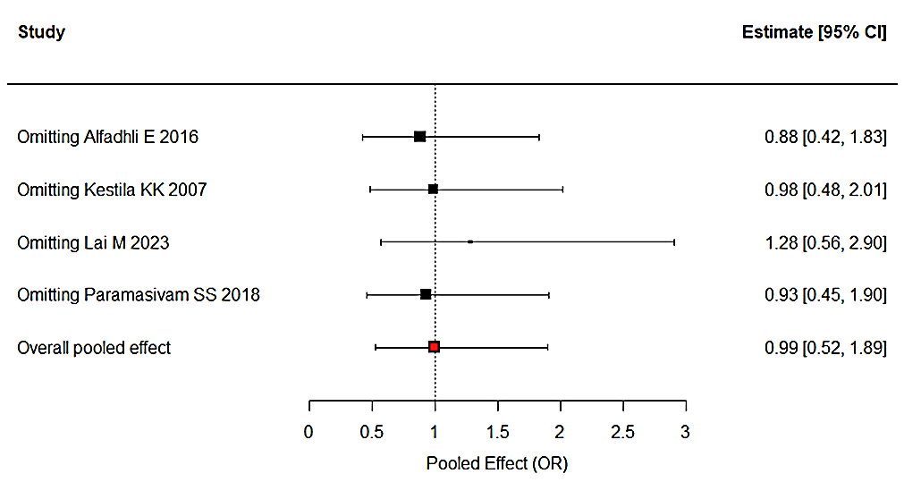
NICU admission
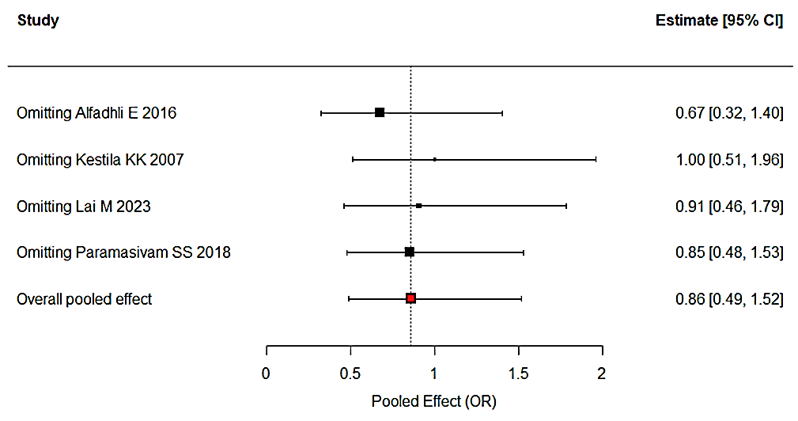

Figure S6. Sensitivity analysis forest plot. Note: NICU - Neonatal Intensive Care Unit, OR -Odds Ratio

Table S3. Summary of sensitivity analyses and heterogeneity across all outcomes
Outcomes | Studies | Sensitivity analysis |  |  | tau2 | I²(%) | Cochrane Q test |  | Egger’s test
Outcomes | Studies | Effect estimate | 95%CI (low) | 95%CI (High) | tau2 | I²(%) | Chi² | p value | P value
HbA1c | 4 | -0.21 | -0.39 | -0.03 | 0.02 | 74 | 11.54 | 0.01 | 0.12
Birth weight | 5 | -151.70 | -237.20 | -66.14 | 0 | 0 | 1.53 | 0.82 | 0.41
Macrosomia | 4 | 0.50 | 0.40 | 0.62 | 0 | 0 | 2.08 | 0.56 | 0.23
GA at delivery | 3 | -0.09 | -0.40 | 0.21 | 0 | 0 | 1.90 | 0.39 | 0.93
Preterm delivery | 3 | 2.57 | 0.95 | 6.96 | 0 | 0 | 0.73 | 0.70 | 0.45
Caesarean section | 5 | 0.88 | 0.60 | 1.28 | 0 | 0 | 2.12 | 0.71 | 0.60
Neonatal hypoglycemia | 5 | 0.85 | 0.43 | 1.68 | 0 | 0 | 1.36 | 0.85 | 0.47
Neonatal Hyperbilirubinemia | 4 | 0.99 | 0.52 | 1.89 | 0 | 0 | 1.09 | 0.78 | 0.38
LGA | 3 | 0.56 | 0.29 | 1.08 | 0 | 0 | 1.39 | 0.50 | 0.72
NICU | 4 | 0.86 | 0.49 | 1.52 | 0 | 0 | 1.26 | 0.74 | 0.89
Patient requiring Insulin therapy | 4 | 1.84 | 0.99 | 3.43 | 0.14 | 33 | 4.49 | 0.21 | 0.10
Note: CI – Confidence interval, GA – Gestational Age, HbA1c - Glycated Hemoglobin, LGA - Large for Gestational Age, NICU - Neonatal Intensive Care Unit.

