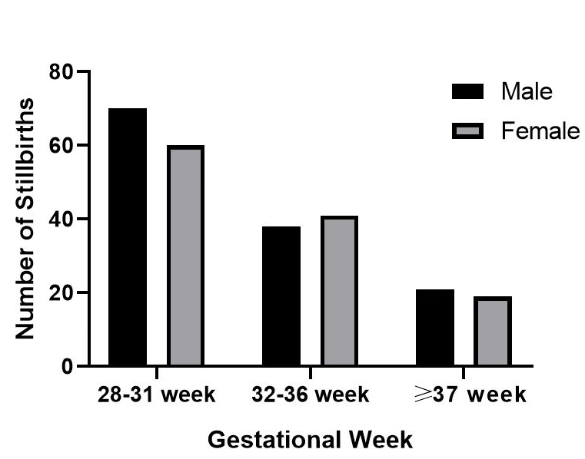
Fig. S1 Comparison of stillborn sex by gestational age subgroup.

Although male stillborn patients outnumbered female stillborn patients between 28 and 31 weeks of gestation, a slight predominance of female cases was observed at 32–36 weeks (Table S1). However, at full term, males again became marginally more prevalent. Statistical analysis revealed no significant differences in the proportional distribution across the three gestational age groups (χ²=0.659, P=0.719; Pearson’s chi-square test).

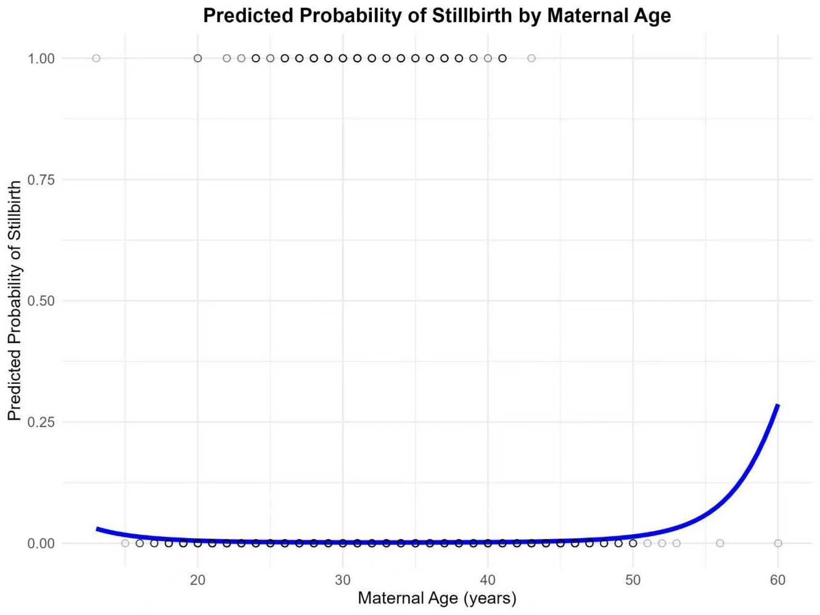

Fig. S2 Predicted probability curve of stillbirth risk by maternal age.
Using maternal age as a continuous variable with an added quadratic term in logistic regression, this plot illustrates the nonlinear U-shaped relationship between maternal age and stillbirth risk; the trough of the curve corresponds to 32.9 years, and young women (≤20 years) showed a more pronounced increase in risk than advanced-age women (40 years).

