Supplementary Figures

S1 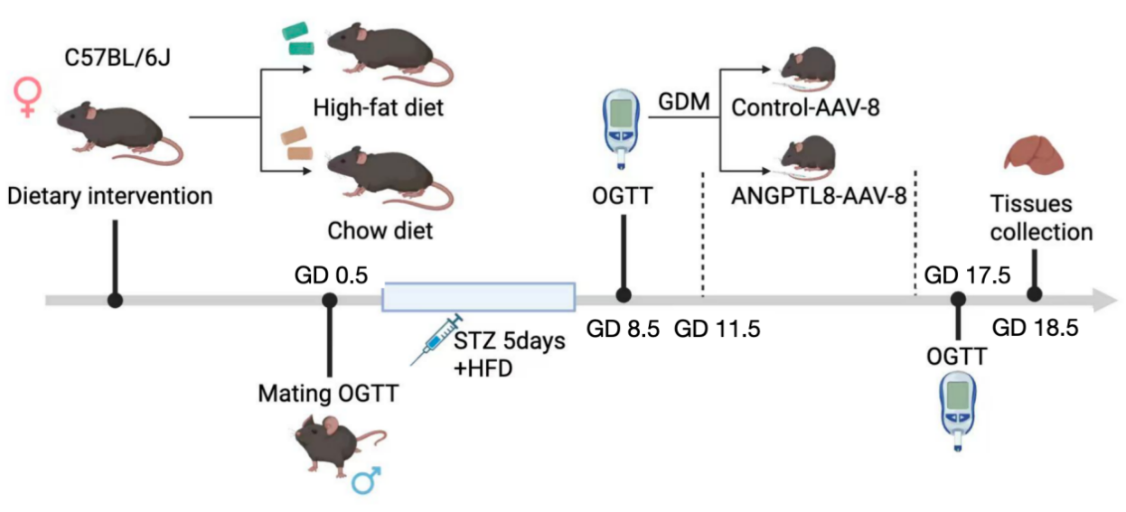
Figure.S1. Schematic of the GDM Mouse Model Induction and Experimental Timeline.
Six-week-old female C57BL/6J mice were fed a high-fat diet (HFD) for one week before mating and throughout pregnancy. After confirming pregnancy (GD 0.5), GDM was induced with daily low-dose STZ injections (40 mg/kg) from GD 3.5 to GD 7.5 and conformed by OGTT（Oral Glucose tolerance tests）at GD 8.5. ANGPTL8 over-expression was achieved via hydrodynamic tail vein injection of AAV8- m-ANGPTL8 at GD 11.5. Oral glucose tolerance tests (OGTT) were performed to assess glucose metabolism, and tissues were collected for analysis at GD 18.5.

S2-A
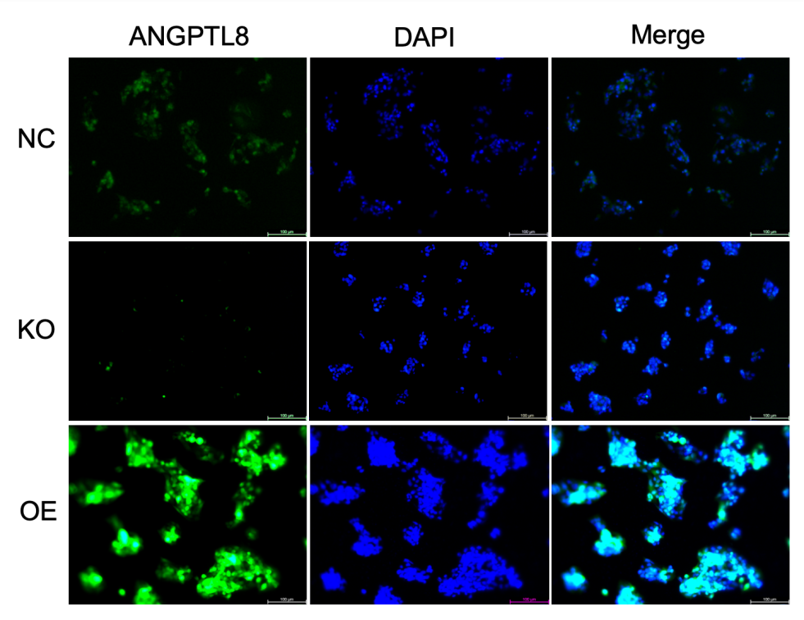
Figure.S2-A. Immunofluorescence analysis of ANGPTL8 in the wild-type Hep G2 cells, the ANGPTL8 knockout (KO) and over-expressing (OE) HepG2 cell lines. (scale=100μM)
NC: wild-type Hep G2 cells, AN-OE: ANGPTL8-overexpressing Hep G2 cells, AN-KO: ANGPTL8-knockouted Hep G2 cells.

S2-B
Figures.S2-B. Mean fluorescence intensity of ANGPTL8 in the wild-type Hep G2 cells, the ANGPTL8 knockout (KO) and over-expressing (OE) HepG2 cell lines. Data are presented as mean±SEM. *P < 0.05, **P < 0.01, *** P < 0.001 vs. wild-type Hep G2 cells.

S3-A
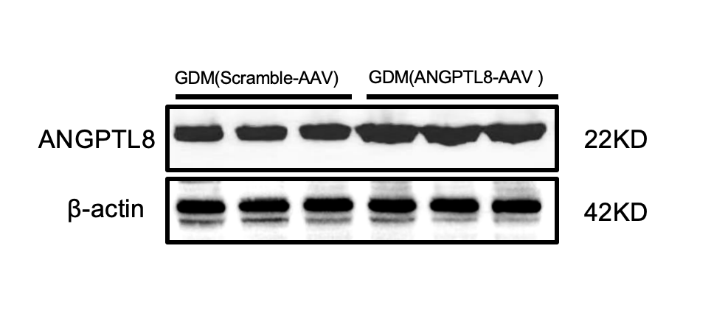

S3-B

Figures.S3A-3B.Western-Blotting analysis of ANGPTL8 expression in liver lysates from GDM mice injected with cAAV or ANGPTL8-AAV. Significant increase in ANGPTL8 protein expression in the livers of the GDM ANGPTL8-AAV group compared to the control group.
Data are presented as mean±SEM. *P < 0.05, **P < 0.01, *** P < 0.001 vs. AAV-Scramble group.

S4-A
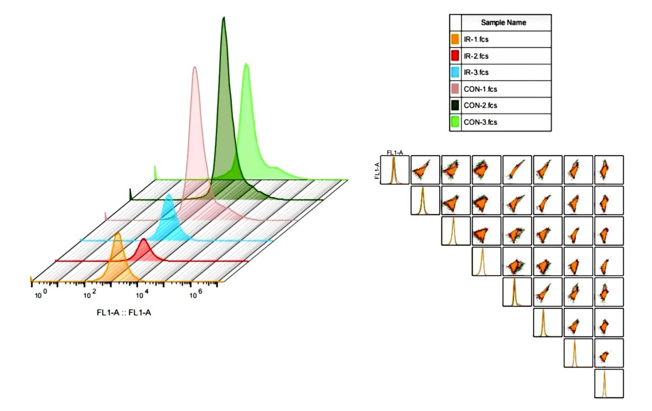

S4-B

Figures.S4A-4B. Both control and IR-HepG2 cells with insulin (100 nM for 20-30min) and conducted a glucose uptake assay using the fluorescent glucose analog 2-NBDG. The glucose uptake was markedly blunted in the IR-induced HepG2 cells.
Data are presented as mean±SEM. *P < 0.05, **P < 0.01, *** P < 0.001 vs. the con.

S5-A

S5-B
Figures.S5A-5B. Oral glucose tolerance test (OGTT) was carried out at GD 0.5 and 8.5. A fasting blood glucose level of 11.1 mmol/L or higher and a random blood glucose level of 16.7 mmol/L or higher measured through the tail vein indicate successful modeling.
Data are presented as mean±SEM. *P < 0.05, **P < 0.01, *** P < 0.001, **** P < 0.0001 vs. the control, ns, no significant.
.

