Supplementary Material
Title: Effectiveness of Oral Dydrogesterone Compared to Placebo in Reducing the Risk of Preterm Birth: Systematic Review and Meta-Analysis
Authors: Sohieb Hedawy*¹, Shahed Aldalahmeh², Eman E. Labeeb³, Abdelrahman A. Khattab³, Esraa K. Sayed⁴, Ahmed Hassan⁵, Ahmed Menshawy⁶
Supplementary Content:
a. Tables: |  | Page
1 | Table S1. Detailed search strategy. | 2
b. Figure: |  | Page
1 | Supplementary Fig 1: Subgroup Analysis by Tablets for gestational age at delivery (Three Tablets vs. Two Tablets). | 2
2 | Supplementary Fig 2: Subgroup Analysis by Country for gestational age at delivery (Thailand vs. Iran). | 3
3 | Supplementary Fig 3: Subgroup Analysis by Tablets for Birth Weight in grams (Three Tablets vs. Two Tablets). | 3
4 | Supplementary Fig 4: Subgroup Analysis by Country for Birth Weight in grams (Thailand vs. Iran). | 4
5 | Supplementary Fig 5: Leave one out meta-analysis of latency period after exclusion of Alizadeh et al, 2022, dydrogesterone vs. placebo | 4
6 | Supplementary Fig 6: Leave one out meta-analysis of birth weight in grams after exclusion of Alizadeh et al, 2022, dydrogesterone vs. placebo | 5
7 | Supplementary Fig 7: Leave one out meta-analysis of GA at delivery in weeks after exclusion of Alizadeh et al, 2022, dydrogesterone vs. placebo | 5
8 | Supplementary Fig 8: Leave one out meta-analysis of GA at delivery <37 weeks after exclusion of Alizadeh et al, 2022, dydrogesterone vs. placebo | 6
9 | Supplementary Fig 9: Leave one out meta-analysis of cesarean section after exclusion of Keshtamandi et al, 2023, dydrogesterone vs. placebo | 6
10 | Supplementary Fig 10: Leave one out meta-analysis of Apgar score <7 at 1-minute weeks after exclusion of Keshtamandi et al, 2023, dydrogesterone vs. placebo | 7
11 | Supplementary Fig 11: Trial sequential analysis (TSA) of the gestational age at delivery. | 7

Table S1. Details of the search strategy
Databases | Restrictions | Term | Number of items found
PubMed | Title and abstract | #1= (“6-Dehydro-9 beta-10 alpha-progesterone” OR “6 Dehydro 9 beta 10 alpha progesterone” OR “Dehydrogesterone” OR “Isopregnenone” OR “Duphaston” OR “dydrogest*” OR “oral progesterone” OR Didrogesterona OR Didrogesterone OR Dydrogesterona OR Dydrogestérone OR Dydrogesterone OR Dydrogesteronum OR Gestatron OR Hydrogesterone OR Hydrogestrone OR Isopregnenone OR “oral Pregnenedione”)  #2= (preterm OR premature) AND (delivery OR birth)  #3= #1 AND #2 | 60
Scopus | Title, abstract and keywords |  | 225
WOS | Topic |  | 80
Cochrane | Title and abstract |  | 53
Total |  |  | 418

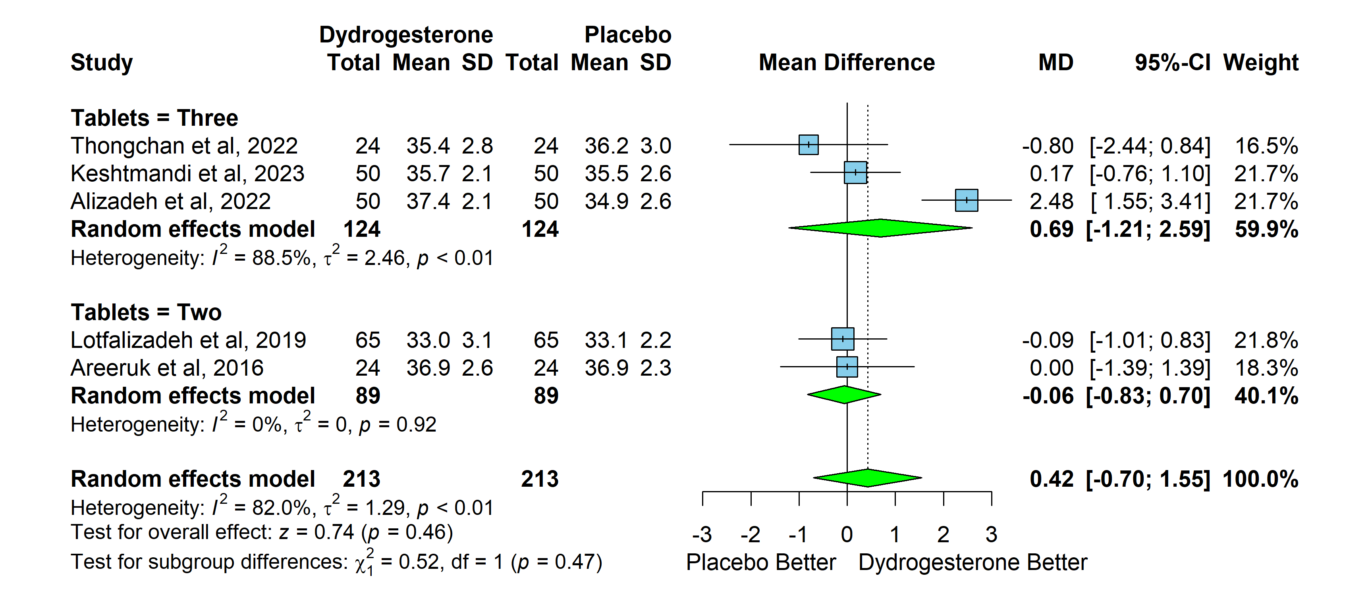
Supplementary Fig 1: Subgroup Analysis by Tablets for gestational age at delivery (Three Tablets vs. Two Tablets).
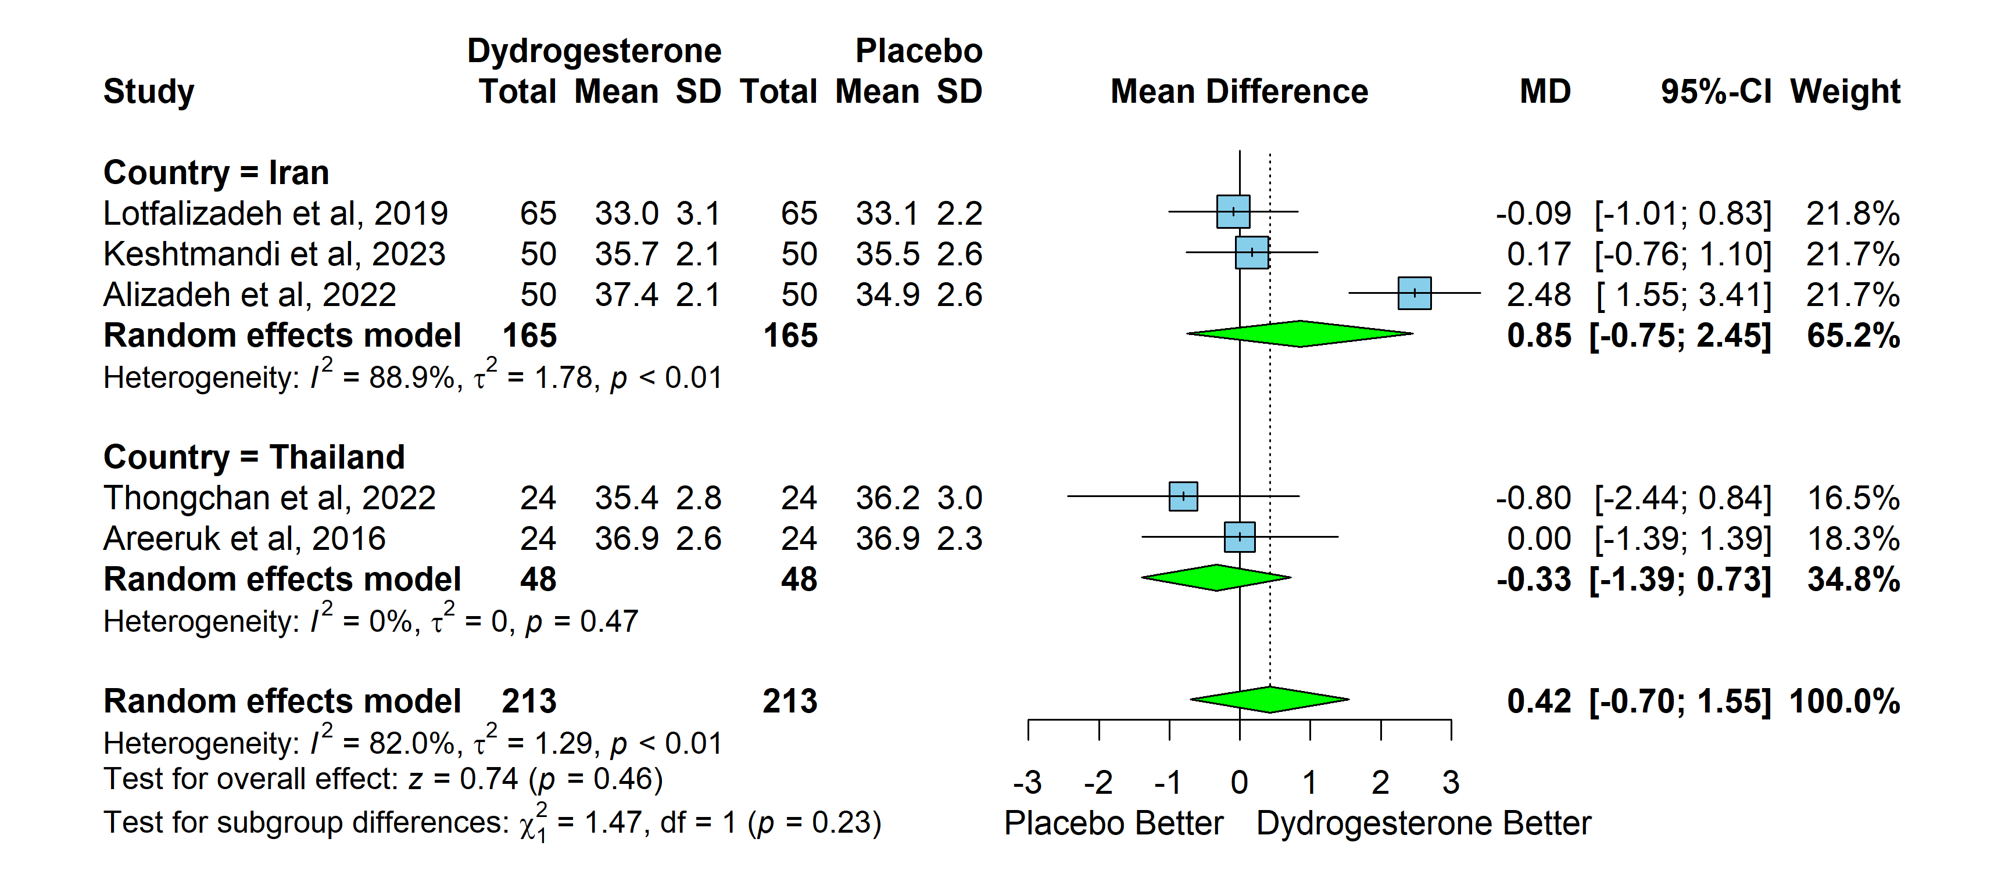
Supplementary Fig 2: Subgroup Analysis by Country for gestational age at delivery (Thailand vs. Iran).
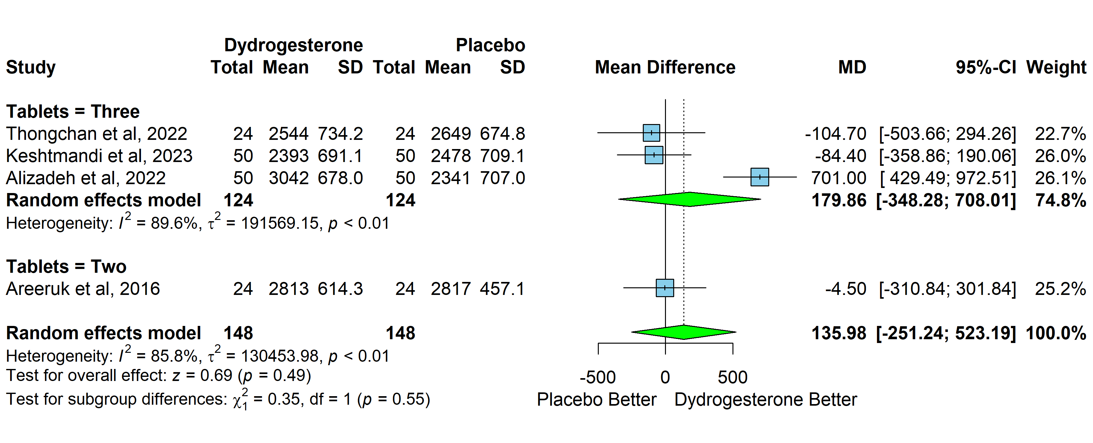
Supplementary Fig 3: Subgroup Analysis by Tablets for Birth Weight in grams (Three Tablets vs. Two Tablets).
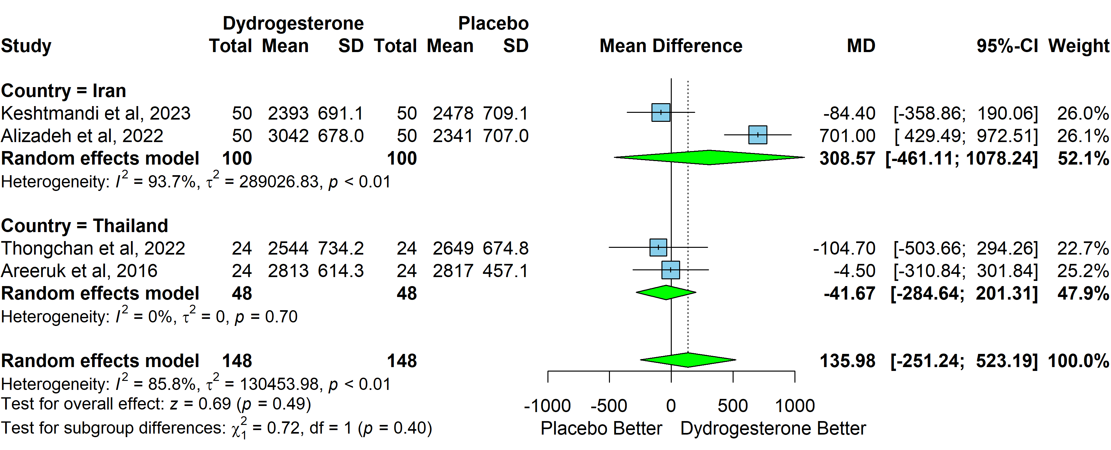
Supplementary Fig 4: Subgroup Analysis by Country for Birth Weight in grams (Thailand vs. Iran).

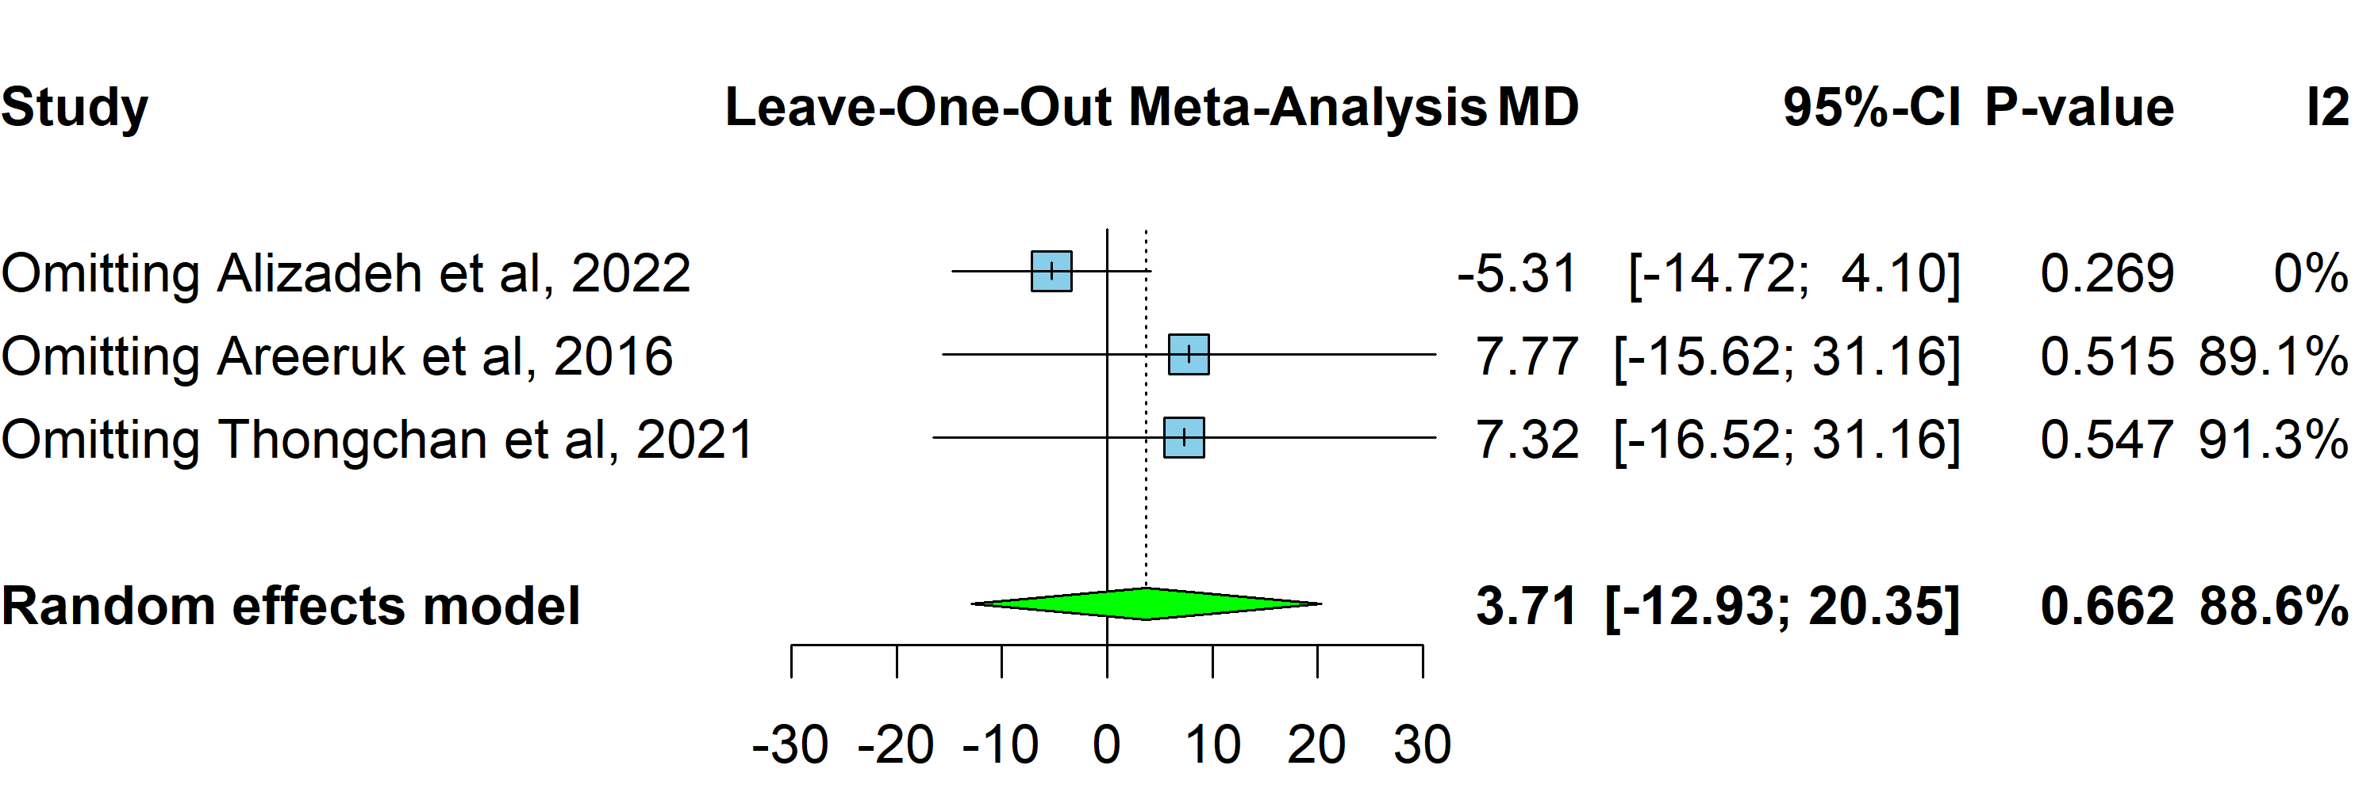
Supplementary Fig 5: Leave one out meta-analysis of latency period after exclusion of Alizadeh et al, 2022, dydrogesterone vs. placebo
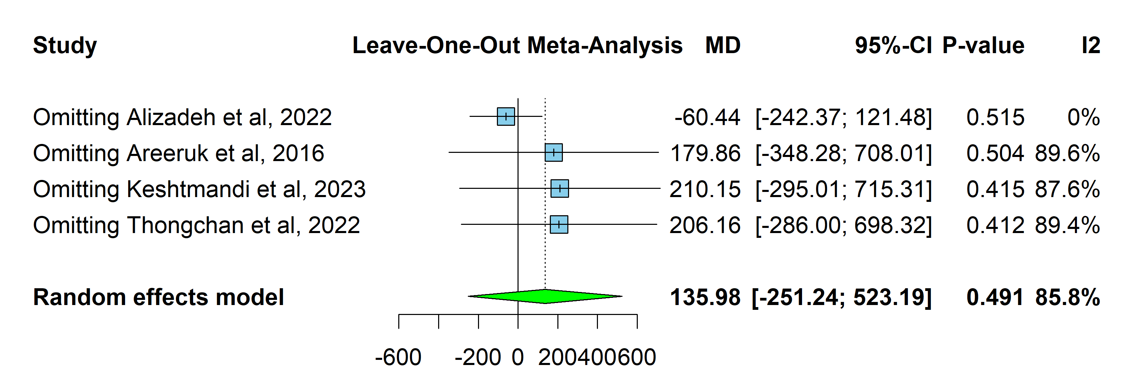
Supplementary Fig 6: Leave one out meta-analysis of birth weight in grams after exclusion of Alizadeh et al, 2022, dydrogesterone vs. placebo
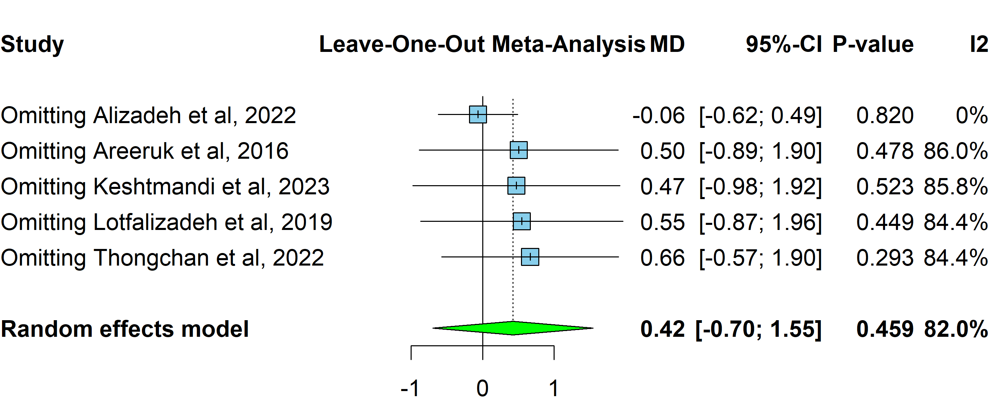
Supplementary Fig 7: Leave one out meta-analysis of GA at delivery in weeks after exclusion of Alizadeh et al, 2022, dydrogesterone vs. placebo
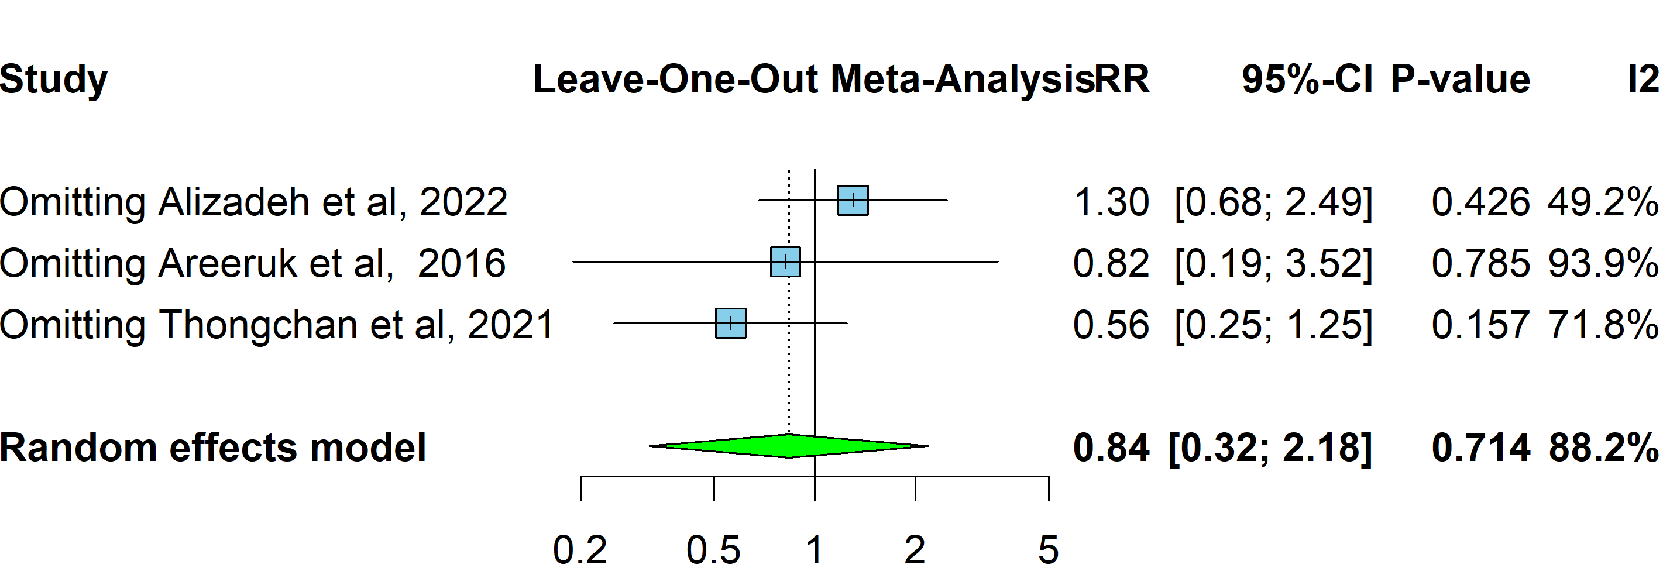
Supplementary Fig 8: Leave one out meta-analysis of GA at delivery <37 weeks after exclusion of Alizadeh et al, 2022, dydrogesterone vs. placebo

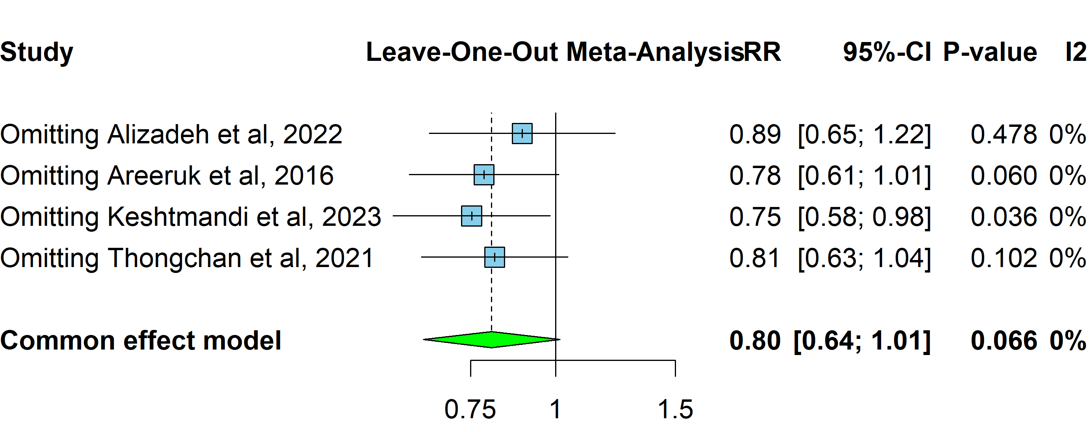
Supplementary Fig 9: Leave one out meta-analysis of cesarean section after exclusion of Keshtamandi et al, 2023, dydrogesterone vs. placebo

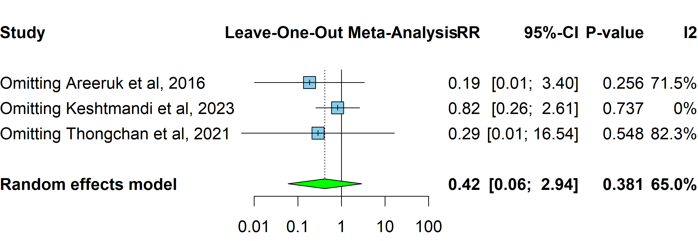
Supplementary Fig 10: Leave one out meta-analysis of Apgar score <7 at 1-minute weeks after exclusion of Keshtamandi et al, 2023, dydrogesterone vs. placebo

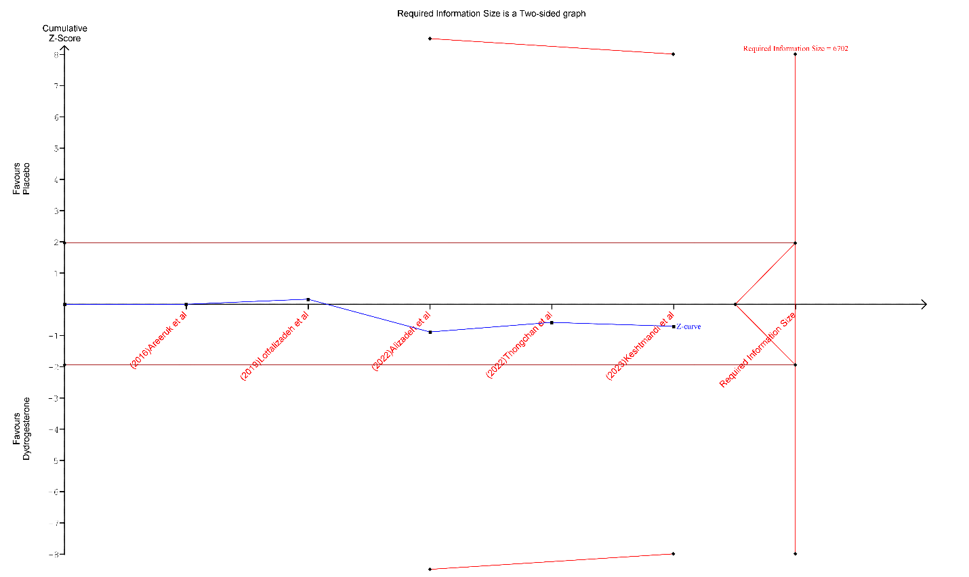
Supplementary Fig 11: Trial sequential analysis (TSA) of the gestational age at delivery.

