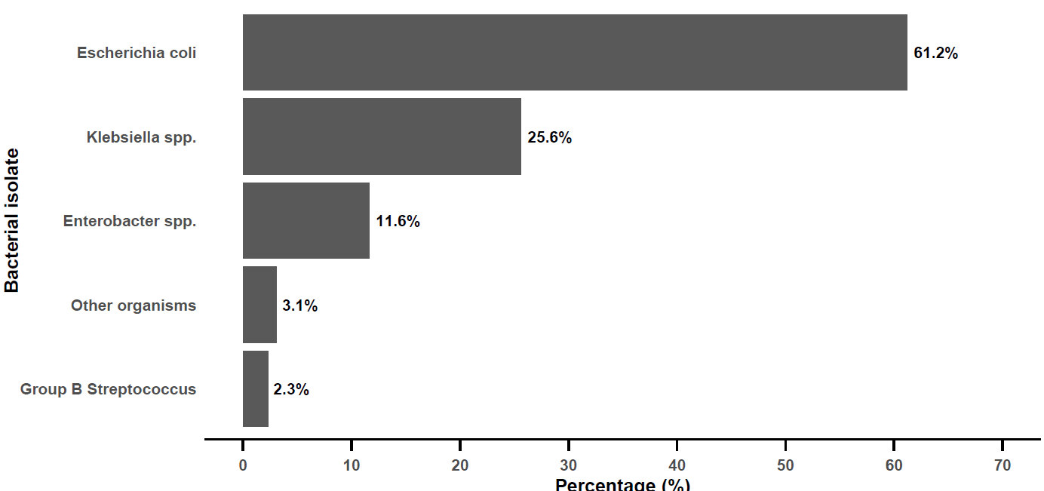
Supplementary Figure S1.
Percentage distribution of bacterial isolates among culture-positive amniotic fluid samples obtained from women with preterm premature rupture of membranes (PPROM) at Mbarara Regional Referral Hospital, Southwestern Uganda (n = 129).
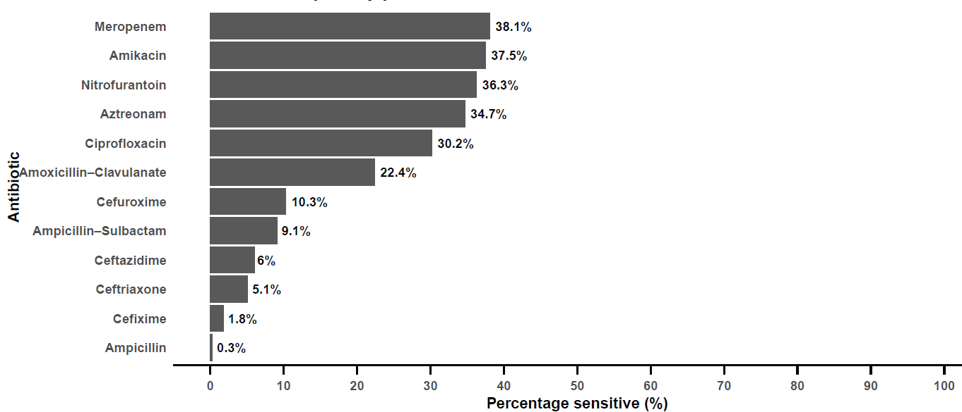
Supplementary Figure S2.
Antibiotic susceptibility patterns of bacterial isolates from culture-positive amniotic fluid samples among women with preterm premature rupture of membranes (PPROM), expressed as percentage sensitive for each antibiotic (n = 129).

