Figure 1. Boxplots of Estimated Fetal Weight Mean Percentage Error
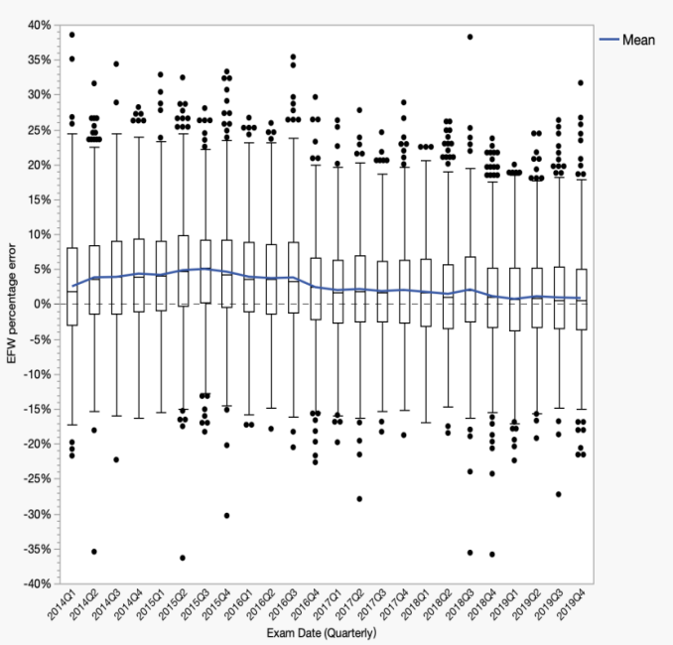  (b)  (a) | 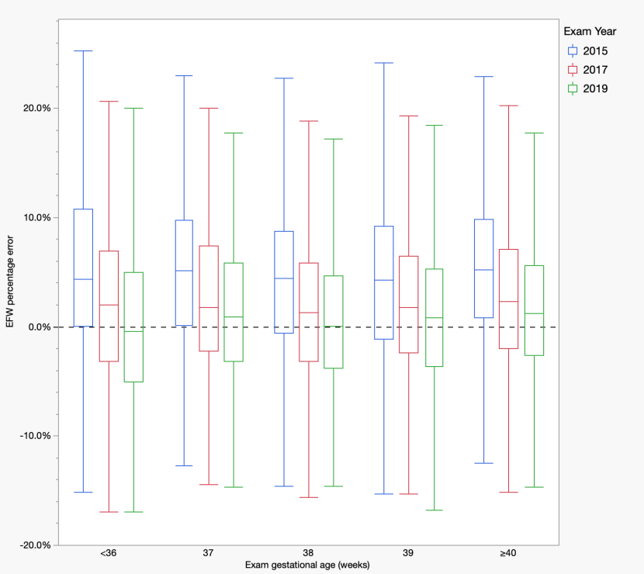

(a) Trends in EFW Mean Percentage Error by Exam Date (2014Q1–2019Q4).(b) EFW Mean Percentage Error by Exam Gestational Age and Exam Year (2015, 2017, and 2019).* < 0.05, ** p < 0.01, *** p < 0.001. EFW: Estimated Fetal Weight.

Figure 2. Proportion of Estimated Fetal Weight Within 10% and 15% of Actual Birth Weight.
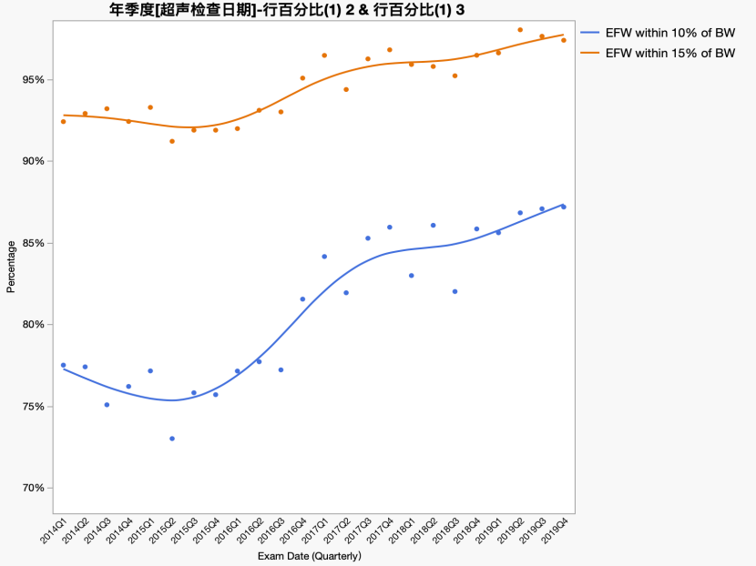  (a)  (b) | 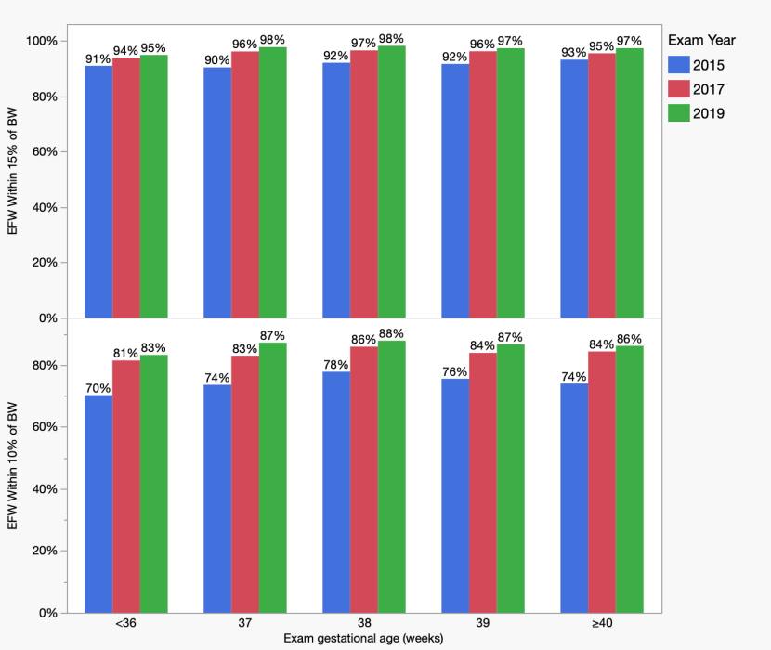
(a) Proportion of EFW Within 10% and 15% of Actual Birth Weight by Exam Date (2014Q1–2019Q4) Using the Hadlock Formula. (b) Proportion of EFW Within 10% (Bottom Panel) and 15% (Top Panel) of Actual Birth Weight by Exam Gestational Age and Exam Year (2015, 2017, and 2019).EFW: Estimated Fetal Weight, BW: birthweight.

Figure 3.Temporal and gestational age-specific trends in median MoM for biparietal diameter, head circumference, abdominal circumference, and femur length
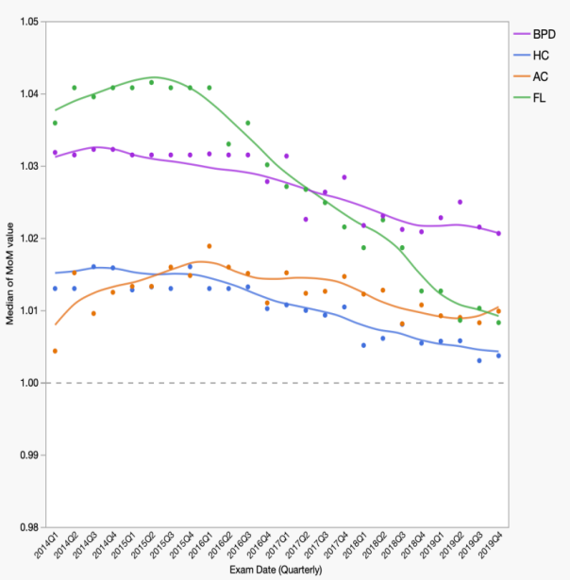
(c)
(a)
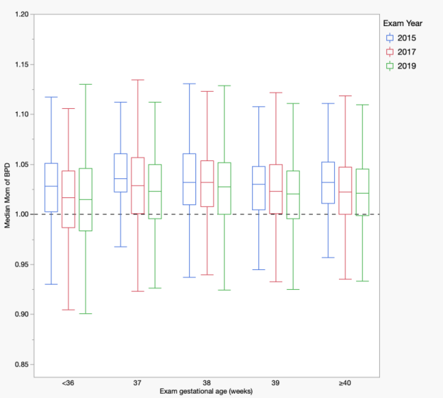  (b)  (e)  (d) | 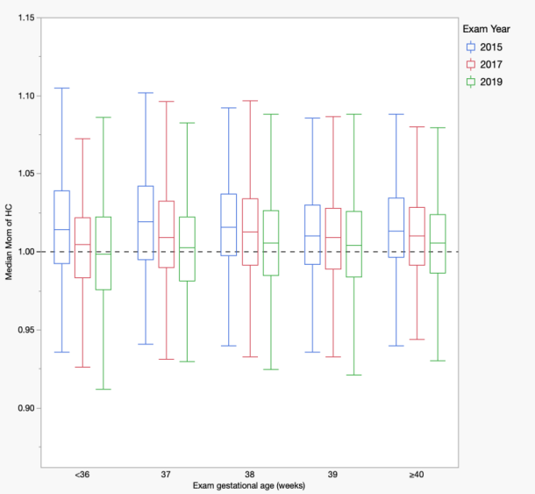
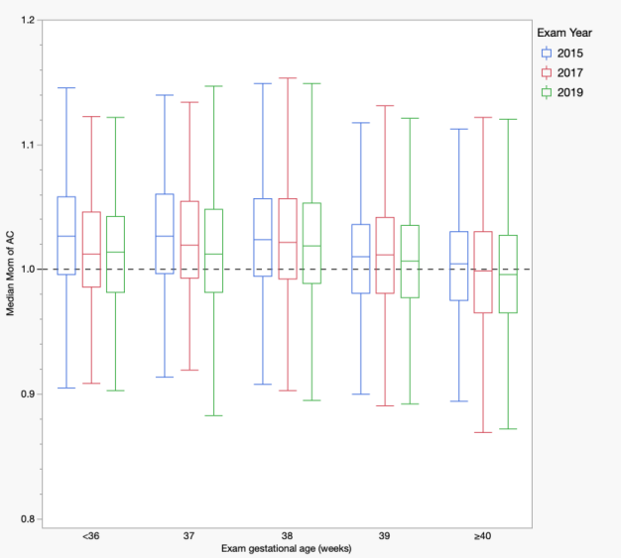 | 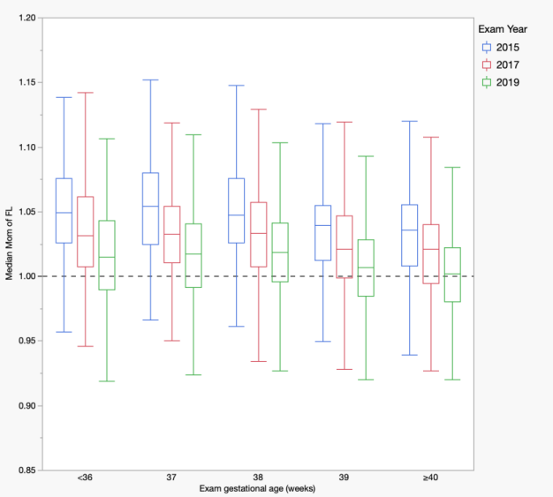
(a)
Median MoM trends of BPD, HC, AC and FL across exam dates (2014-2019). (b-e) Gestational age-specific median MoM trends for (b) BPD, (c) HC, (d) AC, and (e) FL, stratified by exam year (2015, 2017, and 2019). * < 0.05, ** p < 0.01, *** p < 0.001.
(a)

Figure 4. Temporal trends in diagnostic and false-positive rates of estimated fetal weight for identifying fetal growth restriction, large for gestational age, small for gestational age, and extreme birthweights using the Hadlock 1991 reference standard
(b)
(a)
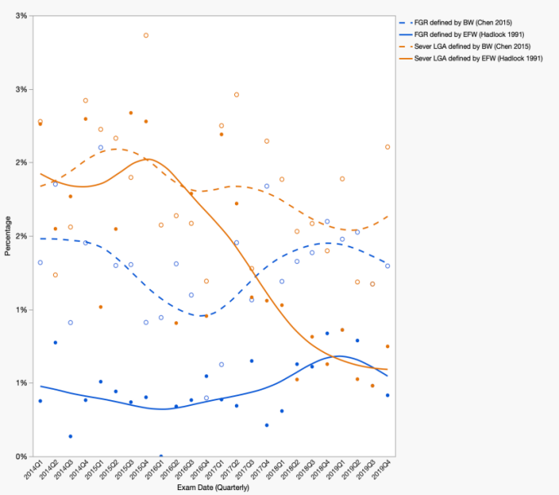  (c)  (d)  (a)  (a) | 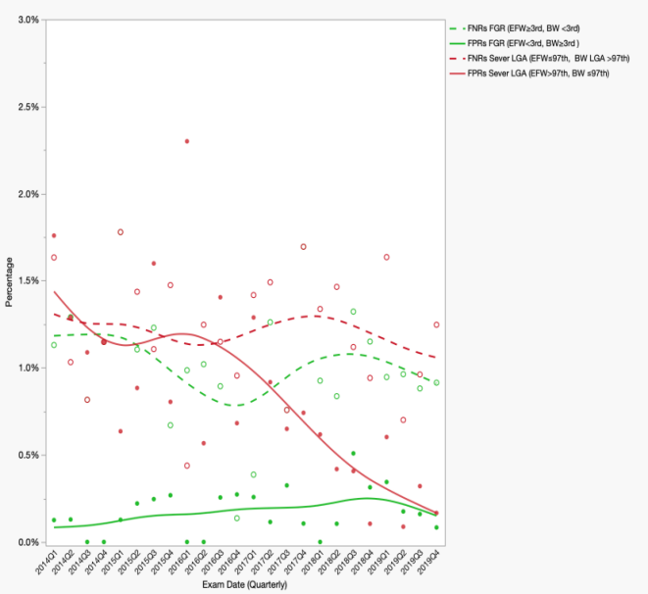
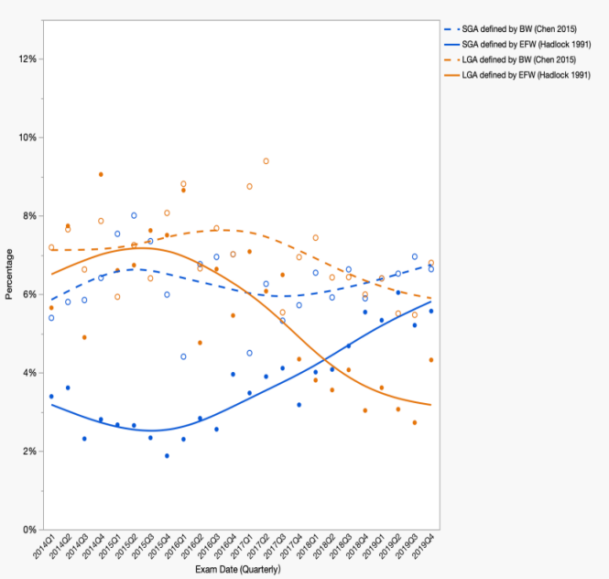  (e)  (f) | 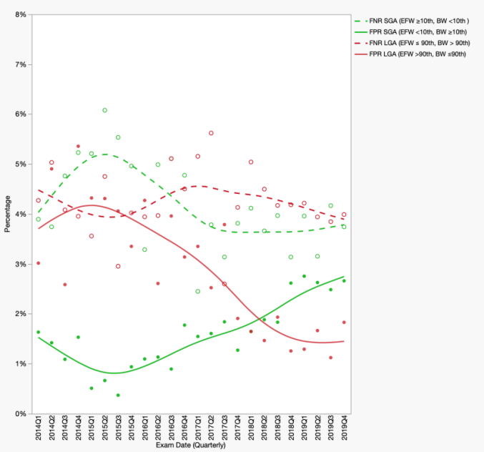
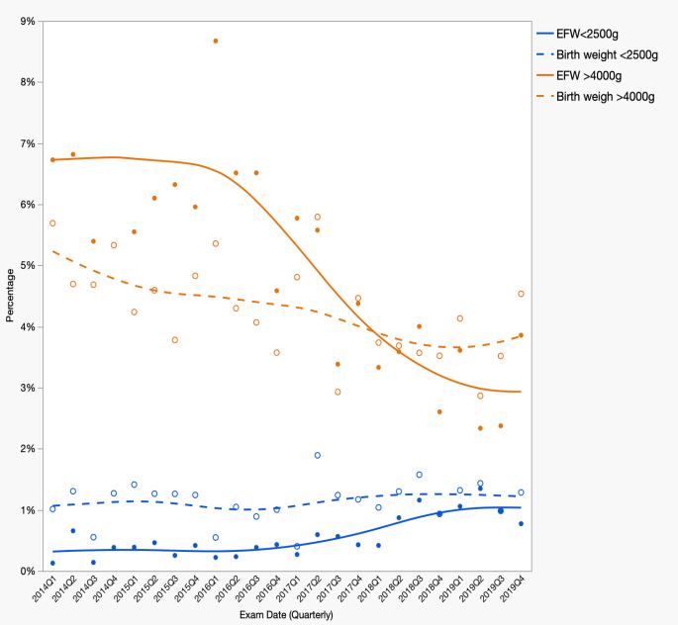 | 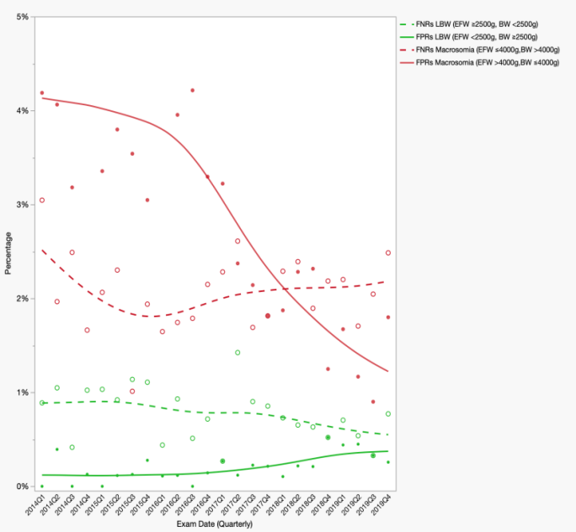
(a) Quarterly trends in the percentage of fetuses classified as FGR and LGA(>97th) based on birth weight (BW, Chen 2015) and estimated fetal weight (EFW, Hadlock 1991).(b) Quarterly trends in classification discrepancies between EFW and BW definitions, including false positives and false negatives for both FGR and LGA(>97th). (c) Quarterly trends in the percentage of fetuses classified as SGA(<10th) and LGA(>90th) based on BW (Chen 2015) and EFW (Hadlock 1991).(d) Quarterly trends in classification discrepancies between EFW and BW definitions, including false positives and false negatives for both SGA(<10th) and LGA(>90th).(e) Quarterly trends in the percentage of fetuses classified as <2500g and >4000g based on BW and EFW .(f) Quarterly trends in classification discrepancies between EFW and BW definitions, including false positives and false negatives for both <2500g and >4000g.

