Supplement: Body Mass Index and breastfeeding behavior among women participants in the Million Veteran Program

Joanna Lankester PhD^{1,2}, Rodrigo Guarischi-Sousa PhD², Austin T Hilliard PhD², VA Million Veteran Program³, Labiba Shere², Marya Husary MPH², Susan Crowe MD⁴, Philip S Tsao PhD^{1,2}, David H Rehkopf ScD, MPH^{5,1}, Themistocles L Assimes MD, PhD^{1,2,5}

- Department of Medicine, Stanford University School of Medicine, Stanford, CA, USA
- VA Palo Alto Health Care System, Palo Alto, CA, USA
- A list of consortium members can be found in the Supplementary File
- Department of Obstetrics & Gynecology, Stanford University School of Medicine, Stanford, CA, USA
- Department of Epidemiology and Population Health, Stanford University School of Medicine, Stanford, CA, USA

Table S1: Phenotype definitions 2
Figure S2: Sample size inclusions/exclusions 3
Table S2: Observational analysis results by category of earliest BMI measurement for participants with pre-pregnancy BMI available 4
Table S3: Observational analysis results for all covariates in the model of BMI at enrollment by quartile vs breastfed for one month 5
Table S4: Observational analysis results for all covariates in the model of continuous BMI at enrollment vs breastfed for one month 6
Table S5: Observational analysis results for all covariates in the model of prepartum BMI by quartile vs breastfed for one month 7
Table S6: Observational analysis results for all covariates in the model of prepartum continuous BMI vs breastfed for one month 8
MVP Acknowledgements 9
Data from the Veterans Healthcare Administration System of Records 10

Table S1: Phenotype definitions
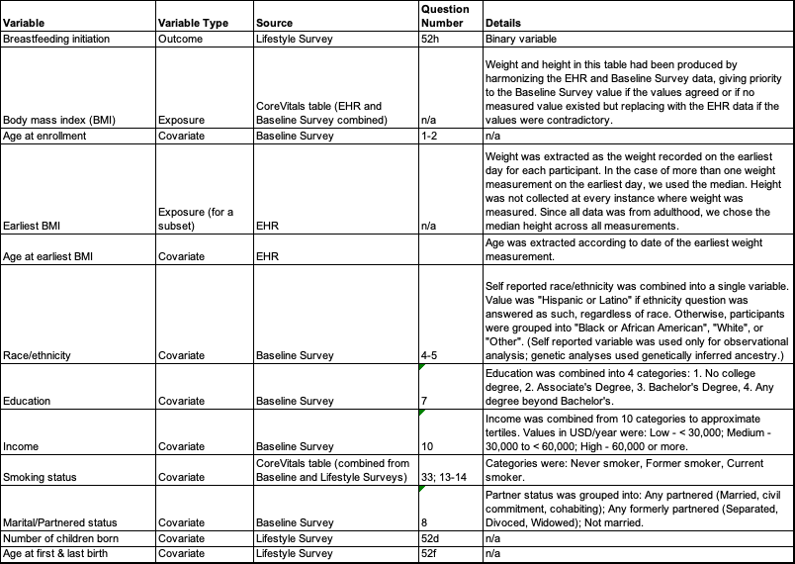

Figure S2: Sample size inclusions/exclusions

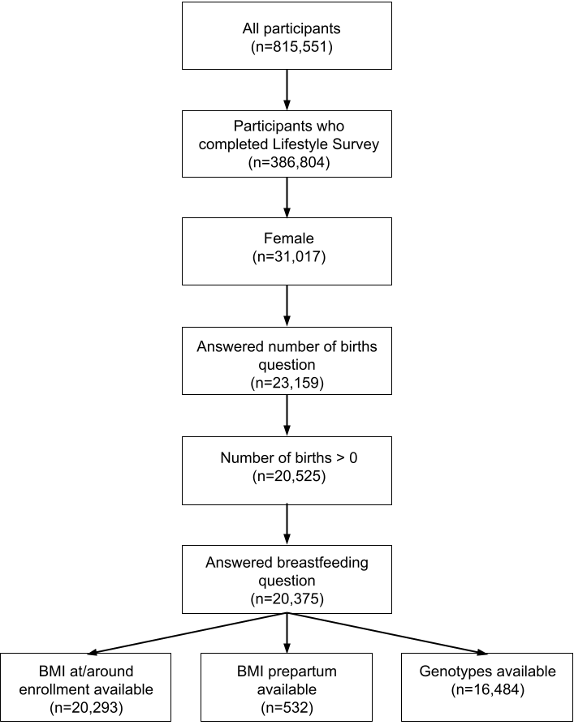

Table S2: Observational analysis results by category of earliest BMI measurement for participants with pre-pregnancy BMI available

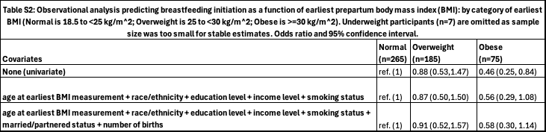

Table S3: Observational analysis results for all covariates in the model of BMI at enrollment by quartile vs breastfed for one month

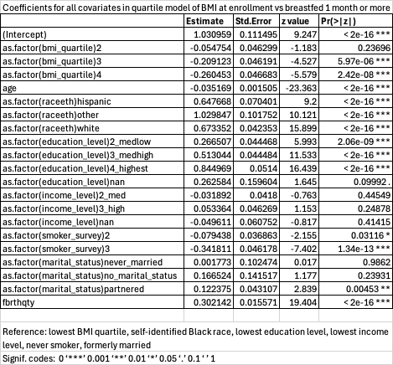

Table S4: Observational analysis results for all covariates in the model of continuous BMI at enrollment vs breastfed for one month
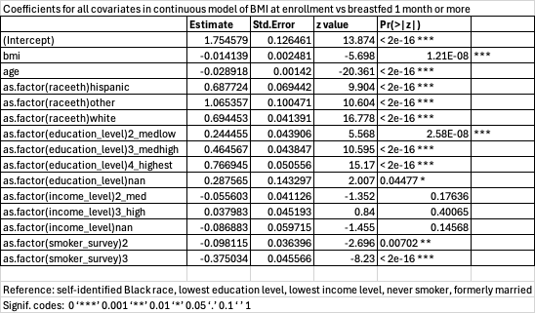

Table S5: Observational analysis results for all covariates in the model of prepartum BMI by quartile vs breastfed for one month
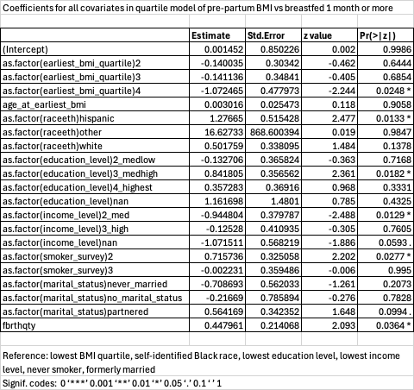

Table S6: Observational analysis results for all covariates in the model of prepartum continuous BMI vs breastfed for one month
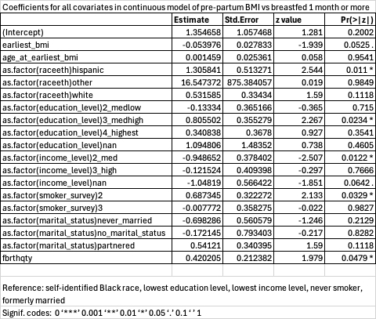

MVP Acknowledgements

VA Million Veteran Program:
Core Acknowledgements for Publications
May 2024

MVP Program Office

- Sumitra Muralidhar, Ph.D., Program Director
US Department of Veterans Affairs, 810 Vermont Avenue NW, Washington, DC 20420
- Jennifer Moser, Ph.D., Associate Director, Scientific Programs
US Department of Veterans Affairs, 810 Vermont Avenue NW, Washington, DC 20420
- Jennifer E. Deen, B.S., Associate Director, Cohort & Public Relations
US Department of Veterans Affairs, 810 Vermont Avenue NW, Washington, DC 20420

MVP Executive Committee

- Co-Chair: Philip S. Tsao, Ph.D.
VA Palo Alto Health Care System, 3801 Miranda Avenue, Palo Alto, CA 94304
- Co-Chair: Sumitra Muralidhar, Ph.D.
US Department of Veterans Affairs, 810 Vermont Avenue NW, Washington, DC 20420
- J. Michael Gaziano, M.D., M.P.H.
VA Boston Healthcare System, 150 S. Huntington Avenue, Boston, MA 02130
- Elizabeth Hauser, Ph.D.
Durham VA Medical Center, 508 Fulton Street, Durham, NC 27705
- Amy Kilbourne, Ph.D., M.P.H.
VA HSR&D, 2215 Fuller Road, Ann Arbor, MI 48105
- Michael Matheny, M.D., M.S., M.P.H.
VA Tennessee Valley Healthcare System, 1310 24th Ave. South, Nashville, TN 37212
- Dave Oslin, M.D.
Philadelphia VA Medical Center, 3900 Woodland Avenue, Philadelphia, PA 19104
- Deepak Voora, MD
Durham VA Medical Center, 508 Fulton Street, Durham, NC 27705

MVP Co-Principal Investigators

- J. Michael Gaziano, M.D., M.P.H.
VA Boston Healthcare System, 150 S. Huntington Avenue, Boston, MA 02130
- Philip S. Tsao, Ph.D.
VA Palo Alto Health Care System, 3801 Miranda Avenue, Palo Alto, CA 94304

MVP Core Operations

- Jessica V. Brewer, M.P.H., Director, MVP Cohort Operations
VA Boston Healthcare System, 150 S. Huntington Avenue, Boston, MA 02130
- Mary T. Brophy M.D., M.P.H., Director, VA Central Biorepository
VA Boston Healthcare System, 150 S. Huntington Avenue, Boston, MA 02130
- Kelly Cho, M.P.H, Ph.D., Director, MVP Phenomics
VA Boston Healthcare System, 150 S. Huntington Avenue, Boston, MA 02130
- Lori Churby, B.S., Director, MVP Regulatory Affairs
VA Palo Alto Health Care System, 3801 Miranda Avenue, Palo Alto, CA 94304
- Scott L. DuVall, Ph.D., Director, VA Informatics and Computing Infrastructure (VINCI)
VA Salt Lake City Health Care System, 500 Foothill Drive, Salt Lake City, UT 84148
- Saiju Pyarajan Ph.D., Director, Data and Computational Sciences
VA Boston Healthcare System, 150 S. Huntington Avenue, Boston, MA 02130
- Robert Ringer, Pharm.D., Director, VA Albuquerque Central Biorepository
New Mexico VA Health Care System, 1501 San Pedro Drive SE, Albuquerque, NM 87108
- Luis E. Selva, Ph.D., Director, MVP Biorepository Coordination
VA Boston Healthcare System, 150 S. Huntington Avenue, Boston, MA 02130
- Shahpoor (Alex) Shayan, M.S., Director, MVP PRE Informatics
VA Boston Healthcare System, 150 S. Huntington Avenue, Boston, MA 02130
- Brady Stephens, M.S., Principal Investigator, MVP Information Center
Canandaigua VA Medical Center, 400 Fort Hill Avenue, Canandaigua, NY 14424
- Stacey B. Whitbourne, Ph.D., Director, MVP Cohort Development and Management
VA Boston Healthcare System, 150 S. Huntington Avenue, Boston, MA 02130

MVP Publications and Presentations Committee

- Co-Chair: Themistocles L. Assimes, M.D., Ph. D
VA Palo Alto Health Care System, 3801 Miranda Avenue, Palo Alto, CA 94304
- Co-Chair: Adriana Hung, M.D.; M.P.H
VA Tennessee Valley Healthcare System, 1310 24th Ave. South, Nashville, TN 37212
- Co-Chair: Henry Kranzler, M.D.
Philadelphia VA Medical Center, 3900 Woodland Avenue, Philadelphia, PA 19104

Data from the Veterans Healthcare Administration System of Records

US Department of Veterans Affairs. System of Records Notice 97VA10P1: Consolidated Data Information System-VA. 76 FR 25409. May 4, 2011. Amended March 3, 2015.

