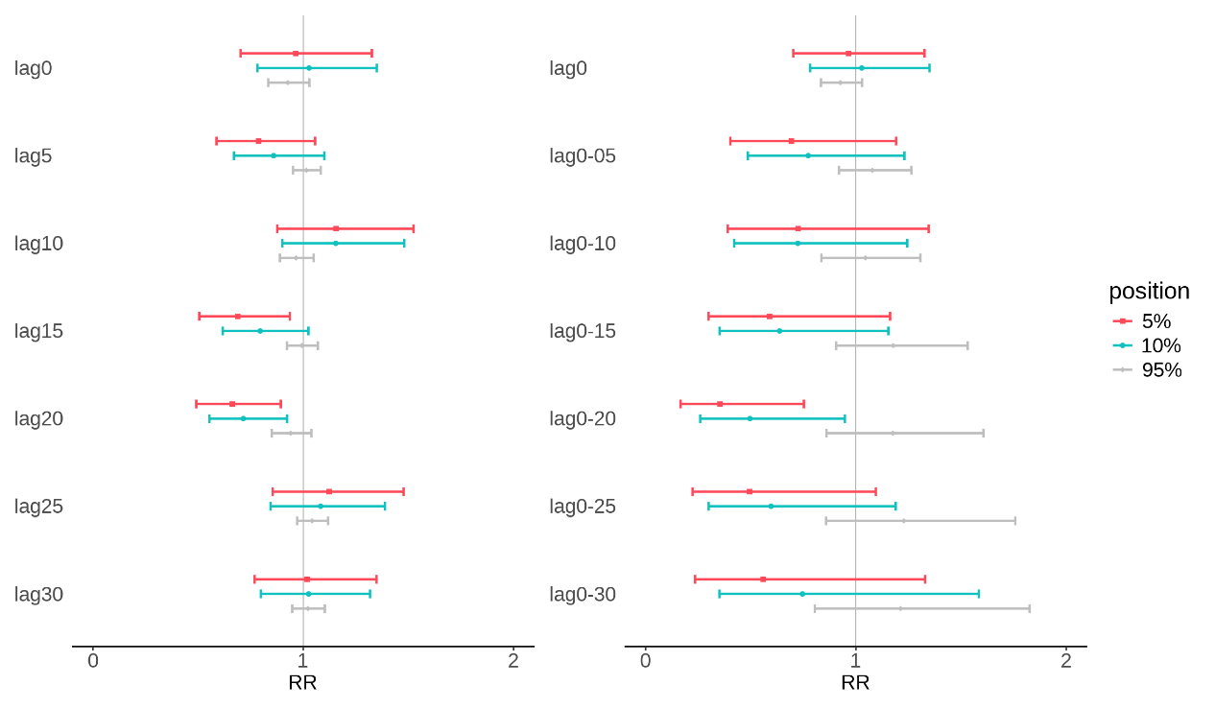

The 90th percentile of temperature served as a reference point in assessing the single and cumulative effects of temperature difference at different lag days.

Stratified analysis of environmental temperature difference and preeclampsia admission by age

Stratified analysis of environmental temperature difference and preeclampsia admission in different gestational weeks

