Effects of Different Types of Exercise Interventions on Perinatal Depression, Anxiety, and Quality of Life: A Systematic Review and Meta-Analysis
Supplementary Material

Part 1: Search strategies 1
eAppendix1. Search strategy in CNKI. 1
eAppendix2. Search strategy in Wangfang. 2
eAppendix3. Search strategy in VIP. 3
eAppendix4. Search strategy in PubMed. 4
eAppendix5. Search strategy in Web of Science. 5
eAppendix6. Search strategy in EMbase. 6
eAppendix7. Search strategy in The Cochrane Library. 7
Part 2: Literature screening 8
eAppendix8. PRISMA flow diagram of study selection. 8
Part 3: Basic characteristics of the included studies 9
eAppendix9. Table S1 Basic characteristics of the included studies. 9
eAppendix10. Table S2 Table of Preset Classification Frameworks. 14
Part 4: Quality assessment of included studies 19
eAppendix 11. Risk of bias graph of the included studies. 19
Part 5: Meta-analysis results for different outcome measures 20
eAppendix 12. Preventing antenatal depression 20
eAppendix 13. Treatment for antenatal depression 25
eAppendix 14. Preventing postnatal depression 26
eAppendix 15. Treatment of postnatal depression 30
eAppendix 16. Preventing antenatal anxiety 34
eAppendix 17. Treatment for antenatal anxiety 38
eAppendix 18. The therapeutic effect on quality of life 42
Part 6: Publication bias assessment 46
eAppendix 19. Funnel plot 46

Part 1: Search strategies

eAppendix 1. Search strategy in CNKI.
Database | Search strategy | Amount
CNKI
#1 | SU=（“运动干预” OR “运动疗法” OR “体育锻炼” OR “身体活动” OR “运动训练” OR “体力活动”） OR TKA=（“有氧运动” OR “瑜伽” OR “普拉提” OR “太极” OR “气功” OR “阻力训练” OR “抗阻训练” OR “力量训练” OR “步行” OR “跑步” OR “舞蹈” OR “水中运动” OR “盆底运动” OR “凯格尔运动”） | 26,840
#2 | SU=（“围产期” OR “产前” OR “孕期” OR “妊娠期” OR “产后” OR “产妇”） | 112,350
#3 | SU=（“抑郁” OR “抑郁症” OR “焦虑” OR “焦虑症” OR “生活质量” OR “生命质量” OR “心理健康”） OR TKA=（“爱丁堡产后抑郁量表” OR "EPDS" OR “状态 - 特质焦虑量表” OR "STAI" OR "SF - 36" OR "WHOQOL"） | 89,720
#4 | SU=（“随机对照试验” OR “随机临床试验”） OR TKA=（“随机” OR "RCT" OR "randomized controlled trial" OR “随机分配” OR “随机分组”） NOT TKA=（“动物” OR “小鼠” OR “大鼠” OR “综述” OR “荟萃分析”） | 67,580
#5 | #1 AND #2 AND #3 AND #4 | 190

eAppendix 2. Search strategy in Wangfang.
Database | Search strategy | Amount
Wangfang
#1 | 主题：（运动干预） OR 题名：（运动干预 OR 运动疗法 OR 身体活动 OR 体育锻炼 OR 运动训练 OR 有氧运动 OR 瑜伽 OR 太极 OR 阻力训练） OR 摘要：（运动干预 OR 运动疗法 OR 身体活动 OR 体育锻炼 OR 运动训练 OR 有氧运动 OR 瑜伽 OR 太极 OR 阻力训练） | 35,620
#2 | 主题：（围产期抑郁症） OR 题名：（围产期抑郁 OR 产前抑郁 OR 产后抑郁 OR 孕期抑郁 OR 围产期焦虑 OR 产后焦虑 OR 生活质量） OR 摘要：（围产期抑郁 OR 产前抑郁 OR 产后抑郁 OR 孕期抑郁 OR 围产期焦虑 OR 产后焦虑 OR 生活质量） | 92,340
#3 | 摘要：（随机 OR 随机对照试验 OR RCT） NOT 题名：（综述 OR 荟萃分析 OR 动物） | 78,410
#4 | (#1) AND (#2) AND (#3) | 245

eAppendix 3. Search strategy in VIP.
Database | Search strategy | Amount
VIP
#1 | （K=运动干预） OR (T=(运动干预 OR 运动疗法 OR 身体活动 OR 体育锻炼 OR 运动训练 OR 有氧运动 OR 瑜伽)) OR (R=(运动干预 OR 运动疗法 OR 身体活动 OR 体育锻炼 OR 运动训练 OR 有氧运动 OR 瑜伽)) | 43,210
#2 | （K=围产期抑郁症） OR (T=(围产期抑郁 OR 产前抑郁 OR 产后抑郁 OR 孕期抑郁 OR 围产期焦虑 OR 产后焦虑 OR 生活质量)) OR (R=(围产期抑郁 OR 产前抑郁 OR 产后抑郁 OR 孕期抑郁 OR 围产期焦虑 OR 产后焦虑 OR 生活质量)) | 87,650
#3 | R=随机 | 65,430
#4 | (#1) AND (#2) AND (#3) | 141

eAppendix 4. Search strategy in PubMed.
Database | Search strategy | Amount
PubMed
#1 | Search: Depression, Postpartum [MeSH Terms] | 7,515
#2 | Search: "Postpartum Depression" OR "Postnatal Depression" OR "Postnatal Dysphoria" OR "Postpartum Dysphoria" OR "Puerperal depression" OR "Antepartum depression" OR "Antenatal depression" OR "Perinatal depression" OR "Prenatal depression" OR "Depression | 11,470
#3 | #1 OR #2 | 13,440
#4 | Search: Exercise [MeSH Terms] | 18,693
#5 | Search: "Exercise" OR "Exercises" OR "Physical Activity" OR "Physical Activities" OR "Motor Activity" OR "Sport" OR "Aerobics" OR "Training" OR "Trainings" OR "Jogging" OR "Walking" OR "Ambulation" OR "Yoga" OR "Swimming" OR "Dancing" OR "Cycling" OR "Resistance" OR "Pilates" OR "Stretching" OR "Tai Ji" | 156,700
#6 | #4 OR #5 | 22,350
#7 | Search: Perinatal period[MeSH] | 2,185
#8 | Search: "Anxiety"[MeSH] OR "Anxiety Disorders"[MeSH] OR "anxiety" OR "anxious" | 6,260
#9 | Search: "Quality of Life"[MeSH] OR "quality of life" OR "life quality" OR "QoL" OR "SF-36" OR "WHOQOL" | 13,365
#10 | Search: "randomized controlled trial"[Publication Type] OR "randomized"[Title/Abstract] OR "randomly"[Title/Abstract] OR "RCT"[Title/Abstract] | 521,109
#11 | #3 OR #8 OR #9 | 11,400
#12 | #6 AND #7 AND #10 AND #11 | 485

eAppendix 5. Search strategy in Web of Science.
Database | Search strategy | Amount
Web of Science
#1 | '((((((((((TS=(Postpartum Depression)) OR TS=(Postnatal Depression)) OR TS=(Postnatal Dysphoria)) OR TS=(Postpartum Dysphoria)) OR TS=(Puerperal depression)) OR TS=(Antepartum depression)) OR TS=(Antenatal depression)) OR TS=(Perinatal depression)) OR TS=(Prenatal depression)) OR TS=(Depression during pregnancy)) OR TS=(Postpartum psychosis)) OR TS=(Anxiety)) OR TS=(Anxious)) OR TS=(State-Trait Anxiety Inventory)) OR TS=(STAI)) OR TS=(Quality of Life)) OR TS=(life quality)) OR TS=(QoL)) OR TS=(SF-36)) OR TS=(WHOQOL) | 30,480
#2 | ((((((((((((((((((TS=(Exercise)) OR TS=(Exercises)) OR TS=(Physical Activity)) OR TS=(Physical Activities)) OR TS=(Motor Activity)) OR TS=(Sport)) OR TS=(Aerobics)) OR TS=(Training)) OR TS=(Trainings)) OR TS=(Jogging)) OR TS=(Walking)) OR TS=(Ambulation)) OR TS=(Yoga)) OR TS=(Swimming)) OR TS=(Dancing)) OR TS=(Cycling)) OR TS=(Resistance)) OR TS=(Pilates)) OR TS=(Stretching) | 15,764
#3 | #1 AND #2 | 622

eAppendix 6. Search strategy in EMBASE.
Database | Search strategy | Amount
Embase
#1 | 'Postpartum Depression'/exp OR 'Postnatal Depression' OR 'Postnatal Dysphoria' OR 'Postpartum Dysphoria' OR 'Puerperal depression' OR 'Antepartum depression' OR 'Antenatal depression' OR 'Perinatal depression' OR 'Prenatal depression' OR 'Depression during pregnancy' OR 'Postpartum psychosis' OR 'Anxiety'/exp OR 'anxiety' OR 'anxious' OR 'State-Trait Anxiety Inventory' OR 'STAI' OR 'Quality of Life'/exp OR 'quality of life' OR 'life quality' OR 'QoL' OR 'SF-36' OR 'WHOQOL' | 21,704
#2 | 'Exercise'/exp OR 'Exercises' OR 'Physical Activity' OR 'Physical Activities' OR 'Motor Activity' OR 'Sport' OR 'Aerobics' OR 'Training' OR 'Trainings' OR 'Jogging' OR 'Walking' OR 'Ambulation' OR 'Yoga' OR 'Swimming' OR 'Dancing' OR 'Cycling' OR 'Resistance' OR 'Pilates' | 72,967
#3 | #1 AND #2 | 670

eAppendix 7. Search strategy in The Cochrane Library.
Database | Search strategy | Amount
Cochrane Library
#1 | MeSH descriptor: [Depression, Postpartum] explode all trees | 873
#2 | (Postpartum Depression) OR (Postnatal Depression) OR (Postnatal Dysphoria) OR (Postpartum Dysphoria) OR (Puerperal depression) OR (Antepartum depression) OR (Antenatal depression) OR (Perinatal depression) OR (Prenatal depression) OR (Depression during pregnancy) OR (Postpartum psychosis) OR (Anxiety) OR (Anxious) OR (State-Trait Anxiety Inventory) OR (STAI) OR (Quality of Life) OR (life quality) OR (QoL) OR (SF-36) OR (WHOQOL) | 5,575
#3 | #1 OR #2 | 5,575
#4 | MeSH descriptor: [Exercise] explode all trees | 38,509
#5 | (Exercise) OR (Exercises) OR (Physical Activity) OR (Physical Activities) OR (Motor Activity) OR (Sport) OR (Aerobics) OR (Training) OR (Trainings) OR (Jogging) OR (Walking) OR (Ambulation) OR (Yoga) OR (Swimming) OR (Dancing) OR (Cycling) OR (Resistance) OR (Pilates) OR (Stretching) | 323,435
#6 | #4 OR #5 | 323,686
#7 | #3 AND #6 | 759

Part 2: Literature screening

eAppendix 8. PRISMA flow diagram of study selection.
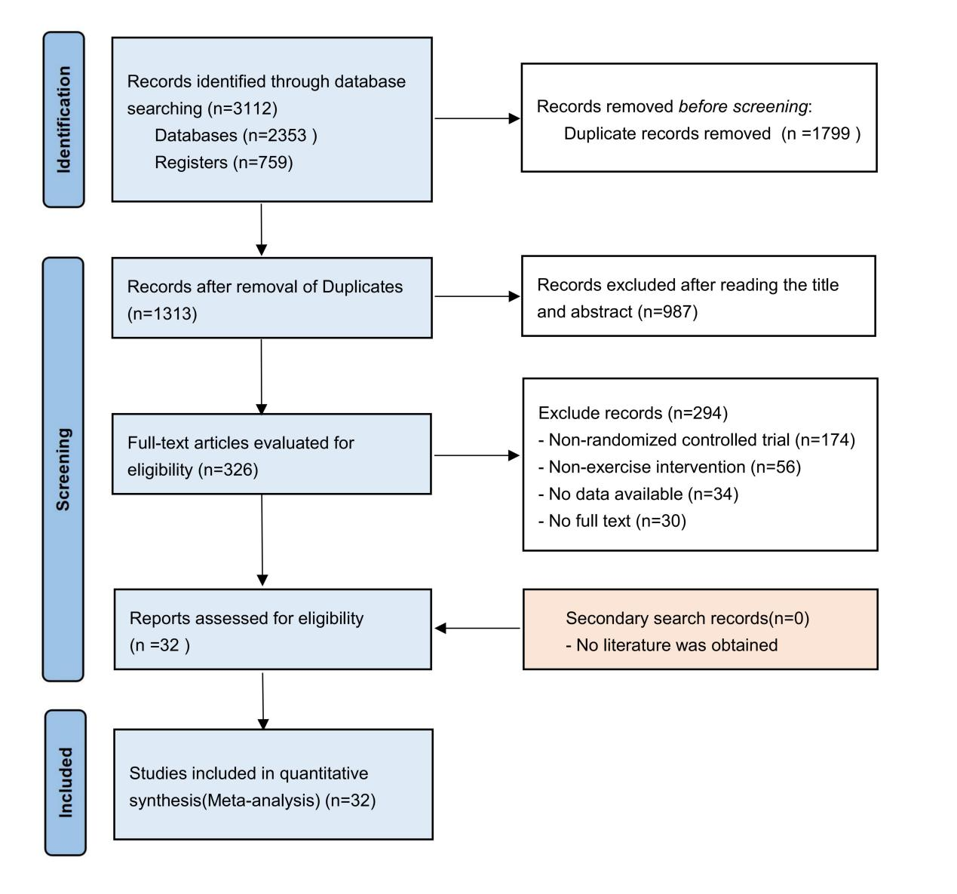

Fig. S1 PRISMA flow diagram of study selection.

Part 3: Basic characteristics of the included studies

eAppendix 9. Table S1 Basic characteristics of the included studies.
Study | Country | Participants | Age | Intervention | Schedule | Participant Profile | Intervention Aim | Target Condition | Outcomes | Adherence
Angelo et al. | Colombia | IG: n=37 | IG:21±3 | Aerobic exercise | 3x60 min/week, 21 weeks | APW | Prevention | Prenatal Depression | CES-D | 80.3% (High)
Angelo et al. | Colombia | CG: n = 37 | CG:21±3 | Usual care
Araceli et al. | Spain | IG: n=148 | IG:31.1±4.1 | Aerobic water exercise | 2x45 min/week, 35 weeks | APW | Prevention | Postpartum Depression | EDPS | NR
Araceli et al. | Spain | CG: n=146 | CG:31.5±4.2 | Usual care
Amandaª et al. | UK | IG: n=391 | IG:27.5±6.3 | Treadmill walking | 2x30 min/week, 8 weeks | APW | Prevention | Prenatal Depression  Postpartum Depression | EPDS | NR
Amandaª et al. | UK | CG: n = 393 | CG:27.5±6.3 | Health education
Kyle et al. | USA | IG: n=23 | IG:29.74±5.40 | Yoga | 1x75 min/week, 8 weeks | PWD, PWA | Treatment | Prenatal Anxiety  Prenatal Depression | EPDS | 75% (Low/Moderate)
Kyle et al. | USA | CG: n = 23 | CG:30.57±4.46 | Usual care
Kylieª et al. | Australia | IG: n=9 | IG:27~73 | Pram walking | 2x40 min/week, 12 weeks | PPD | Treatment | Postpartum Depression | EPDS | 75% (Low/Moderate)
Kylieª et al. | Australia | CG: n=10 | CG:40~60 | Social support
Tiffany et al. | USA | IG: n=46 | IG:24.4±4.7 | Yoga | 1x20 min/week, 12 weeks | PWD | Treatment | Prenatal Depression  Postpartum Depression | EPDS  STAI | 93.5% retention (High)
Tiffany et al. | USA | CG: n=46 | CG:24.5±5.02 | Social support
Beth et al. | USA | IG: n=56 | IG:28.02±5.60 | Physical activity promotion | 5x30 min/week, 12 weeks | APW | Prevention | Prenatal Depression  Postpartum Depression | EPDS | NR
Beth et al. | USA | CG: n = 55 | CG:31.44±5.31 | Usual care
Kylie^{b} et al. | Australia | IG: n=10 | IG:21~30 | Group pram walking | 3x30-40 min/week, 12 weeks | PPD | Treatment | Postpartum Depression | EPDS | 66% (Low/Moderate)
Kylie^{b} et al. | Australia | CG: n=10 | CG:21~30 | Usual care
Amanda^{b} et al. | UK | IG: n=20 | IG:21~40 | Behavioral counseling intervention | 5x30 min/week, 12 weeks | PPD | Treatment | Postpartum Depression | EPDS | 90.9% met goal (High)
Amanda^{b} et al. | UK | CG: n=18 | CG:21~40 | Usual care
Angela et al. | USA | IG: n=48 | IG:30.44±6.17 | Yoga | 2x30 min/week | APW | Prevention | Prenatal Anxiety | HADS-A  HADS-D | NR
Angela et al. | USA | CG: n=31 | CG:27.65±7.46 | Usual care
Shu et al. | China | IG: n=33 | IG:20~35 | Sports Support Program | 3 sessions/week, 21 weeks | PPD | Treatment | Postpartum Depression | EPDS | NR
Shu et al. | China | CG: n=30 | CG:20~35 | Usual care
Fatemeh et al. | Iran | IG: n=42 | IG:25.2±4.6 | Low-intensity stretching and breathing exercises | 3x20-30 min/week | APW | Prevention | Postpartum Depression | EPDS | Low compliance (Low/Moderate)
Fatemeh et al. | Iran | CG: n = 42 | CG:25.3±5.2 | Health education
Young et al. | Korea | IG: n=23 | IG:32.22±2.58 | Structured Bed Exercise | NR | APW | Prevention | Prenatal Anxiety  Prenatal Depression | EPDS  STAI | 100% (High)
Young et al. | Korea | CG: n = 22 | CG:31.50±4.48 | Usual care
Colleen et al. | USA | IG: n=71 | IG:18~40 | Walking | 12weeks | APP | Prevention | Postpartum Depression | EPDS | 66.2% retention (Low/Moderate)
Colleen et al. | USA | CG: n = 68 | CG:18~40 | Usual care
Huang et al. | China | IG: n=64 | IG:30.67±3.70 | Physical Activity Counseling and Education | 6x30-40 min/week, 24 weeks | APP | Prevention | Postpartum Depression | BDI | 78.8% retention (Low/Moderate)
Huang et al. | China | CG: n=64 | CG:31.91±4.85 | Health education
Kim et al. | Korea | IG: n=8 | IG:39.71±2.01 | Online Pilates exercise | 2x50 min/week, 8 weeks | APW | Prevention | Postpartum Depression | EPDS | NR
Kim et al. | Korea | CG: n=8 | CG:38.14±1.39 | Usual care
James et al. | UK | IG: n=31 | IG:31±5 | Prenatal yoga | 8 weeks | PWA | Treatment | Prenatal Anxiety | EPDS | ≥75% (Low/Moderate)
James et al. | UK | CG: n = 28 | CG:31±7 | Usual care
Emily et al. | Australia | IG: n=62 | IG:29.3±4.0 | Exercise guided by a physical therapist | 3x45 min/week, 20 weeks | APP | Prevention | Postpartum Depression | EPDS | 96.3% retention (High)
Emily et al. | Australia | CG: n=73 | CG:30.1±5.3 | Usual care
Pooja et al. | India | IG: n=34 | IG:18~35 | Prenatal yoga | 8 weeks | APP | Treatment | Prenatal Anxiety  Prenatal Depression  Quality of life | DASS | NR
Pooja et al. | India | CG: n=43 | CG:18~35 | Usual care
Semiha et al. | Turkey | IG: n=34 | IG:28.90±4.83 | Postpartum aerobic exercise | 5x30 min/week, 4 weeks | PPD | Treatment | Postpartum Depression | EPDS | NR
Semiha et al. | Turkey | CG: n=31 | CG:28.90±4.83 | Usual care
Canan et al. | Turkey | IG: n=25 | IG:29.48±3.65 | Progressive muscle relaxation exercise | 3 sessions/week, 6 weeks | APW | Prevention | Postpartum Depression | EPDS | 100% retention (High)
Canan et al. | Turkey | CG: n=27 | CG:26.22±3.78 | Usual care
Megan et al. | Australia | IG: n=32 | IG:33.6±3.7 | Move home-based physical activity | 12weeks | PPD | Treatment | Postpartum Depression | EPDS | NR
Megan et al. | Australia | CG: n=30 | CG:33.0±3.7 | Usual care
Liu et al. | China | IG: n=32 | IG:29.00±2.81 | Prenatal yoga | 3x60 min/week, 12 weeks | APW | Prevention | Prenatal Anxiety  Prenatal Depression | EPDS  STAI | 100% (High)
Liu et al. | China | CG: n = 32 | CG:28.16±2.78 | Usual care
Satyapriya et al. | India | IG: n=51 | IG:26.41±3.01 | Integrated yoga | 7x60 min/week, 16 weeks | APW | Prevention | Prenatal Anxiety  Prenatal Depression | HADS-A  HADS-D  STAI | NR
Satyapriya et al. | India | CG: n = 45 | CG:24.96±2.58 | Prenatal care
Carolina et al. | Brazil | IG: n=192 | IG:27.2±5.5 | Aerobic and resistance training | 3x60 min/week, 16 weeks | APW | Prevention | Postpartum Depression | EPDS | NR
Carolina et al. | Brazil | CG: n = 387 | CG:27.3±5.5 | Usual care
Pelin et al. | Turkey | IG: n=17 | IG:30.8±7.0 | Pilates-based therapeutic exercise | 2x60 min/week, 12 weeks | APW | Prevention | Prenatal Anxiety  Prenatal Depression | HADS-A  HADS-D | 88% (High)
Pelin et al. | Turkey | CG: n = 17 | CG:28.8±5.6 | Usual care
Dominikaª et al. | Poland | IG: n=34 | IG:31±4 | Family Physical Activity Intervention | 3x60 min/week, 8 weeks | APW | Prevention | Prenatal Depression  Quality of life | BDI  SF-12 | 80% (High)
Dominikaª et al. | Poland | CG: n=20 | CG:32±4 | Health education
Dominik et al. | Poland | IG: n=22 | IG:30.18±4.21 | High intensity interval training | 3x60 min/week, 8 weeks | APW | Prevention | Prenatal Depression  Quality of life | BDI  SF-12 | 80% (High)
Dominik et al. | Poland | CG: n=16 | CG:32.38±3.52 | Health education
Lisa et al. | USA | IG: n=12 | IG:28.0±5.9 | Prenatal yoga | 75 min/week, 9 weeks | PWD | Treatment | Prenatal Depression | EPDS | 63% (Low/Moderate)
Lisa et al. | USA | CG: n=8 | CG:28.9±6.0 | Health education
Yang et al. | China | IG: n=64 | IG:31.89±4.03 | Aerobic gymnastics exercise | 3x15 min/week, 21 weeks | APP | Prevention | Postpartum Depression | EPDS | NR
Yang et al. | China | CG: n=65 | CG:32.45±4.12 | Usual care
Cathryn et al. | USA | IG: n=10 | IG:27.1±2.88 | Prenatal Yoga | 1x75 min/week, 9 weeks | PWD, PWA | Treatment | Prenatal Anxiety  Prenatal Depression | POMS | NR
Cathryn et al. | USA | CG: n=9 | CG:30.11±4.10 | Usual care
Patrick et al. | Athens | IG: n=44 | IG:28±5 | Resistance training | 2x17 min/week, 12 weeks | APW | Prevention | Prenatal Depression  Quality of life | POMS  SF-36 | 78.4% (Low/Moderate)
Patrick et al. | Athens | CG: n=45 | CG:29±4 | Usual care
Note: NR, Not reported; IG, intervention group; CG, control group; APW, Asymptomatic Prenatal Women; PWD, Prenatal Women with Depression; PWA, Prenatal Women with Anxiety; PPD, Postpartum Women with Depression; PPA, Postpartum Women with Anxiety; APP, Asymptomatic Postpartum Women; EPDS, Edinburgh Postnatal Depression Scale; CES-D, Center for Epidemiological Studies Depression Scale; BDI, Beck Depression Inventory; HADS-D, Hospital Anxiety and Depression Scale-Depression; HADS-A, Hospital Anxiety and Depression Scale-Anxiety; POMS, Profile of Mood States; SF-36, The 36-item Short Form Health Survey; SF-12, The 12-item Short Form Health Survey; QOL-BREF, WHO-QOL-BREF questionnaire.

eAppendix 10. Table S2 Table of Preset Classification Frameworks.
Study | Description of Interventions | Intervention Type Classification  (Core Active Ingredient) | Control group description | Control Group Classification
Angelo et al. | Aerobic exercise (mixed training: walking, aerobics, stretching, relaxation) | Structured aerobic/endurance exercise | Routine care (no specific exercise intervention) | Routine care/no treatment control
Araceli et al. | Aerobic aquatic exercise (water aerobics) | Structured aerobic/endurance exercise | Routine prenatal care | Routine care/no treatment control
Amanda et al. | Aerobic exercise (treadmill walking) combined with physical activity counseling | Structured aerobic/endurance exercise | Routine care (same smoking cessation behavioral support, but no additional physical activity intervention) | Routine care/no treatment control
Kyle et al. | Yoga (a mind-body exercise) | Structured mind-body exercise | Routine treatment (participants not restricted from seeking treatment outside the study) | Routine care/no treatment control
Kyliea et al. | Stroller walking (pushing a stroller while walking) | Structured aerobic/endurance exercise | Social support group (unstructured gatherings providing social and emotional support, no physical activity) | Attention/education control
Tiffany et al. | Yoga (yoga comprising only physical postures) | Structured mind-body exercise | Social support group (leaderless group discussions providing social and emotional support) | Attention/education control
Beth et al. | Physical activity promotion (remote counseling, based on self-determination and social cognitive theories) | Behavioral activation and supportive intervention | Routine treatment (care as determined by healthcare providers) | Routine care/no treatment control
Kylieb et al. | Multi-intervention program (group stroller walking + informal social support) | Structured aerobic/endurance exercise | Non-intervention control group (only fitness tests and questionnaires, alternative exercise program provided at study end) | Routine care/no treatment control
Amandab et al. | Behavioral counseling intervention (aimed at promoting physical activity, based on behavior change theories) | Behavioral activation and supportive intervention | Routine treatment (asked not to change current exercise patterns) | Routine care/no treatment control
Angela et al. | Yoga intervention (adaptive yoga designed for high-risk bedrest pregnant women) | Structured mind-body exercise | Routine care (standard care without yoga instruction) | Routine care/no treatment control
Shu et al. | Exercise support program (including structured group sessions and home practice CD) | Structured aerobic/endurance exercise | Routine care (standard postpartum care) | Routine care/no treatment control
Fatemeh et al. | Home-based low-intensity stretching and breathing exercises (via educational CD) | Structured aerobic/endurance exercise | Routine care (a single 40-minute prenatal and postnatal routine education session) | Routine care/no treatment control
Young et al. | Structured bed exercises (including isometric and isotonic exercises) | Structured functional/fitness training | Routine care (no structured bed exercises) | Routine care/no treatment control
Colleen et al. | Social support-based walking intervention ("Madres para la Salud" program) | Structured aerobic/endurance exercise | Attention control group (monthly health-themed newsletters, weekly telephone consultations) | Attention/education control
Huang et al. | Individualized diet and physical activity counseling education | Behavioral activation and supportive intervention | Routine care (routine obstetric outpatient education program) | Routine care/no treatment control
Kim et al. | Real-time online Pilates exercises | Structured mind-body exercise | Non-exercise control group (no participation in any exercise) | Routine care/no treatment control
James et al. | Prenatal yoga | Structured mind-body exercise | Routine care (receiving routine prenatal care) | Routine care/no treatment control
Emily et al. | "Mother-Infant" program (physiotherapist-guided exercises + health education) | Structured aerobic/endurance exercise | Social support group (weekly unstructured gatherings) | Attention/education control
Pooja et al. | Prenatal yoga (YOGESTA) | Structured mind-body exercise | Routine care (no yoga or exercise intervention, only normal walking) | Routine care/no treatment control
Semiha et al. | Postpartum exercise (home-based, individual, unsupervised, light-to-moderate first 2 weeks, moderate-to-vigorous next 2 weeks) | Structured aerobic/endurance exercise | Routine care (standard care provided by family health centers) | Routine care/no treatment control
Canan et al. | Online health training/consultation combined with Progressive Muscle Relaxation Exercise (PMRE) | Structured aerobic/endurance exercise | Routine follow-up | Routine care/no treatment control
Megan et al. | Multicomponent, home-based physical activity intervention (providing equipment, web app, logs, etc.) | Behavioral activation and supportive intervention | Routine activity (asked to continue daily activities) | Routine care/no treatment control
Liu et al. | Prenatal yoga | Structured mind-body exercise | Routine prenatal care (including prenatal education, childbirth preparation materials, etc.) | Attention/education control
Satyapriya et al. | Integrated yoga therapy (including lectures, breathing exercises, postures, meditation, etc.) | Structured mind-body exercise | Standard prenatal exercise (simple stretching exercises) | Attention/education control
Carolina et al. | Moderate-intensity, supervised physical exercise program (aerobic + resistance) | Structured functional/fitness training | Routine activity (advised to maintain daily activities) | Routine care/no treatment control
Pelin et al. | Pilates-based therapeutic exercise | Structured mind-body exercise | Routine care (receiving routine postpartum care) | Routine care/no treatment control
Dominikaa et al. | Multicomponent, home-based physical activity intervention (providing equipment, web app, logs, etc.) | Structured aerobic/endurance exercise | Routine activity (asked to continue daily activities) | Routine care/no treatment control
Dominikab et al. | Online health training/consultation combined with Progressive Muscle Relaxation Exercise (PMRE) | Behavioral activation and supportive intervention | Routine follow-up | Routine care/no treatment control
Lisa et al. | Prenatal yoga | Structured mind-body exercise | Perinatal health education (workshops focusing on maternal-infant health and general health) | Attention/education control
Yang et al. | Home-based aerobic gymnastics exercise (using DVD) | Structured aerobic/endurance exercise | Routine postpartum care (including learning postpartum exercises such as Kegel exercises) | Routine care/no treatment control
Cathryn et al. | Prenatal yoga (option for online or in-person classes) | Structured mind-body exercise | Non-yoga control group (asked not to participate in yoga during the study) | Routine care/no treatment control
Patrick et al. | Low-to-moderate intensity resistance training (machine-based) | Structured functional/fitness training | Waitlist control group (no treatment) | Routine care/no treatment control

Part 4: Quality assessment of included studies

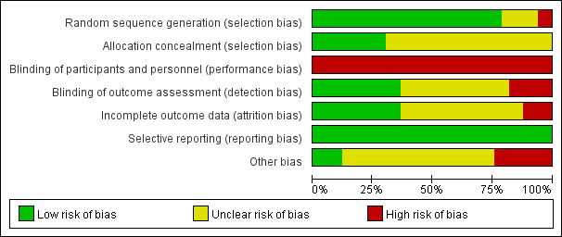
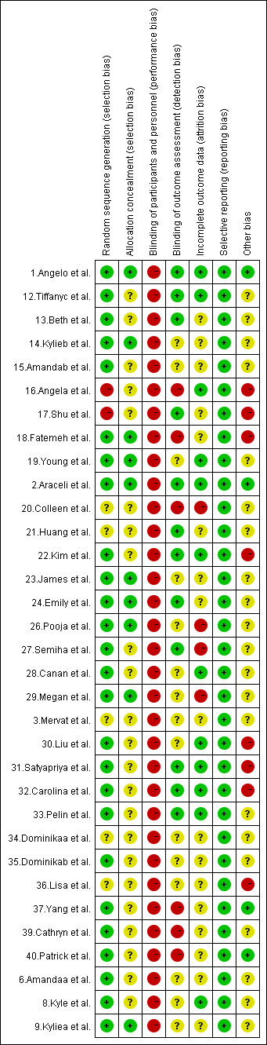
eAppendix 11. Risk of bias graph of the included studies.

Fig. S2 Risk of bias graph of the included studies.

Part 5: Meta-analysis results for different outcome measures

eAppendix 12. Preventing antenatal depression
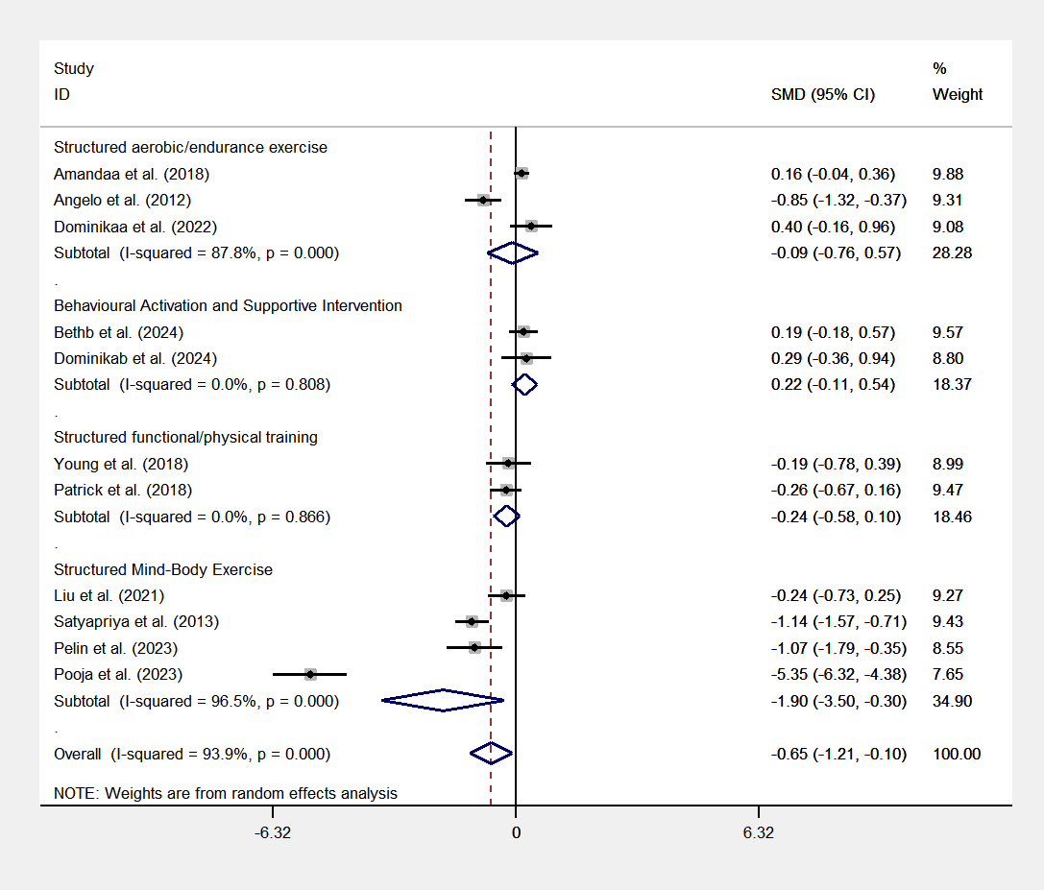
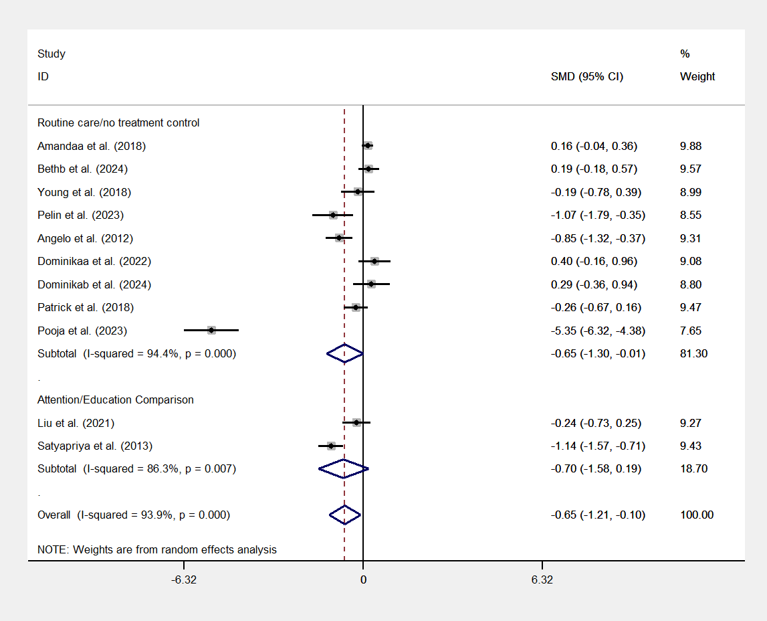

Fig. S3 Subgroup analysis by intervention type. Fig. S4 Subgroup analysis by comparison type.

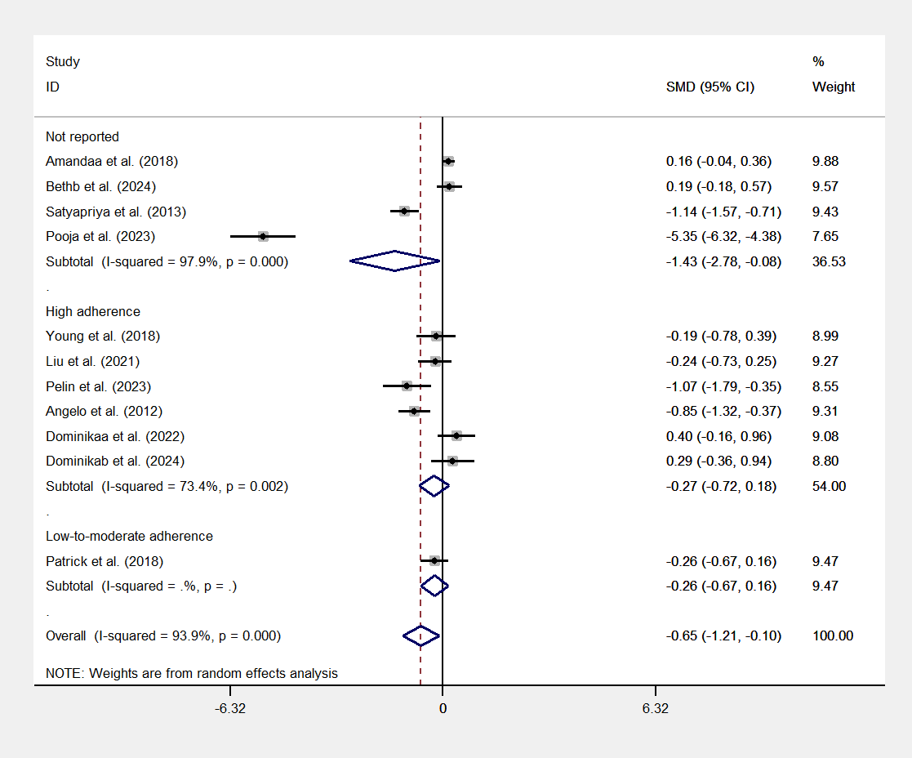

Fig. S5 Subgroup analysis by exercise adherence.
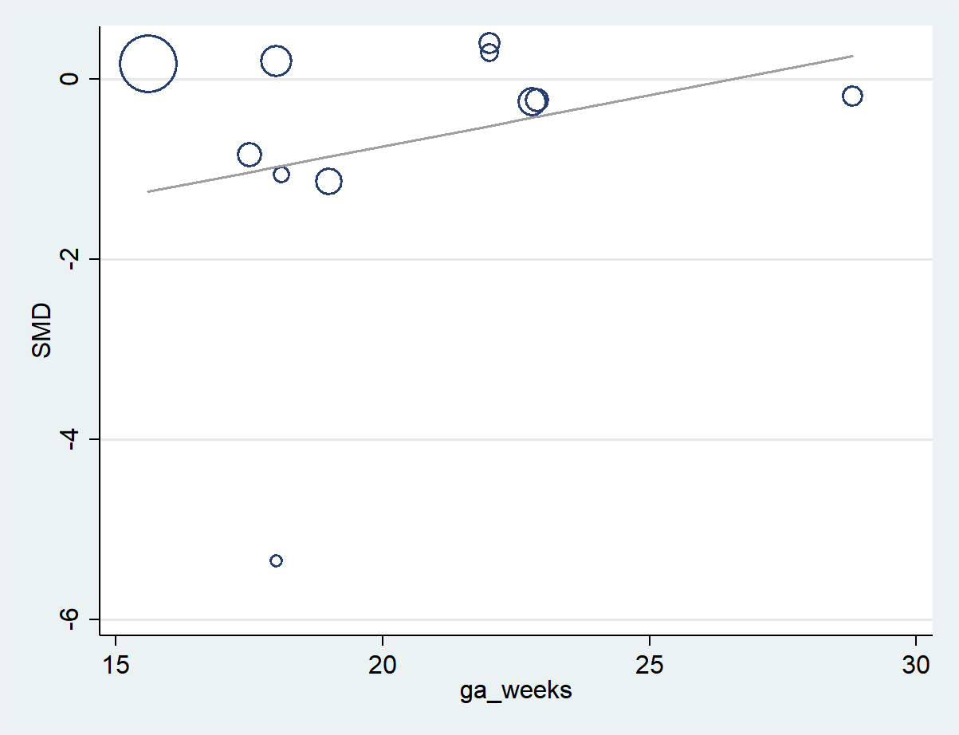

Fig. S6 Bubble plot of meta-regression by mean gestational age at baseline. Each bubble represents an individual study, with the size of the bubble proportional to the study's weight in the random-effects model. The horizontal axis indicates the mean gestational age (weeks), and the vertical axis represents the standardized mean difference (SMD). The solid line represents the fitted regression line.
Table S3 Subgroup analysis results.
Type | Category | Studies | Effect size (95% CI) | I² | P-value (within group)
Intervention Type | Structured Mind-Body Exercise | n=4 | SMD = -1.898 (95% CI: -3.501 to -0.295) | 96.5% | P = 0.020
Intervention Type | Structured functional/physical training | n=2 | SMD = -0.236 (95% CI: -0.576 to 0.104) | 0% | P = 0.174
Intervention Type | Structured aerobic/endurance exercise | n=3 | SMD = -0.092 (95% CI: -0.758 to 0.573) | 87.8% | P = 0.786
Intervention Type | Behavioral Activation and Supportive Intervention | n=2 | SMD = 0.218 (95% CI: -0.105 to 0.541) | 0% | P = 0.186
Comparison Type | Routine care/no treatment control | n=9 | SMD = -0.655 (95% CI: -1.300 to -0.010) | 94.4% | P = 0.047
Comparison Type | Attention/Education Comparison | n=2 | SMD = -0.698 (95% CI: -1.582 to 0.187) | 86.3% | P = 0.122
Exercise Adherence | Not reported | n=4 | SMD = -1.430 (95% CI:-2.776 to-0.083) | 97.9% | P = 0.037
Exercise Adherence | High adherence | n=6 | SMD = -0.272 (95% CI:-0.723 to 0.179) | 73.4% | P = 0.237
Exercise Adherence | Low-to-moderate adherence | n=1 | SMD = -0.257 (95% CI:-0.674 to 0.161) | - | P = 0.228

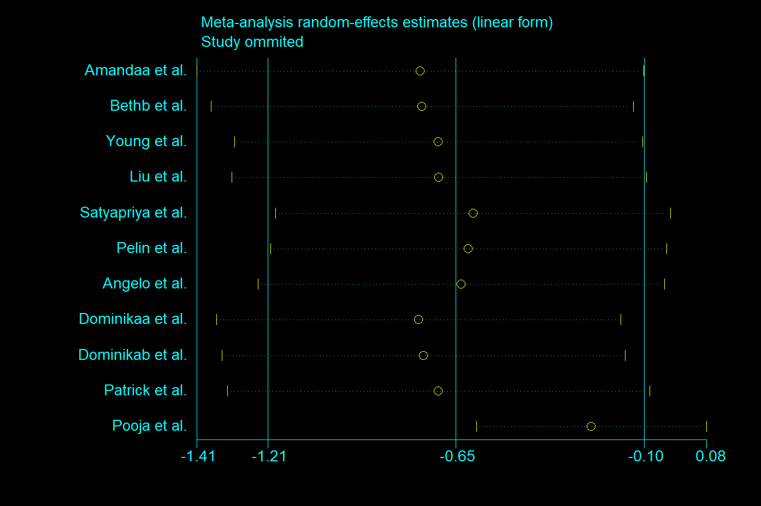

Fig. S7. Leave-one-out sensitivity analysis for preventing antenatal depression. Dots and horizontal lines represent the recalculated pooled Standardized Mean Differences (SMDs) and 95% confidence intervals (CIs) when the specific study on the left is omitted. The solid vertical line indicates the line of no effect (SMD = 0). The central dashed line and its flanking dotted lines represent the original pooled SMD and its 95% CI, respectively. The consistent alignment of recalculated estimates confirms the high robustness of the primary findings.

eAppendix 13. Treatment for antenatal depression
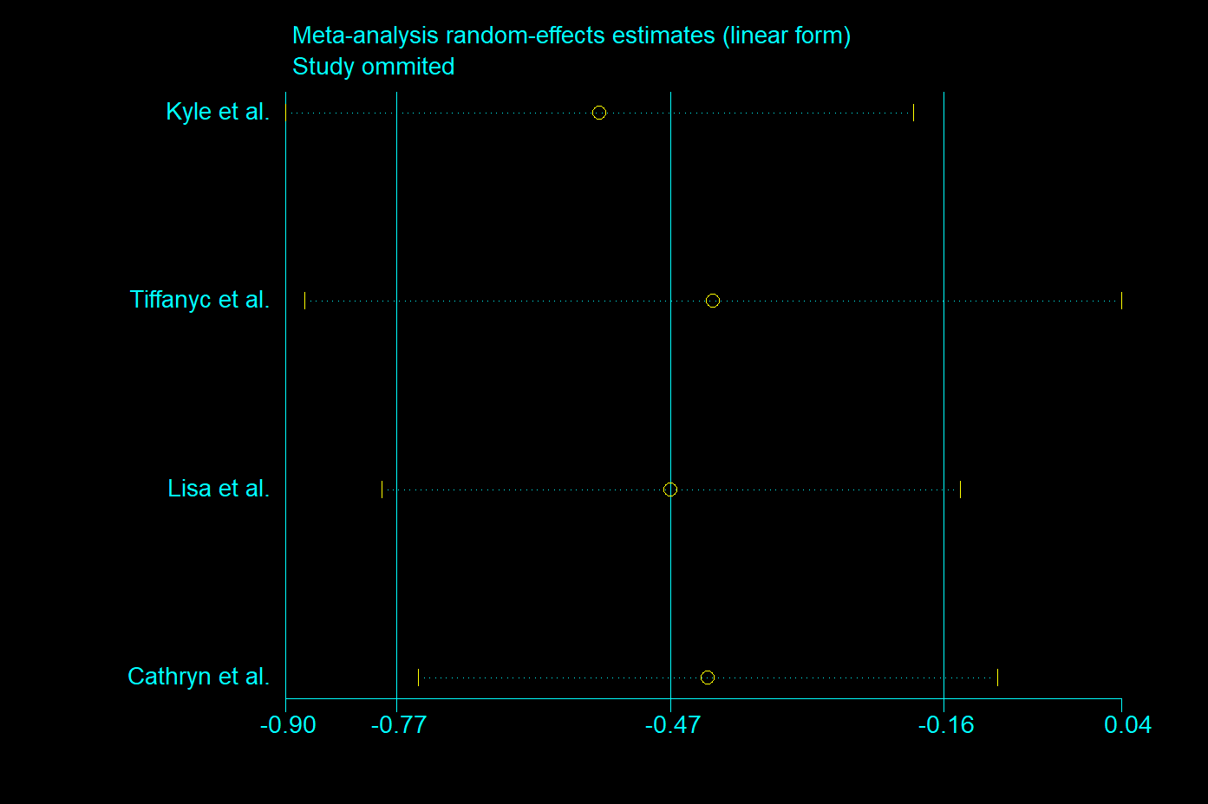

Fig. S8. Leave-one-out sensitivity analysis for treating antenatal depression. Dots and horizontal lines represent the recalculated pooled Standardized Mean Differences (SMDs) and 95% confidence intervals (CIs) when the specific study on the left is omitted. The solid vertical line indicates the line of no effect (SMD = 0). The central dashed line and its flanking dotted lines represent the original pooled SMD and its 95% CI, respectively. The consistent alignment of recalculated estimates confirms the high robustness of the primary findings.

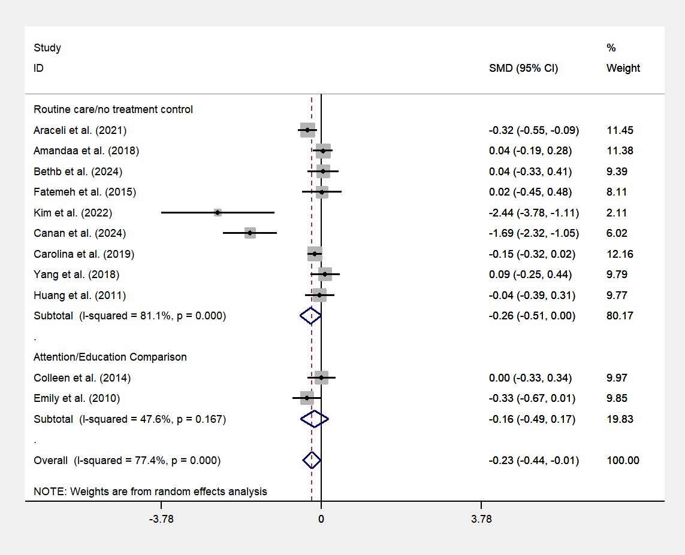
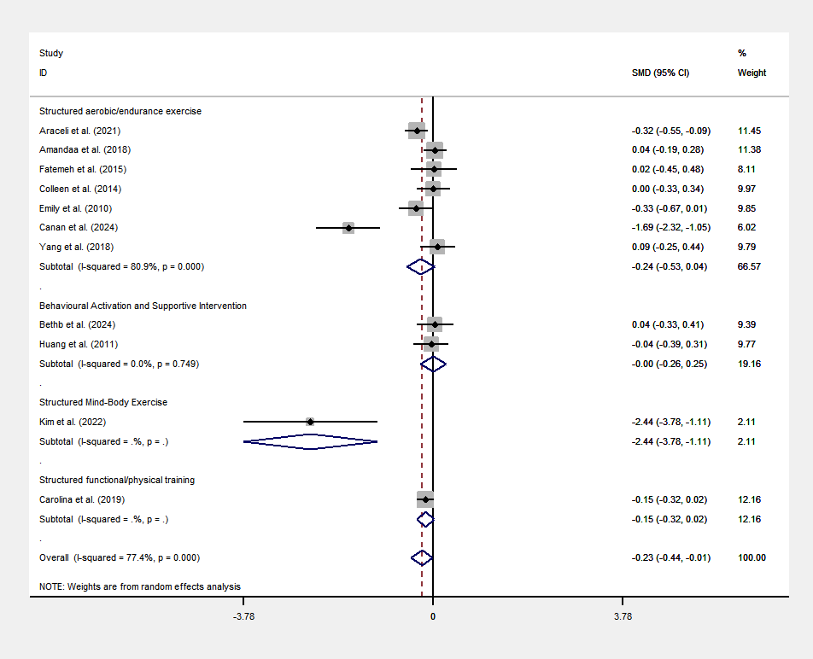
eAppendix 14. Preventing postnatal depression

Fig. S9 Subgroup analysis by intervention type. Fig. S10 Subgroup analysis by comparison type.

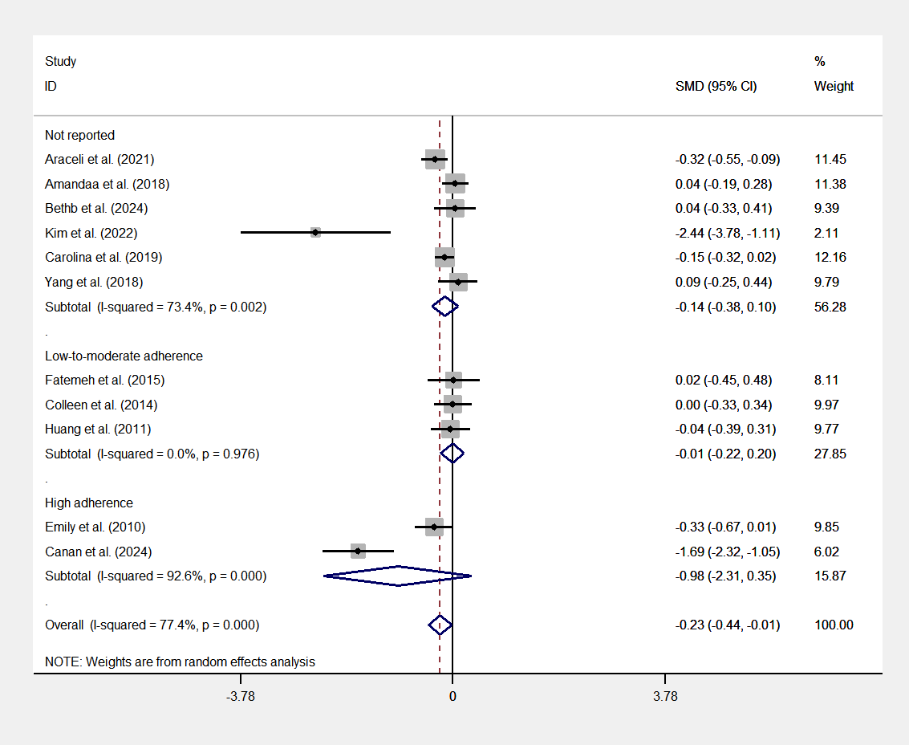

Fig. S11 Subgroup analysis by exercise adherence.
Table S4 Subgroup analysis results.
Type | Category | Studies | Effect size (95% CI) | I² | P-value (within group)
Intervention Type | Structured functional/physical training | n=1 | SMD = -0.151 (95% CI: -0.324 to 0.022) | - | P = 0.087
Intervention Type | Behavioral Activation and Supportive Intervention | n=2 | SMD = -0.002 (95% CI: -0.255 to 0.252) | 0% | P = 0.990
Intervention Type | Structured aerobic/endurance exercise | n=7 | SMD = -0.245 (95% CI: -0.533 to 0.044) | 80.9% | P = 0.096
Intervention Type | Structured Mind-Body Exercise | n=1 | SMD = -2.444 (95% CI: -3.779 to -1.110) | - | P = 0.000
Comparison Type | Routine care/no treatment control | n=9 | SMD = -0.256 (95% CI: -0.512 to 0.000) | 81.1% | P = 0.050
Comparison Type | Attention/Education Comparison | n=2 | SMD = -0.162 (95% CI: -0.491 to 0.167) | 47.6% | P = 0.335
Exercise Adherence | Not reported | n=6 | SMD = -0.140 (95% CI: -0.377 to 0.096, ) | 73.4% | P = 0.246
Exercise Adherence | High adherence | n=2 | SMD = -0.010 (95% CI: -0.223 to 0.203, ) | 0% | P = 0.926
Exercise Adherence | Low-to-moderate adherence | n=3 | SMD = -0.982 (95% CI: -2.309 to 0.346, ) | 92.6% | P = 0.147

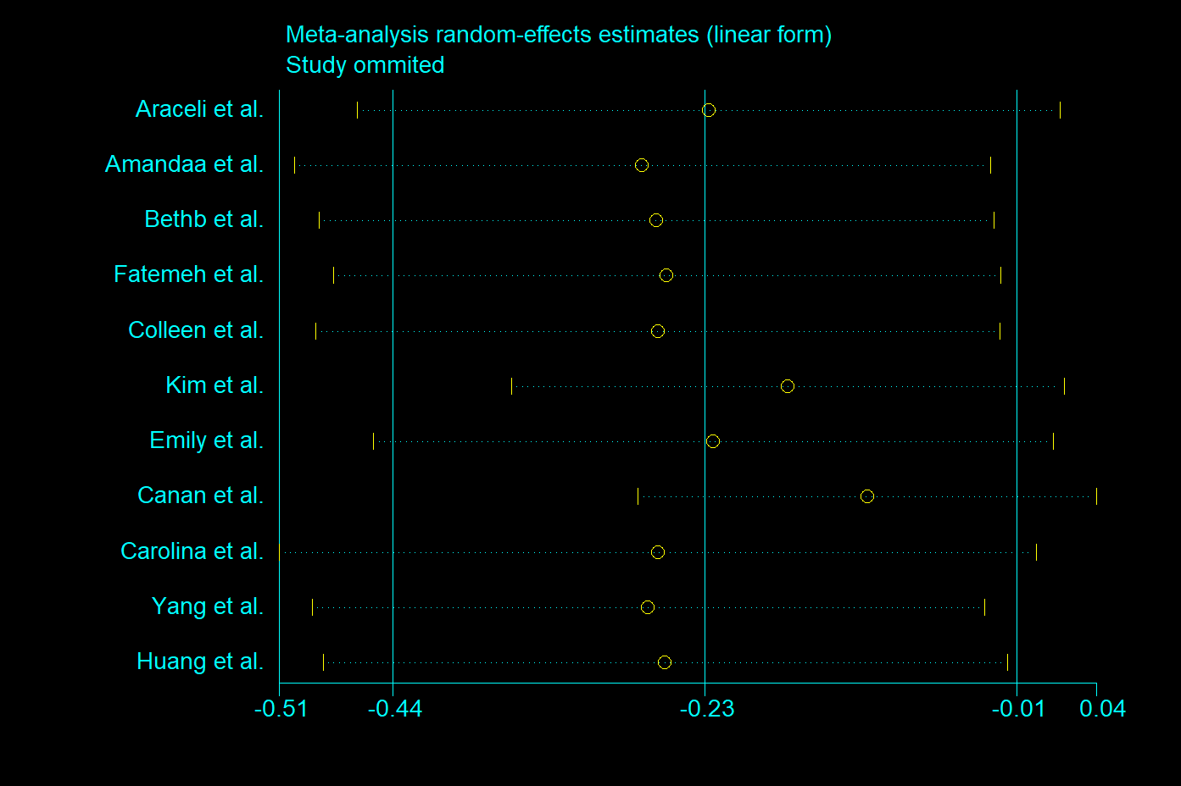

Fig. S12. Leave-one-out sensitivity analysis for preventing postnatal depression. Dots and horizontal lines represent the recalculated pooled Standardized Mean Differences (SMDs) and 95% confidence intervals (CIs) when the specific study on the left is omitted. The solid vertical line indicates the line of no effect (SMD = 0). The central dashed line and its flanking dotted lines represent the original pooled SMD and its 95% CI, respectively. The consistent alignment of recalculated estimates confirms the high robustness of the primary findings.

eAppendix 15. Treatment of postnatal depression
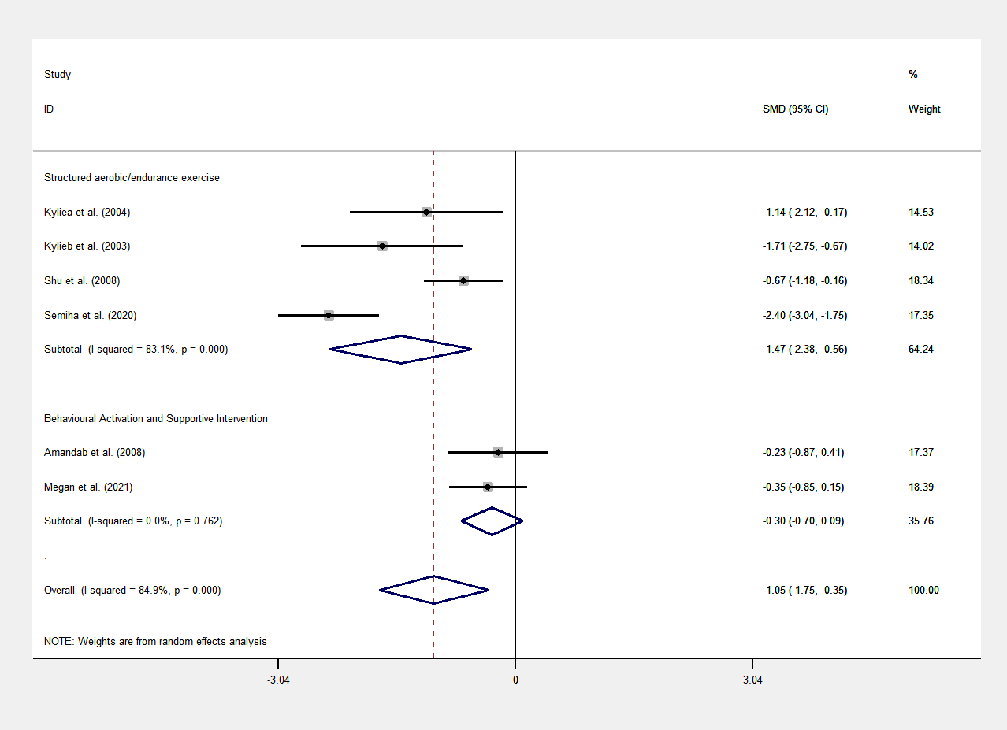
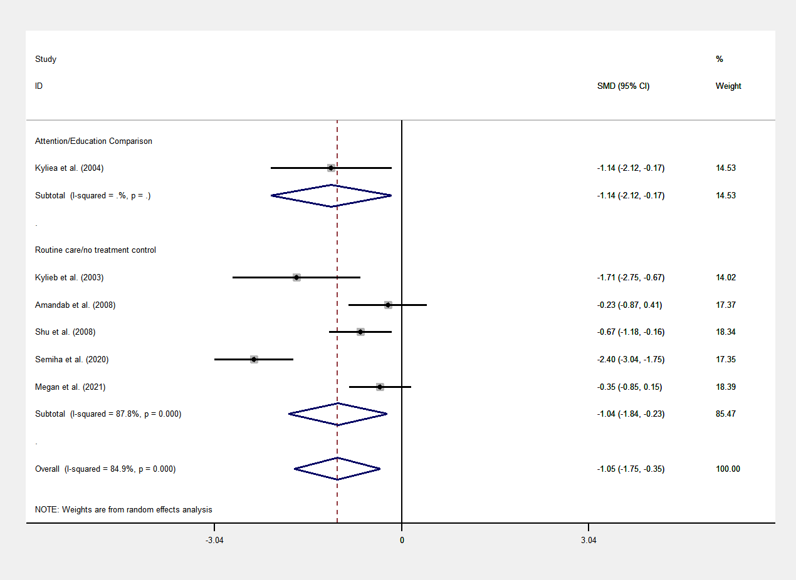

Fig. S13 Subgroup analysis by intervention type. Fig. S14 Subgroup analysis by comparison type.

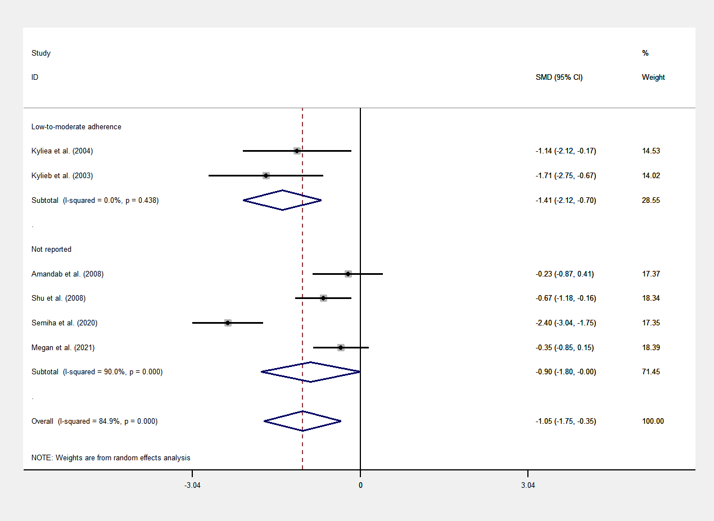

Fig. S15 Subgroup analysis by exercise adherence.
Table S5 Subgroup analysis results.
Type | Category | Studies | Effect size (95% CI) | I² | P-value (within group)
Intervention Type | Structured aerobic/endurance exercise | n=4 | SMD = -1.470 (95% CI: -2.381 to -0.560) | 83.1% | P = 0.002
Intervention Type | Behavioral Activation and Supportive Intervention | n=2 | SMD = -0.304 (95% CI: -0.699 to 0.091) | 0% | P = 0.131
Comparison Type | Routine care/no treatment control | n=5 | SMD = -1.035 (95% CI: -1.837 to -0.234) | 87.8% | P = 0.011
Comparison Type | Attention/Education Comparison | n=1 | SMD = -1.145 (95% CI: -2.124 to -0.165) | - | P = 0.022
Exercise Adherence | Not reported | n=4 | SMD = -0.900 (95% CI: -1.799 to -0.002) | 90% | P = 0.050
Exercise Adherence | Low-to-moderate adherence | n=2 | SMD = -1.410 (95% CI: -2.123 to -0.697) | 0% | P = 0.000

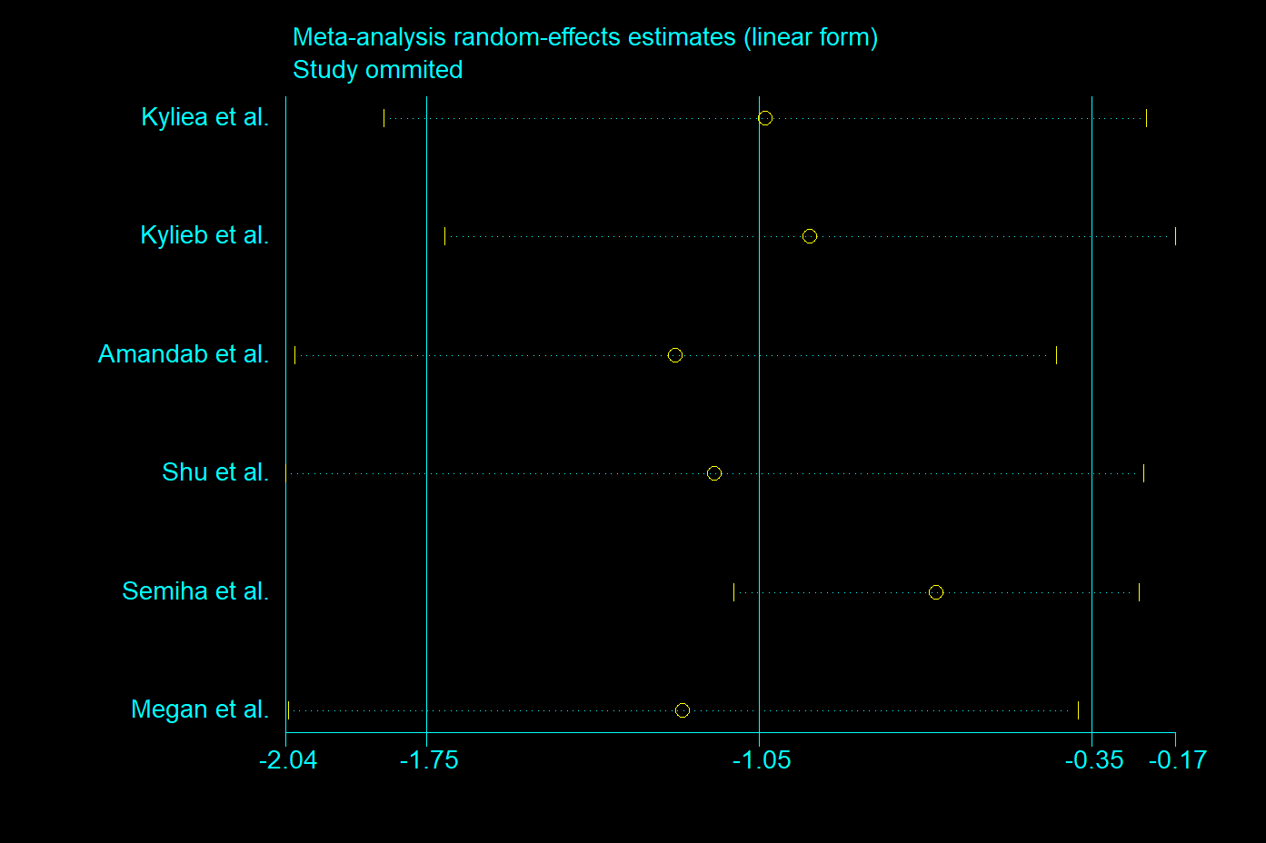

Fig. S16. Leave-one-out sensitivity analysis for treating postnatal depression. Dots and horizontal lines represent the recalculated pooled Standardized Mean Differences (SMDs) and 95% confidence intervals (CIs) when the specific study on the left is omitted. The solid vertical line indicates the line of no effect (SMD = 0). The central dashed line and its flanking dotted lines represent the original pooled SMD and its 95% CI, respectively. The consistent alignment of recalculated estimates confirms the high robustness of the primary findings.

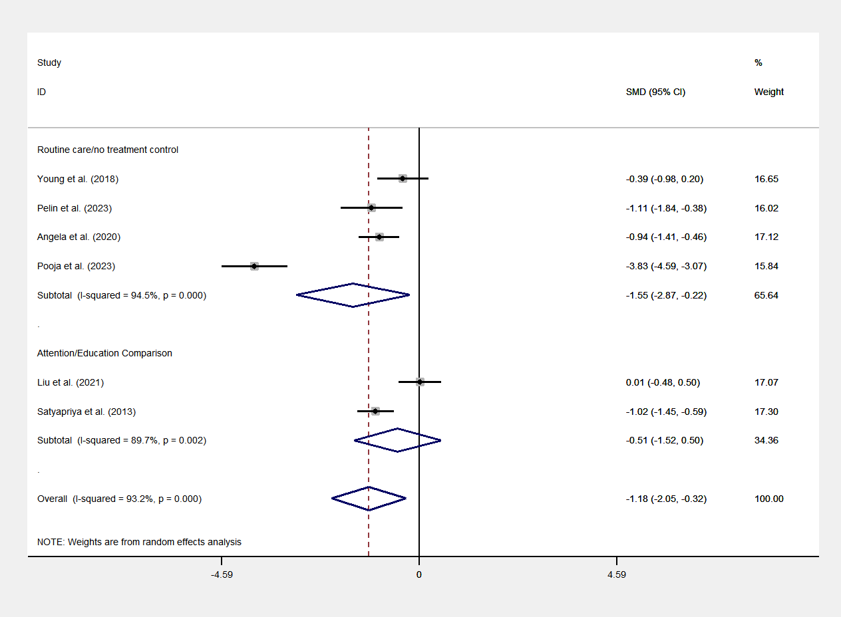
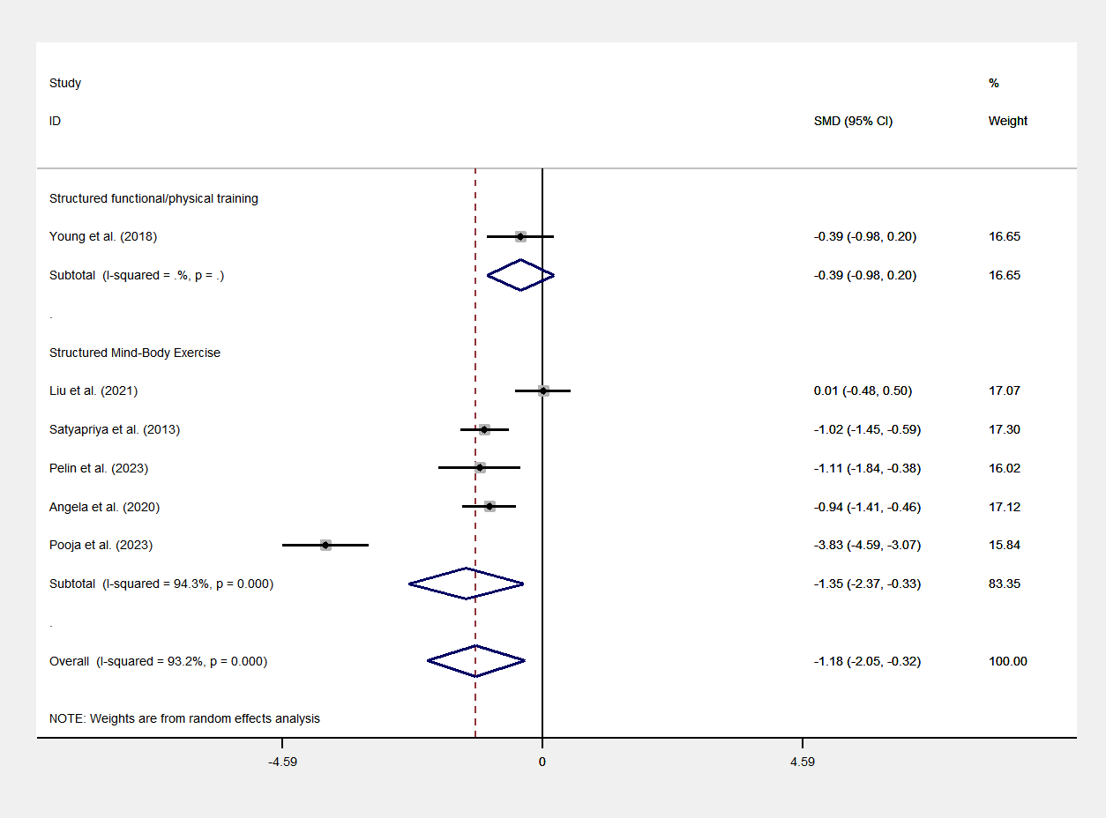
eAppendix 16. Preventing antenatal anxiety

Fig. S17 Subgroup analysis by intervention type. Fig. S18 Subgroup analysis by comparison type.

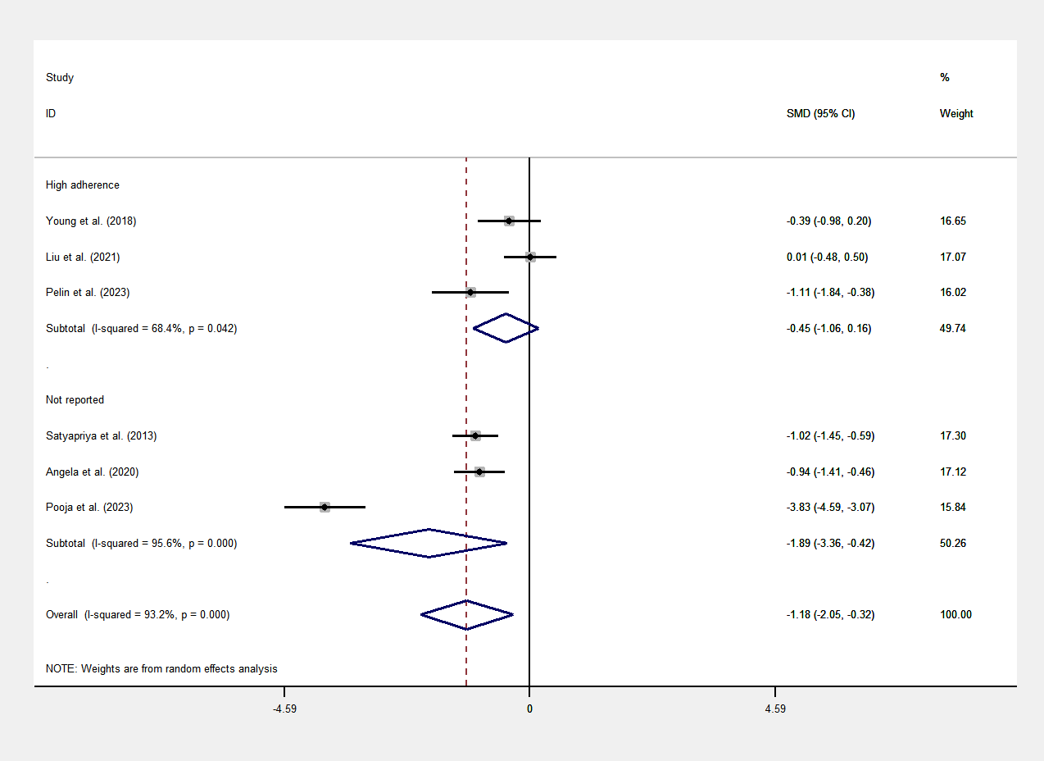

Fig. S19 Subgroup analysis by exercise adherence.
Table S6 Subgroup analysis results.
Type | Category | Studies | Effect size (95% CI) | I² | P-value (within group)
Intervention Type | Structured functional/physical training | n=1 | SMD = -0.386 (95% CI: -0.976 to 0.205) | - | P = 0.200
Intervention Type | Structured Mind-Body Exercise | n=5 | SMD = -1.347 (95% CI: -2.366 to -0.329) | 94.3% | P = 0.010
Comparison Type | Routine care/no treatment control | n=4 | SMD = -1.547 (95% CI: -2.870 to -0.224) | 94.5% | P = 0.022
Comparison Type | Attention/Education Comparison | n=2 | SMD = -0.511 (95% CI: -1.524 to 0.501) | 89.7% | P = 0.322
Exercise Adherence | Not reported | n=3 | SMD = -1.893 (95% CI: -3.364 to -0.422) | 95.6% | P = 0.012
Exercise Adherence | High adherence | n=3 | SMD = -0.447 (95% CI: -1.060 to 0.165) | 68.4% | P = 0.152

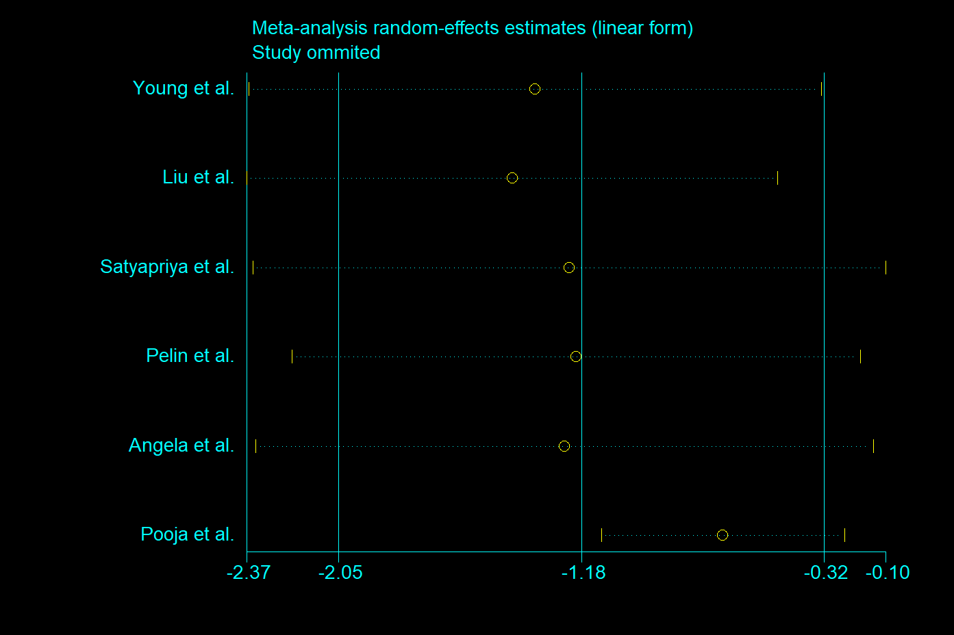

Fig. S20. Leave-one-out sensitivity analysis for preventing antenatal anxiety. Dots and horizontal lines represent the recalculated pooled Standardized Mean Differences (SMDs) and 95% confidence intervals (CIs) when the specific study on the left is omitted. The solid vertical line indicates the line of no effect (SMD = 0). The central dashed line and its flanking dotted lines represent the original pooled SMD and its 95% CI, respectively. The consistent alignment of recalculated estimates confirms the high robustness of the primary findings.

eAppendix 17. Treatment for antenatal anxiety
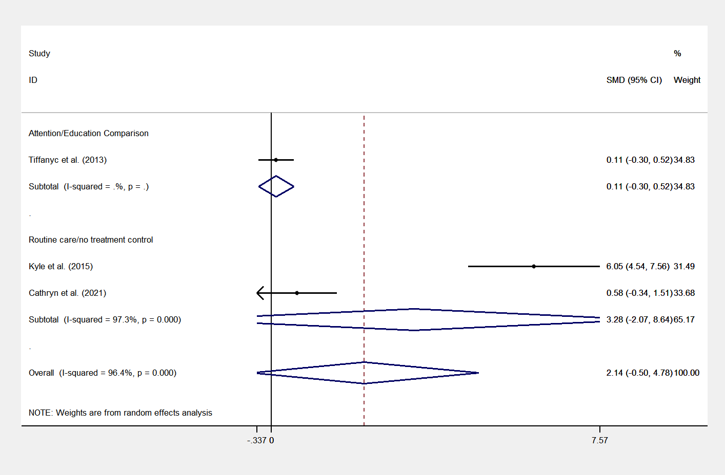

Fig. S21 Subgroup analysis by comparison type.

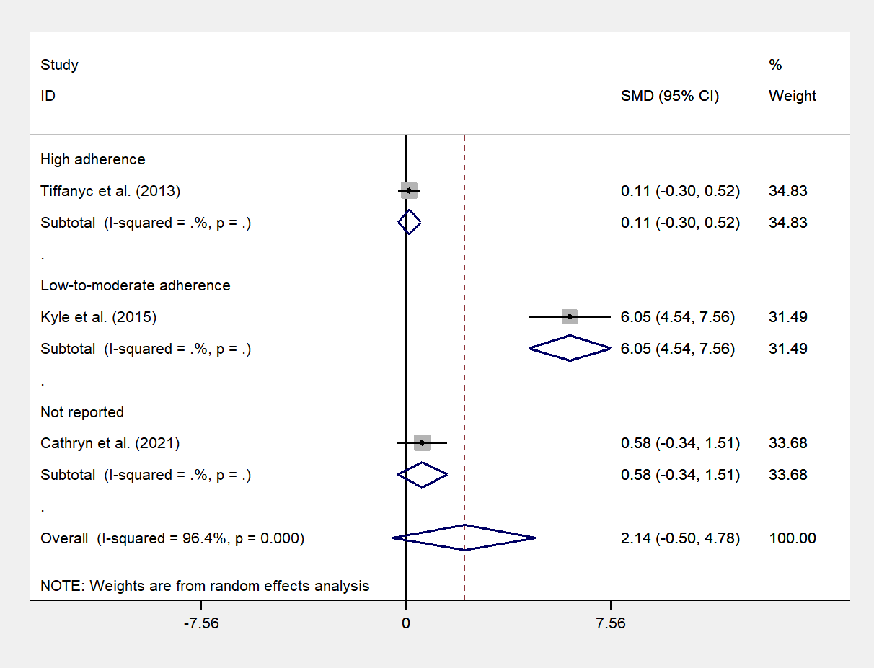

Fig. S22 Subgroup analysis by exercise adherence.
Table S7 Subgroup analysis results.
Type | Category | Studies | Effect size (95% CI) | I² | P-value (within group)
Comparison Type | Routine care/no treatment control | n=2 | SMD = 3.283 (95% CI:-2.073 to 8.638) | 97.3% | P = 0.230
Comparison Type | Attention/Education Comparison | n=1 | SMD = 0.109 (95% CI:-0.300 to 0.518) | - | P = 0.601
Exercise Adherence | Not reported | n=1 | SMD = 0.585 (95% CI: -0.337 to 1.506) | - | P = 0.214
Exercise Adherence | High adherence | n=1 | SMD = 0.109 (95% CI: -0.300 to 0.518) | - | P = 0.601
Exercise Adherence | Low-to-moderate adherence | n=1 | SMD = 6.050 (95% CI: 4.535 to 7.565) | - | P = 0.000

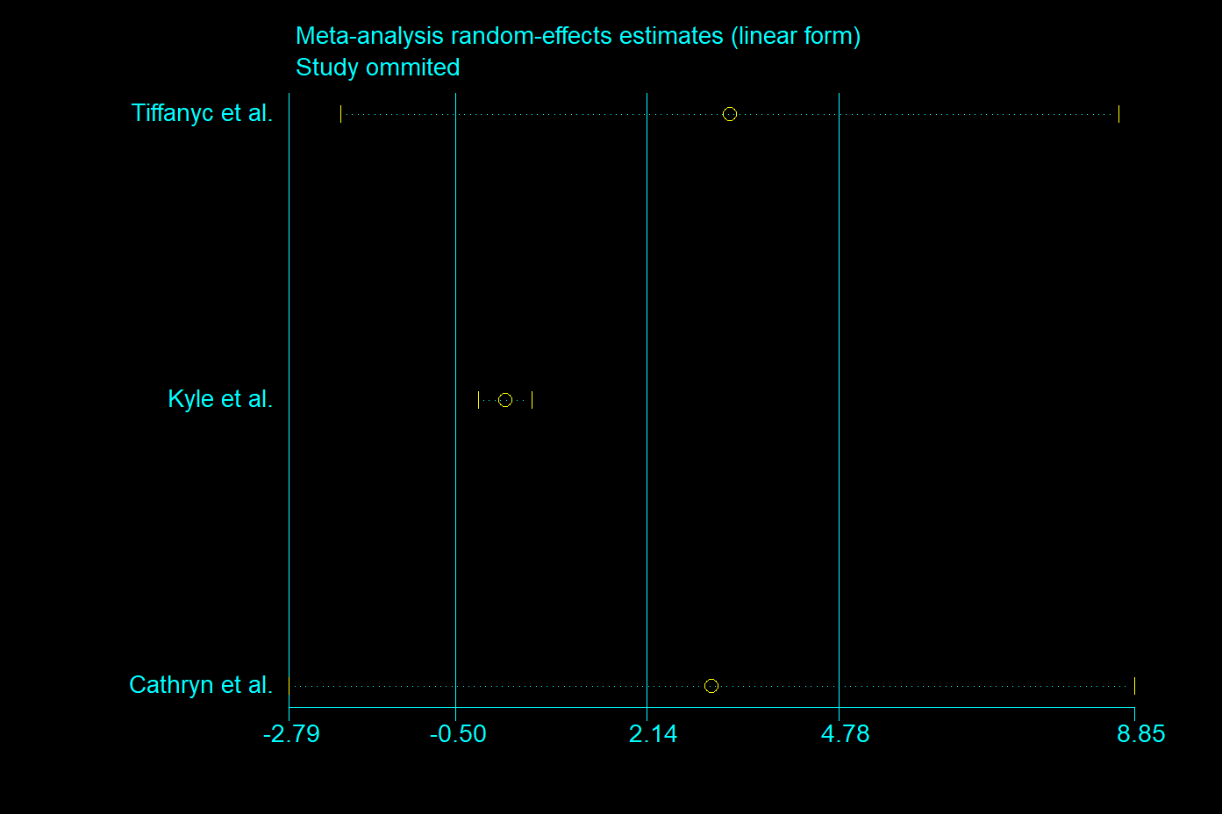

Fig. S23. Leave-one-out sensitivity analysis for treating antenatal anxiety. Dots and horizontal lines represent the recalculated pooled Standardized Mean Differences (SMDs) and 95% confidence intervals (CIs) when the specific study on the left is omitted. The solid vertical line indicates the line of no effect (SMD = 0). The central dashed line and its flanking dotted lines represent the original pooled SMD and its 95% CI, respectively. The consistent alignment of recalculated estimates confirms the high robustness of the primary findings.

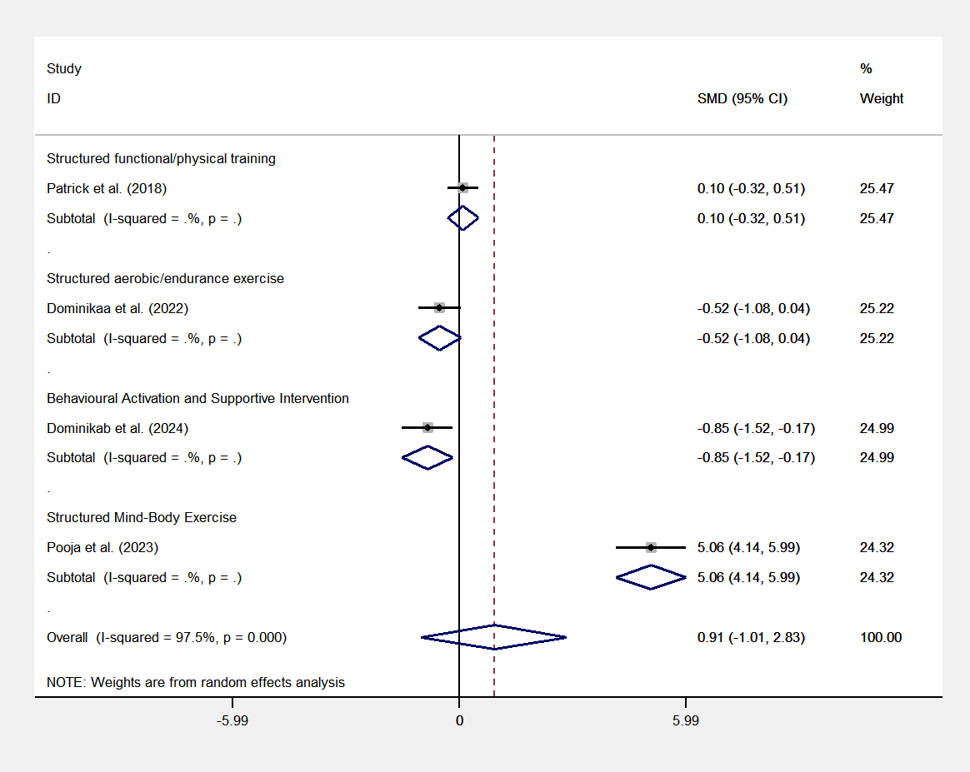
eAppendix 18. The therapeutic effect on quality of life

Fig. S24 Subgroup analysis by intervention type.
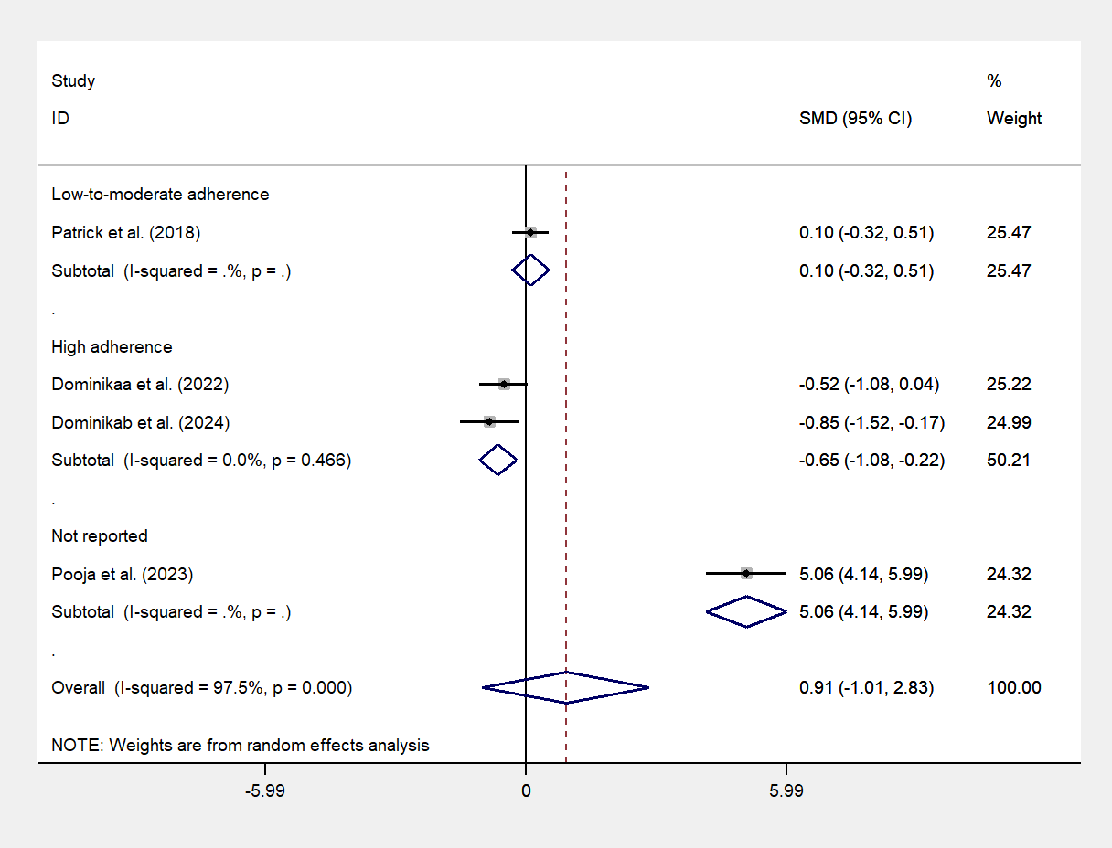

Fig. S25 Subgroup analysis by exercise adherence.
Table S8 Subgroup analysis results.
Type | Category | Studies | Effect size (95% CI) | I² | P-value (within group)
Intervention Type | Structured functional/physical training | n=1 | SMD = 0.099 (95% CI: -0.317 to 0.514) | - | P = 0.642
Intervention Type | Behavioral Activation and Supportive Intervention | n=1 | SMD = -0.846 (95% CI: -1.519 to -0.173) | - | P = 0.014
Intervention Type | Structured aerobic/endurance exercise | n=1 | SMD = -0.520 (95% CI: -1.081 to 0.041) | - | P = 0.069
Intervention Type | Structured Mind-Body Exercise | n=1 | SMD = 5.062 (95% CI: 4.136 to 5.989) | - | P = 0.000
Exercise Adherence | Not reported | n=1 | SMD = 5.062 (95% CI: 4.136 to 5.989) | - | P = 0.000
Exercise Adherence | High adherence | n=2 | SMD = -0.654 (95% CI: -1.085 to -0.223) | 0% | P = 0.003
Exercise Adherence | Low-to-moderate adherence | n=1 | SMD = 0.099 (95% CI: -0.317 to 0.514) | - | P = 0.642

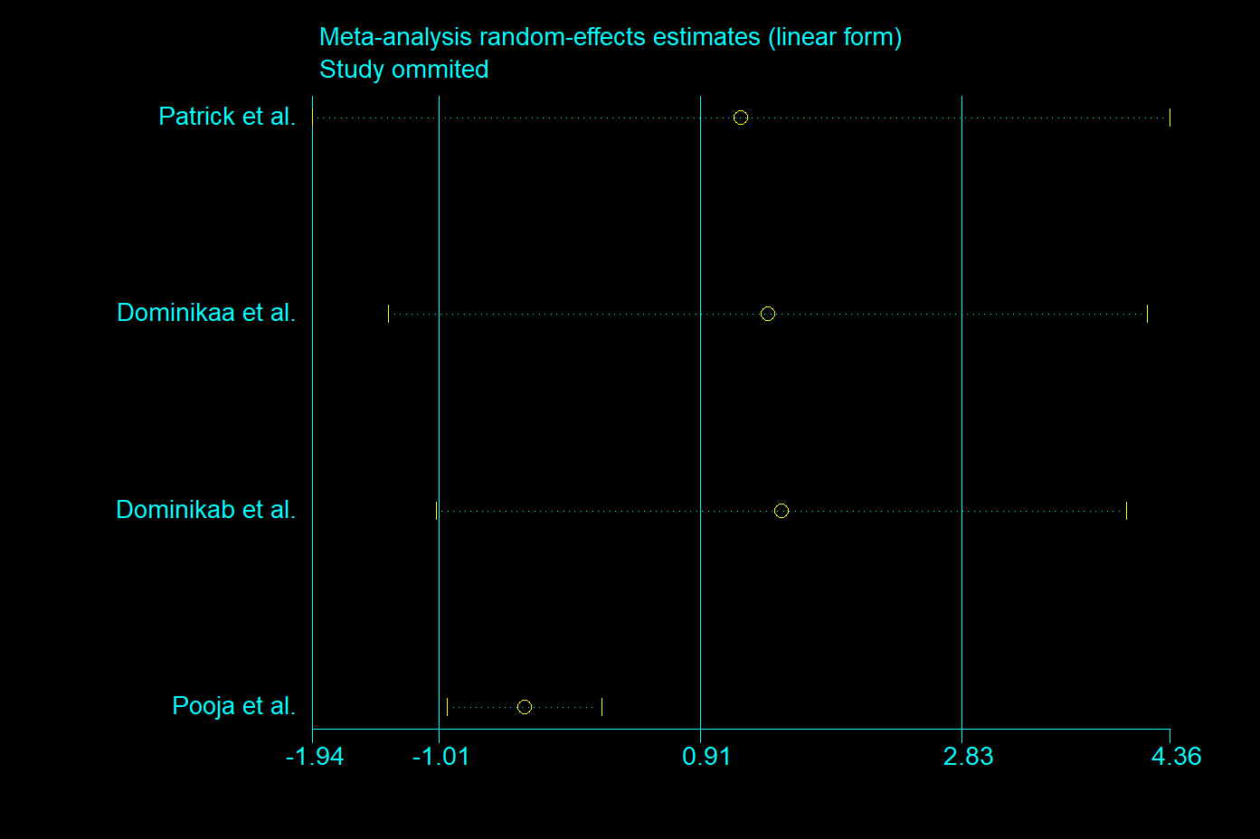

Fig. S26. Leave-one-out sensitivity analysis for the therapeutic effect on quality of life. Dots and horizontal lines represent the recalculated pooled Standardized Mean Differences (SMDs) and 95% confidence intervals (CIs) when the specific study on the left is omitted. The solid vertical line indicates the line of no effect (SMD = 0). The central dashed line and its flanking dotted lines represent the original pooled SMD and its 95% CI, respectively. The consistent alignment of recalculated estimates confirms the high robustness of the primary findings.

Part 6: Publication bias assessment

eAppendix 19. Funnel plot
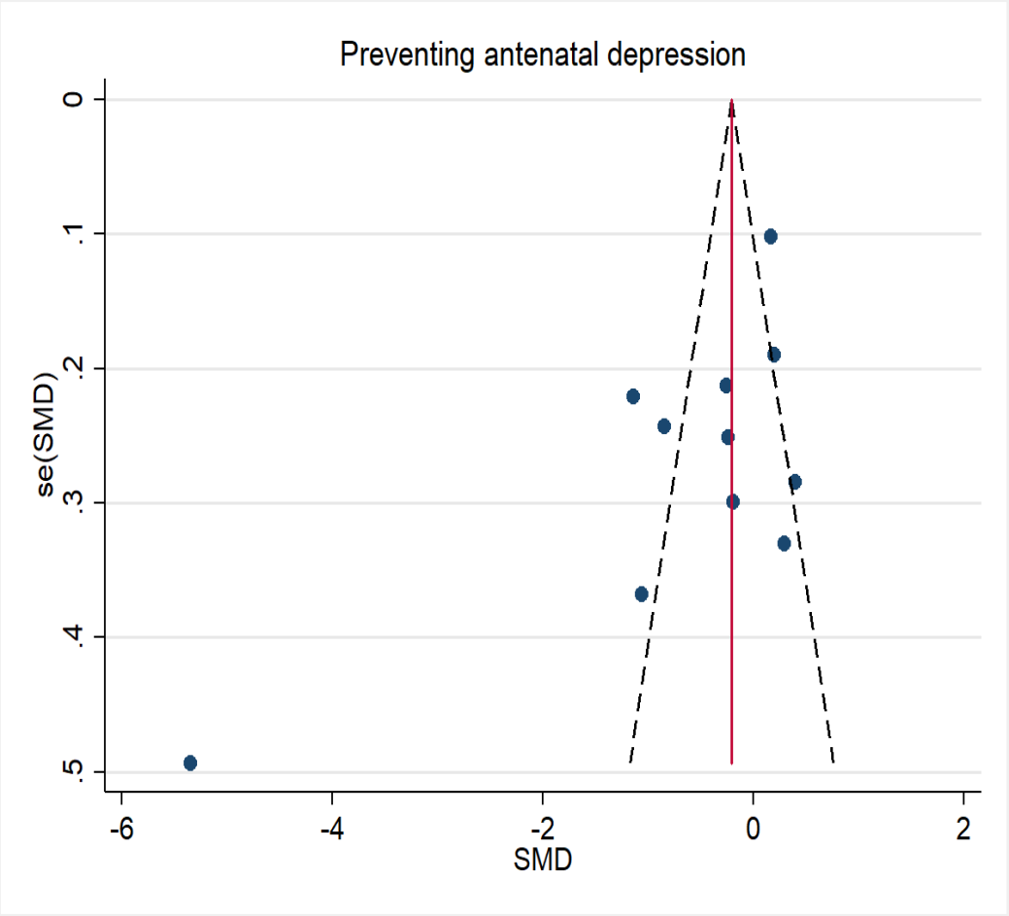
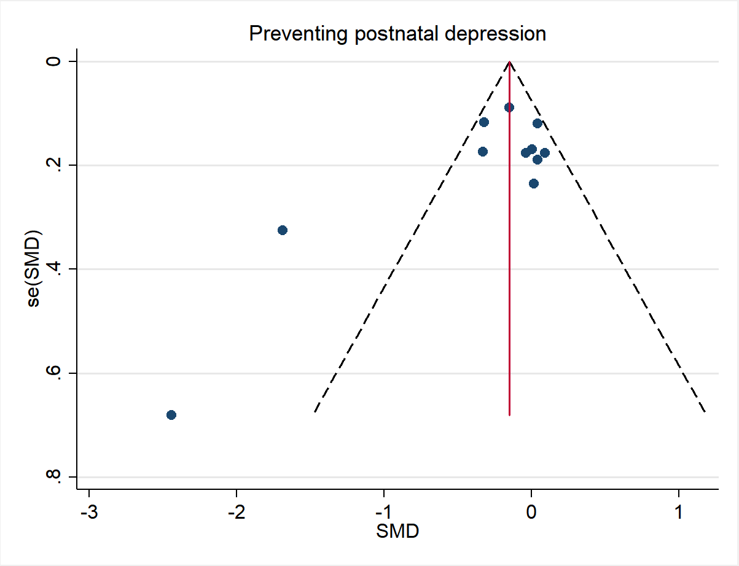

Figure S27. Funnel plot for Preventing antenatal depression. Figure S28. Funnel plot for Preventing postnatal depression.

