Supplementary Materials

Supplementary Table 1A. Search strategy for Embase.

1 | exp Buprenorphine/ or Opiate Substitution Treatment
2 | Methadone/
3 | ((methadone or methadose or “opioid agonist therap*’” or “opioid agonist treatment*” or “opiate agonist therap’” or “opiate agonist treatment* or “medication assisted treatment’” or “medication assisted therap*” or OAT or “medication assisted recovery” or “opioid replacement therap*” or buprenorphine or suboxone or “opiate treat*” or “opioid treat*” or “Injectable hydromorph*” or medication*) adj2 “opioid use disorder”).tw,kw.
4 | Searches 1 or 2 or 3
5 | (pregnan* or prenatal or perinatal or “birth weight” or birthweight or stillbirth or miscarriage or preterm birth or pre-term birth or premature* or “gestational age”).mp. [mp=title, abstract, heading word, drug trade name, original title, device manufacturer, drug manufacturer, device trade name, keyword heading word, floating subheading word, candidate term word]
6 | Searches 4 and 5
7 | Limit search 6 to English language
8 | Limit search 7 to “humans only (removes records about animals)”
9 | Limit search 8 to “remove preprint records”
10 | Limit search 9 to conference abstracts
11 | Limit search 10 to yr=“2019-Current”

Supplementary Table 1B. Search Strategy for CINAHL
 | Query | Limiters/Expanders
S1 | buprenorphine | Search modes  -Boolean/Phrase
S2 | methadone | Search modes  -Boolean/Phrase
S3 | methadone or methadose or "opioid agonist therap*"or "opioid agonist treatment*" or "opiate agonist therap*" or "opiate agonist treatment*" or "medication assisted treatment*" or "medication assisted therap*" or OAT or "medication assisted recovery" or "opioid replacement therap*" or buprenorphine or suboxone or "opiate treat*" or "opioid treat*" or "injectable hydromorph* | Search modes  -Boolean/Phrase
S4 | (methadone or methadose or opioid agonist treatment* or OAT or opiate agonist treatment* or opioid agonist therap*) and (or S3) | Search modes  -Boolean/Phrase
S5 | pregnan* or prenatal or perinatal or "birth weight" or birthweight or stillbirth or miscarriage or preterm birth or pre-term birth or prematur* or "gestational age" | Search modes  -Boolean/Phrase
S6 | (pregnan* or prenatal or perinatal or "birth weight" or birthweight or stillbirth or miscarriage or preterm birth or pre-term birth or prematur* or "gestational age") AND (S4 AND S5) | Search modes  -Boolean/Phrase
S7 | (pregnan* or prenatal or perinatal or "birth weight" or birthweight or stillbirth or miscarriage or preterm birth or pre-term birth or prematur* or "gestational age") and (S4 and S5) | Limiters  - English Language; Peer Reviewed; Human  Search modes  -Boolean/Phrase

Supplementary Table 1C. Medline Search Strategy
1 | exp Buprenorphine/ or Opiate Substitution Treatment/
2 | Methadone/
3 | ((methadone or methadose or "opioid agonist therap*" or "opioid agonist treatment* or "opiate agonist therap*" or  "opiate agonist treatment" or "medication assisted treatment*" or "medication assisted therap* or OAT or "medication assisted recovery" or "opioid replacement therap*" or buprenorphine or suboxone or "opiate treat*" or "opioid treat*" or  "injectable hydromorph*or medication**) adj2 "opioid use disorder").tw,kw.
4 | 1 or 2 or 3
5 | (pregnan* or prenatal or perinatal or "birth weight" or birthweight or stillbirth or miscarriage or preterm birth or pre-term birth or prematur" or "gestational age").mp. (mp=title, abstract, original title, name of substance word, subject heading word, floating sub-heading word, keyword heading word, organism supplementary concept word, protocol supplementary concept word, rare disease supplementary concept word, unique identifier, synonyms]
6 | 4 and 5
7 | limit 6 to English language
8 | limit 7 to "humans only (removes records about animals)"

Supplementary Table 1D. PsycINFO Search
 | Search Terms | Search Options
S1 | methadone or methadose or "opioid agonist therap*" or "opioid agonist treatment** or "opiate agonist therap*" or "opiate agonist treatment*" or "medication assisted treatment'" or "medication assisted therap*" or  OAT or "medication assisted recovery" or "opioid replacement therap'" or buprenorphine or suboxone or  "opiate treat'" or "opioid treat*" or "injectable hydromorph* | Search modes - Boolean/Phrase
S2 | pregnan* or prenatal or perinatal or "birth weight" or birthweight or stillbirth or miscarriage or preterm birth or pre-term birth or prematur* or "gestational age" | Search modes - Boolean/Phrase
S3 | S1 AND S2 | Search modes - Boolean/Phrase
S4 | S1 AND S2 | Limiters - Scholarly (Peer Reviewed) Journals; English  Search modes - Boolean/Phrase
S5 | S1 AND S2 | Limiters - Scholarly (Peer Reviewed) Journals; English  Search modes - Boolean/Phrase

Supplementary Table 2. Review Population, Intervention, Comparator, and Outcomes

Population | Pregnant people with opioid use disorder
Intervention | Buprenorphine (with or without naloxone)
Comparator | Methadone
Outcomes | Preterm birth, low birthweight, small for gestational age, stillbirth, neonatal abstinence syndrome

Supplementary Table 3. Risk of bias for observational studies (Newcastle Ottawa Scale)

Study ID | Selection | Comparability | Outcome | Total Stars
Binder 2008 | **** | - | *** | 7
Brogly 2018 (neonatal) | **** | * | *** | 8
Brogly 2018 (prenatal) | **** | - | *** | 7
Coulson 2021 | **** | - | *** | 7
Cutler 2023 | **** | * | *** | 8
Kanervo 2022 | **** | - | *** | 7
Kelty 2017 | **** | * | *** | 8
Knittel 2023 | **** | - | *** | 7
Kumar 2021 | **** | - | *** | 7
Lacroix 2011 | ** | - | *** | 7
Lejeune 2006 | **** | - | *** | 7
Lemon 2018 | **** | ** | *** | 9
Meyer 2015 | **** | * | *** | 8
Nechanska 2018 | **** | ** | *** | 9
Norgaard 2015 | **** | * | *** | 8
Petrich 2022 | **** | ** | *** | 9
Staszewski 2020 | **** | - | *** | 7
Suarez 2022 | **** | ** | *** | 9
Wang 2023 | **** | ** | *** | 9
Welle-Strand 2013 | **** | * | *** | 8
Wiegand 2015 | **** | ** | *** | 9
Wurst 2016 | **** | * | *** | 8

Supplementary Figure 1. Risk of Bias Summary
Study | Bias arising from the randomization process | Bias due to deviations from intended interventions: PTB | Bias due to deviations from intended interventions: SGA | Bias due to deviations from intended interventions: NOWS treatment | Bias due to missing outcome data: PTB | Bias due to missing outcome data: SGA | Bias due to missing outcome data: NOWS treatment | Bias in measurement of the outcome: PTB | Bias in measurement of the outcome: SGA | Bias in measurement of the outcome: NOWS treatment | Bias in selection of the reported result: PTB | Bias in selection of the reported result: SGA | Bias in selection of the reported result: NOWS treatment | Overall bias: PTB | Overall bias: SGA | Overall bias: NOWS treatment
Fischer 2006 | ? | + | + | + | + | + | + | + | + | + | + | + | + | + | + | +
Holbrook 2012 | ? | + | + | + | + | + | + | + | + | + | + | + | + | + | + | +
Jones 2005 | ? | + | + | + | + | + | + | + | + | + | + | + | + | + | + | +
Jones 2010 | ? | + | + | + | + | + | + | + | + | + | + | + | + | + | + | +
Metz 2011 | ? | + | + | + | + | + | + | + | + | + | + | + | + | + | + | +

? | Unclear risk of bias
+ | Low risk of bias

Supplementary Figure 2.
2A. Funnel plot for preterm birth
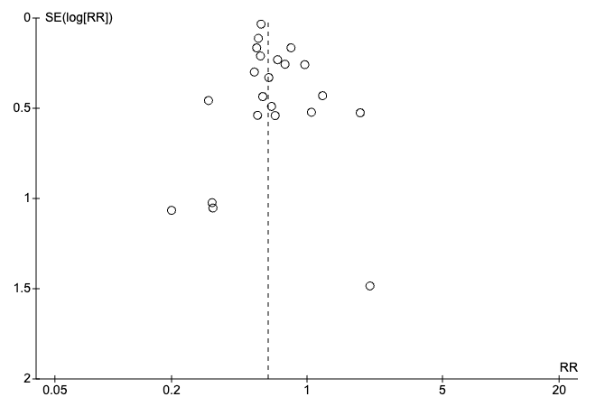
2B. Funnel plot for NAS treatment
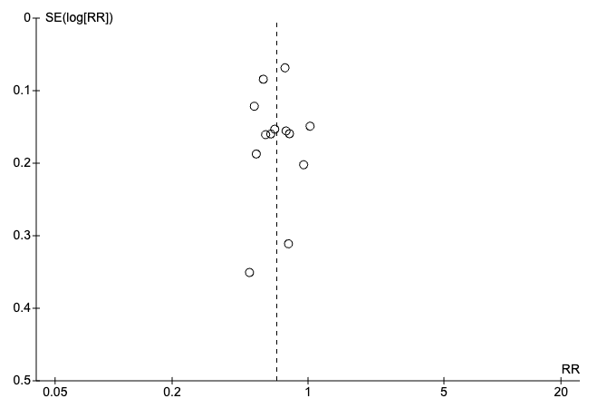
2C. Funnel plot for small for gestational age

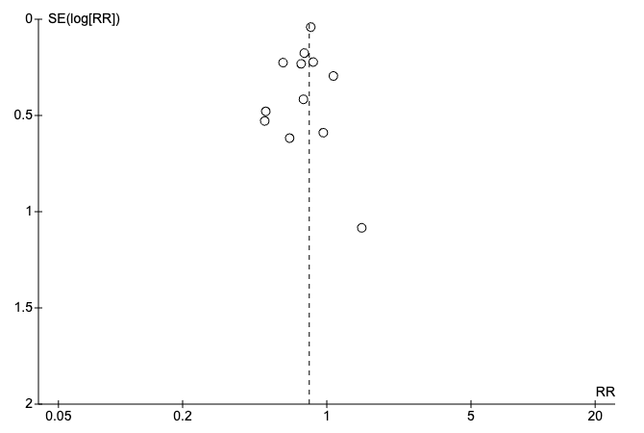
Supplementary Figure 3A. Adjusted Odds Ratios for Preterm Birth
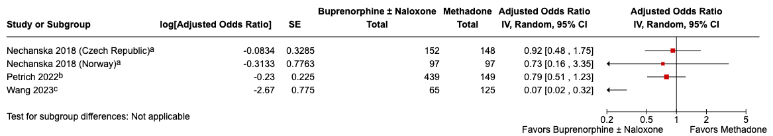
Adjusted for age, marital status, education, smoking. Calculated among singleton live births.
^{b}Adjusted for gestational age at initiation of care, gestational age at delivery, SSRI, fetal sex, breastfeeding, marijuana use and >1 illicit drug
^{c}Numerator model adjusted for baseline covariates (i.e., maternal age, race, year of birth, multiple gestation, pre-existing comorbid conditions, and healthcare resource utilization at baseline); denominator model adjusting for additional time-varying comedication use, substance use, infant sex, previous exposure history, and markers of opioid use disorder severity.

Abbreviations: CI, confidence interval; IV, inverse variance; SE, standard error

Supplementary Figure 3B. Adjusted Odds Ratios for Low Birthweight
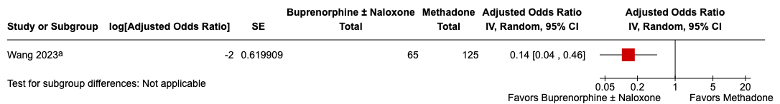
ªNumerator model adjusted for baseline covariates (i.e., maternal age, race, year of birth, multiple gestation, pre-existing comorbid conditions, and healthcare resource utilization at baseline); denominator model adjusting for additional time-varying comedication use, substance use, infant sex, previous exposure history, and markers of opioid use disorder severity.

Abbreviations: CI, confidence interval; IV, inverse variance; SE, standard error

Supplementary Figure 3C. Adjusted Odds Ratios for Small for Gestational Age
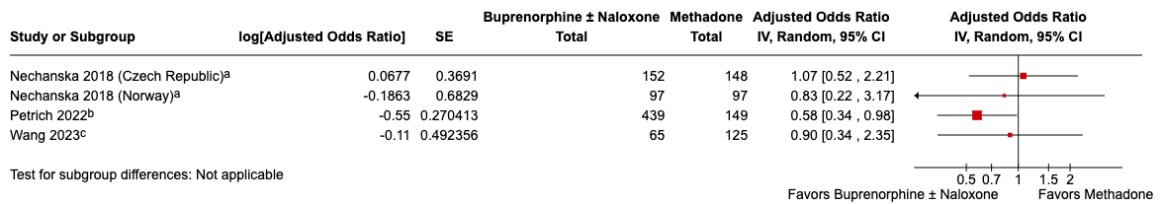
ªAdjusted for age, marital status, education, smoking. Calculated among singleton live births.
^{b}Adjusted for gestational age at initiation of care, gestational age at delivery, SSRI, fetal sex, breastfeeding, Marijuana use and >1 illicit drug
^{c}Numerator model adjusted for baseline covariates (i.e., maternal age, race, year of birth, multiple gestation, pre-existing comorbid conditions, and healthcare resource utilization at baseline); denominator model adjusting for additional time-varying comedication use, substance use, infant sex, previous exposure history, and markers of opioid use disorder severity.

Abbreviations: CI, confidence interval; IV, inverse variance; SE, standard error

Supplementary Figure 3D. Adjusted Odds Ratios for Neonatal Abstinence Syndrome (Diagnosed)
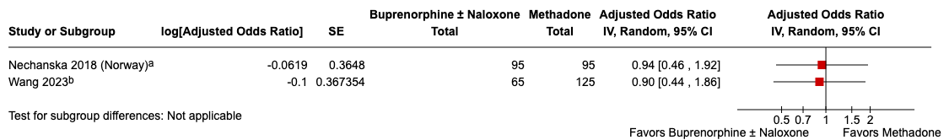
ªAdjusted for age, marital status, education, smoking. Calculated among singleton live births.
^{b}Numerator model adjusted for baseline covariates (i.e., maternal age, race, year of birth, multiple gestation, pre-existing comorbid conditions, and healthcare resource utilization at baseline); denominator model adjusting for additional time-varying comedication use, substance use, infant sex, previous exposure history, and markers of opioid use disorder severity.

Abbreviations: CI, confidence interval; IV, inverse variance; SE, standard error

Supplementary Figure 3E. Adjusted Odds Ratios for Neonatal Abstinence Syndrome (Treated)

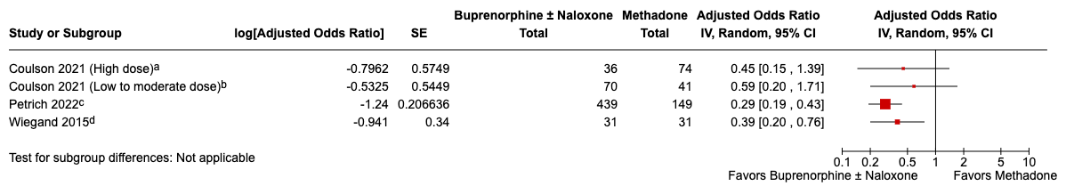
ªHigh dose buprenorphine = ≥17 mg/day; High dose methadone = ≥90 mg/day; adjusted for psychopharmacotherapy
^{b}Low to moderate dose buprenorphine = ≥16 mg/day; low to moderate dose methadone = ≥89 mg/day; adjusted for psychopharmacotherapy
^{c}Adjusted for gestational age at initiation of care, gestational age at delivery, SSRI, fetal sex, breastfeeding, Marijuana use and >1 illicit drug
^{d}Adjusted for gestational age at delivery and maternal indication for opioids

Abbreviations: CI, confidence interval; IV, inverse variance; SE, standard error

Supplementary Figure 4A. Adjusted Risk Ratios for Preterm Birth
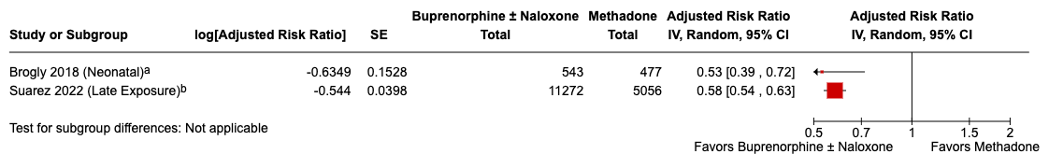
ªAdjusted for maternal age, maternal race/ethnicity, and year of delivery. External confounder data with bias analysis also applied.
^{b}Adjusted for markers of history of opioid use disorder and severity, nonopioid substance use or dependence, medical conditions associated with opioid use disorder, mental health conditions, chronic coexisting conditions, other medication use, health care utilization metrics, proxies for social issues, demographic characteristics, and proxies for socioeconomic status. The high-dimensional propensity-score analysis empirically selected 200 variables from all available diagnosis codes, procedure codes, and medication dispensations on the basis of the strength of their relationship to the exposure status for inclusion in the propensity score along with all prespecified covariates.

Abbreviations: CI, confidence interval; IV, inverse variance; SE, standard error

Supplementary Figure 4B. Adjusted Risk Ratios for Low Birthweight

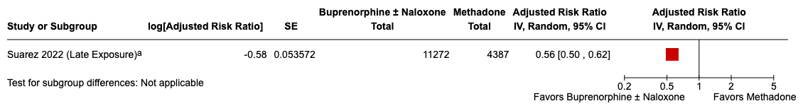
ªAdjusted for markers of history of opioid use disorder and severity, nonopioid substance use or dependence, medical conditions associated with opioid use disorder, mental health conditions, chronic coexisting conditions, other medication use, health care utilization metrics, proxies for social issues, demographic characteristics, and proxies for socioeconomic status. The high-dimensional propensity-score analysis empirically selected 200 variables from all available diagnosis codes, procedure codes, and medication dispensations on the basis of the strength of their relationship to the exposure status for inclusion in the propensity score along with all prespecified covariates.

Abbreviations: CI, confidence interval; IV, inverse variance; SE, standard error

Supplementary Figure 4C. Adjusted Risk Ratios for Small for Gestational Age

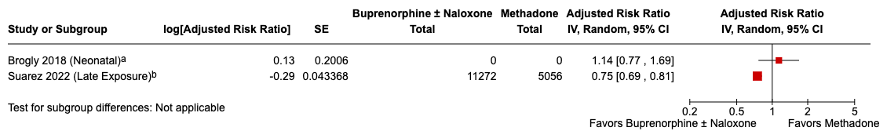
ªAdjusted for maternal age, maternal race/ethnicity, and year of delivery. External confounder data with bias analysis also applied.
^{b}Adjusted for markers of history of opioid use disorder and severity, nonopioid substance use or dependence, medical conditions associated with opioid use disorder, mental health conditions, chronic coexisting conditions, other medication use, health care utilization metrics, proxies for social issues, demographic characteristics, and proxies for socioeconomic status. The high-dimensional propensity-score analysis empirically selected 200 variables from all available diagnosis codes, procedure codes, and medication dispensations on the basis of the strength of their relationship to the exposure status for inclusion in the propensity score along with all prespecified covariates.

Abbreviations: CI, confidence interval; IV, inverse variance; SE, standard error

Supplementary Figure 4D. Adjusted Risk Ratios for Neonatal Abstinence Syndrome (Diagnosis)

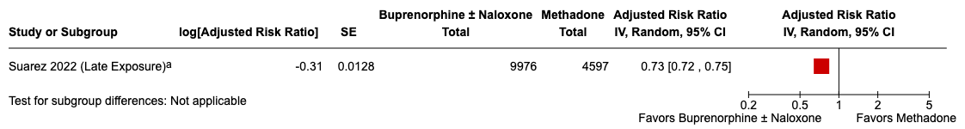
ªAdjusted for markers of history of opioid use disorder and severity, nonopioid substance use or dependence, medical conditions associated with opioid use disorder, mental health conditions, chronic coexisting conditions, other medication use, health care utilization metrics, proxies for social issues, demographic characteristics, and proxies for socioeconomic status. The high-dimensional propensity-score analysis empirically selected 200 variables from all available diagnosis codes, procedure codes, and medication dispensations on the basis of the strength of their relationship to the exposure status for inclusion in the propensity score along with all prespecified covariates.

Abbreviations: CI, confidence interval; IV, inverse variance; SE, standard error

Supplementary Figure 4E. Adjusted Risk Ratios for Neonatal Abstinence Syndrome (Treatment)

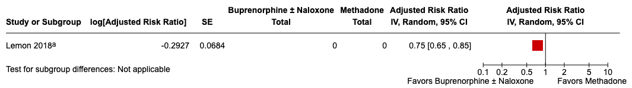

ªAdjusted for parity, maternal race, age, smoking status, marital status, and mediating role of preterm birth

Abbreviations: CI, confidence interval; IV, inverse variance; SE, standard error

