SUPPLEMENTARY MATERIALS
Supplementary Table S1. Comprehensive Performance Metrics of Prediction Models
Model | Outcome | AUC (95% CI) | Brier Score | Calibration Intercept | Calibration Slope | Hosmer-Lemeshow Chi-square | Hosmer-Lemeshow P Value
Height + PAPP-A + PlGF | FGR | 0.742 (0.633-0.851) | 0.0191 | 0 | 1 | 8.19 | 0.415
Height + PAPP-A | FGR | 0.736 (0.629-0.843) | 0.0192 | 0 | 1 | 4.2 | 0.838
Height + PlGF | FGR | 0.732 (0.619-0.845) | 0.0192 | 0 | 1 | 5.73 | 0.677
BMI + PAPP-A + MAP MoM | GDM | 0.666 (0.619-0.712) | 0.1193 | 0 | 1 | 8.44 | 0.392
BMI + PAPP-A | GDM | 0.667 (0.622-0.713) | 0.1195 | 0 | 1 | 8.47 | 0.389
BMI + MAP MoM | GDM | 0.662 (0.615-0.709) | 0.1198 | 0 | 1 | 2.9 | 0.941
TypeI Diabetes + SLE + PAPP-A + PIGF MoM | PTB | 0.665 (0.553-0.776) | 0.0245 | 0 | 1 | 9.38 | 0.312
TypeI Diabetes + PAPP-A + PIGF MoM | PTB | 0.656 (0.546-0.766) | 0.0247 | 0 | 1 | 8.40 | 0.395
PAPP-A + PIGF MoM | PTB | 0.646 (0.538-0.753) | 0.0253 | 0 | 1 | 7.48 | 0.486
Age + PIGF MoM | Placenta | 0.765 (0.588-0.941) | 0.0098 | 0 | 1 | 7.17 | 0.518
Age | Placenta | 0.708 (0.489-0.941) | 0.0097 | 0 | 1 | 19.53 | 0.012
PIGF MoM | Placenta | 0.664 (0.519-0.808) | 0.0100 | 0 | 1 | 7.97 | 0.436

Supplementary Table S2. Model Coefficients and Odds Ratios for Best-Performing Prediction Models
Model | Variable | Coefficient | SE | OR | CI_lower | CI_upper | p_value
FGR | Height | -0.1509 | 0.0437 | 0.86 | 0.787 | 0.935 | 0.0006
FGR | PAPP-A | -0.0003 | 0.0001 | 1 | 0.999 | 1 | 0.0693
FGR | PlGF | -0.0171 | 0.0161 | 0.983 | 0.951 | 1.013 | 0.2887
GDM | BMI | 0.1604 | 0.0274 | 1.174 | 1.113 | 1.239 | <0.001
GDM | PAPP-A | -0.0001 | 0 | 1 | 1 | 1 | 0.0586
Placenta Previa | Age | 0.2218 | 0.0716 | 1.248 | 1.085 | 1.44 | 0.0019
Placenta Previa | PlGF | -0.0324 | 0.0221 | 0.968 | 0.923 | 1.007 | 0.1421
Preterm Birth | TypeI | 3.6762 | 1.308 | 39.495 | 1.675 | 489.716 | 0.0049
Preterm Birth | SLE | 2.5628 | 1.1961 | 12.972 | 0.613 | 110.787 | 0.0322
Preterm Birth | PAPP-A | 0.0002 | 0.0001 | 1 | 1 | 1 | 0.0009
Preterm Birth | PlGF_MoM | -1.2818 | 0.5519 | 0.278 | 0.089 | 0.769 | 0.0202

Note:
- Intercept terms are omitted for clinical interpretability. OR, odds ratio; CI, confidence interval; SE, standard error.
- Some odds ratios (e.g., Type I diabetes in preterm birth model) are associated with very wide confidence intervals due to the limited number of events, indicating substantial statistical uncertainty. These estimates should be interpreted with caution.
Supplementary Table S3. Distribution of Maternal Characteristics Across Pregnancy Outcomes
Characteristic | PE+ (n=154) | PE- (n=1434) | p-value | FGR+ (n=31) | FGR- (n=3879) | p-value | GDM+ (n=838) | GDM-(n=3072) | p-value | Preterm+ (n=190) | Preterm- (n=3720) | p-value
Age, years | 32.53 (30.14,34.87) | 32.06 (29.49,34.79) | P = 0.3556 | 31.94 (29.60,34.86) | 32.10 (29.58,34.79) | P = 0.8479 | 32.96 (30.29,36.08) | 31.94 (29.42,34.58) | P = 0.0001** | 32.76 (29.61,34.35) | 32.09 (29.57,34.81) | P = 0.9750
Height, cm | 164.0 (161.2,167.0) | 163.2 (159.8,167.2) | P = 0.1554 | 159.8 (155.825,165.0) | 163.2 (159.975,167.2) | P = 0.0047** | 163.0 (159.75,166.6) | 163.3 (160.0,167.3) | P = 0.4050 | 163.4 (160.75,168.125) | 163.2 (159.9,167.2) | P = 0.3537
Weight, kg | 66.9 (57.3,72.3) | 58.3 (53.0,64.1) | P < 0.0001** | 55.9 (48.125,63.975) | 58.4 (53.175,64.4) | P = 0.0631 | 62.2 (56.1,69.05) | 57.8 (52.9,63.5) | P < 0.0001** | 57.0 (53.1,63.425) | 58.4 (53.2,64.5) | P = 0.6392
BMI, kg/m² | 24.58 (21.50,26.96) | 21.79 (19.92,23.66) | P < 0.0001** | 20.68 (19.06,24.63) | 21.86 (19.94,23.80) | P = 0.2911 | 24.30 (21.10,25.46) | 21.63 (19.82,23.48) | P < 0.0001** | 21.60 (19.52,22.85) | 21.88 (19.95,23.81) | P = 0.2953
Smoker, n (%) | 1 (1.82%) | 5 (0.33%) | P = 0.0809 | 0 | 15 (0.39%) | P = 0.7292 | 4 (0.43%) | 12 (0.38%) | P = 0.9031 | 4 (2.04%) | 12 (0.33%) | P = 0.0574*
Type I diabetes, n(%) | 1 (1.82%) | 3 (0.20%) | P = 0.1341 | 0 | 10 (0.26%) | P = 1.0 | 0 | 9 (0.30%) | P = 1.00 | 4 (2.04%) | 7 (0.20%) | P = 0.1202
Chronic hypertension, n (%) | 4 (7.27%) | 4 (0.27%) | P < 0.0001** | 0 | 20 (0.51%) | P = 0.6892 | 7 (0.86%) | 14 (0.45%) | P = 0.4214 | 0 | 20 (0.53%) | P = 0.6094
SLE, n (%) | 0 | 4 (0.27%) | P = 1.0000 | 0 | 10 (0.26%) | P = 1.0000 | 0 | 9 (0.30%) | P = 1.0000 | 4 (2.04%) | 3 (0.20%) | P = 0.1202
APS, n(%) | 0 | 4 (0.27%) | P = 1.0000 | 0 | 10 (0.26%) | P = 1.0000 | 0 | 9 (0.30%) | P = 1.0000 | 4 (2.04%) | 7 (0.20%) | P = 0.1202
PE history, n(%) | 1 (1.82%) | 2 (0.13%) | P = 0.1023 | 0 | 3 (0.19%) | P = 1.0000 | 0 | 7 (0.23%) | P = 1.0000 | 0 | 7 (0.20%) | P = 1.0000
PE family history, n(%) | 4 (7.27%) | 13 (0.87%) | P < 0.0001** | 1 (3.23%) | 7 (1.09%) | P = 0.2666 | 7 (0.86%) | 35 (1.13%) | P = 0.7151 | 4 (2.04%) | 39 (1.06%) | P = 0.5161
PAPP-A MoM | 0.79 (0.51,1.38) | 1.01 (0.62,1.51) | P = 0.1385 | 1733.77 (1150.66,3299.43) | 2643.19 (1537.66,4320.25) | P = 0.0039** | 0.96 (0.55,1.44) | 1.01 (0.64,1.52) | P = 0.1781 | 1.01 (0.64,1.59) | 1.00 (0.62,1.51) | P = 0.5949
PlGF MoM | 0.71 (0.60,1.13) | 0.91 (0.65,1.18) | P = 0.0624* | 29.66 (16.32,39.26) | 32.42 (23.46,43.59) | P = 0.0650* | 0.90 (0.66,1.15) | 0.91 (0.65,1.18) | P = 0.6402 | 0.80 (0.58,1.02) | 0.91 (0.65,1.18) | P = 0.0543*
MAP MoM | 1.11 (1.03,1.20) | 1.02 (0.95,1.09) | P < 0.0001** | 86.67 (79.83,94.25) | 86.00 (79.33,93.00) | P = 0.8339 | 1.05 (0.96,1.12) | 1.02 (0.95,1.10) | P = 0.0150** | 1.04 (0.94,1.10) | 1.03 (0.95,1.10) | P = 0.9121
Note: P-values for continuous variables were calculated using the Mann-Whitney U test. For categorical variables, Fisher's exact test was used when two or more cells had expected frequencies less than 5; otherwise, the Chi-square test was applied.

Supplementary Table S4. Internal validation results for best FGR prediction model
Metric | Value | Description
Apparent AUC in training set | 0.7263 | Model performance on the training set
Average optimism (Bootstrap) | 0.0299 | Degree of overfitting estimated by bootstrap
Optimism-corrected AUC | 0.6964 | Model performance after correcting for overfitting
Independent test set AUC | 0.6908 | Model performance on the independent test set
Lower bound of test set AUC 95% CI | 0.5175 | Lower bound of the 95% confidence interval for test set AUC
Upper bound of test set AUC 95% CI | 0.8642 | Upper bound of the 95% confidence interval for test set AUC

Supplementary Table S5. Internal validation results for best GDM prediction model
Metric | Value | Description
Apparent AUC in training set | 0.6426 | Model performance on the training set
Average optimism (Bootstrap) | 0.0032 | Degree of overfitting estimated by bootstrap
Optimism-corrected AUC | 0.6393 | Model performance after correcting for overfitting
Independent test set AUC | 0.6746 | Model performance on the independent test set
Lower bound of test set AUC 95% CI | 0.6003 | Lower bound of the 95% confidence interval for test set AUC
Upper bound of test set AUC 95% CI | 0.7489 | Upper bound of the 95% confidence interval for test set AUC

Supplementary Figure 5. and Figure 6. Calibration Plot for FGR and GDM
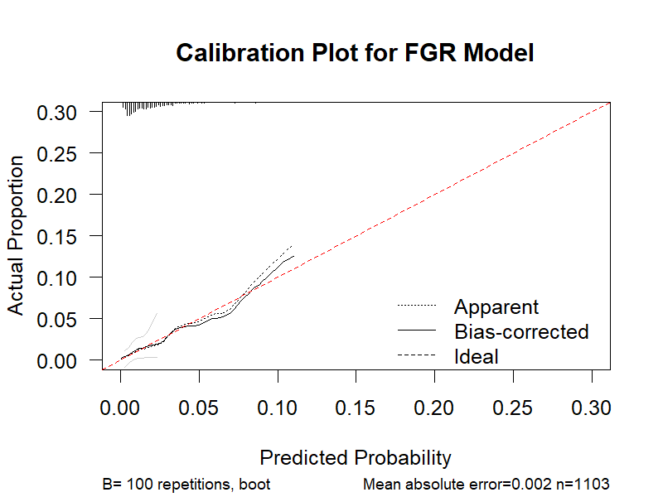
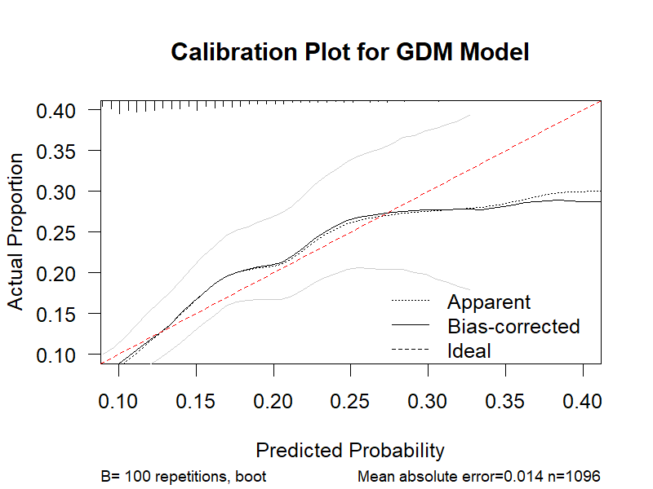
Note: The x-axis represents predicted probabilities; the y-axis represents observed proportions of FGR and GDM. The dashed line indicates perfect calibration (ideal line); points closer to the dashed line indicate better agreement between predicted and observed risks.

