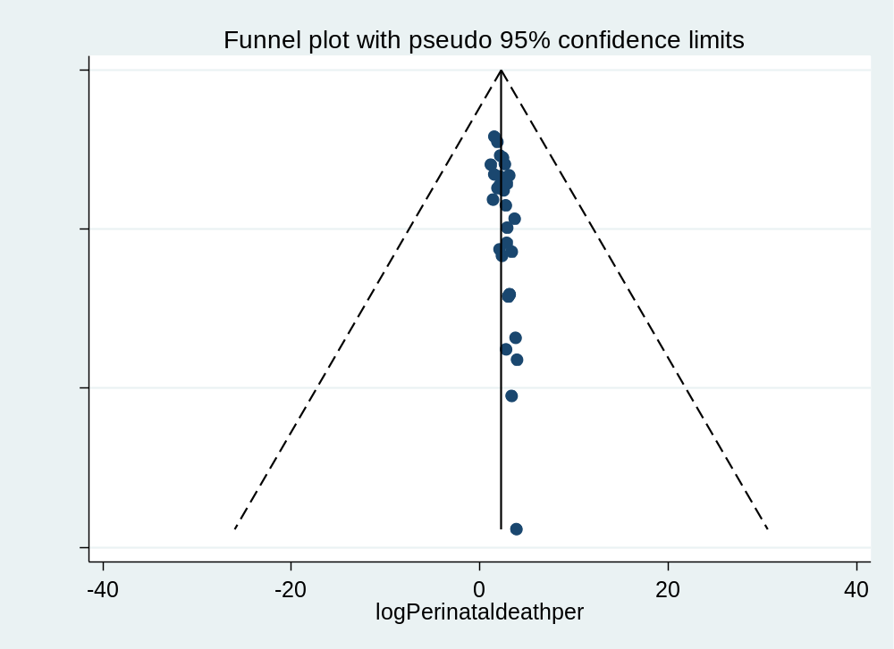
Figure 8: - Funnel plot show the distribution of studies for the estimation of perinatal mortality in study of perinatal outcome among IUGR fetus with affected Doppler finding: a systematic review and meta-analysis of a global literature.
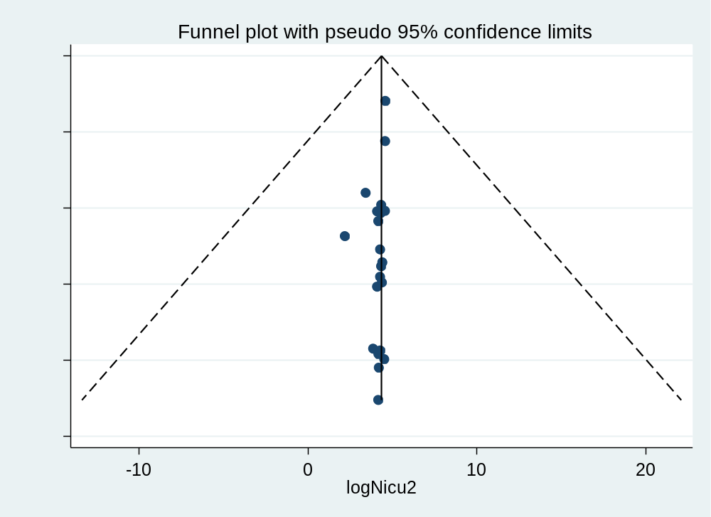
Figure 9: - Funnel plot show the distribution of studies for the estimation of NICU admission in study of perinatal outcome among IUGR fetus with affected Doppler finding: a systematic review and meta-analysis of a global literature.
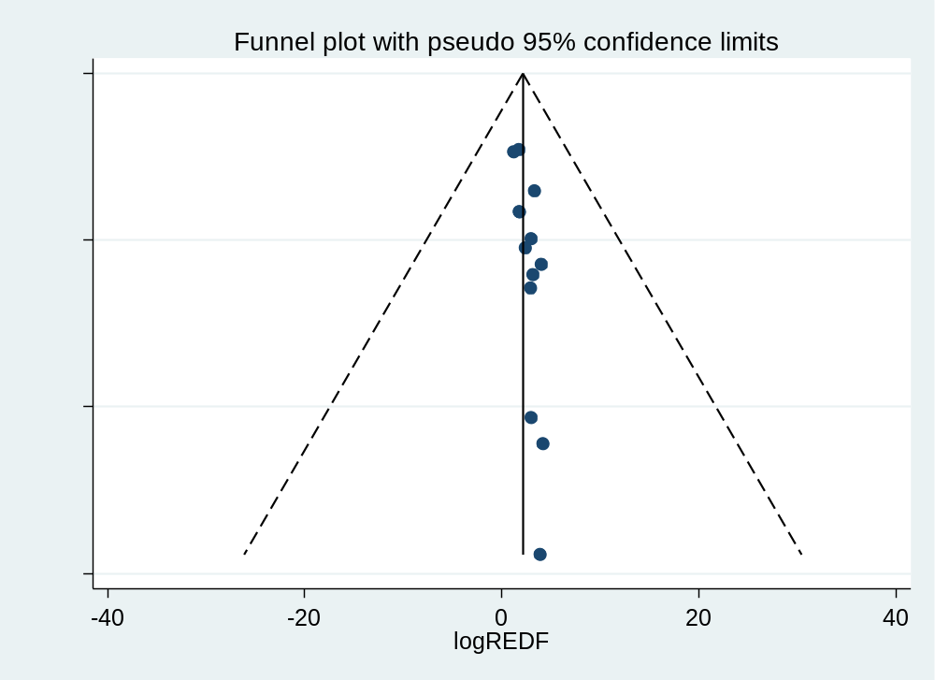
Figure 10: - Funnel plot show the distribution of studies for the estimation of REDF umbilical artery doppler finding in study of perinatal outcome among IUGR fetus with affected Doppler finding: a systematic review and meta-analysis of a global literature.
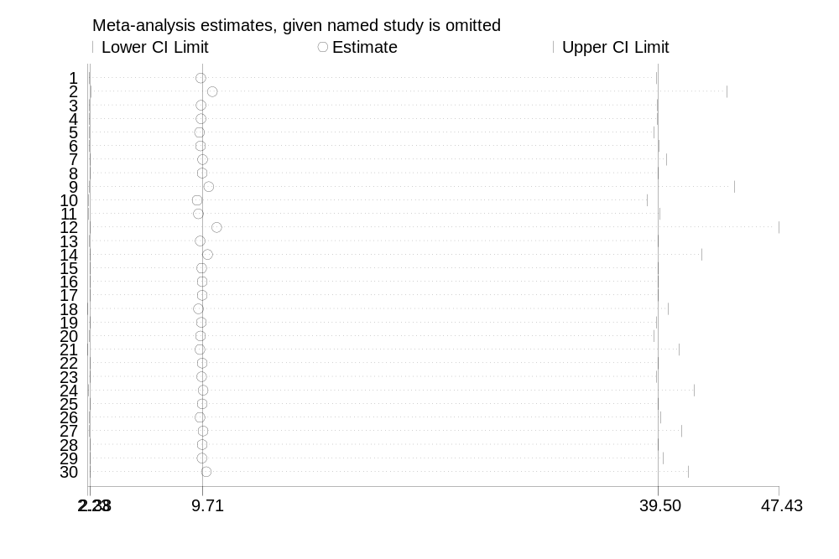
Figure 11: - The forest plot presents a sensitivity analysis of the pooled estimate of perinatal mortality in the study of perinatal outcome among IUGR fetus with affected umbilical doppler finding a systematic review and meta-analysis with a global literature.
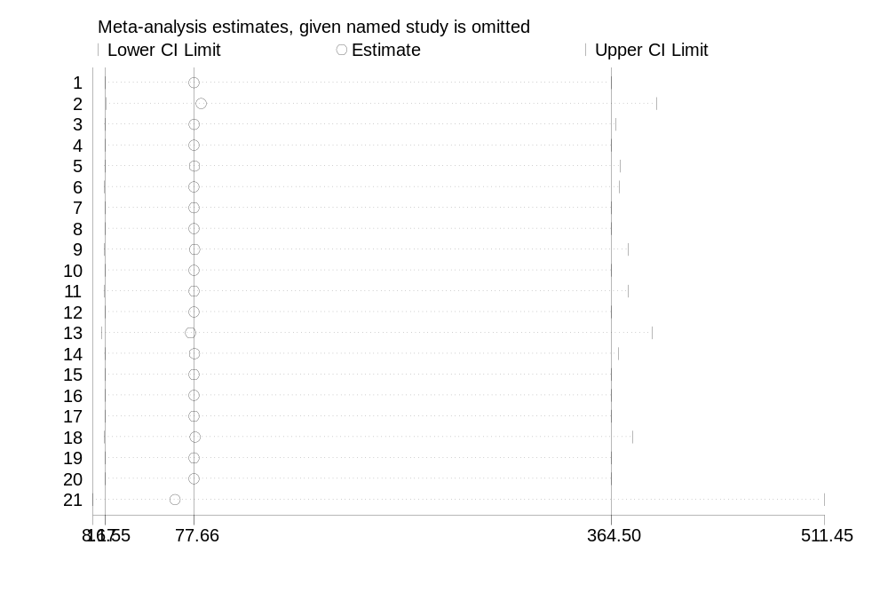
Figure 12: - The forest plot presents a sensitivity analysis of the pooled estimate of NICU admission in the study of perinatal outcome among IUGR fetus with affected umbilical doppler finding a systematic review and meta-analysis with a global literature.
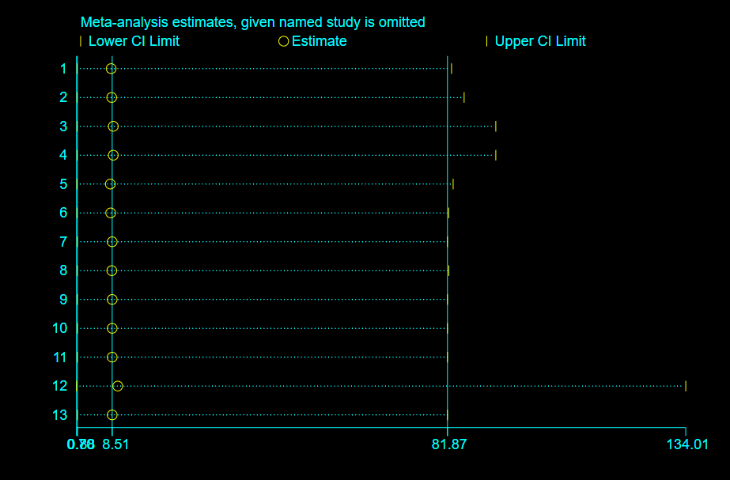
Figure 13: - The forest plot presents a sensitivity analysis of the pooled estimate of REDF umbilical artery doppler finding in the study of perinatal outcome among IUGR fetus with affected umbilical doppler finding a systematic review and meta-analysis with a global literature.

