SUPPLEMENTAL MATERIAL
Associations between Per- and Polyfluoroalkyl Substances and Maternal Thyroid Function: The Role of Iodine Status and Thyroid Autoantibodies

Fig. S1 Correlation matrix of 13 PFASs concentrations in the serum of study participants.
Fig. S2. Dose–response relationships between PFAS exposure and TSH based on restricted cubic spline (RCS) models
Fig. S3. Dose–response relationships between PFAS exposure and FT₃ based on RCS models.
Fig. S4. Dose–response relationships between PFAS exposure and FT₄ based on RCS models
Fig. S5. Dose–response relationships between PFAS exposure and Tg based on RCS models
Fig. S6. Dose–response relationships between PFAS exposure and TSH/FT₄ based on RCS models
Fig. S7. Dose–response relationships between PFAS exposure and FT₄/FT₃ based on RCS models.
Fig. S8 Variable weight plot from the qgcomp model for the 13 PFASs mixture.
Fig. S9. Variable weight plot from the qgcomp model for PFAS significant in univariate analyses.
Fig. S10. Variable weight plot from the qgcomp model for PFAS selected by LASSO
Fig. S11. Effects of LASSO-selected PFAS on thyroid function measures in BKMR.
Fig. S12. Effects of PFAS with significant single-pollutant associations on thyroid function measures in BKMR.
Table S1 Abbreviations and detection rates of 34 PFASs measured in this study.
Table S2. Distribution of PFAS concentrations and thyroid function measurements in this study.
Table S3. Adjusted associations of single serum PFAS concentrations with thyroid hormone levels
Table S4. Adjusted associations of PFAS quartiles with thyroid hormone levels.
Table S5. Regression with LASSO: major PFAS contributors to thyroidfunction.
Table S6. Interaction effects of serum PFAS and iodine status on thyroid function.
Table S7. Interaction effects of serum PFAS and autoantibody status on thyroid function.

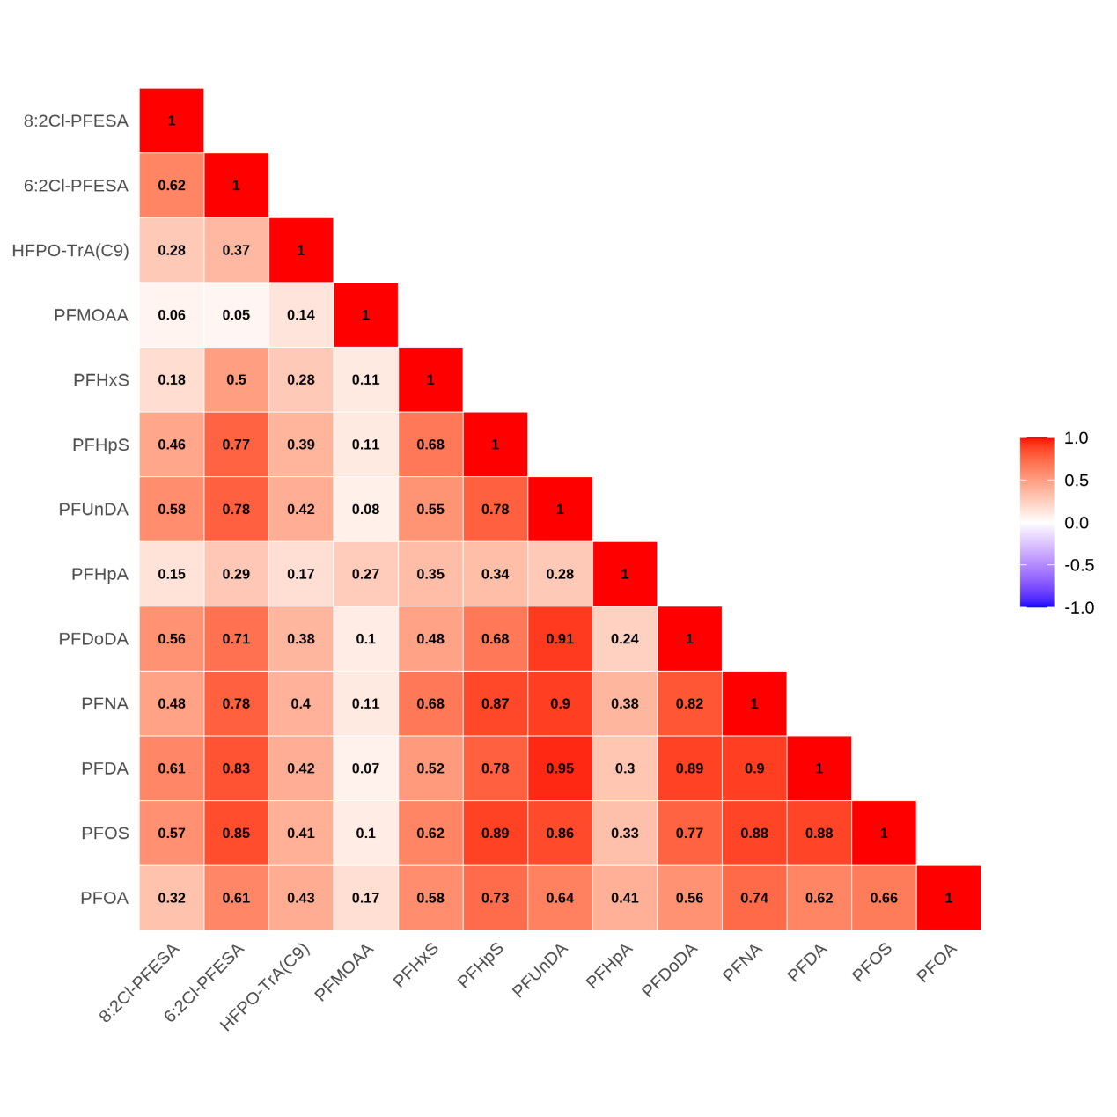
Fig. S1 Correlation matrix of 13 PFASs concentrations in the serum of study participants.
.
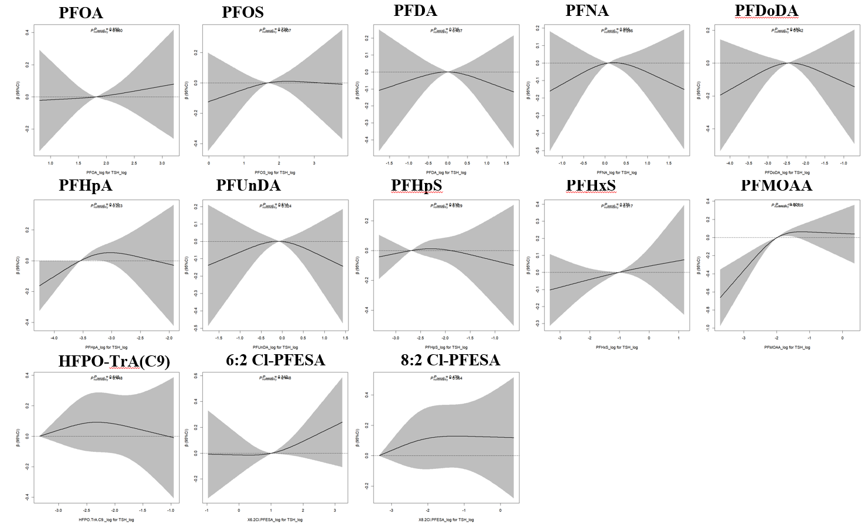
Fig. S2. Dose–response relationships between PFAS exposure and TSH based on restricted cubic spline (RCS) models
Note: P_{overall} means global association, P_{nonlinearity} means nonlinear trend test.
Covariates adjusted for included age, BMI, ethnicity, education, occupation, passive smoking, alcohol consumption, and serum iodine.
Both exposure and outcome measures were log-transformed.

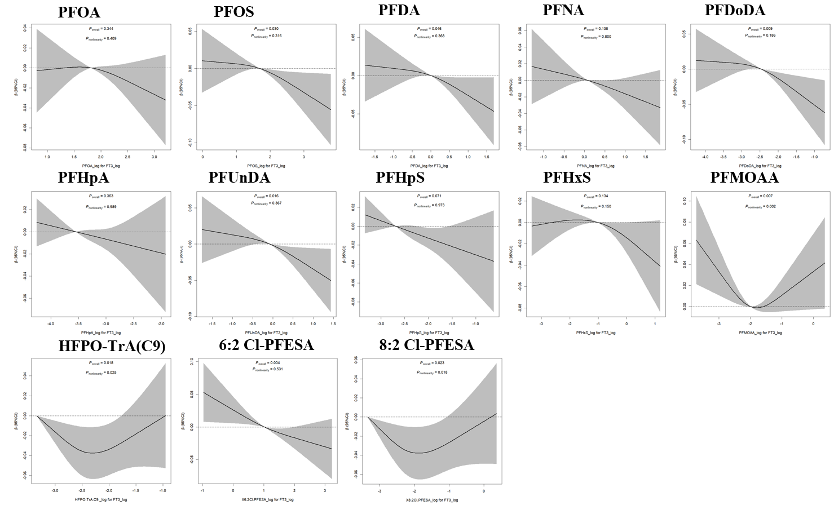
Fig. S3. Dose–response relationships between PFAS exposure and FT₃ based on RCS models.

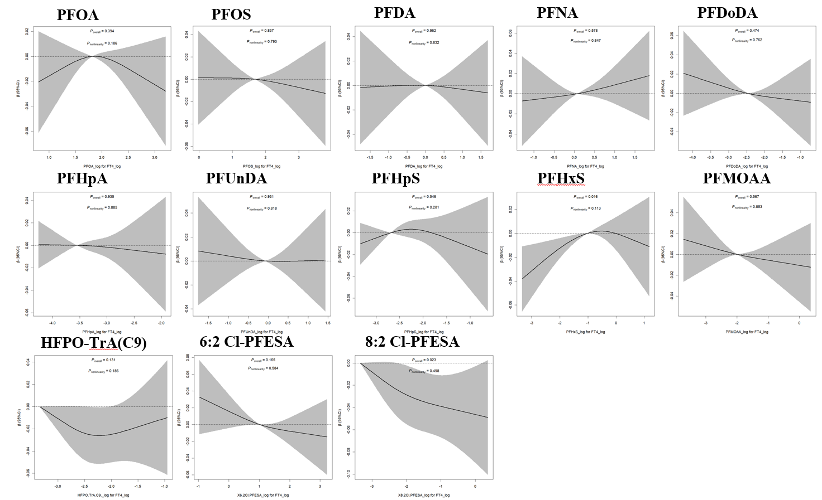
Fig. S4. Dose–response relationships between PFAS exposure and FT₄ based on RCS models

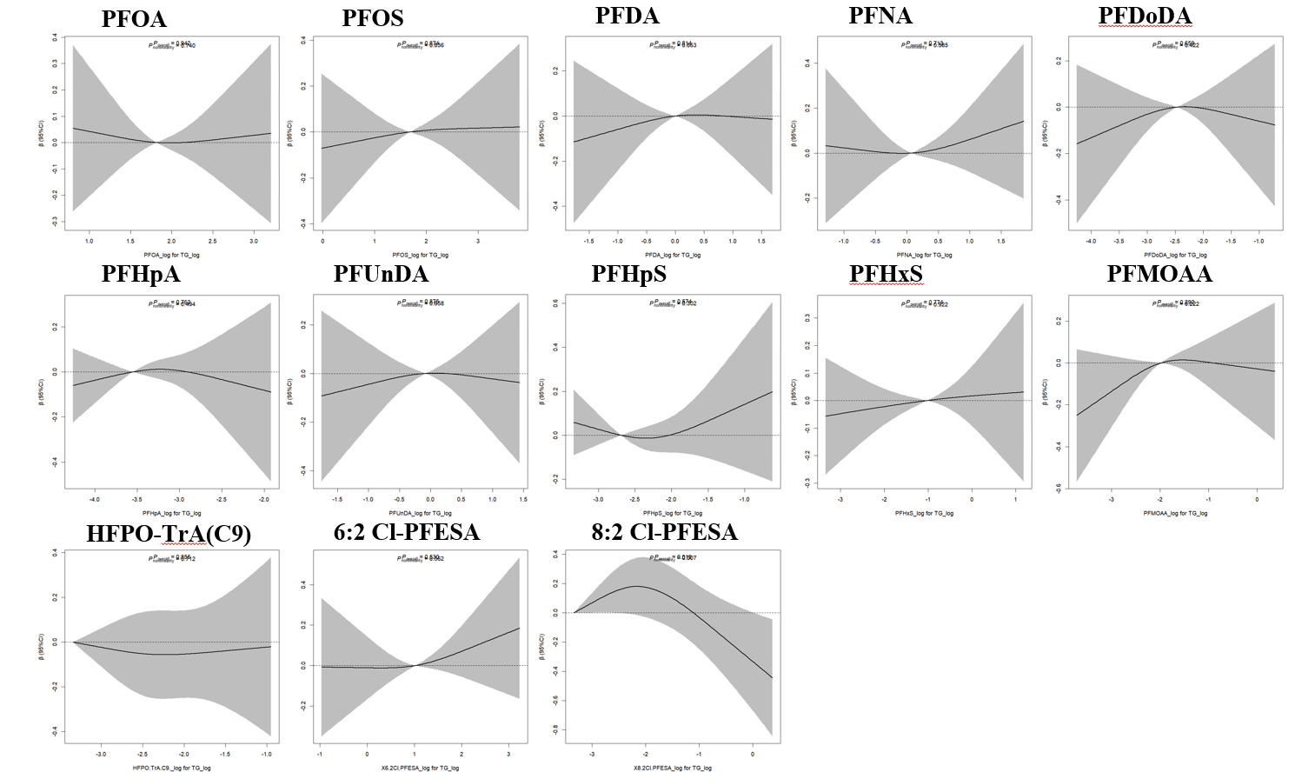
Fig. S5. Dose–response relationships between PFAS exposure and Tg based on RCS models

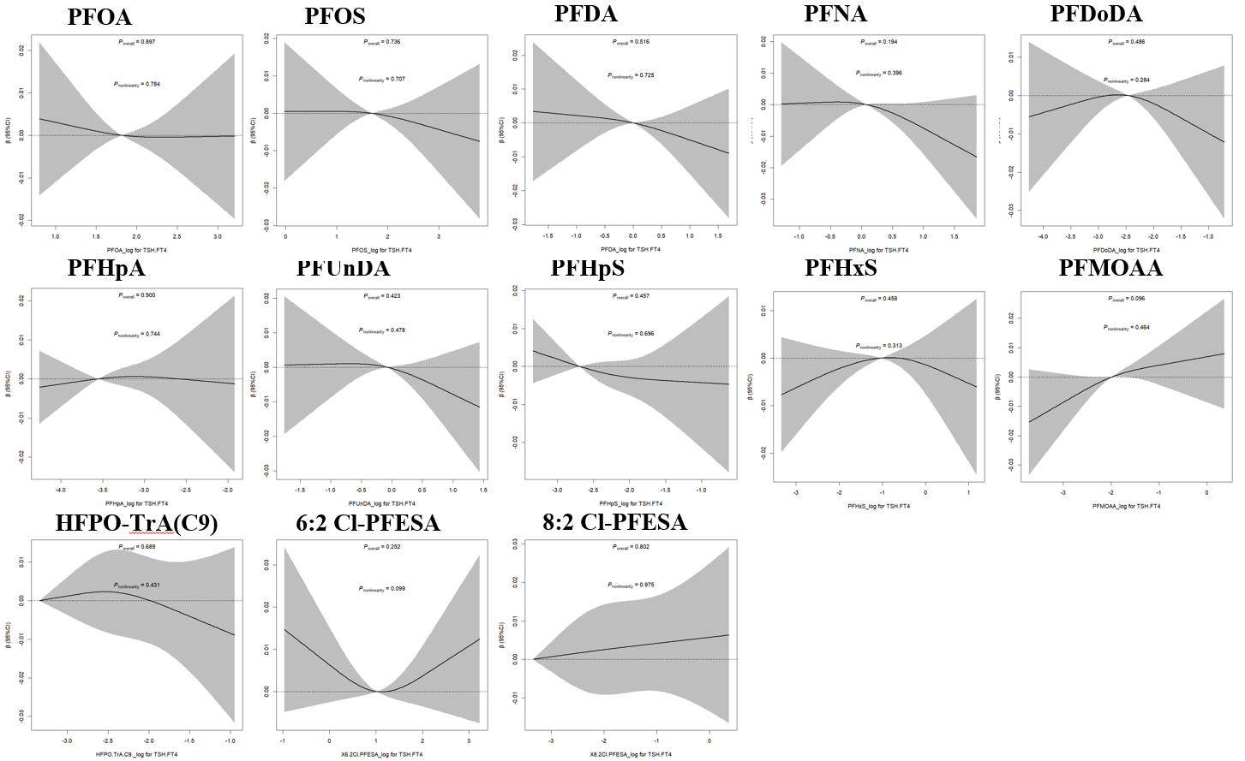
Fig. S6. Dose–response relationships between PFAS exposure and TSH/FT₄ based on RCS models

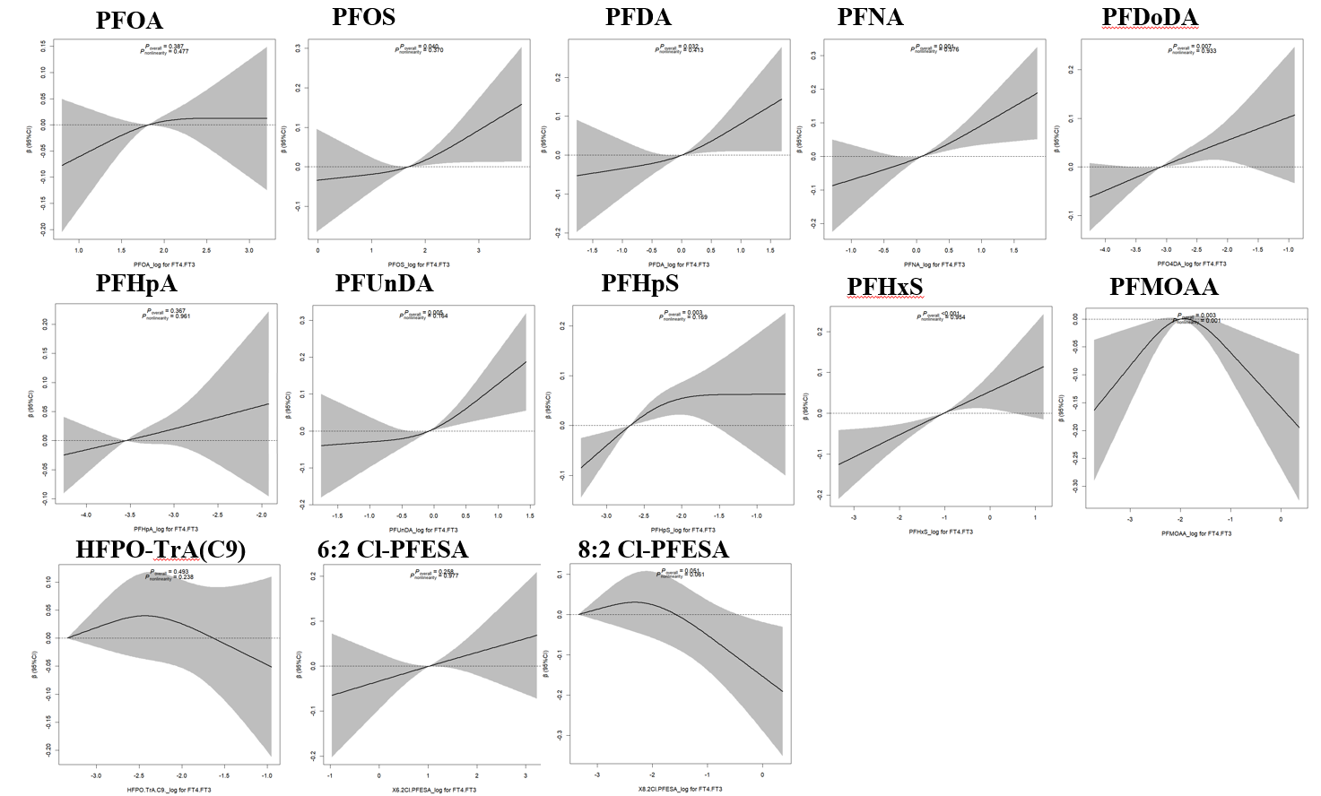
Fig. S7. Dose–response relationships between PFAS exposure and FT₄/FT₃ based on RCS models.

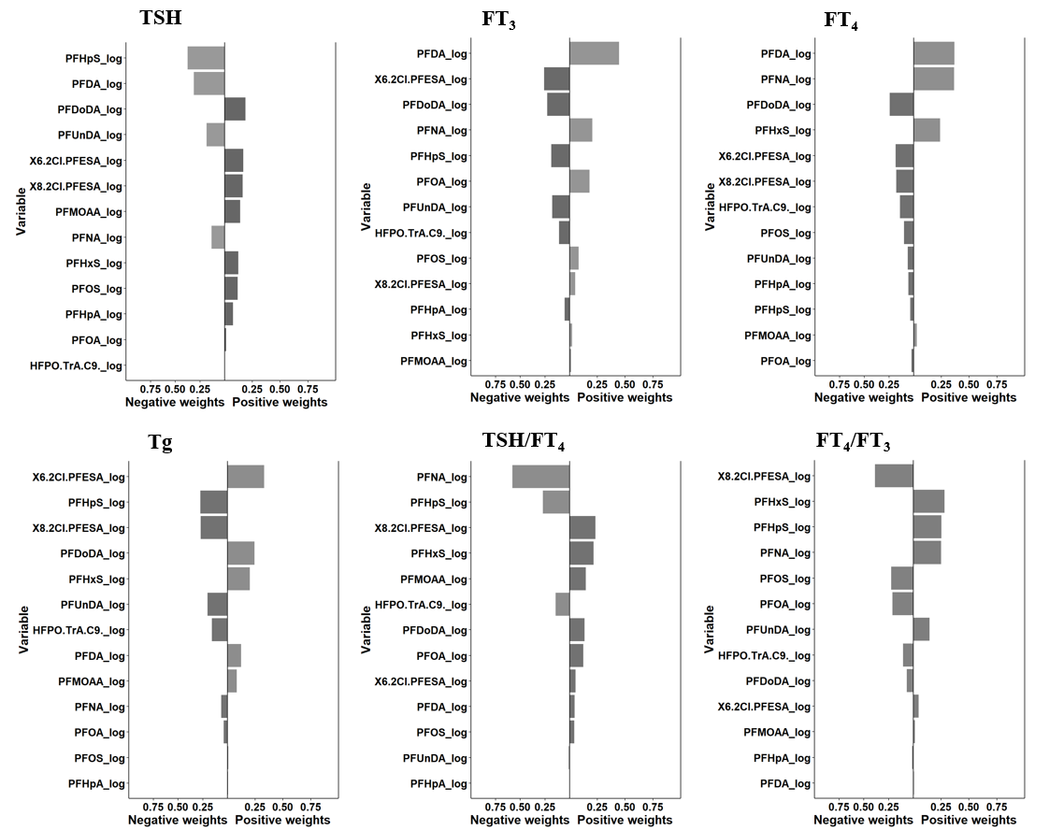

Fig. S8. Variable weight plot from the qgcomp model for the 13 PFASs mixture.
Covariates adjusted for included age, BMI, ethnicity, education, occupation, passive smoking, alcohol consumption, and serum iodine.
Both exposure and outcome measures were log-transformed.
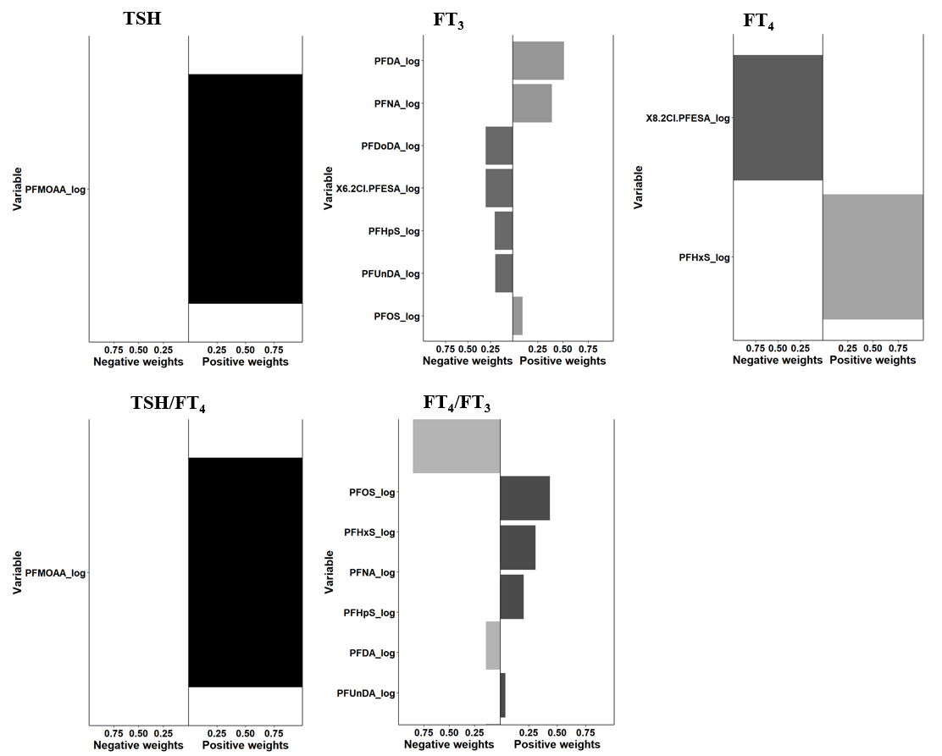
Fig. S9. Variable weight plot from the qgcomp model for PFAS significant in univariate analyses.
Note: Tg (no significant associations) was excluded from presentation.
Covariates adjusted for included age, BMI, ethnicity, education, occupation, passive smoking, alcohol consumption, and serum iodine.
Both exposure and outcome measures were log-transformed.
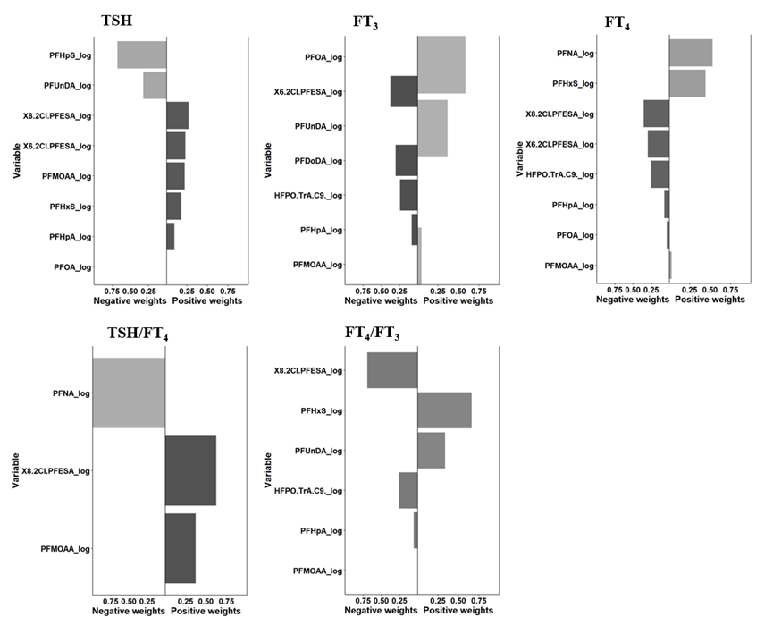

Fig. S10. Variable weight plot from the qgcomp model for PFAS selected by LASSO.
Note: Tg (no significant associations) was excluded from presentation.
Covariates adjusted for included age, BMI, ethnicity, education, occupation, passive smoking, alcohol consumption, and serum iodine.
Both exposure and outcome measures were log-transformed.
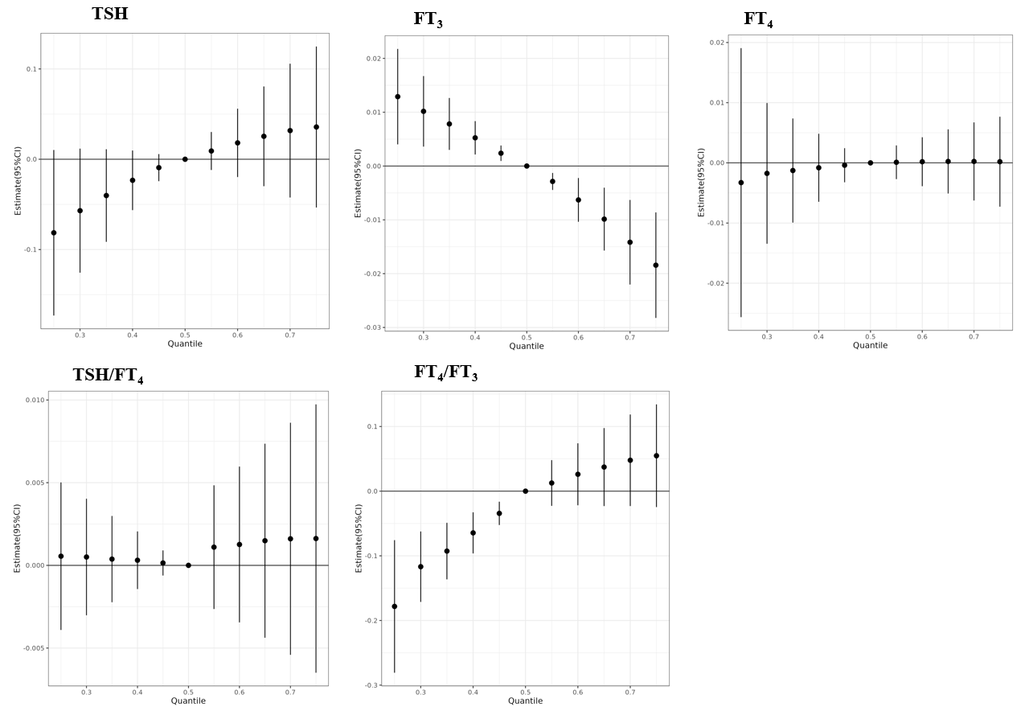
Fig. S11. Effects of LASSO-selected PFAS on thyroid function measures in BKMR.
Note: Effect estimates across quantiles of the PFAS mixture (x-axis) for the specified outcome (y-axis), with 95% confidence intervals. Tg (no significant associations) was excluded from presentation. Models adjusted for serum iodine.
Abbreviations: FT₃, free triiodothyronine; FT₄, free thyroxine.
Both exposure and outcome measures were log-transformed.
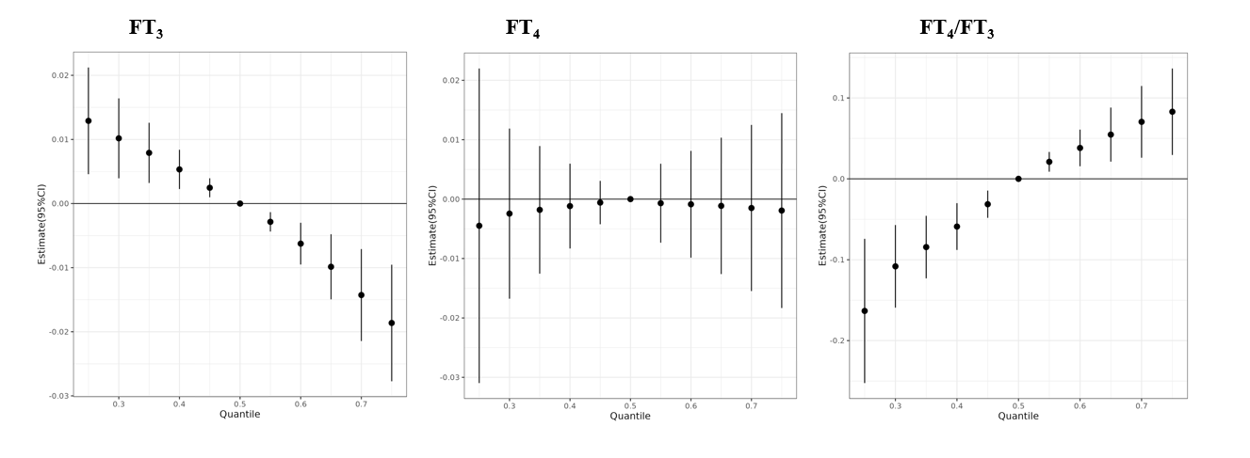
Fig. S12. Effects of PFAS with significant single-pollutant associations on thyroid function measures in BKMR.
Note: Effect estimates across quantiles of the PFAS mixture (x-axis) for the specified outcome (y-axis), with 95% confidence intervals. TSH (only one significant association) and Tg (no significant associations) were excluded from presentation. Models adjusted for serum iodine.
Abbreviations: TSH, thyroid-stimulating hormone; FT₃, free triiodothyronine; FT₄, free thyroxine.
Both exposure and outcome measures were log-transformed.
Table S1 Abbreviations and detection rates of 34 PFASs measured in this study.
Full Name | Abbreviation | Detection Rate (%)
Perfluoroalkyl carboxylic acids | PFCAs
Perfluorobutanoic acid | PFBA | 22.37
Perfluoropentanoic acid | PFPeA | 31.58
Perfluorohexanoic acid | PFHxA | 24.78
Perfluoroheptanoic acid | PFHpA | 69.96
Perfluorooctanoic acid | PFOA | 100
Perfluorononanoic acid | PFNA | 100
Perfluorodecanoic acid | PFDA | 100
Perfluoroundecanoic acid | PFUnDA | 100
Perfluorododecanoic acid | PFDoDA | 95.94
Perfluoroalkane sulfonic acids | PFSAs
Perfluorobutane sulfonate | PFBS | 0.44
Perfluoropentane sulfonate | PFPeS | 3.73
Perfluorohexane sulfonate | PFHxS | 74.45
Perfluoroheptane sulfonate | PFHpS | 68.42
Perfluorooctane sulfonate | PFOS | 100
Perfluoroalkyl ether carboxylic acids | PFECAs
Perfluoro-2-methoxyacetic acid | PFMOAA | 99.56
Perfluoro-(3,5-dioxahexanoic) acid | PFO2HxA | 0.88
Perfluoro-3,5,7-trioxaoctanoic acid | PFO3OA | 33.66
Perfluoro-4-oxapentanoic acid | PF4OPeA | 0.22
Perfluoro-5-oxahexanoic acid | PF5OHxA | 0.11
Hexafluoropropylene oxide dimer acid | HFPO-DA | 13.82
Hexafluoropropylene oxide trimer acid (c9) | HFPO-TrA(C9) | 41.78
Hexafluoropropylene oxide trimer acid (c8) | HFPO-TrA(C8) | 10.86
Hexafluoropropylene oxide trimer acid (c7) | HFPO-TrA(C7) | 0.22
Hexafluoropropylene oxide tetramer acid | HFPO-TeA | 0.33
Perfluoro-3,6-dioxaoctanoic acid | PFO2OA | 0
Perfluoro-3,6,9-trioxadecanoic acid | PFO3DA | 1.32
Perfluoro-2-methoxypropanoic acid | PMPA | 0.33
2-(heptafluoropropoxy)-2-fluoroacetic acid | C3F7OCFHCOOH | 0
Perfluoro-3,6-dioxaheptanoic acid | 3,6-OPFHpA | 0.11
Perfluoroalkyl ether sulfonic acids | PFESAs
7-Hydro-perfluoro-4-methyl-3,6-dioxooctane sulfonic acid | H-PFMO2OSA | 0.22
Polyfluoroalkyl ether sulfonic acids | PFESAs
6:2 Hydrogen-substituted polyfluorinated ether sulfonic acid | 6:2 H-PFESA | 0
Chloropolyfluoroalkyl ether sulfonic acids | Cl-PFESAs
4:2 chlorinated polyfluorinated ether sulfonic acid | 4:2Cl-PFESA | 26.97
6:2 chlorinated polyfluorinated ether sulfonate | 6:2Cl-PFESA | 100
8:2 chlorinated polyfluorinated ether sulfonate | 8:2Cl-PFESA | 47.48
Bold indicates a detection rate > 40%

Table S2. Distribution of PFAS concentrations and thyroid function measurements in this study.
PFAS (ng/mL) | Mean | Median（IQR） | GM
PFOA | 7.63 | 6.15 (4.46, 9.11) | 6.51
PFOS | 8.33 | 5.40(3.29,10.23) | 5.79
PFDA | 1.33 | 1.00 (0.62, 1.65) | 1.00
PFNA | 1.54 | 1.08 (0.69, 1.89) | 1.17
PFDoDA | 0.11 | 0.09 (0.05, 0.14) | 0.08
PFHpA | 0.04 | 0.03 (0.01, 0.05) | 0.03
PFUnDA | 1.17 | 0.93 (0.58, 1.47) | 0.92
PFHpS | 0.10 | 0.07 (0.04, 0.13) | 0.77
PFHxS | 0.69 | 0.36 (0.04, 0.96) | 0.26
PFMOAA | 0.34 | 0.14 (0.09, 0.21) | 0.14
HFPO-TrA(C9) | 0.07 | 0.04 (0.04, 0.08) | 0.05
6:2 Cl-PFESA | 4.42 | 2.78 (1.62, 4.93) | 2.89
8:2 Cl-PFESA | 0.14 | 0.04 (0.04, 0.10) | 0.07
TSH (μIU/mL) | 1.38 | 1.18 (0.62, 1.85) | 0.86
FT₃ (pmol/L) | 5.05 | 4.86 (4.50, 5.32) | 4.95
FT₄ (pmol/L) | 17.96 | 17.27 (15.71,19.11) | 17.62
Tg (nmol/L) | 13.66 | 10.88 (6.34, 17.80) | 8.68
Abbreviations: LOD, limit of detection; GM, geometric mean; IQR, interquartile range; TSH, thyroid-stimulating hormone; FT₄, free thyroxine; FT₃, free triiodothyronine; Tg, thyroglobulin.

Table S3. Adjusted associations of single serum PFAS concentrations with thyroid hormone levels
PFAS | β (95% CI), P
PFAS | TSH | FT₃ | FT₄ | Tg | TSH/FT₄ | FT₄/FT₃
PFOA | 0.042 (-0.109, 0.193), 0.583 | -0.012 (-0.032, 0.008), 0.229 | -0.003 (-0.023, 0.016), 0.735 | -0.008 (-0.159, 0.144), 0.922 | -0.002 (-0.010, 0.007), 0.706 | 0.037 (-0.024, 0.098), 0.238
PFOS | 0.031 (-0.07, 0.132), 0.544 | -0.017 (-0.03, -0.003)*, 0.014 | -0.004 (-0.017, 0.010), 0.5924 | 0.025 (-0.077, 0.126), 0.6344 | -0.002 (-0.008, 0.004), 0.492 | 0.049 (0.009, 0.090)*, 0.017
PFDA | -0.005 (-0.119,0.108), 0.925 | -0.018 (-0.033, -0.003)*, 0.021 | -0.001 (-0.016, 0.013), 0.855 | 0.027 (-0.087, 0.142), 0.638 | -0.004 (-0.010, 0.003), 0.274 | 0.058 (0.012, 0.104)*, 0.013
PFNA | -0.003 (-0.122, 0.117), 0.967 | -0.016 (-0.032, -0.0001)*, 0.0487 | 0.008 (-0.007, 0.024), 0.3037 | 0.038 (-0.082, 0.158), 0.5387 | -0.006 (-0.012, 0.001), 0.1097 | 0.089 (0.041, 0.136)***, < 0.001
PFDoDA | 0.017 (-0.093, 0.127), 0.764 | -0.021 (-0.035, -0.006)**, 0.005 | -0.009 (-0.023, 0.006), 0.236 | 0.025 (-0.086, 0.135), 0.663 | -0.002 (-0.008, 0.005), 0.589 | 0.043 (-0.001, 0.087), 0.057
PFHpA | 0.110 (-0.016, 0.236), 0.087 | -0.012 (-0.029, 0.005), 0.154 | -0.003 (-0.019, 0.014), 0.737 | 0.018 (-0.109, 0.144), 0.785 | 0.001 (-0.006, 0.008), 0.747 | 0.037 (-0.014, 0.088), 0.157
PFUnDA | 0.003 (-0.123, 0.116), 0.960 | -0.022 (-0.038, -0.006)**, 0.006 | -0.002 (-0.018, 0.013), 0.765 | 0.016 (-0.104, 0.136), 0.788 | -0.004 (-0.011, 0.003), 0.269 | 0.072 (0.024, 0.120)**, 0.004
PFHpS | 0.003 (-0.114, 0.119), 0.964 | -0.018 (-0.034, -0.003)*, 0.021 | 0.002 (-0.013, 0.017), 0.824 | 0.013 (-0.105, 0.130), 0.833 | -0.004 (-0.011, 0.003), 0.234 | 0.075 (0.028, 0.122)**, 0.002
PFHxS | 0.041 (-0.016, 0.098), 0.163 | -0.005 (-0.013, 0.002), 0.163 | 0.009 (0.002, 0.016)*, 0.016 | 0.021 (-0.037, 0.078), 0.479 | 0.001 (-0.002, 0.005), 0.461 | 0.053 (0.030, 0.076)***, < 0.001
PFMOAA | 0.162 (0.069, 0.255)***, < 0.001 | -0.004 (-0.016, 0.009), 0.543 | -0.006 (-0.019, 0.006), 0.294 | 0.047 (-0.047, 0.141), 0.324 | 0.006 (0.0002, 0.011)*. 0.041 | -0.012 (-0.050, 0.026), 0.525
HFPO-TrA(C9) | 0.036 (-0.094, 0.166), 0.589 | -0.016 (-0.033, 0.002), 0.079 | -0.013 (-0.030,0.004), 0.128 | -0.028 (-0.159, 0.103), 0.67 | -0.001 (-0.009, 0.006), 0.724 | 0.004 (-0.049, 0.056), 0.892
6:2 Cl-PFESA | 0.060 (-0.034, 0.153), 0.210 | -0.021 (-0.033, -0.008)**, 0.001 | -0.011 (-0.023, 0.001), 0.069 | 0.046 (-0.048, 0.140), 0.334 | -0.0005 (-0.006, 0.005), 0.863 | 0.032 (-0.006, 0.070), 0.099
8:2 Cl-PFESA | 0.050 (-0.041, 0.139), 0.286 | -0.008 (-0.02, 0.004), 0.169 | -0.016 (-0.027, -0.004)**, 0.008 | -0.039 (-0.129, 0.052), 0.405 | 0.002 (-0.003, 0.007), 0.506 | -0.029 (-0.065, 0.007), 0.119
*: p < 0.05，**: p < 0.01，***: p < 0.001;
Covariates adjusted for included age, BMI, ethnicity, education, occupation, passive smoking, alcohol consumption, and serum iodine.
Both exposure and outcome measures were log-transformed.

Table S4. Adjusted associations of PFAS quartiles with thyroid hormone levels.
PFAS, (N) | β (95% CI), P
PFAS, (N) | TSH | FT₃ | FT₄ | Tg | TSH/FT₄ | FT₄/FT₃
PFOA  Q1, (n = 228)  Q2, (n = 228)  Q3, (n = 227)  Q4, (n = 228) | Reference  0.017 (-0.209, 0.244), 0.882  0.096 (-0.133, 0.325), 0.414  0.037 (-0.196, 0.270), 0.755 | Reference  0.007 (-0.023, 0.037), 0.641  0.005 (-0.025, 0.036), 0.744  -0.005 (-0.036, 0.026), 0.751 | Reference  0.005 (-0.024, 0.034), 0.739  0.008 (-0.022, 0.038), 0.596  0.010 (-0.020, 0.040), 0.522 | Reference  0.265 (0.038, 0.492)*, 0.022  -0.031 (-0.261,0.198), 0.790  0.136 (-0.097, 0.369), 0.252 | Reference  -0.004 (-0.017, 0.009), 0.554  0.001 (-0.012, 0.014), 0.866  -0.005 (-0.018, 0.008), 0.467 | Reference  -0.009 (-0.100, 0.083), 0.855  0.018 (-0.074, 0.111), 0.702  0.064 (-0.030, 0.158), 0.183
PFOS  Q1, (n = 228)  Q2, (n = 228)  Q3, (n = 227)  Q4, (n = 228) | Reference  0.191 (-0.035, 0.418), 0.098  0.131 (-0.098, 0.361), 0.263  0.195 (-0.042, 0.432), 0.105 | Reference  -0.028 (-0.058, 0.002), 0.066  -0.017 (-0.047, 0.013), 0.275  -0.055 (-0.087, -0.024)***, <0.001 | Reference  -0.013 (-0.042, 0.017), 0.390  -0.010 (-0.040, 0.020), 0.512  -0.014 (-0.044, 0.017), 0.390 | Reference  0.122 (-0.106, 0.351), 0.294  0.036 (-0.195, 0.268), 0.758  0.031 (-0.208, 0.270), 0.798 | Reference  0.007 (-0.006, 0.020), 0.276  -0.0004 (-0.014, 0.013), 0.950  0.002 (-0.011, 0.016), 0.742 | Reference  0.049 (-0.042, 0.140), 0.295  0.029 (-0.063, 0.121), 0.539  0.153 (0.058, 0.248)**, 0.001
PFDA  Q1, (n = 228)  Q2, (n = 228)  Q3, (n = 227)  Q4, (n = 228) | Reference  0.029 (-0.197, 0.256), 0.800  0.181 (-0.050, 0.412), 0.125  0.008 (-0.229, 0.244), 0.950 | Reference  -0.014 (-0.044, 0.017), 0.376  -0.027 (-0.058, 0.004), 0.085  -0.041 (-0.072, -0.009)*, 0.011 | Reference  0.007 (-0.023, 0.036), 0.653  -0.018 (-0.048, 0.012), 0.233  0.003 (-0.028, 0.033), 0.866 | Reference  0.175 (-0.053, 0.404), 0.132  0.065 (-0.168, 0.297), 0.585  0.119 (-0.119, 0.357), 0.328 | Reference  -0.004 (-0.017, 0.009), 0.507  0.003 (-0.010, 0.016), 0.632  -0.007 (-0.021, 0.007), 0.313 | Reference  0.071 (-0.020, 0.162), 0.129  0.027 (-0.066, 0.120), 0.565  0.158 (0.063, 0.253)**, 0.001
PFNA  Q1, (n = 228)  Q2, (n = 228)  Q3, (n = 227)  Q4, (n = 228) | Reference  0.256 (0.030, 0.483)*, 0.027  0.111 (-0.118, 0.340), 0.341  0.052 (-0.186, 0.291), 0.668 | Reference  -0.008 (-0.038, 0.023), 0.622  -0.016 (-0.047, 0.014), 0.302  -0.029 (-0.061, 0.003), 0.077 | Reference  -0.010 (-0.039, 0.020), 0.519  0.007 (-0.023, 0.036), 0.664  0.013 (-0.018, 0.044), 0.428 | Reference  0.049 (-0.180, 0.278), 0.675  -0.094 (-0.325, 0.137), 0.427  0.044 (-0.197, 0.285), 0.721 | Reference  0.012 (-0.001, 0.025), 0.069  -0.004 (-0.017, 0.009), 0.517  -0.006 (-0.020, 0.008), 0.381 | Reference  -0.009 (-0.100, 0.083), 0.854  0.084 (-0.008, 0.177), 0.073  0.154 (0.058, 0.250)**, 0.002
PFDoDA  Q1, (n = 229)  Q2, (n = 229)  Q3, (n = 227)  Q4, (n = 226) | Reference  0.177 (-0.050, 0.404), 0.127  0.117 (-0.114, 0.347), 0.321  0.054 (-0.181, 0.289), 0.652 | Reference  -0.013 (-0.043, 0.017), 0.403  -0.025 (-0.055, 0.006), 0.112  -0.044 (-0.075, -0.013)**, 0.006 | Reference  -0.023 (-0.052, 0.007), 0.128  -0.011 (-0.041, 0.019), 0.485  -0.022 (-0.052, 0.009), 0.159 | Reference  0.158 (-0.071, 0.386), 0.177  -0.006 (-0.237, 0.226), 0.962  0.120 (-0.117, 0.356), 0.322 | Reference  0.010 (-0.003, 0.023), 0.131  0.002 (-0.012, 0.015), 0.815  -0.001 (-0.015, 0.012), 0.858 | Reference  -0.041 (-0.133, 0.051), 0.380  0.051 (-0.042, 0.144), 0.279  0.076 (-0.019, 0.171), 0.116
PFHpA  Q1, (n = 274)  Q2, (n = 183)  Q3, (n =226)  Q4, (n = 228) | Reference  0.232 (0.0001, 0.464), 0.0502  0.202 (-0.014, 0.419), 0.068  0.216 (-0.002, 0.434), 0.052 | Reference  -0.011 (-0.042, 0.020), 0.485  -0.018 (-0.047, 0.011), 0.232  -0.015 (-0.044, 0.015), 0.326 | Reference  -0.005 (-0.035, 0.025), 0.758  -0.004 (-0.032, 0.025), 0.807  -0.002 (-0.031, 0.026), 0.880 | Reference  0.049 (-0.185, 0.283), 0.683  0.026 (-0.192, 0.245), 0.815  0.056 (-0.164, 0.276), 0.619 | Reference  0.007 (-0.006, 0.020), 0.303  0.002 (-0.011, 0.014), 0.794  0.005 (-0.008, 0.017), 0.471 | Reference  0.023 (-0.071, 0.117), 0.639  0.049 (-0.039, 0.137), 0.272  0.048 (-0.040, 0.136), 0.287
PFUnDA  Q1, (n = 228 )  Q2, (n = 228)  Q3, (n = 227)  Q4, (n = 228) | Reference  -0.010 (-0.237, 0.217), 0.930  0.120 (-0.110, 0.349), 0.306  -0.061 (-0.295, 0.173), 0.610 | Reference  -0.013 (-0.043, 0.017), 0.388  -0.025 (-0.056, 0.005), 0.108  -0.041 (-0.072, -0.010)*, 0.011 | Reference  -0.000 (-0.030, 0.029), 0.995  0.0003 (-0.030, 0.030), 0.982  -0.001 (-0.031, 0.029), 0.948 | Reference  0.230 (0.002, 0.459)*, 0.049  0.048 (-0.183, 0.279), 0.684  0.098 (-0.138, 0.333), 0.416 | Reference  -0.001 (-0.014, 0.012), 0.891  0.003 (-0.010, 0.016), 0.686  -0.006 (-0.020, 0.007), 0.363 | Reference  0.043 (-0.048, 0.135), 0.354  0.086 (-0.006, 0.179), 0.068  0.141 (0.046, 0.235)**, 0.004
PFHpS  Q1, (n = 288)  Q2, (n = 168)  Q3, (n = 227)  Q4, (n = 228) | Reference  -0.008 (-0.243, 0.227), 0.944  0.073 (-0.143, 0.290), 0.506  -0.012 (-0.237, 0.213), 0.915 | Reference  0.018 (-0.013, 0.050), 0.245  -0.008 (-0.037, 0.020), 0.566  -0.031 (-0.061, -0.001)*, 0.043 | Reference  0.017 (-0.013, 0.048), 0.266  0.012 (-0.016, 0.040), 0.417  0.013 (-0.016, 0.042), 0.378 | Reference  0.135 (-0.101, 0.371), 0.263  -0.064 (-0.281, 0.153), 0.564  0.007 (-0.219, 0.233), 0.949 | Reference  -0.005 (-0.018, 0.009), 0.494  -0.004 (-0.016, 0.008), 0.524  -0.010 (-0.023, 0.003), 0.117 | Reference  -0.005 (-0.099, 0.089), 0.916  0.079 (-0.007, 0.166), 0.073  0.163 (0.073, 0.254)***, < 0.001
PFHxS  Q1, (n = 233)  Q2, (n = 223)  Q3, (n = 227)  Q4, (n = 228) | Reference  0.111 (-0.115, 0.338), 0.336  0.161 (-0.071, 0.394) 0.175  0.108 (-0.128, 0.345), 0.370 | Reference  -0.012 (-0.042, 0.018), 0.424  0.009 (-0.022, 0.039), 0.589  -0.031 (-0.063, -0.000)*, 0.049 | Reference  0.005 (-0.025, 0.034), 0.756  0.046 (0.016, 0.076)**, 0.003  0.029 (-0.002, 0.059), 0.067 | Reference  0.151 (-0.077, 0.379), 0.195  0.047 (-0.187, 0.281), 0.696  0.065 (-0.172, 0.303), 0.591 | Reference  0.011 (-0.002, 0.024), 0.110  0.010 (-0.004, 0.023), 0.153  0.001 (-0.012, 0.015), 0.832 | Reference  0.058 (-0.033, 0.149), 0.211  0.135 (0.042, 0.228)**, 0.004  0.222 (0.128, 0.317)***, < 0.001
PFMOAA  Q1, (n = 228)  Q2, (n = 228)  Q3, (n = 227)  Q4, (n = 228) | Reference  0.353 (0.129, 0.578)**, 0.002  0.171 (-0.053, 0.396), 0.135  0.390 (0.165, 0.616)***, 0.007 | Reference  -0.029 (-0.059, 0.0006), 0.055  -0.025 (-0.055, 0.005), 0.109  -0.001 (-0.032, 0.029), 0.925 | Reference  0.0003 (-0.029, 0.030), 0.984  0.0106 (-0.019, 0.040), 0.478  0.0011 (-0.028, 0.031), 0.942 | Reference  0.206 (-0.021, 0.432), 0.076  0.185 (-0.042, 0.412), 0.110  0.026 (-0.202, 0.254), 0.826 | Reference  0.008 (-0.005, 0.021), 0.207  0.005 (-0.008, 0.018), 0.414  0.016 (0.003, 0.029)*, 0.013 | Reference  0.093 (0.003, 0.184)*, 0.044  0.120 (0.029, 0.211)**, 0.009  0.002 (-0.089, 0.094), 0.961
HFPO-TrA(C9)  Q1, (n = 530)  Q2, (n = 189)  Q3, (n = 192) | < Reference  0.095 (-0.109, 0.299), 0.363  0.077 (-0.127, 0.281), 0.462 | < Reference  -0.035 (-0.062, -0.008)*, 0.011  -0.024 (-0.051, 0.003), 0.084 | < Reference  -0.024 (-0.050, 0.002), 0.076  -0.017 (-0.043, 0.010), 0.220 | < Reference  0.049 (-0.157, 0.254), 0.642  -0.051 (-0.256, 0.154), 0.626 | < Reference  0.005 (-0.007, 0.016), 0.441  -0.002 (-0.014, 0.010), 0.739 | < Reference  0.039 (-0.044, 0.121), 0.358  0.018 (-0.064, 0.101), 0.665
6:2 Cl-PFESA  Q1, (n = 228)  Q2, (n = 228)  Q3, (n = 227)  Q4, (n = 228) | Reference  0.208 (-0.019, 0.435), 0.073  0.029 (-0.202, 0.260), 0.804  0.197 (-0.038, 0.433), 0.101 | Reference  -0.028 (-0.058, 0.002), 0.066  -0.030 (-0.060, 0.001), 0.058  -0.053 (-0.024, -0.021)**, 0.001 | Reference  -0.033 (-0.063, -0.004)*, 0.028  -0.020 (-0.050, 0.010), 0.187  -0.028 (-0.058, 0.003), 0.077 | Reference  0.107 (-0.122, 0.336), 0.360  0.050 (-0.183, 0.283), 0.674  0.187 (-0.050, 0.425), 0.123 | Reference  0.009 (-0.004, 0.022), 0.186  -0.005 (-0.018, 0.008), 0.450  0.004 (-0.010, 0.017), 0.573 | Reference  -0.013 (-0.105, 0.079), 0.782  0.028 (-0.066, 0.121), 0.561  0.094 (-0.002, 0.189), 0.054
8:2 Cl-PFESA  Q1, (n = 478)  Q2, (n = 216)  Q3, (n = 217) | < Reference  0.145 (-0.055, 0.344), 0.155  0.073 (-0.130, 0.276), 0.480 | < Reference  -0.025 (-0.051, 0.002), 0.066  -0.027 (-0.054, -0.000)*, 0.047 | < Reference  -0.012 (-0.038, 0.014), 0.354  -0.036 (-0.062, -0.009)**, 0.008 | < Reference  0.290 (0.090, 0.490)**, 0.004  0.024 (-0.180, 0.227), 0.819 | < Reference  0.004 (-0.007, 0.015), 0.492  0.0004 (-0.011, 0.012), 0.941 | < Reference  0.042 (-0.039, 0.122), 0.309  -0.037 (-0.120, 0.045), 0.371
*: p < 0.05，**: p < 0.01，***: p < 0.001.
Note: 8:2 Cl-PFESA, HFPO-TrA(C9): Q1 = concentrations < LOD, Q2 = LOD ≤ concentration < median, Q3 = median ≤ concentration ≤ maximum value.
Covariates adjusted for included age, BMI, ethnicity, education, occupation, passive smoking, alcohol consumption, and serum iodine.
Both exposure and outcome measures were log-transformed.

Table S5. Regression with LASSO: major PFAS contributors to thyroid function.
 | β (95% CI) , P | Main exposure contributors
TSH | 0.911(0.487,1.336)***, < 0.001 | PFOA, PFHpA, PFUnDA, PFHxS, PFHpS, PFMOAA, 6:2 Cl-PFESA, 8:2 Cl-PFESA
FT₃ | 0.973(0.430,1.516)***, < 0.001 | PFOA, PFDoDA, PFHpA, PFUnDA, PFMOAA, HFPO-TrA(C9), 6:2 Cl-PFESA
FT₄ | 0.822(0.516,1.128)***, < 0.001 | PFOA, PFNA, PFHpA, PFHxS, PFMOAA, HFPO-TrA(C9), 6:2 Cl-PFESA, 8:2 Cl-PFESA
TSH/FT₄ | 1.407(0.512,2.301)**, 0.003 | PFNA, PFMOAA, 8:2 Cl-PFESA
FT₄/FT₃ | 0.891(0.595,1.187)***, < 0.001 | PFHpA, PFUnDA, PFHxS, PFMOAA, HFPO-TrA(C9), 8:2 Cl-PFESA
*: p < 0.05，**: p < 0.01，***: p < 0.001.
Note: Tg (no significant associations) was excluded from presentation.
Covariates adjusted for included age, BMI, ethnicity, education, occupation, passive smoking, alcohol consumption, and serum iodine.
Both exposure and outcome measures were log-transformed.
Table S6. Interaction between serum PFAS and serum iodine concentration (SIC) levels on thyroid function.
PFAS | β (95% CI) , P
PFAS | TSH | FT₃ | FT₄ | Tg | TSH/FT₄ | FT₄/FT₃
PFOA  Interaction Term  Low SIC  High SIC | 0.026 (-0.272, 0.324), 0.864  0.014 (-0.199, 0.228), 0.896  0.040 (-0.174, 0.254), 0.712 | -0.026 (-0.066, 0.015), 0.216  0.005 (-0.024, 0.034), 0.752  -0.021 (-0.050, 0.008), 0.159 | -0.021 (-0.060, 0.019), 0.302  0.010 (-0.018, 0.038), 0.494  -0.011 (-0.039, 0.017), 0.449 | 0.125 (-0.170, 0.421), 0.406  -0.070 (-0.282, 0.141), 0.516  0.055 (-0.157, 0.267), 0.609 | 0.004 (-0.012, 0.020), 0.631  -0.002 (-0.014, 0.009), 0.693  0.002 (-0.010, 0.013), 0.783 | 0.026 (-0.091, 0.144), 0.658  0.019 (-0.065, 0.103), 0.0653  0.046 (-0.038, 0.130), 0.287
PFOS  Interaction Term  Low SIC  High SIC | 0.019 (-0.174, 0.212), 0.845  0.045 (-0.094, 0.185), 0.525  0.064 (-0.078, 0.207), 0.375 | -0.023 (-0.049, 0.004), 0.090  -0.008 (-0.027, 0.010), 0.383  -0.031 (-0.050, -0.012)**, 0.002 | -0.021 (-0.047, 0.004), 0.101  0.001 (-0.017, 0.020), 0.881  -0.020 (-0.039, -0.001)*, 0.038 | 0.173 (-0.017, 0.364), 0.075  -0.067 (-0.205, 0.071), 0.341  0.106 (-0.035, 0.247), 0.139 | -0.005 (-0.015, 0.006), 0.386  0.002 (-0.006, 0.010), 0.635  -0.003 (-0.011, 0.005), 0.478 | 0.009 (-0.067, 0.085), 0.815  0.035 (-0.020, 0.090), 0.212  0.044 (-0.012, 0.100), 0.124
PFDA  Interaction Term  Low SIC  High SIC | -0.003 (-0.220, 0.215), 0.981  0.037 (-0.119, 0.194), 0.639  0.035 (-0.127, 0.197), 0.674 | -0.025 (-0.055, 0.004), 0.093  -0.011 (-0.032, 0.010), 0.317  -0.036 (-0.058, -0.014)**, 0.001 | -0.027 (-0.055, 0.002), 0.071  0.002 (-0.019, 0.022), 0.868  -0.025 (-0.046, -0.003)*, 0.023 | 0.218 (0.003, 0.434)*, 0.047  -0.089 (-0.244, 0.065), 0.257  0.129 (-0.031, 0.289), 0.114 | -0.008 (-0.020, 0.004), 0.204  0.003 (-0.006, 0.011), 0.564  -0.005 (-0.014, 0.004), 0.248 | 0.001 (-0.085, 0.086), 0.982  0.042 (-0.020, 0.103), 0.184  0.043 (-0.021, 0.106), 0.190
PFNA  Interaction Term  Low SIC  High SIC | 0.023 (-0.205, 0.251)  , 0.843  0.017 (-0.150, 0.184), 0.843  0.040 (-0.126, 0.206), 0.638 | -0.028 (-0.059, 0.003)  , 0.073  -0.005 (-0.027, 0.018), 0.676  -0.033 (-0.056, -0.011)**, 0.004 | -0.028 (-0.058, 0.002)  , 0.066  0.015 (-0.007, 0.037), 0.181  -0.013 (-0.035, 0.009), 0.238 | 0.159 (-0.067, 0.384)  , 0.168  -0.052 (-0.217, 0.113), 0.538  0.107 (-0.058, 0.271), 0.205 | -0.005 (-0.018, 0.007)  , 0.393  -0.0003 (-0.010, 0.009), 0.945  -0.006 (-0.015, 0.003), 0.215 | 0.010 (-0.079, 0.099)  , 0.831  0.069 (0.004, 0.134)*, 0.039  0.079 (0.014, 0.144)*, 0.018
PFDoDA  Interaction Term  Low SIC  High SIC | -0.002 (-0.214, 0.210), 0.986  0.041 (-0.111, 0.195), 0.591  0.040 (-0.115, 0.195), 0.614 | -0.015 (-0.043, 0.014), 0.314  -0.016 (-0.037, 0.005), 0.129  -0.031 (-0.052, -0.010)**, 0.004 | -0.026 (-0.054, 0.002), 0.070  -0.001 (-0.022, 0.019), 0.875  -0.027 (-0.048, -0.007)**, 0.009 | 0.114 (-0.096, 0.324), 0.289  -0.039 (-0.190 0.113), 0.615  0.075 (-0.079, 0.229), 0.340 | -0.006 (-0.017, 0.006), 0.337  0.003 (-0.006, 0.011), 0.507  -0.003 (-0.011, 0.006), 0.510 | -0.034 (-0.118, 0.049), 0.418  0.049 (-0.011, 0.109), 0.111  0.014 (-0.047, 0.075), 0.642
PFHpA  Interaction Term  Low SIC  High SIC | 0.108 (-0.144, 0.360), 0.400  0.071 (-0.11, 0.252), 0.440  0.179 (0.002, 0.357)*, 0.048 | 0.016 (-0.018, 0.051), 0.348  -0.023 (-0.048, 0.001), 0.066  -0.007 (-0.031, 0.017), 0.587 | -0.016 (-0.049, 0.017), 0.282  0.002 (-0.022, 0.026), 0.891  -0.014 (-0.038, 0.009), 0.233 | -0.180 (-0.430, 0.070), 0.158  0.106 (-0.074, 0.285), 0.249  -0.075 (-0.251, 0.102), 0.407 | 0.003 (-0.011, 0.017), 0.677  0.0001 (-0.010, 0.010), 0.984  0.003 (-0.007, 0.013), 0.542 | -0.115 (-0.214, -0.016)*, 0.023  0.091 (0.020, 0.162)*, 0.012  -0.023 (-0.094, 0.046), 0.501
PFUnDA  Interaction Term  Low SIC  High SIC | -0.030 (-0.259, 0.200), 0.801  0.045 (-0.119, 0.209), 0.590  0.016 (-0.155, 0.187), 0.858 | -0.025 (-0.056, 0.006), 0.121  -0.014 (-0.037, 0.008), 0.206  -0.039 (-0.062, -0.016)***, < 0.001 | -0.029 (-0.059, 0.001), 0.063  0.003 (-0.018, 0.025), 0.757  -0.025* (-0.048, -0.003), 0.028 | 0.169 (-0.058, 0.396), 0.146  -0.075 (-0.237, 0.088), 0.368  0.094 (-0.075, 0.264), 0.275 | -0.008 (-0.021, 0.005), 0.215  0.002 (-0.007, 0.011), 0.618  -0.006 (-0.015, 0.004), 0.235 | -0.007 (-0.097, 0.083), 0.877  0.061 (-0.004, 0.125), 0.065  0.053 (-0.014, 0.120), 0.119
PFHpS  Interaction Term  Low SIC  High SIC | -0.076 (-0.300, 0.148), 0.507  0.061 (-0.105, 0.227), 0.470  -0.015 (-0.176, 0.146), 0.856 | -0.014 (-0.045, 0.016), 0.363  -0.013 (-0.035, 0.010), 0.265  -0.027 (-0.049, -0.005)*, 0.016 | -0.010 (-0.039, 0.020), 0.519  0.002 (-0.020, 0.024), 0.846  -0.008 (-0.029, 0.014), 0.486 | 0.155 (-0.067, 0.377), 0.172  -0.073 (-0.237, 0.090), 0.380  0.081 (-0.078, 0.241), 0.318 | -0.008 (-0.020, 0.005), 0.213  0.002 (-0.008, 0.011), 0.729  -0.006 (-0.015, 0.003), 0.169 | 0.023 (-0.065, 0.110), 0.613  0.053 (-0.012, 0.118), 0.108  0.076 (0.013, 0.139)*, 0.019
PFHxS  Interaction Term  Low SIC  High SIC | -0.079 (-0.188, 0.030), 0.156  0.075 (-0.003, 0.153), 0.061  -0.004 (-0.085, 0.077), 0.925 | 0.002 (-0.013, 0.017), 0.812  -0.005 (-0.016, 0.006), 0.354  -0.003 (-0.014, 0.008), 0.564 | -0.000 (-0.015, 0.014), 0.968  0.010 (-0.000, 0.020), 0.061  0.010 (-0.001. 0.020), 0.079 | 0.051 (-0.058, 0.159), 0.360  -0.004 (-0.082, 0.074), 0.922  0.047 (-0.034, 0.127), 0.255 | -0.006 (-0.012, 0.000), 0.069  0.004 (0.000, 0.009)*, 0.046  -0.001 (-0.006, 0.003), 0.610 | -0.001 (-0.043, 0.041), 0.964  0.052 (0.022, 0.083)***, < 0.001  0.051 (0.020, 0.083)**, 0.002
PFMOAA  Interaction Term  Low SIC  High SIC | 0.052 (-0.136, 0.240), 0.591  0.144 (0.013, 0.275)*, 0.032  0.196 (0.061, 0.331)**, 0.005 | -0.013 (-0.039, 0.013), 0.319  0.000 (-0.018, 0.018), 0.997  -0.013 (-0.032, 0.005), 0.166 | -0.007 (-0.032, 0.018), 0.581  -0.004 (-0.022,0.013), 0.630  -0.011 (-0.029, 0.007), 0.215 | -0.008 (-0.196, 0.179), 0.933  0.052 (-0.079, 0.183), 0.436  0.044 (-0.091, 0.178), 0.522 | 0.000 (-0.010, 0.011), 0.951  0.004 (-0.003, 0.012), 0.237  0.005 (-0.003, 0.012), 0.217 | 0.017 (-0.057, 0.092), 0.651  -0.017 (-0.069, 0.035), 0.529  0.0005 (-0.053, 0.053), 0.986
HFPO-TrA(C9)  Interaction Term  Low SIC  High SIC | 0.083 (-0.181, 0.348), 0.538  0.004 (-0.192, 0.200), 0.971  0.087 (-0.092, 0.265), 0.341 | -0.036 (-0.072, -0.001)*, 0.047  0.003 (-0.024, 0.029), 0.835  -0.034 (-0.058, -0.009)**, 0.007 | -0.021 (-0.056, 0.014), 0.230  -0.004 (-0.030, 0.021), 0.735  -0.026 (-0.050, -0.002)*, 0.032 | -0.021 (-0.056, 0.014), 0.194  -0.127 (-0.321, 0.067), 0.201  0.047 (-0.130, 0.224), 0.604 | -0.001 (-0.016, 0.013), 0.872  0.000 (-0.011, 0.011), 0.987  -0.001 (-0.011, 0.009), 0.826 | 0.052 (-0.052, 0.156), 0.323  -0.030 (-0.107, 0.047), 0.441  0.022 (-0.048, 0.092), 0.537
6:2 Cl-PFESA  Interaction Term  Low SIC  High SIC | 0.135 (-0.046, 0.317), 0.144  0.021 (-0.108, 0.151), 0.749  0.156 (0.023, 0.290)*, 0.021 | -0.028 (-0.053, -0.004)*, 0.025  -0.010 (-0.028, 0.008), 0.264  -0.038 (-0.056, -0.020)***, < 0.001 | -0.024 (-0.048, -0.000)*, 0.048  -0.006 (-0.023, 0.011), 0.506  -0.030 (-0.048, -0.012)***, < 0.001 | 0.125 (-0.055, 0.305), 0.175  -0.022 (-0.150, 0.107), 0.739  0.103 (-0.029, 0.235), 0.128 | 0.002 (-0.008, 0.012), 0.754  0.0005 (-0.007, 0.007), 0.896  0.002 (-0.005, 0.009), 0.579 | 0.017 (-0.054, 0.089), 0.633  0.012 (-0.039, 0.063), 0.643  0.030 (-0.023, 0.082), 0.271
8:2 Cl-PFESA  Interaction Term  Low SIC  High SIC | 0.089 (-0.090, 0.267), 0.330  0.023 (-0.103, 0.148), 0.725  0.111 (-0.018, 0.241), 0.092 | -0.013 (-0.037, 0.012), 0.310  -0.005 (-0.022, 0.012), 0.556  -0.018 (-0.035, -0.000)*, 0.049 | -0.021 (-0.045, 0.002), 0.076  -0.009 (-0.026, 0.007), 0.281  -0.030 (-0.047, -0.013)***, < 0.001 | 0.024 (-0.153, 0.201), 0.794  -0.053 (-0.178, 0.071), 0.403  -0.030 (-0.158, 0.100), 0.652 | -0.001 (-0.011, 0.008), 0.772  0.003 (-0.004, 0.010), 0.447  0.001 (-0.006, 0.008), 0.735 | -0.033 (-0.103, 0.037), 0.351  -0.016 (-0.065, 0.033), 0.527  -0.049 (-0.100, 0.002), 0.058
*: p < 0.05，**: p < 0.01，***: p < 0.001;
Note: Low SIC and High SIC groups were categorized based on the median serum iodine concentration (84.99 μg/L).
Covariates adjusted for included age, BMI, ethnicity, education, occupation, passive smoking, and alcohol consumption.
Both exposure and outcome measures were log-transformed.
Table S7. Interaction effects of serum PFAS and autoantibody status on thyroid function
PFAS | β (95% CI), P
 | TSH | FT₃ | FT₄ | Tg | TSH/FT₄ | FT₄/FT₃
PFOA  Interaction Term  Positive  Negative | -0.138 (-0.635, 0.359), 0.586  0.103 (-0.368, 0.574), 0.668  -0.035 (-0.200, 0.130), 0.675 | 0.004 (-0.063, 0.071),  0.900  -0.005 (-0.069, 0.059), 0.875  -0.001 (-0.023, 0.021), 0.945 | 0.031 (-0.039, 0.100),  0.392  -0.015 (-0.081, 0.051), 0.654  0.015 (-0.008, 0.039), 0.194 | -0.094 (-0.531, 0.344),  0.674  0.080 (-0.335, 0.494), 0.706  -0.014 (-0.159, 0.131), 0.852 | -0.008 (-0.035, 0.020),  0.584  0.004 (-0.022, 0.029), 0.775  -0.004 (-0.013, 0.005), 0.404 | 0.098 (-0.096, 0.293),  0.322  -0.034 (-0.219, 0.150), 0.715  0.064 (-0.001, 0.129), 0.053
PFOS  Interaction Term  Positive  Negative | -0.362 (-0.677, -0.046)*, 0.025  0.347 (0.049, 0.646)*, 0.023  -0.014 (-0.125, 0.097), 0.799 | 0.069 (0.026, 0.111)**, 0.002  -0.076 (-0.116, -0.036)***, < 0.001  -0.007 (-0.022, 0.008), 0.348 | 0.070 (0.025, 0.114)**, 0.002  -0.063 (-0.105, -0.021)**, 0.003  0.006 (-0.009, 0.022), 0.427 | 0.251 (-0.027, 0.528), 0.077  -0.222 (-0.485, 0.041), 0.099  0.029 (-0.069, 0.126), 0.566 | -0.006 (-0.023, 0.012), 0.530  0.003 (-0.013, 0.020), 0.693  -0.002 (-0.008, 0.004), 0.472 | 0.006 (-0.117, 0.130), 0.921  0.044 (-0.073, 0.161), 0.458  0.051 (0.007, 0.094)* 0.023
PFDA  Interaction Term  Positive  Negative | -0.603 (-0.964, -0.243)** , 0.001  0.535 (0.192, 0.877)**, 0.002  -0.068 (-0.193, 0.056), 0.280 | 0.094 (0.045, 0.142)***, < 0.001  -0.101 (-0.147, -0.055)***, < 0.001  -0.007 (-0.024, 0.009), 0.393 | 0.107 (0.057, 0.158)***, < 0.001  -0.097 (-0.145, -0.049)***, < 0.001  0.010 (-0.007, 0.028), 0.242 | 0.157 (-0.162, 0.475), 0.336  -0.128 (-0.430, 0.175), 0.409  0.029 (-0.081, 0.139), 0.606 | -0.021 (-0.041, -0.001)*, 0.036  0.016 (-0.003, 0.034), 0.104  -0.006 (-0.012, 0.001), 0.110 | 0.050 (-0.092, 0.191), 0.493  0.013 (-0.122, 0.148), 0.848  0.063 (0.014, 0.112)*, 0.012
PFNA  Interaction Term  Positive  Negative | -0.499 (-0.881, -0.117)*, 0.011  0.427 (0.063, 0.791)*, 0.022  -0.072 (-0.202, 0.058), 0.280 | 0.080 (0.028, 0.131)**, 0.002  -0.083 (-0.132, -0.034)***, < 0.001  -0.003 (-0.021, 0.014), 0.706 | 0.085 (0.032, 0.139)**, 0.002  -0.063 (-0.114, -0.012)*, 0.016  0.022 (0.004, 0.041)*, 0.017 | 0.127 (-0.210, 0.465)  , 0.459  -0.094 (-0.415, 0.227), 0.567  0.033 (-0.081, 0.148), 0.568 | -0.020 (-0.041, 0.001)  , 0.060  0.012 (-0.007, 0.032), 0.219  -0.008 (-0.015, -0.000)*, 0.036 | 0.021 (-0.128, 0.171), 0.781  0.074 (-0.069, 0.216), 0.310  0.095 (0.044, 0.146)*** < 0.001
PFDoDA  Interaction Term  Positive  Negative | -0.459 (-0.790, -0.128)**, 0.007  0.415 (0.103, 0.727)**, 0.009  -0.044 (-0.165, 0.077), 0.477 | 0.076 (0.032, 0.121)***, < 0.001  -0.085 (-0.127, -0.043)***, < 0.001  -0.009 (-0.025, 0.007), 0.288 | 0.097 (0.051, 0.144)***, < 0.001  -0.091 (-0.135, -0.048)***, < 0.001  0.006 (-0.011, 0.023), 0.485 | 0.390 (0.099, 0.681)**, 0.009  -0.346 (-0.621, -0.071)*, 0.014  0.044 (-0.063, 0.150), 0.422 | -0.013 (-0.031, 0.005), 0.154  0.010 (-0.007, 0.027), 0.234  -0.003 (-0.009, 0.004), 0.411 | 0.076 (-0.054, 0.206), 0.252  -0.023 (-0.145, 0.100), 0.716  0.053 (0.006, 0.101)*, 0.028
PFHpA  Interaction Term  Positive  Negative | 0.142 (-0.330, 0.615), 0.556  0.005 (-0.448, 0.457), 0.984  0.147 (0.010, 0.283)*，0.035 | -0.089 (-0.153, -0.025)**, 0.006  0.067 (0.006, 0.128)*, 0.031  -0.022 (-0.040, -0.003)*, 0.021 | -0.086 (-0.152, -0.019)*, 0.012  0.072 (0.009, 0.136)*, 0.026  -0.013 (-0.033, 0.006), 0.174 | -0.675 (-1.090, -0.261)**, 0.001  0.622 (0.225, 1.019)**, 0.002  -0.053 (-0.173, 0.066), 0.382 | 0.006 (-0.019, 0.032), 0.629  -0.003 (-0.028, 0.021), 0.784  0.003 (-0.005, 0.010), 0.446 | 0.024 (-0.162, 0.209), 0.803  0.011 (-0.167, 0.189), 0.908  0.034 (-0.019, 0.088), 0.212
PFUnDA  Interaction Term  Positive  Negative | -0.580 (-0.943, -0.218)**, 0.002  0.500 (0.158, 0.843)**, 0.004  -0.080 (-0.211, 0.051), 0.233 | 0.093 (0.045, 0.142)***, < 0.001  -0.102 (-0.148, -0.056)***, < 0.001  -0.009 (-0.027, 0.009), 0.323 | 0.103 (0.052, 0.154)***, < 0.001  -0.091 (-0.139, -0.043)***, < 0.001  0.013 (-0.006, 0.031), 0.179 | 0.190 (-0.130, 0.511), 0.245  -0.165 (-0.468, 0.138), 0.287  0.026 (-0.090, 0.142), 0.663 | -0.016 (-0.036, 0.004), 0.117  0.010 (-0.008, 0.029), 0.282  -0.006 (-0.013, 0.002), 0.126 | 0.039 (-0.103, 0.182), 0.591  0.039 (-0.095, 0.174), 0.566  0.079 (0.027, 0.130)**, 0.003
PFHpS  Interaction Term  Positive  Negative | -0.300 (-0.675, 0.075), 0.118  0.258 (-0.099, 0.615), 0.156  -0.042 (-0.170, 0.086), 0.522 | 0.047 (-0.004, 0.097), 0.072  -0.057 (-0.105, -0.008)*, 0.021  -0.010 (-0.027, 0.007)， 0.255 | 0.052 (-0.001, 0.105), 0.054  -0.041 (-0.091, 0.009), 0.111  0.011 (-0.007, 0.029), 0.226 | 0.308 (-0.023, 0.638), 0.068  -0.285 (-0.599, 0.029), 0.076  0.023 (-0.090, 0.135), 0.693 | -0.009 (-0.029, 0.012), 0.411  0.004 (-0.016, 0.023), 0.700  -0.005 (-0.012, 0.002), 0.182 | 0.021 (-0.126, 0.168)  , 0.781  0.058 (-0.081, 0.198), 0.411  0.079 (0.029, 0.129)**, 0.002
PFHxS  Interaction Term  Positive  Negative | 0.087 (-0.082, 0.256), 0.313  -0.055 (-0.214, 0.104), 0.500  0.032 (-0.031, 0.096), 0.316 | -0.020 (-0.043, 0.003), 0.088  0.016 (-0.006, 0.037), 0.154  -0.004 (-0.013, 0.004), 0.323 | -0.005 (-0.029, 0.018), 0.666  0.019 (-0.004, 0.041), 0.101  0.013 (0.005, 0.022)**, 0.003 | -0.012 (-0.161, 0.137), 0.879  0.034 (-0.106, 0.174), 0.635  0.022 (-0.033, 0.078), 0.431 | 0.001 (-0.008, 0.011), 0.754  -0.000 (-0.009, 0.008), 0.916  0.001 (-0.002, 0.004), 0.567 | 0.013 (-0.048, 0.075), 0.668  0.022 (-0.039, 0.083), 0.481  0.065 (0.041, 0.089)***, < 0.001
PFMOAA  Interaction Term  Positive  Negative | -0.036 (-0.336, 0.264), 0.814  0.240 (-0.042, 0.522), 0.096  0.204 (0.102, 0.306)***, < 0.001 | -0.030 (-0.071, 0.011), 0.147  0.016 (-0.023, 0.054), 0.424  -0.015 (-0.028, -0.001)* 0.040 | -0.027 (-0.069, 0.016), 0.218  0.007 (-0.033, 0.047), 0.736  -0.020 (-0.034, -0.005)**，0.007 | -0.236 (-0.502, 0.031), 0.083  0.247 (-0.003, 0.498), 0.0530  0.012 (-0.079, 0.103), 0.797 | -0.007 (-0.024, 0.009), 0.395  0.013 (-0.002, 0.029), 0.096  0.006 (0.000, 0.012)* 0.036 | 0.014 (-0.105, 0.132), 0.823  -0.036 (-0.147, 0.076), 0.532  -0.022 (-0.063, 0.018), 0.286
HFPO-TrA(C9)  Interaction Term  Positive  Negative | -0.304 (-0.739, 0.130), 0.170  0.307 (-0.103, 0.718)  , 0.143  0.003 (-0.141, 0.147), 0.964 | 0.070 (0.012, 0.128)*, 0.019  -0.078 (-0.133, -0.023)**, 0.006  -0.008 (-0.027, 0.011), 0.411 | 0.066 (0.005, 0.127)*, 0.035  -0.072 (-0.129, -0.014)*, 0.014  -0.006 (-0.026, 0.014), 0.565 | 0.375 (-0.007, 0.757), 0.055  -0.354 (-0.715, 0.007), 0.055  0.021 (-0.105, 0.147), 0.744 | -0.022 (-0.046, 0.001), 0.064  0.018 (-0.004, 0.041), 0.106  -0.004 (-0.012, 0.004), 0.327 | -0.010 (-0.181, 0.161), 0.910  0.013 (-0.148, 0.175), 0.871  0.003 (-0.053, 0.060), 0.971
6:2 Cl-PFESA  Interaction Term  Positive  Negative | -0.482 (-0.783, -0.182)**, 0.002  0.490 (0.206, 0.774)***, < 0.001  0.007 (-0.095, 0.110), 0.887 | 0.113 (0.073, 0.153)***, < 0.001  -0.119 (-0.157, -0.081)***, < 0.001  -0.007 (-0.020, 0.007), 0.341 | 0.112 (0.070, 0.153)***, < 0.001  -0.109 (-0.149, -0.070)***, < 0.001  0.002 (-0.012, 0.017), 0.734 | 0.199 (-0.066, 0.465), 0.142  -0.154 (-0.405, 0.097), 0.230  0.045 (-0.045, 0.136), 0.329 | -0.015 (-0.031, 0.002), 0.082  0.013 (-0.002, 0.029), 0.099  -0.001 (-0.007, 0.004), 0.609 | 0.026 (-0.086, 0.138), 0.652  0.062 (-0.053, 0.177), 0.294  0.032 (-0.008, 0.073), 0.117
8:2 Cl-PFESA  Interaction Term  Positive  Negative | -0.263 (-0.525, -0.001)*, 0.05  0.287 (0.042, 0.533)*, 0.022  0.024 (-0.075, 0.123), 0.629 | 0.057 (0.022, 0.092)**, 0.002  -0.061 (-0.094, -0.028)*, < 0.001  -0.004 (-0.017, 0.009), 0.557 | 0.034 (-0.003, 0.070), 0.074  -0.049 (-0.083, -0.015)**, 0.005  -0.015 (-0.029, -0.002)*, 0.029 | -0.230 (-0.461, 0.001), 0.051  0.162 (-0.054, 0.378), 0.143  -0.069 (-0.156, 0.018), 0.123 | -0.008 (-0.023, 0.006), 0.254  0.009 (-0.004, 0.022), 0.189  0.001 (-0.005, 0.006), 0.815 | -0.082 (-0.185, 0.021), 0.120  0.038 (-0.058, 0.135), 0.436  -0.044 (-0.082, -0.005)*, 0.028
*: p < 0.05，**: p < 0.01，***: p < 0.001.
Note: Thyroid autoantibody positivity was defined as TPOAb > 34 IU/mL or/and TgAb > 115 IU/mL.
Covariates adjusted for included age, BMI, ethnicity, education, occupation, passive smoking, alcohol consumption, and serum iodine levels.
Both exposure and outcome measures were log-transform.

Table S8. Number and percentage of participants across quartile categories of maternal PFAS concentrations (N=911)
 |  | n (%)
PFOA | Q1  Q2  Q3  Q4 | 228 (25.0)  228 (25.0)  227 (24.9)  228 (25.0)
PFOS | Q1  Q2  Q3  Q4 | 228 (25.0)  228 (25.0)  227 (24.9)  228 (25.0)
PFDA | Q1  Q2  Q3  Q4 | 228 (25.0)  228 (25.0)  227 (24.9)  228 (25.0)
PFNA | Q1  Q2  Q3  Q4 | 228 (25.0)  228 (25.0)  227 (24.9)  228 (25.0)
PFDoDA | Q1  Q2  Q3  Q4 | 229 (25.1)  229 (25.1)  227 (24.9)  226 (24.8)
PFHpA | Q1  Q2  Q3  Q4 | 274 (30.1)  183 (20.1)  226 (24.8)  228 (25.0)
PFUnDA | Q1  Q2  Q3  Q4 | 228 (25.0)  228 (25.0)  227 (24.9)  228 (25.0)
PFHpS | Q1  Q2  Q3  Q4 | 288 (31.6)  168 (18.4)  227 (24.9)  228 (25.0)
PFHxS | Q1  Q2  Q3  Q4 | 233 (25.6)  223 (24.5)  227 (24.9)  228 (25.0)
PFMOAA | Q1  Q2  Q3  Q4 | 228 (25.0)  228 (25.0)  227 (24.9)  228 (25.0)
HFPO-TrA(C9) | Q1  Q2  Q3 | 530 (58.2)  189 (20.7)  192 (21.1)
6:2 Cl-PFESA | Q1  Q2  Q3  Q4 | 228 (25.0)  228 (25.0)  227 (24.9)  228 (25.0)
8:2 Cl-PFESA | Q1  Q2  Q3 | 478 (52.5)  216 (23.7)  217 (23.8)

Note: 8:2 Cl-PFESA, HFPO-TrA(C9): Q1 = concentrations < LOD, Q2 = LOD ≤ concentration < median, Q3 = median ≤ concentration ≤ maximum value.

