Supplementary material: Data integrity and outcome reliability
This supplement documents the reliability of the electronic medical record (EMR) extraction underlying the analysis. Its purpose is to demonstrate, transparently, which recorded fields are suitable for inference and which are not, and to justify the choice of an objective laboratory primary outcome (peri-operative hemoglobin change) over recorded estimated blood loss (EBL).

S1. Plausibility of hemoglobin values
Pre-delivery, post-delivery, and peri-operative change in hemoglobin were within physiologic ranges, with no impossible values (none <3 or >20 g/dL across 1,265 pre- and 1,370 post-delivery measurements). The distribution of peri-operative hemoglobin change was smooth and unimodal, with no concentration on template-like values: the most frequent single value accounted for under 5% of observations (Supplementary Figure S1B). This is the pattern expected of an instrument-generated laboratory measure.

S2. Contrast between a manually recorded field and an instrument-generated field
The recorded EBL field showed strong digit preference and value heaping, whereas hemoglobin did not (Supplementary Figure S1A). Among vaginal deliveries, 71% of EBL values in the carbetocin arm and 99% in the no-carbetocin arm were exact multiples of 50 mL, and approximately 60% of carbetocin EBL values were recorded as exactly 30 or 50 mL versus 2.4% in the no-carbetocin arm. By contrast, only about 20% of peri-operative hemoglobin-change values fell on a coarse 0.5 g/dL grid, consistent with values distributed on the native 0.1 g/dL laboratory scale rather than on a data-entry template. This difference is the basis for using hemoglobin change, not recorded EBL, for inference.

S3. Internal consistency of the hemoglobin outcome
Within cesarean deliveries, peri-operative hemoglobin change correlated with recorded EBL in the expected direction (greater recorded loss associated with a larger hemoglobin decline), with a consistent negative Spearman correlation in both arms (carbetocin and no-carbetocin) of similar magnitude (Supplementary Figure S2). Although recorded cesarean EBL is confounded by amniotic fluid and is not used as a primary measure, this concordance indicates that the objective hemoglobin value reflects clinical reality rather than random or templated entry.

S4. Completeness and timing of hemoglobin measurement
Paired peri-operative hemoglobin was available for 61% of carbetocin and 53% of no-carbetocin cesarean deliveries; for vaginal deliveries, paired values were available for only about 1% of cases, reflecting selective rather than routine post-partum testing after vaginal birth. Because of this, no hemoglobin-based outcome is reported for vaginal delivery. For the cesarean primary outcome, the modest differential in availability is acknowledged: the adjusted continuous estimate was analyzed as complete cases and was stable across low- and high-risk strata, whereas the binary severe-decline comparison is sensitive to extreme missing-data assumptions and is reported only as supportive.

S5. Blood transfusion (lower-bound, exploratory)
Transfusion status was extracted from the structured record as a binary indicator (any transfusion recorded vs none). Transfused units were not analyzed because the recorded unit counts reflect whole-admission totals (including non-obstetric and intensive-care transfusions and implausible aggregate values) rather than delivery-related transfusion, and so are not interpretable for this analysis.
The binary indicator is a lower bound and undercounts true transfusion. On audit, several patients with a large peri-operative hemoglobin decline or a very low post-delivery hemoglobin were recorded as not transfused: all 9 patients with a hemoglobin fall of ≥4 g/dL, and roughly three-quarters of patients with a post-delivery hemoglobin <7 g/dL, carried no transfusion flag. These combinations are clinically improbable and indicate incomplete capture. Transfusion findings are therefore presented as exploratory and directional only.
Rates. Any transfusion was recorded in 91 of 6,266 deliveries (1.5%). By delivery mode, the recorded rate was 2.5% with carbetocin versus 3.2% without for cesarean delivery (odds ratio 0.78, p=0.35) and 0.9% versus 0.7% for vaginal delivery (p=0.37); none of the overall comparisons reached significance. Two high-risk subgroup comparisons were nominally significant but rest on very few events and point in opposite directions (vaginal high-risk: 3.3% vs 1.4%, higher with carbetocin, p=0.04; vaginal low-risk: 0% vs 0.4%, p=0.05), and we do not interpret them. These data do not support a reduction in transfusion with carbetocin; they are reported for completeness.
Internal consistency. Despite undercounting, the transfusion flag rose monotonically with the severity of hemoglobin decline (1.4% at a fall of 0–1 g/dL, 2.0% at 1–2 g/dL, and 6.0% at ≥2 g/dL), supporting coherence between the objective hemoglobin outcome and recorded transfusion. As expected, a subset of transfused patients showed little or no net hemoglobin fall because transfusion itself raises post-transfusion hemoglobin; because transfused patients are few (1.5%), this has negligible effect on the primary hemoglobin analysis but is noted.
In summary, transfusion was too incompletely captured to serve as an outcome and is not used to support any treatment claim; it is reported as a lower-bound, exploratory measure whose dose-response with hemoglobin decline corroborates the reliability of the primary objective outcome.

Supplementary figures
Figure S1. Manual EBL is heaped on round numbers while the hemoglobin laboratory value is not: digit-preference comparison by treatment arm (A) and the smooth, unimodal distribution of peri-operative hemoglobin change (B).
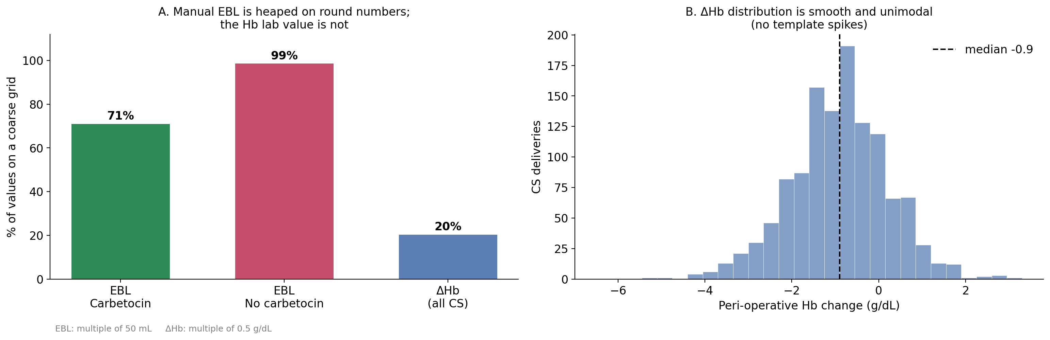
Figure S2. Peri-operative hemoglobin change tracks recorded cesarean EBL, indicating internal consistency between the objective laboratory value and the free-text field.
