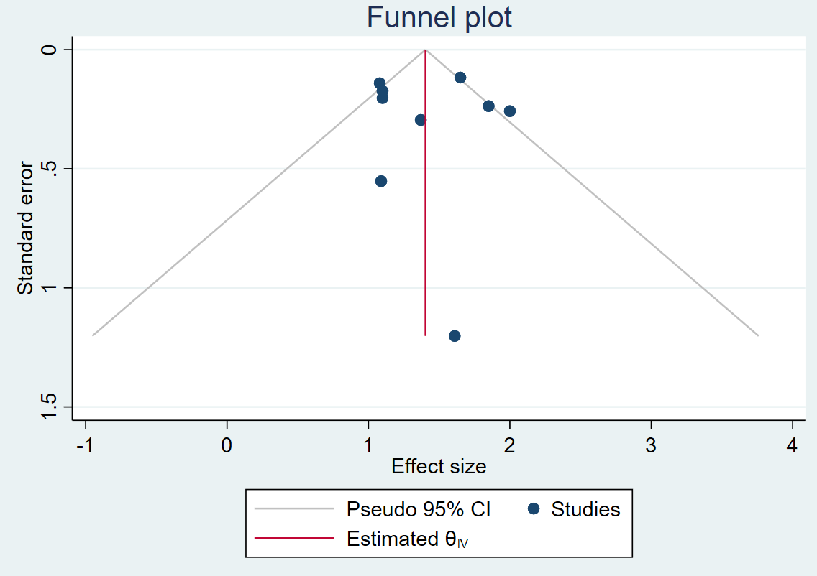
Figure S8: Funnel plot for IPV and BF initiation

Egger’s test for small study effects (p=0.866)

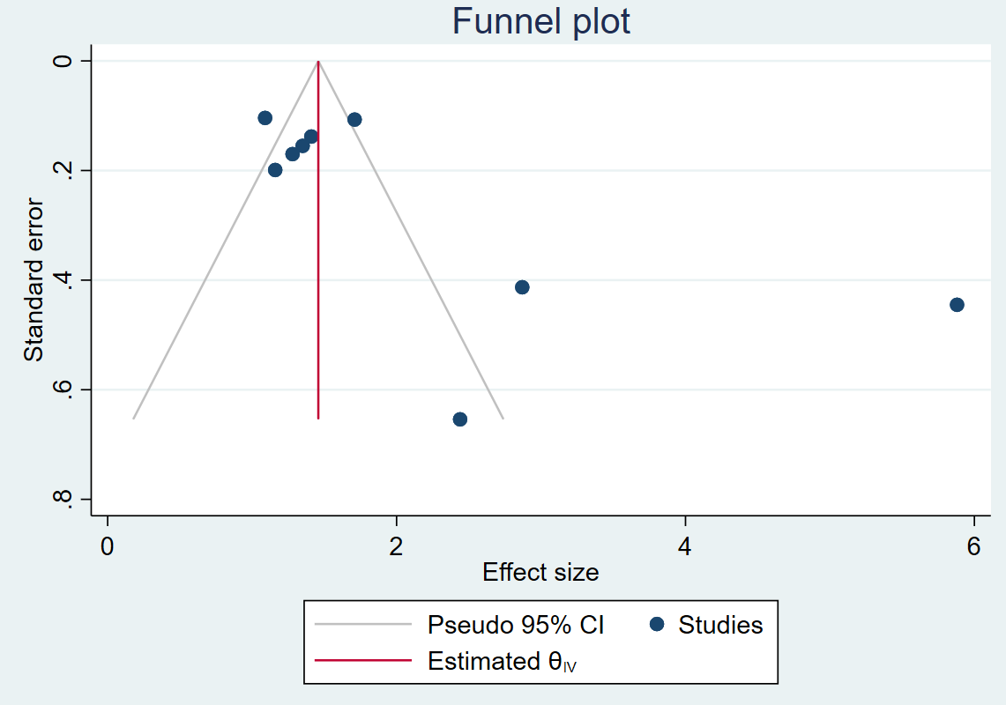
Figure S8a: IPV and EBF funnel plot and Egger’s test

Egger’s test for small study effects (p=0.019)

Trim and Fill output for IPV and EBF
Trim-and-fill analysis

 | 9
  Number of observed studies
Number of imputed studies | 0
Observed pooled effect (95% CI) | 2.089 (1.116–3.061)
Adjusted pooled effect (Observed + Imputed) (95% CI) | 2.089 (1.116–3.061)

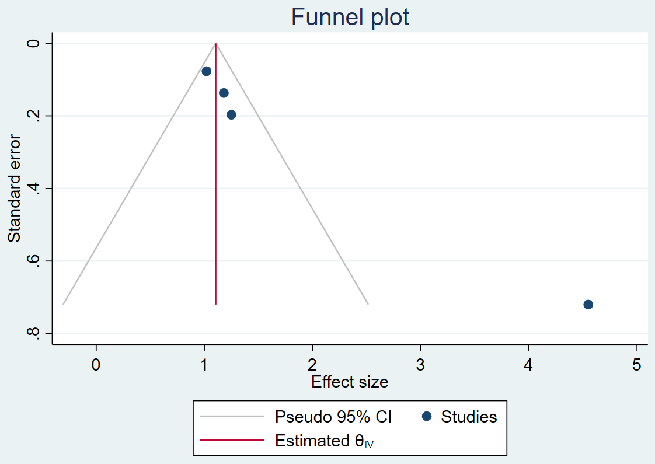
Figure S8b: IPV and BF duration

Egger’s test for small study effects (p < 0.001)

Trim-and-fill analysis

Number of observed studies

Number of imputed studies | 0
Observed pooled effect (95% CI) | 1.878 (0.377–3.380)
Adjusted pooled effect (Observed + Imputed) (95% CI) | 1.878 (0.377–3.380)

