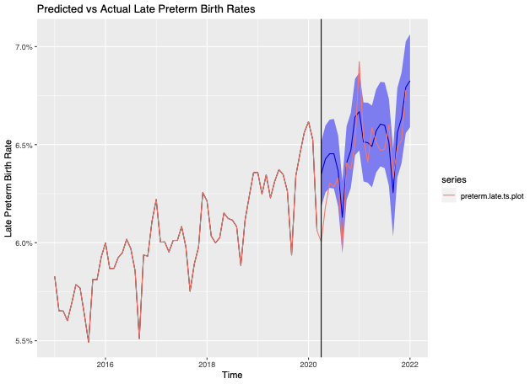
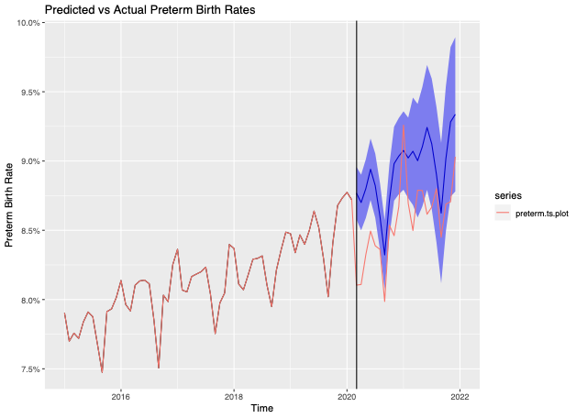
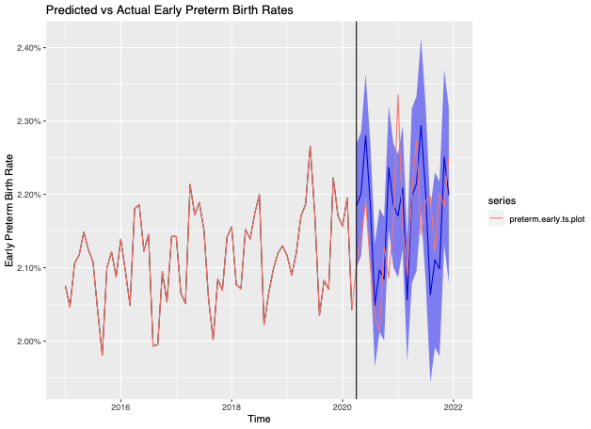
Supp Figure 1
C..
B..
A.
Late PTB Rates
Early PTB Rates
Total PTB Rates

Supp Figure 1. ARMA Models showing A) total B) early and C) late predicted PTB rates (blue line) compared to observed preterm birth rates (red line) from 2015 to 2021.

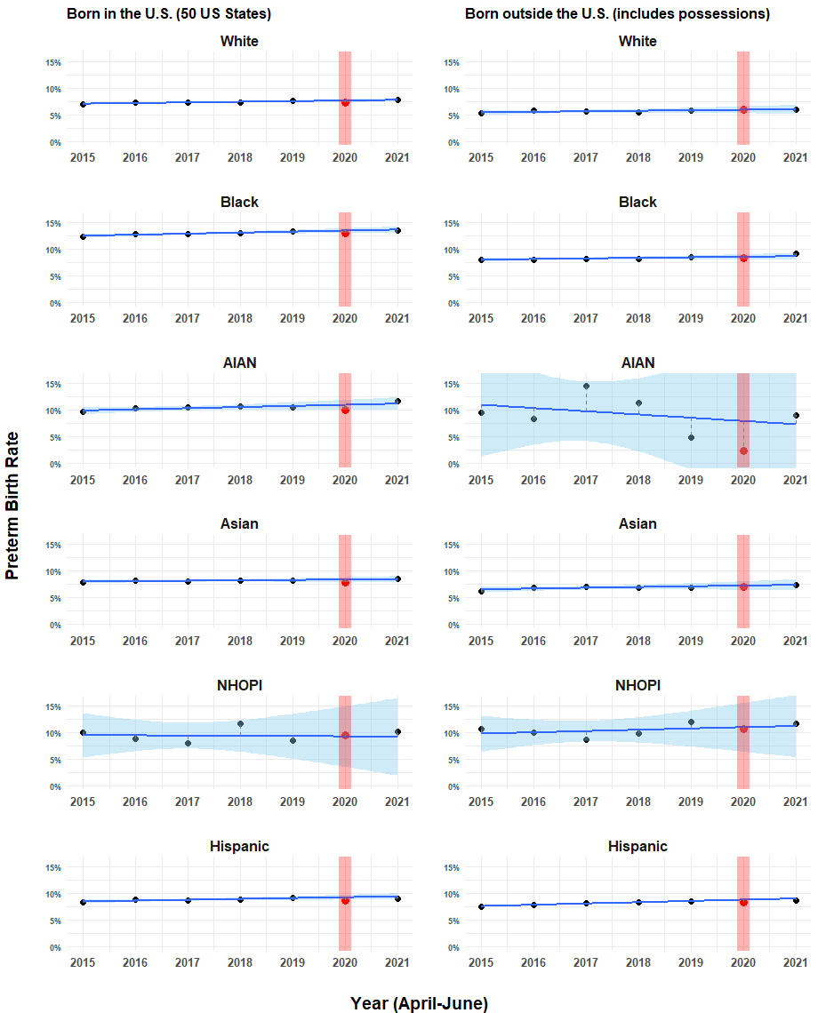
Supp Figure 2. Predicted vs. observed PTB rates by race and nativity, with uniform scales. Each dot represents the average rate from April to June for each year. Blue regression lines represent predicted average rates of PTB from April to June for each year, and blue shaded areas represent 95% CI for predicted rates. The vertical red shaded bar highlights observed data from April-June of 2020, during the pandemic.

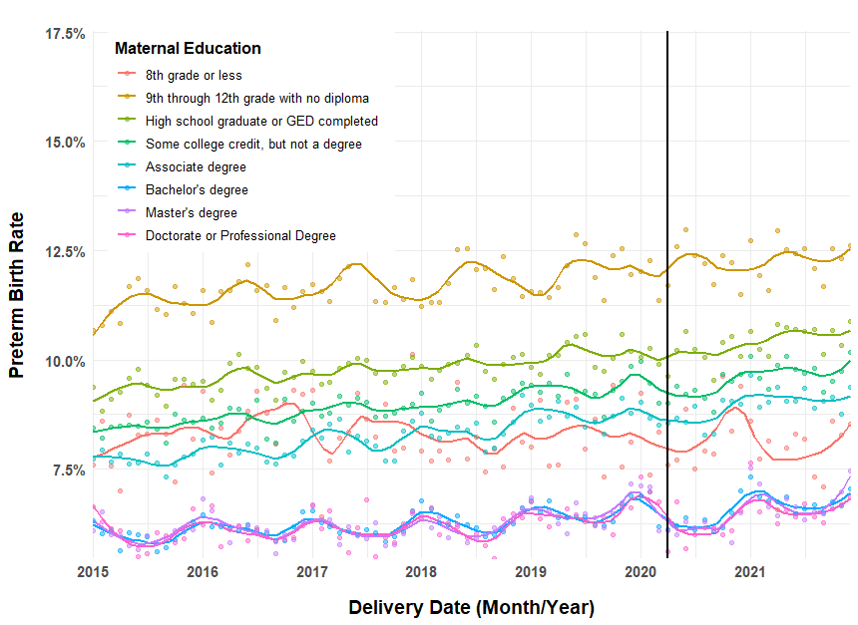
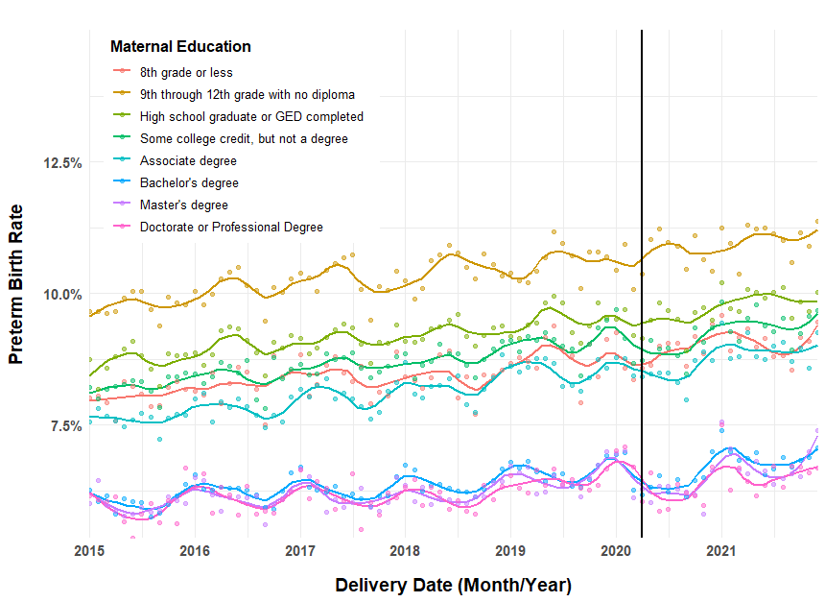
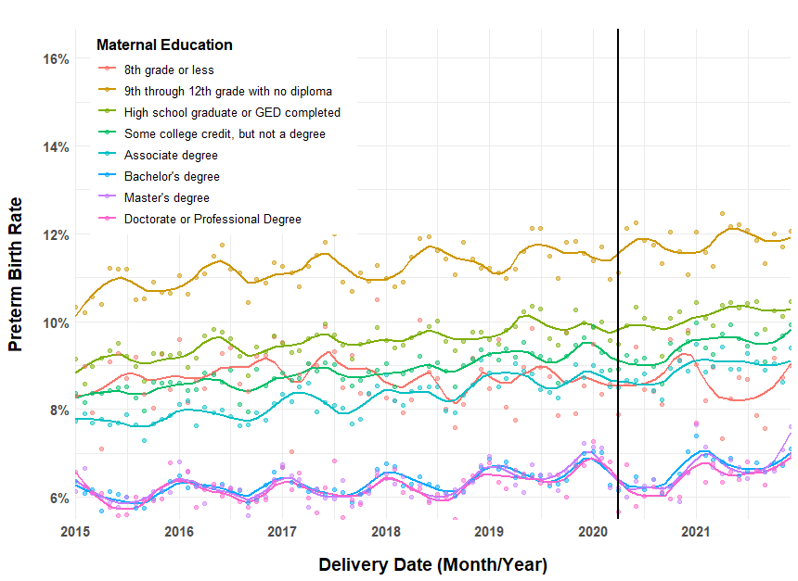
A.
B.
Supp Figure 3. PTB rates by delivery date from 2015 to 2021, stratified by education levels, A) all women; B) US-born women only, C) among non-Hispanic women only, and D) among US-born non-Hispanic women only.

PTB rate for all births by maternal education level
PTB rate for US-born women by maternal education level

D.
PTB rate for non-Hispanic US-born women by maternal education level
C.
PTB rate for non-Hispanic women by maternal education level
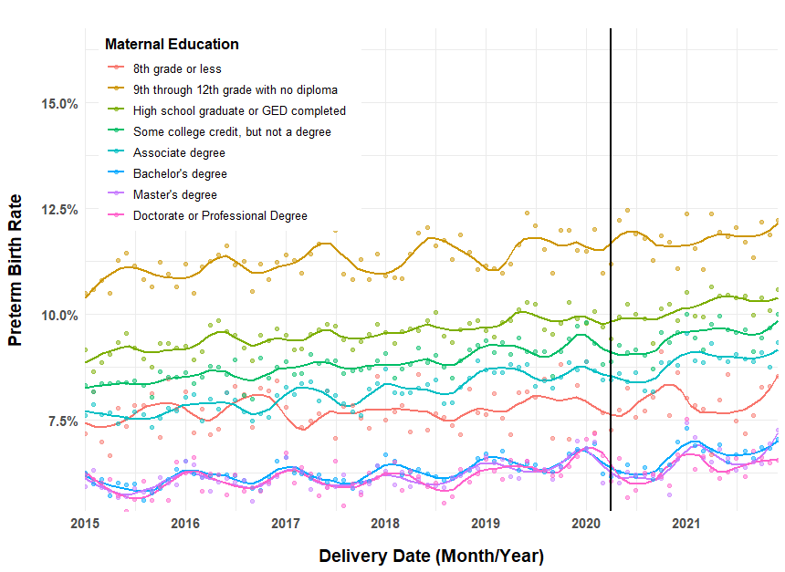

Supplemental Table 1. Demographics of mothers with 8th grade education relative to all other levels.
 | 8th Grade or Less | All Other Levels | p-values*
N | 829,550 | 24,524,625
Mean Age (years) | 29.635 | 28.869 | 0
Race, proportion
White | 0.214 | 0.529 | 0
Black | 0.066 | 0.146 | 0
Hispanic | 0.658 | 0.225 | 0
Asian | 0.045 | 0.063 | 0
AIAN | 0.003 | 0.008 | 0
NHOPI | 0.002 | 0.003 | <0.0001
More than One | 0.007 | 0.023 | 0
Unknown or Not Stated | 0.004 | 0.004 | 0.152
Nativity, proportion
US Born | 0.260 | 0.791 | 0
Foreign Born | 0.737 | 0.207 | 0
Unknown | 0.003 | 0.002 | <0.0001
Marital Status, proportion
Married | 0.469 | 0.552 | 0
Unmarried | 0.441 | 0.368 | 0
Unknown | 0.090 | 0.079 | <0.0001
WIC Status, proportion
Receiving WIC | 0.611 | 0.348 | 0
No WIC | 0.374 | 0.642 | 0
Unknown | 0.015 | 0.011 | 0
Insurance, proportion |  |  | 0
Private | 0.073 | 0.507 | 0
Public & Self Pay | 0.872 | 0.449 | 0
Unknown | 0.054 | 0.043 | 0
Induction, proportion
Yes | 0.201 | 0.285 | 0
No | 0.798 | 0.715 | 0
Unknown | 0.001 | 0.001 | <0.0001
Birth Location, proportion
Hospital | 0.921 | 0.984 | 0
Home | 0.053 | 0.010 | 0
Other & Unknown | 0.026 | 0.006 | 5.23E-10
*Note, p-values are from t-tests or ANOVAs for continuous variables, and chi-square tests for continuous variables. Due to extremely large sample sizes, all tests were significant, with the exception of unknown race.

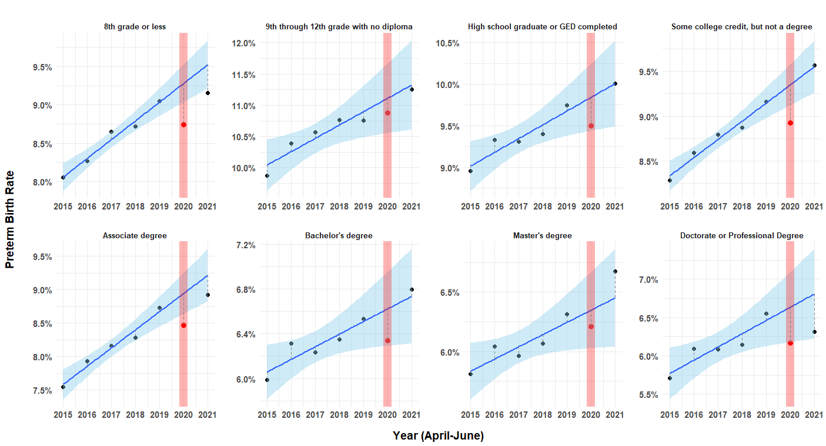
Supp Figure 4. Predicted vs. observed PTB rates by all maternal levels of education. Each dot represents the average rate from April to June for each year. Blue regression lines represent predicted average rates of PTB from April to June for each year, and blue shaded areas represent 95% CI for predicted rates. The vertical red shaded bar highlights observed data from April-June of 2020, during the pandemic. Note: the scales are different to maximize the view of changes during the pandemic.
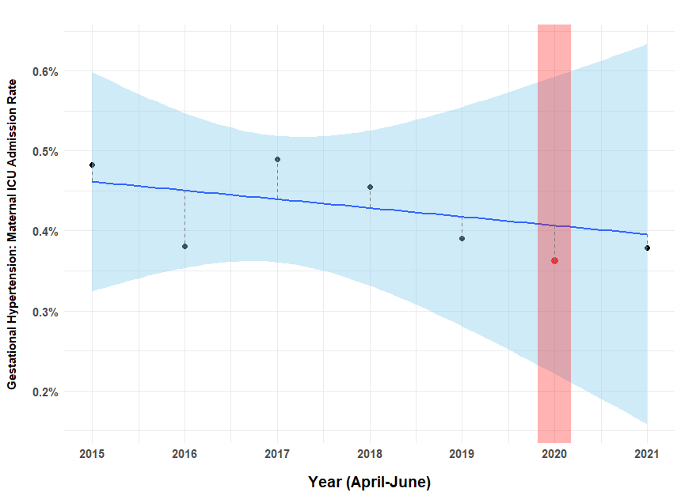
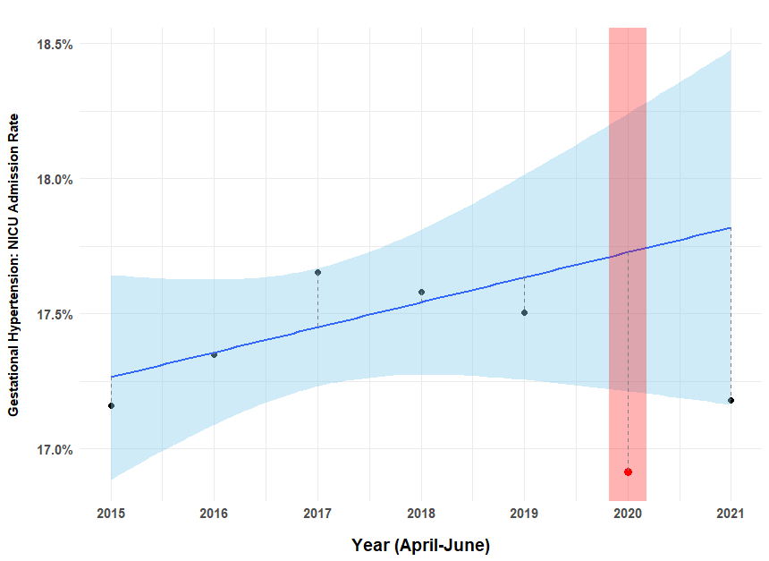

Supp Figure 5. Predicted vs. observed A) neonatal ICU and B) maternal ICU rates within women with gestational hypertension. Each dot represents the average rate from April to June for each year. Blue regression lines represent predicted average rates of PTB from April to June for each year, and blue shaded areas represent 95% CI for predicted rates. The vertical red shaded bar highlights observed data from April-June of 2020, during the pandemic. Note: the scales are different to maximize the view of changes during the pandemic.

