Figure 2
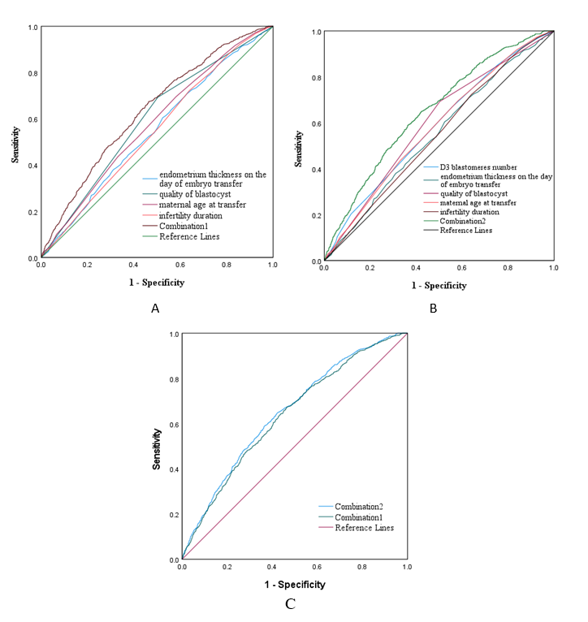
Fig.2 Receiver operating characteristic(ROC) for the LBR using the number of D3 blastomeres of blastocyst arising from in frozen-thawed blastocyst embryo transfer cycles and quality of blastocyst and endometrium thickness on the day of embryo transfer and maternal age at transfer and infertility duration.(A)Combination1 is a new variable generated when using all these factors except for the number of D3 blastomeres for combined prediction. (B)Combination2 is a new variable generated when using these all factors for combined prediction.(C) Receiver operating characteristic(ROC) of Combination1 and Combination2.AUC=area under the curve. the AUC of the ROC were improved after including the number of D3 blastomeres (Combation2-Combation1AUC=0.012,95%CI: 0.004–0.023 ,p=0.007).

