Additional files
Additional files legends

Additional file 1. Literature-based risk factors for PPD assessed in the survey.
Format: Word document (.docx).
Description: Supplementary table summarising literature-based psychosocial and biological risk factors included in the online survey.

Additional file 2. Full survey (English version).
Format: Word document (.docx).
Description: Complete questionnaire containing all survey items and response options as presented to participants via SoSciSurvey.

Additional file 3. Interpretation of Cramer’s V effect size.
Format: Word document (.docx).
Description: Supplementary table outlining the interpretation of Cramer’s V effect sizes based on degrees of freedom, adapted from Cohen (1988)

Additional file 4. Sociodemographic distribution of the study sample.
Format: Word document (.docx).
Description: Supplementary figure showing the distribution of all participants by residence (A), occupational status (B), maternal age (C), and education (D).

Additional file 5. Classification of analysed risk factors for PPD across the primary case-control analysis and sensitivity analyses. Risk factors were classified as non-significant, weak, moderate, or strong according to Bonferroni-corrected chi-square tests and Cramer's V thresholds in regard to degrees of freedom. The primary analysis compared the combined Case group (self-reported PPD and EPDS ≥13) with the Control group, while sensitivity analyses compared women with self-reported PPD and women with EPDS scores ≥13 separately against the Control group. Associations classified as non-significant did not meet the Bonferroni-corrected significance threshold (p < 0.00094).

Risk factor | References | Notes
Polycystic ovary syndrome (PCOS) | Koric et al., 2021; Schoretsanitis et al., 2022 | -
Premenstrual syndrome (PMS) | Cao et al., 2020; Gastaldon et al., 2022 | -
Hormones | Kroll-Desrosiers et al., 2017; Payne and Maguire, 2019; Schiller et al., 2015; Stewart and Vigod, 2019; Yim et al., 2015; Yu et al., 2021 | -
Irritable bowel syndrome (IBS) | - | Hypothesised based on gut-brain axis and hormonal influences
Migraine | - | Hypothesised based on hormonal mechanisms (e.g., estrogen fluctuations)
Thyroid dysfunction | - | Hypothesised based on thyroid hormone dysregulation and hormonal impact
Hyperemesis | - | Hypothesised based on hormonal changes (hCG, estrogen, progesterone)
Gestational diabetes | Gastaldon et al., 2022; Huang et al., 2015; Silverman et al., 2017) | -
Birth mode + caesarean section | Beck-Hiestermann et al., 2024; Gastaldon et al., 2022; Xu et al., 2017; Zhao and Zhang, 2020 | -
Peridural anaesthesia (PDA) | Eckerdal et al., 2020; Lim et al., 2018 | -
Sleep disturbance | Koutra et al., 2018; Okun, 2016; Zhao and Zhang, 2020 | -
History of depression | Gopalan et al., 2022; Payne and Maguire, 2019; Silverman et al., 2017; Stewart and Vigod, 2019; Yu et al., 2021; Zhao and Zhang, 2020 | -
Family history of PPD | Klein et al., 2024 | -
Prenatal depression | Hofmeier et al., 2023 | -
Relationship satisfaction | Payne and Maguire, 2019; Yu et al., 2021 | -
Support | Payne and Maguire, 2019; Stewart and Vigod, 2019; Yim et al., 2015; Yu et al., 2021; Zhao and Zhang, 2020 | -
Stress | Chai et al., 2022; Jaramillo et al., 2023; Khoury et al., 2023; Payne and Maguire, 2019; Yu et al., 2021 | -
Birth complications | Jaramillo et al., 2023; Urbanová et al., 2021; Zhao and Zhang, 2020 | -
Birth satisfaction | Jaramillo et al., 2023; Urbanová et al., 2021; Zhao and Zhang, 2020 | -
Traumatic birth | Jaramillo et al., 2023; Beck-Hiestermann et al., 2024; Kountanis et al., 2020 | -
Breastfeeding | Henshaw, 2023; Koutra et al., 2018 | -
Additional file 1.

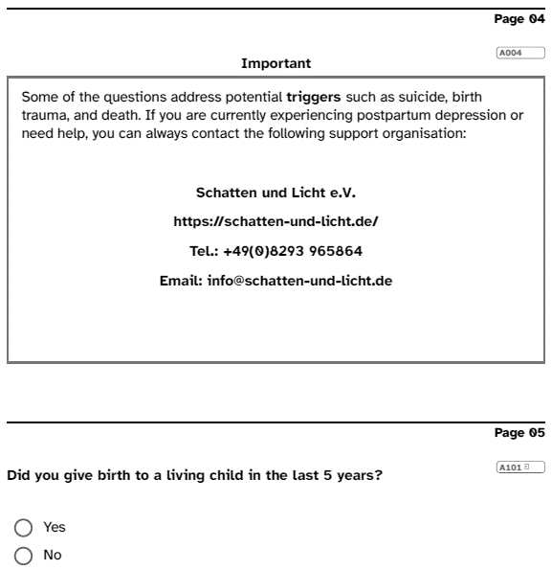
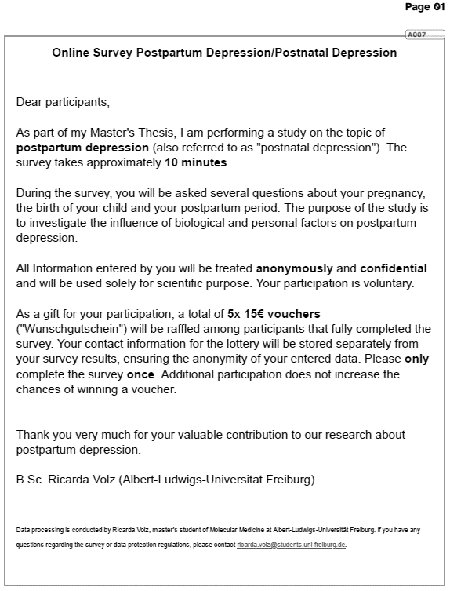
Additional file 2.

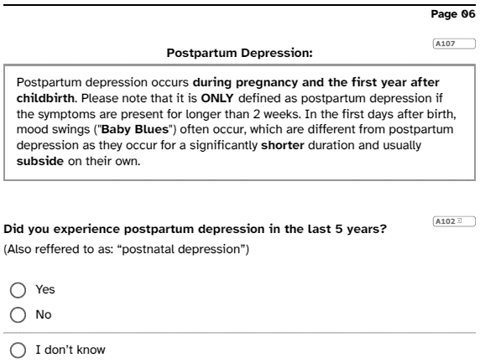
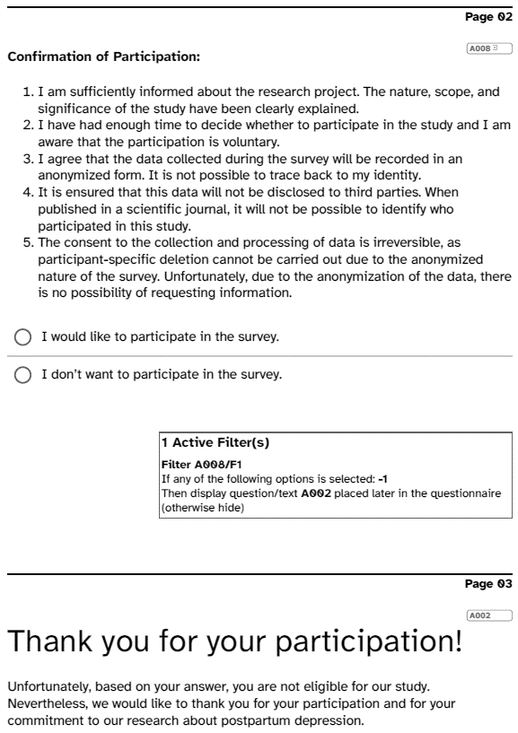

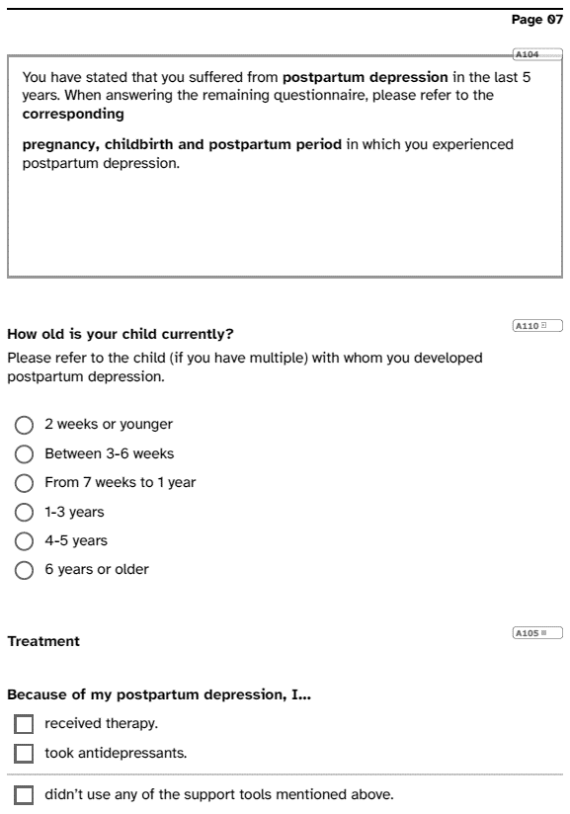
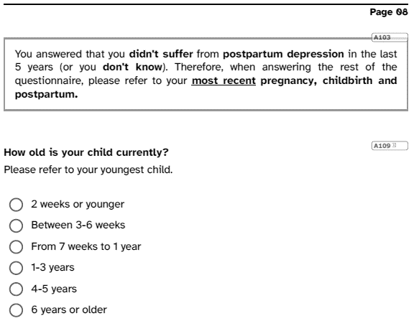
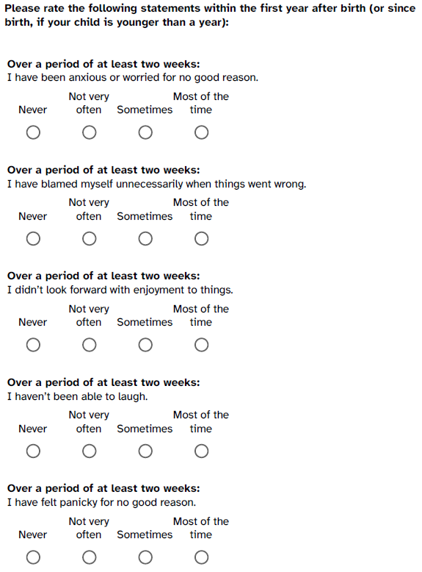
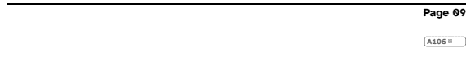
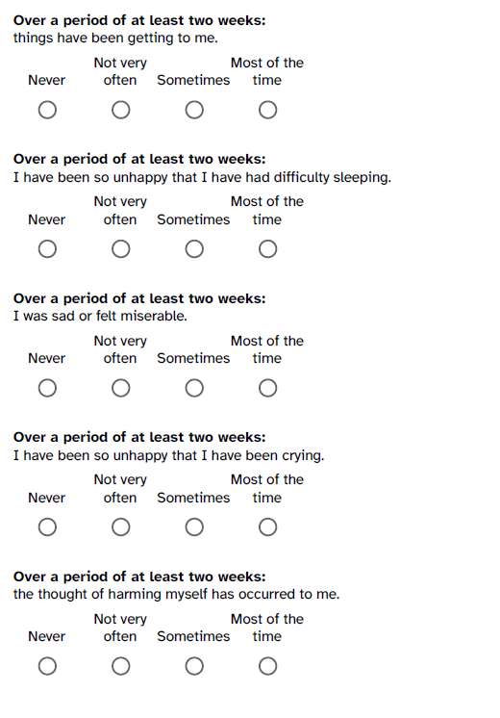

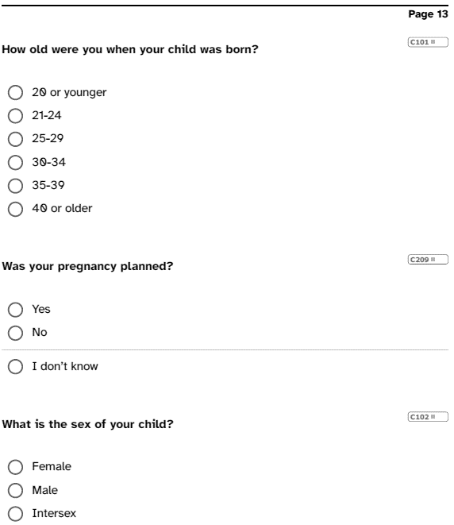
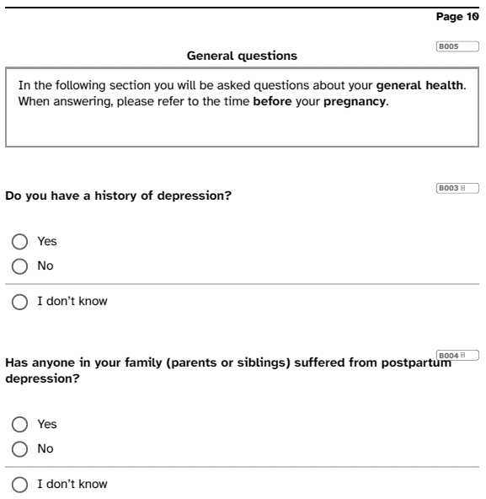
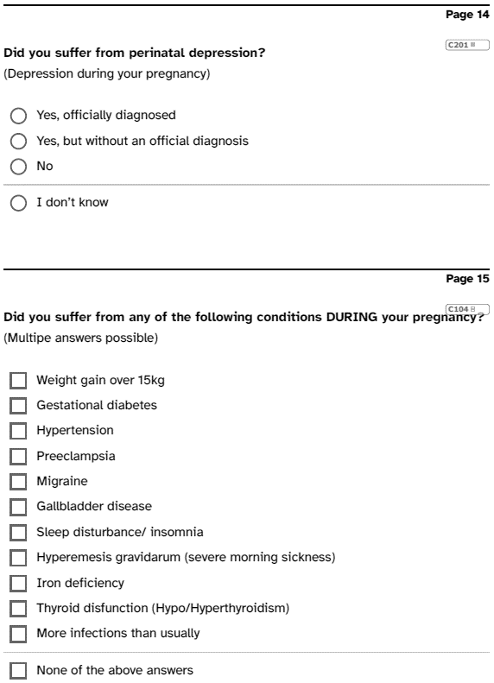
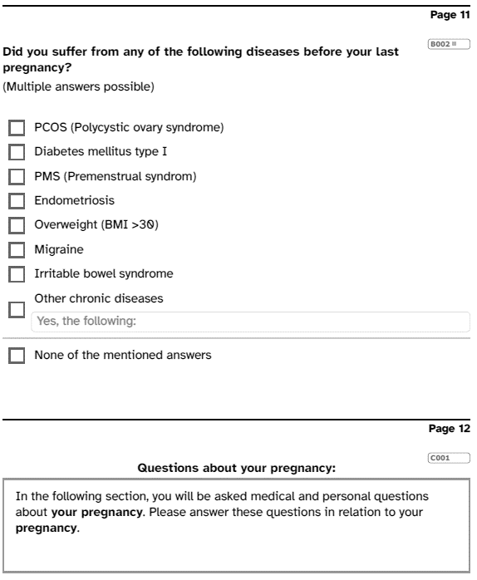

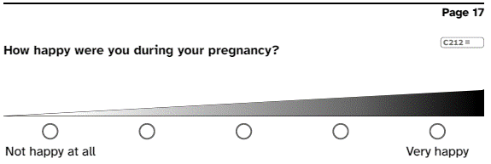
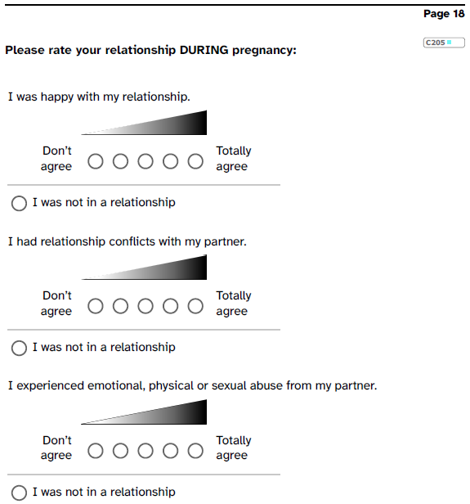
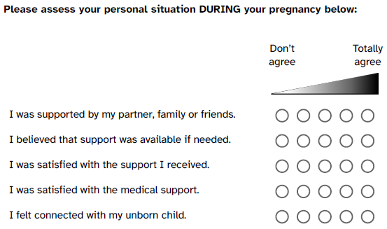
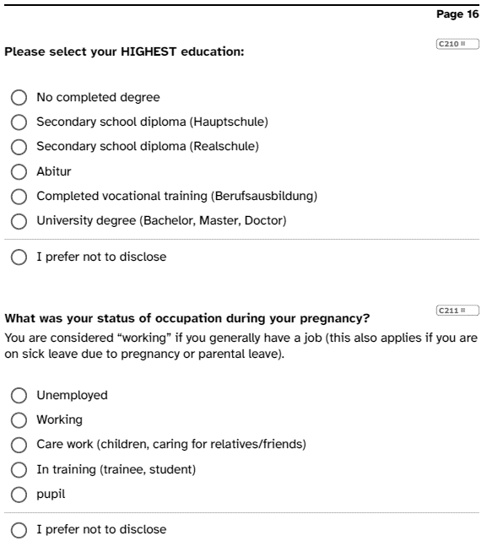

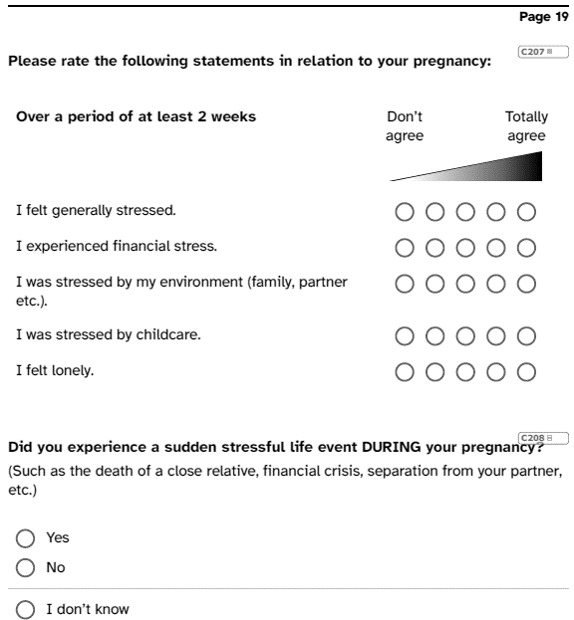

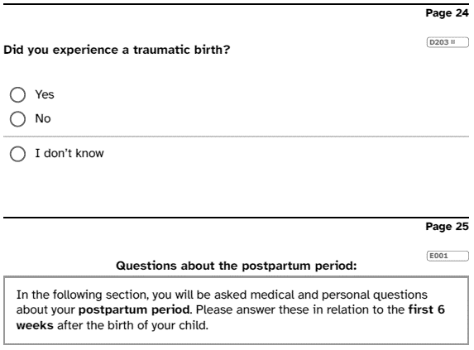
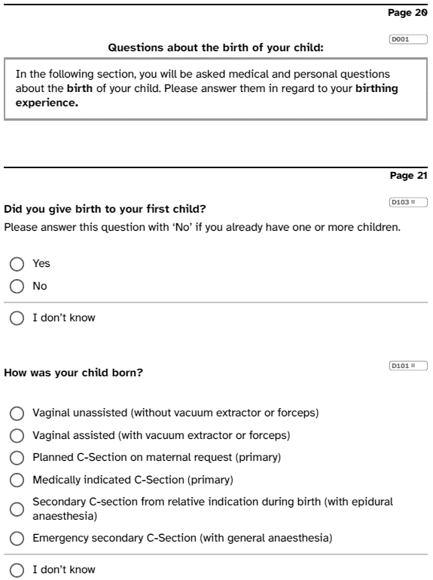
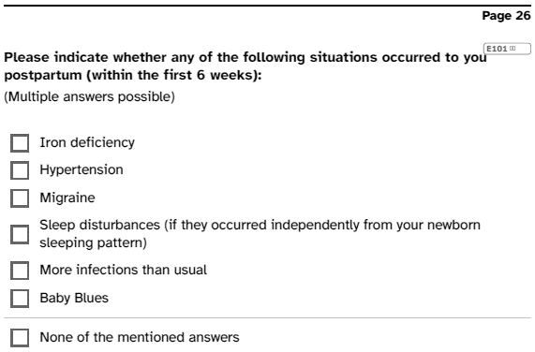
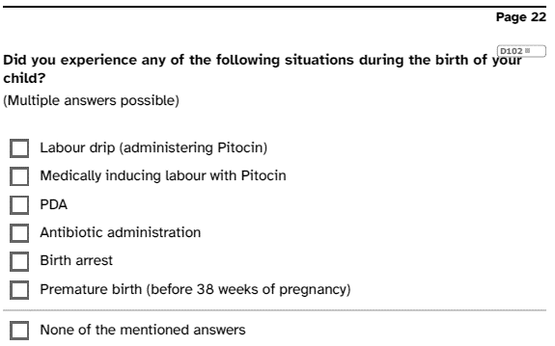

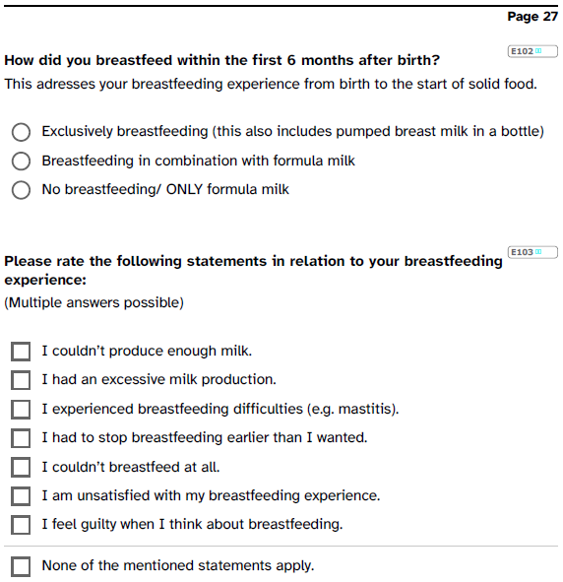
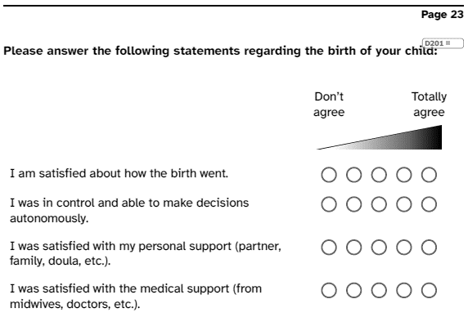

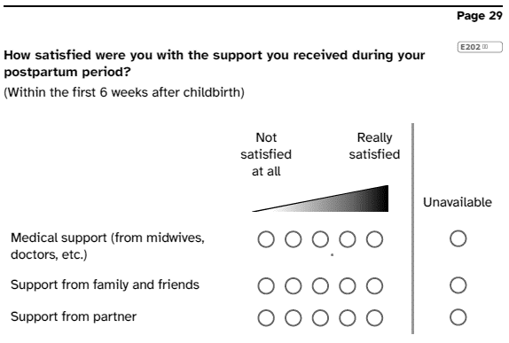
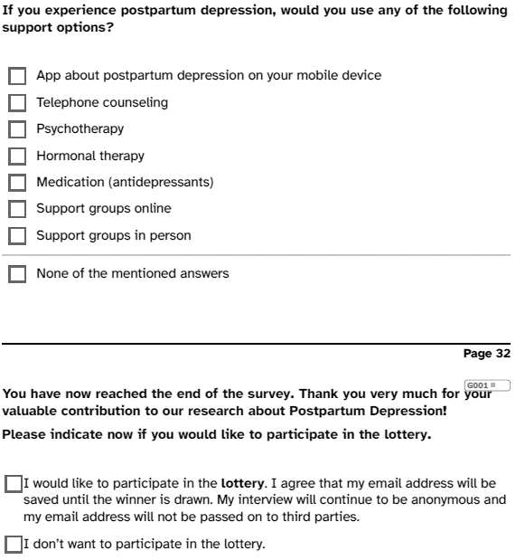
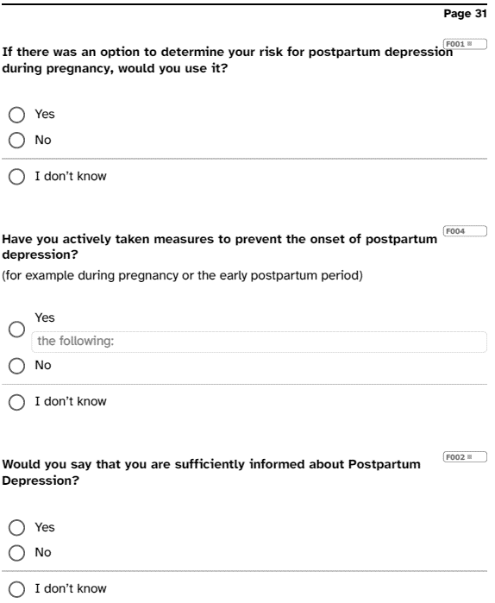
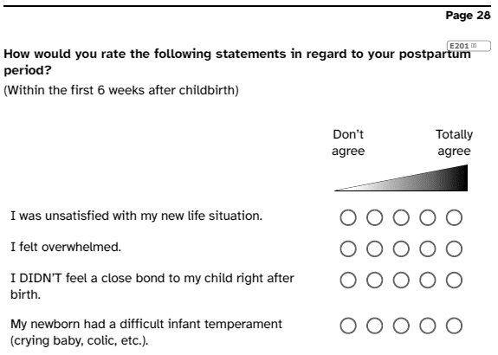

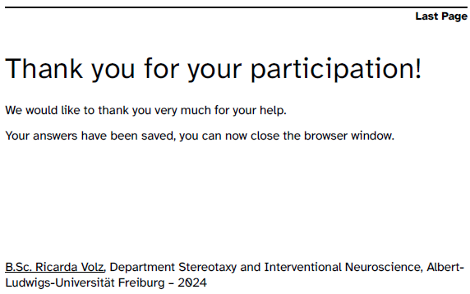

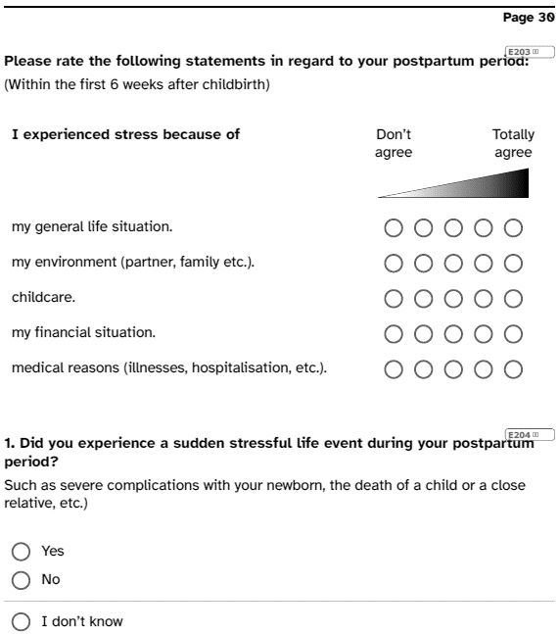

Additional file 3.
df | Neglectable association | Weak association | Moderate association | Strong association
1 | 0-0.1 | 0.1-0.3 | 0.3-0.5 | >0.5
2 | 0-0.07 | 0.07-0.21 | 0.21-0.35 | >0.35
3 | 0-0.06 | 0.06-0.17 | 0.17-0.29 | >0.29
4 | 0-0.05 | 0.05-0.15 | 0.15-0.25 | >0.25
≥5 | 0-0.04 | 0.04-0.13 | 0.13-0.22 | >0.22

Additional file 4.
A
B
C
D

Additional file 5.
Variable | Item | Case vs Control | PPD vs Control | EPDS ≥13 vs Control
History of depression |  | Moderate | Moderate | Moderate
Family history of depression |  | Weak | Weak | Weak
Conditions before pregnancy | PCOS | Non-significant | Non-significant | Non-significant
 | IBS | Non-significant | Weak | Non-significant
 | PMS | Weak | Weak | Non-significant
 | Migraine | Non-significant | Non-significant | Non-significant
Conditions during pregnancy | Prenatal diabetes | Non-significant | Non-significant | Non-significant
 | Migraine | Non-significant | Non-significant | Non-significant
 | Hyperemesis | Non-significant | Non-significant | Non-significant
 | Preeclampsia | Non-significant | Non-significant | Non-significant
 | Thyroid dysfunction | Non-significant | Non-significant | Non-significant
 | Sleep disturbances | Weak | Weak | Weak
 | More sick than usual | Non-significant | Non-significant | Non-significant
Prenatal depression |  | Strong | Strong | Strong
Support during pregnancy | “I believed that support was available if needed” | Moderate | Moderate | Non-significant
 | “I was satisfied with the support I received” | Moderate | Moderate | Moderate
Chronic stress during pregnancy | “I felt generally stressed” | Strong | Strong | Strong
 | “I experienced financial stress” | Moderate | Moderate | Non-significant
 | “I was stressed by my environment” | Moderate | Moderate | Moderate
 | “I felt lonely” | Strong | Strong | Strong
Episodic stress during pregnancy |  | Non-significant | Non-significant | Non-significant
Happiness during pregnancy |  | Strong | Strong | Moderate
Birth mode |  | Non-significant | Non-significant | Non-significant
Birth satisfaction | “I am satisfied about how the birth went” | Moderate | Strong | Non-significant
 | “I was in control and able to make decisions autonomously” | Moderate | Strong | Moderate
 | “I was satisfied with my personal support” | Moderate | Moderate | Non-significant
 | “I was satisfied with the medical support” | Moderate | Strong | Non-significant
Interventions during birth | Labour drip | Non-significant | Non-significant | Non-significant
 | Epidural anaesthesia | Weak | Non-significant | Non-significant
 | Birth arrest | Non-significant | Non-significant | Non-significant
 | Premature birth | Non-significant | Non-significant | Non-significant
Traumatic birth |  | Moderate | Moderate | Weak
Conditions postpartum | Hypertension | Non-significant | Non-significant | Non-significant
 | Migraine | Non-significant | Non-significant | Non-significant
 | Sleep disturbances postpartum | Moderate | Moderate | Moderate
 | More sick than usual | Non-significant | Non-significant | Non-significant
Breastfeeding until solid foods |  | Weak | Weak | Non-significant
Breastfeeding difficulties | “I couldn't produce enough milk” | Non-significant | Weak | Non-significant
 | “I couldn't breastfeed at all” | Non-significant | Non-significant | Non-significant
 | “I stopped earlier than I wanted” | Weak | Weak | Non-significant
 | “I am unsatisfied with my breastfeeding experience” | Weak | Weak | Weak
 | “I feel guilty about my breastfeeding experience” | Weak | Weak | Weak
Support postpartum | Medical support postpartum | Strong | Strong | Moderate
 | Support from family and friends postpartum | Strong | Strong | Moderate
 | Support from partner postpartum | Moderate | Moderate | Moderate
Chronic stress postpartum | “Stressed by general life situation” | Strong | Strong | Moderate
 | “Stressed by the environment” | Strong | Strong | Moderate
 | “Stressed by the financial situation” | Moderate | Moderate | Moderate
 | “Stressed by medical reasons” | Moderate | Moderate | Non-significant
Episodic stress postpartum |  | Non-significant | Weak | Non-significant

