Contents

Search Strategies 2
Supplementary Table 1. Detailed Search Strategies for All Databases 2
Quality Assessment 4
Supplementary Figure 1. Risk of bias in randomized controlled trial according to ROB -2 Tool and non-randomized studies according to the Cochrane ROBINS-I tool (Risk Of Bias In Non-randomized Studies of Interventions). 4
Supplementary Table 2. Certainty of Evidence Assessed Using the GRADE Approach 5
Supplementary Table 3. Summary of Included Studies 7
Results 9
Supplementary Figure 2. Leave-one-out sensitivity analysis showing the impact of omitting individual studies on the pooled risk ratio for the outcome respiratory distress syndrome and corresponding heterogeneity (I²). 9
Supplementary Figure 3. Leave-one-out sensitivity analysis demonstrating the impact of omitting individual studies on the pooled effect estimate of Neonatal Hypoglycemia. 10
Supplementary Figure 4. Leave-one-out sensitivity analysis demonstrating the impact of omitting individual studies on the pooled effect estimate of Neonatal Jaundice. 10
Supplementary Figure 5. Leave-one-out sensitivity analysis demonstrating the impact of omitting individual studies on the pooled effect estimate of NICU Admissions 10
Supplementary Figure 6. Leave-one-out sensitivity analysis demonstrating the impact of omitting individual studies on the pooled effect estimate of Transient Tachypnea of the Newborn 11
Supplementary Figure 7. Leave-one-out sensitivity analysis demonstrating the impact of omitting individual studies on the pooled effect estimate of Use of Continuous Positive Airway Pressure (CPAP). 11
Supplementary Figure 8. Leave-one-out sensitivity analysis demonstrating the impact of omitting individual studies on the pooled effect estimate of Birth Weight 11

Search Strategies

Supplementary Table 1. Detailed Search Strategies for All Databases
PUBMED
("Pregnancy, Twin"[Mesh] OR "twin pregnancy" OR "twin pregnancies" OR "pregnancy with twins" OR twinning rate) AND ("Betamethasone"[Mesh] OR "Antenatal Corticosteroids"[Mesh] OR "corticosteroid" OR "corticosteroids" OR "adrenal cortex hormone" OR "adrenal cortical steroid" OR "adrenocortical steroid") AND (randomized controlled trial OR controlled clinical trial OR clinical trial OR clinical drug trial OR major clinical trial OR trial, clinical OR randomized OR randomised controlled study OR randomised controlled trial OR randomized controlled study OR trial, randomized controlled OR observational study OR observational studies OR nonexperimental study OR non experimental study OR nonexperimental studies OR non experimental studies OR observation study OR observation studies OR retrospective study OR retrospective studies OR retrospective design OR study, retrospective OR prospective study OR prospective studies OR study, prospective OR prospective method)
EMBASE
('twin pregnancy'/exp OR 'pregnancy with twins' OR 'pregnancy, twin' OR 'twin pregnancies' OR 'twin pregnancy' OR 'twinning rate') AND ('antenatal corticosteroid'/exp OR ('corticosteroid'/exp OR 'adrenal cortex hormone' OR 'adrenal cortex hormones' OR 'adrenal cortical hormone' OR 'adrenal cortical hormones' OR 'adrenal cortical steroid' OR 'adrenal steroid' OR 'adrenal steroid hormone' OR 'adreno cortical steroid' OR 'adreno corticosteroid' OR 'adrenocortical hormone' OR 'adrenocortical steroid' OR 'adrenocorticosteroid' OR 'cortical steroid' OR 'cortico steroid' OR 'corticoid' OR 'corticosteroid' OR 'corticosteroid agent' OR 'corticosteroid calcium' OR 'corticosteroid hormone' OR 'corticosteroids' OR 'corticosteroids, inhalation' OR 'corticosteroids, ophthalmic' OR 'corticosteroids, otic' OR 'corticosteroids, systemic' OR 'corticosteroids, topical' OR 'dermocorticosteroid' OR 'fluorinated corticosteroid')) AND ('randomized controlled trial'/exp OR 'clinical trial'/exp OR 'observational study'/exp OR 'retrospective study'/exp OR 'prospective study'/exp)
COCHRANE
ID Search Hits
#1 MeSH descriptor: [Pregnancy, Twin] explode all trees
#2 twin pregnancy
#3 twin pregnancies
#4 pregnancy with twins
#5 twinning rate
#6 #1 OR #2 OR #3 OR #4 OR #5
#7 MeSH descriptor: [Betamethasone] explode all trees
#8 MeSH descriptor: [Adrenal Cortex Hormones] explode all trees
#9 Antenatal Corticosteroids
#10 corticosteroids
#11 adrenal cortex hormone
#12 adrenal cortical steroid
#13 adrenocortical steroid
#14 #7 OR #8 OR #9 OR #10 OR #11 OR #12 OR #13
#15 #6 AND #14
SCOPUS
TITLE-ABS-KEY(("Pregnancy, Twin" OR "twin pregnancy" OR "twin pregnancies" OR "pregnancy with twins" OR twinning rate) AND ("Betamethasone" OR "Antenatal Corticosteroids" OR "corticosteroid" OR "corticosteroids" OR "adrenal cortex hormone" OR "adrenal cortical steroid" OR "adrenocortical steroid"))

Quality Assessment

Supplementary Figure 1. Risk of bias in randomized controlled trial according to ROB -2 Tool and non-randomized studies according to the Cochrane ROBINS-I tool (Risk Of Bias In Non-randomized Studies of Interventions).

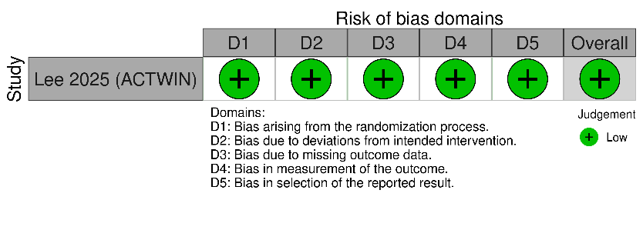
ROB 2

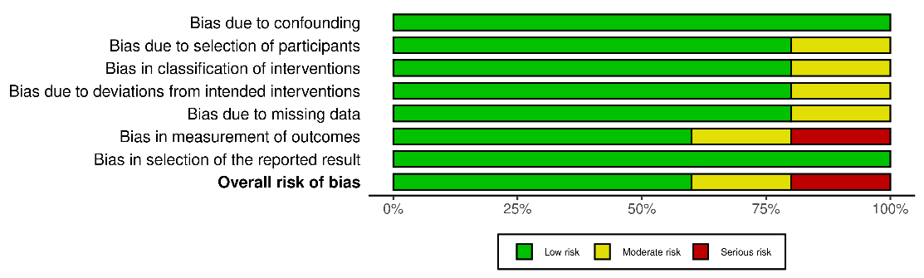
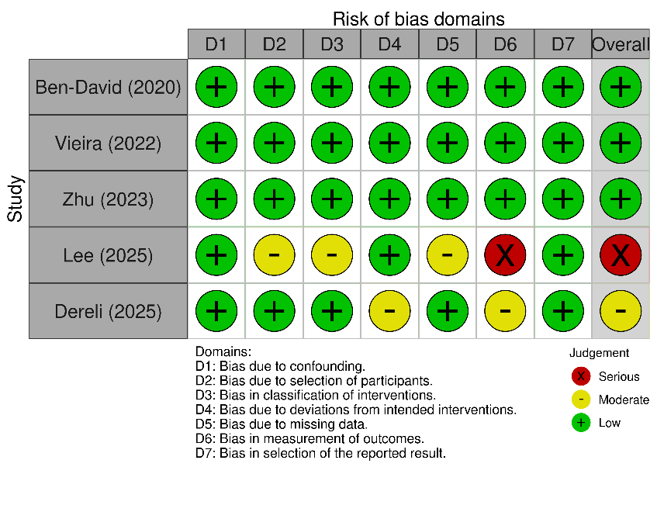
ROBINS - I

Supplementary Table 2. Certainty of Evidence Assessed Using the GRADE Approach

Outcomes | Anticipated absolute effects* (95% CI) |  | Relative effect  (95% CI) | № of participants  (studies) | Certainty of the evidence  (GRADE) | Comments
Outcomes | Risk with Non-ACS approach | Risk with Antenatal Corticosteroid
Birth Weight |  | MD 0.08 Kg lower  (0.15 lower to 0.01 lower) | - | 15208  (6 non-randomised studies) | ⨁◯◯◯  Very low^{a,b} | Antenatal Corticosteroid may reduce/have little to no effect on birth weight but the evidence is very uncertain.
Composite Respiratory Morbidity | 123 per 1,000 | 123 per 1,000  (77 to 196) | RR 1.00  (0.63 to 1.60) | 2752  (3 non-randomised studies) | ⨁⨁◯◯  Low^{c,d} | Antenatal Corticosteroid may result in little to no difference in Composite Respiratory Morbidity.
Continuous Positive Airway Pressure (CPAP) Use | 53 per 1,000 | 54 per 1,000  (21 to 140) | RR 1.03  (0.39 to 2.67) | 4726  (4 non-randomised studies) | ⨁◯◯◯  Very low^{e,f} | Antenatal Corticosteroid may increase/have little to no effect on continuous positive airway pressure (CPAP) use but the evidence is very uncertain.
5-Minute Apgar Score | 20 per 1,000 | 44 per 1,000  (1 to 1,000) | RR 2.20  (0.04 to 135.81) | 1584  (2 non-randomised studies) | ⨁◯◯◯  Very low^{f,g} | The evidence is very uncertain about the effect of Antenatal Corticosteroid on 5-minute Apgar score.
Neonatal Hypoglycemia | 110 per 1,000 | 175 per 1,000  (127 to 243) | RR 1.60  (1.16 to 2.22) | 5758  (5 non-randomised studies) | ⨁⨁⨁◯  Moderate^{h} | Antenatal Corticosteroid probably results in an increase in neonatal hypoglycemia.
Neonatal Jaundice | 229 per 1,000 | 252 per 1,000  (206 to 307) | RR 1.10  (0.90 to 1.34) | 4726  (4 non-randomised studies) | ⨁⨁◯◯  Low^{f,i} | Antenatal Corticosteroid may result in little to no difference in neonatal jaundice.
Mechanical Ventilation | 19 per 1,000 | 23 per 1,000  (12 to 44) | RR 1.19  (0.61 to 2.30) | 4726  (4 non-randomised studies) | ⨁⨁⨁◯  Moderate^{f} | Antenatal Corticosteroid probably results in little to no difference in mechanical ventilation.
Neonatal Intensive Care Unit (NICU) Admission | 316 per 1,000 | 437 per 1,000  (323 to 592) | RR 1.38  (1.02 to 1.87) | 5758  (5 non-randomised studies) | ⨁⨁◯◯  Low^{j} | Antenatal Corticosteroid likely results in an increase in neonatal intensive care unit (NICU) admission.
Respiratory Distress Syndrome (RDS) | 43 per 1,000 | 62 per 1,000  (27 to 144) | RR 1.44  (0.62 to 3.32) | 5758  (5 non-randomised studies) | ⨁◯◯◯  Very low^{f,k} | The evidence is very uncertain about the effect of Antenatal Corticosteroid on respiratory distress syndrome (RDS).
Transient Tachypnea of the Newborn (TTN) | 130 per 1,000 | 125 per 1,000  (62 to 249) | RR 0.96  (0.48 to 1.92) | 4726  (4 non-randomised studies) | ⨁◯◯◯  Very low^{f,l} | Antenatal Corticosteroid may increase/have little to no effect on transient tachypnea of the newborn (TTN) but the evidence is very uncertain.
*The risk in the intervention group (and its 95% confidence interval) is based on the assumed risk in the comparison group and the relative effect of the intervention (and its 95% CI).
CI: confidence interval; MD: mean difference; RR: risk ratio
GRADE Working Group grades of evidence
High certainty: we are very confident that the true effect lies close to that of the estimate of the effect.
Moderate certainty: we are moderately confident in the effect estimate: the true effect is likely to be close to the estimate of the effect, but there is a possibility that it is substantially different.
Low certainty: our confidence in the effect estimate is limited: the true effect may be substantially different from the estimate of the effect.
Very low certainty: we have very little confidence in the effect estimate: the true effect is likely to be substantially different from the estimate of effect.

Explanations
a. Downgraded one level for risk of bias because Lee et al. (2025) contributed the vast majority of the total population and was judged to be at high risk of bias, reducing confidence in the pooled estimate.
b. Downgraded two levels for inconsistency due to considerable statistical heterogeneity among the included studies (I² = 94.5%), indicating marked variability in the observed effect estimates.
c. Downgraded one level for inconsistency due to substantial statistical heterogeneity among the included studies (I² = 75.0%), indicating variability in the observed effect estimates.
d. Downgraded one level for inconsistency due to substantial statistical heterogeneity among the included studies (I² = 74.0%), indicating variability in the observed effect estimates.
e. Downgraded two levels for inconsistency due to considerable statistical heterogeneity among the included studies (I² = 92.0%), indicating marked variability in the observed effect estimates.
f. Downgraded one level for imprecision because the 95% confidence interval crossed the line of no effect, indicating uncertainty in the estimated treatment effect.
g. Downgraded two levels for inconsistency due to considerable statistical heterogeneity among the included studies (I² = 83.0%), indicating marked variability in the observed effect estimates.
h. Downgraded one level for inconsistency due to substantial statistical heterogeneity among the included studies (I² = 70.1%), indicating variability in the observed effect estimates.
i. Downgraded one level for inconsistency due to moderate statistical heterogeneity among the included studies (I² = 57.9%), indicating variability in the observed effect estimates.
j. Downgraded two levels for inconsistency due to considerable statistical heterogeneity among the included studies (I² = 88.9%), indicating marked variability in the observed effect estimates.
k. Downgraded two levels for inconsistency due to considerable statistical heterogeneity among the included studies (I² = 85.0%), indicating marked variability in the observed effect estimates.
l. Downgraded two levels for inconsistency due to considerable statistical heterogeneity among the included studies (I² = 90.6%), indicating marked variability in the observed effect estimates.

Supplementary Table 3. Summary of Included Studies

Study ID | Study Type | Region | Duration | Intervention | Neonates (n) | Inclusion Criteria | Primary Outcome | Secondary Outcomes | Key Results
Zhu 2023 | Retrospective Cohort | China | 2013–2023 | Dexamethasone vs. None | 3,948 | Prenatal medical record established at the study hospital; late preterm pregnancy | Composite neonatal respiratory morbidity | CPAP use, severe asphyxia, transient tachypnoea | 271 (89.4%) in the ACS group delivered before 37 weeks vs. 711 (42%) in the non-ACS group. The ACS group had lower birth weight than the non-ACS group.
Vieira 2022 | Retrospective Cohort | USA | 2012–2018 | Betamethasone vs. None | 2,064 | Late preterm neonates with no prior ACS exposure | Neonatal respiratory complications and hypoglycaemia | — | Full course vs. no treatment: did not reduce respiratory complications in twins (OR=0.42, p=0.16); increased hypoglycaemia in twins (OR=2.18, p=0.02).
Lee 2025 | Retrospective Cohort | Korea | 2007–2010 | ACS vs. None | 9,450 | Twin children born at 34+0–36+6 weeks who underwent NHSP-IC screening, identified from the KNHI database | Composite adverse neurodevelopmental outcome (autism, cerebral palsy, speech articulation disorder, developmental disorders of scholastic skills or motor function) via ICD-10 codes | — | Risk of long-term adverse neurodevelopmental outcomes did not increase following ACS administration in late preterm twin children.
Dereli 2025 | Retrospective Cohort | Turkey | 2017–2021 | ACS vs. None | 704 | Women with dichorionic-diamniotic twins with a late preterm birth | Composite neonatal outcome: 5-min Apgar score, NICU admission, hypoglycaemia, phototherapy, TTN, RDS, mechanical ventilation, CPAP | — | ACS at or after 34 weeks was not associated with improved neonatal outcomes in DCDA twins born late preterm, and was associated with a higher rate of neonatal hypoglycaemia compared to no treatment.
David 2020 | Retrospective Cohort | Israel | 2016–2018 | Betamethasone vs. None | 580 | All women with twin pregnancies with late preterm live deliveries at the study hospital during the study period | Composite neonatal respiratory morbidity | NICU admission, jaundice requiring phototherapy, hypoglycaemia (blood glucose ≤45 mg/dL) | Late preterm ACS in twin pregnancies did not reduce respiratory morbidity but was associated with a higher risk of neonatal hypoglycaemia.
Lee 2025 (ACTWIN) | Randomised Clinical Trial | Korea | 2018–2024 | Betamethasone vs. Placebo | 1,620 | Twin-pregnant women at 34+0–36+5 weeks at risk of late preterm delivery, enrolled at 8 university-based centres | Perinatal death within 72 h after birth or severe neonatal respiratory morbidity | Mild neonatal respiratory morbidities, other neonatal respiratory morbidities, other neonatal complications, maternal complications | Severe respiratory morbidity or perinatal death was lower with betamethasone (39 [4.8%] vs 60 [7.5%]; RR 0.64, 95% CI 0.42–0.98). CPAP ≥2 h (RR 0.58) and transient tachypnoea (RR 0.47) were also reduced; benefit was confined to delivery ≥12 h to <7 d after the first dose. Neonatal hypoglycaemia was increased (128 [15.6%] vs 94 [11.7%]; RR 1.33, 95% CI 1.01–1.75).
Abbreviations: ACS = Antenatal Corticosteroids | RDS = Respiratory Distress Syndrome | TTN = Transient Tachypnoea of the Newborn | IVH = Intraventricular Haemorrhage | CPAP = Continuous Positive Airway Pressure | NEC = Necrotising Enterocolitis | GDM = Gestational Diabetes Mellitus | SGA = Small for Gestational Age | DCDA = Dichorionic-Diamniotic | PPROM = Preterm Premature Rupture of Membranes
Supplementary Table 3: Summary of Included Studies

Results

Supplementary Figure 2. Leave-one-out sensitivity analysis showing the impact of omitting individual studies on the pooled risk ratio for the outcome respiratory distress syndrome and corresponding heterogeneity (I²).
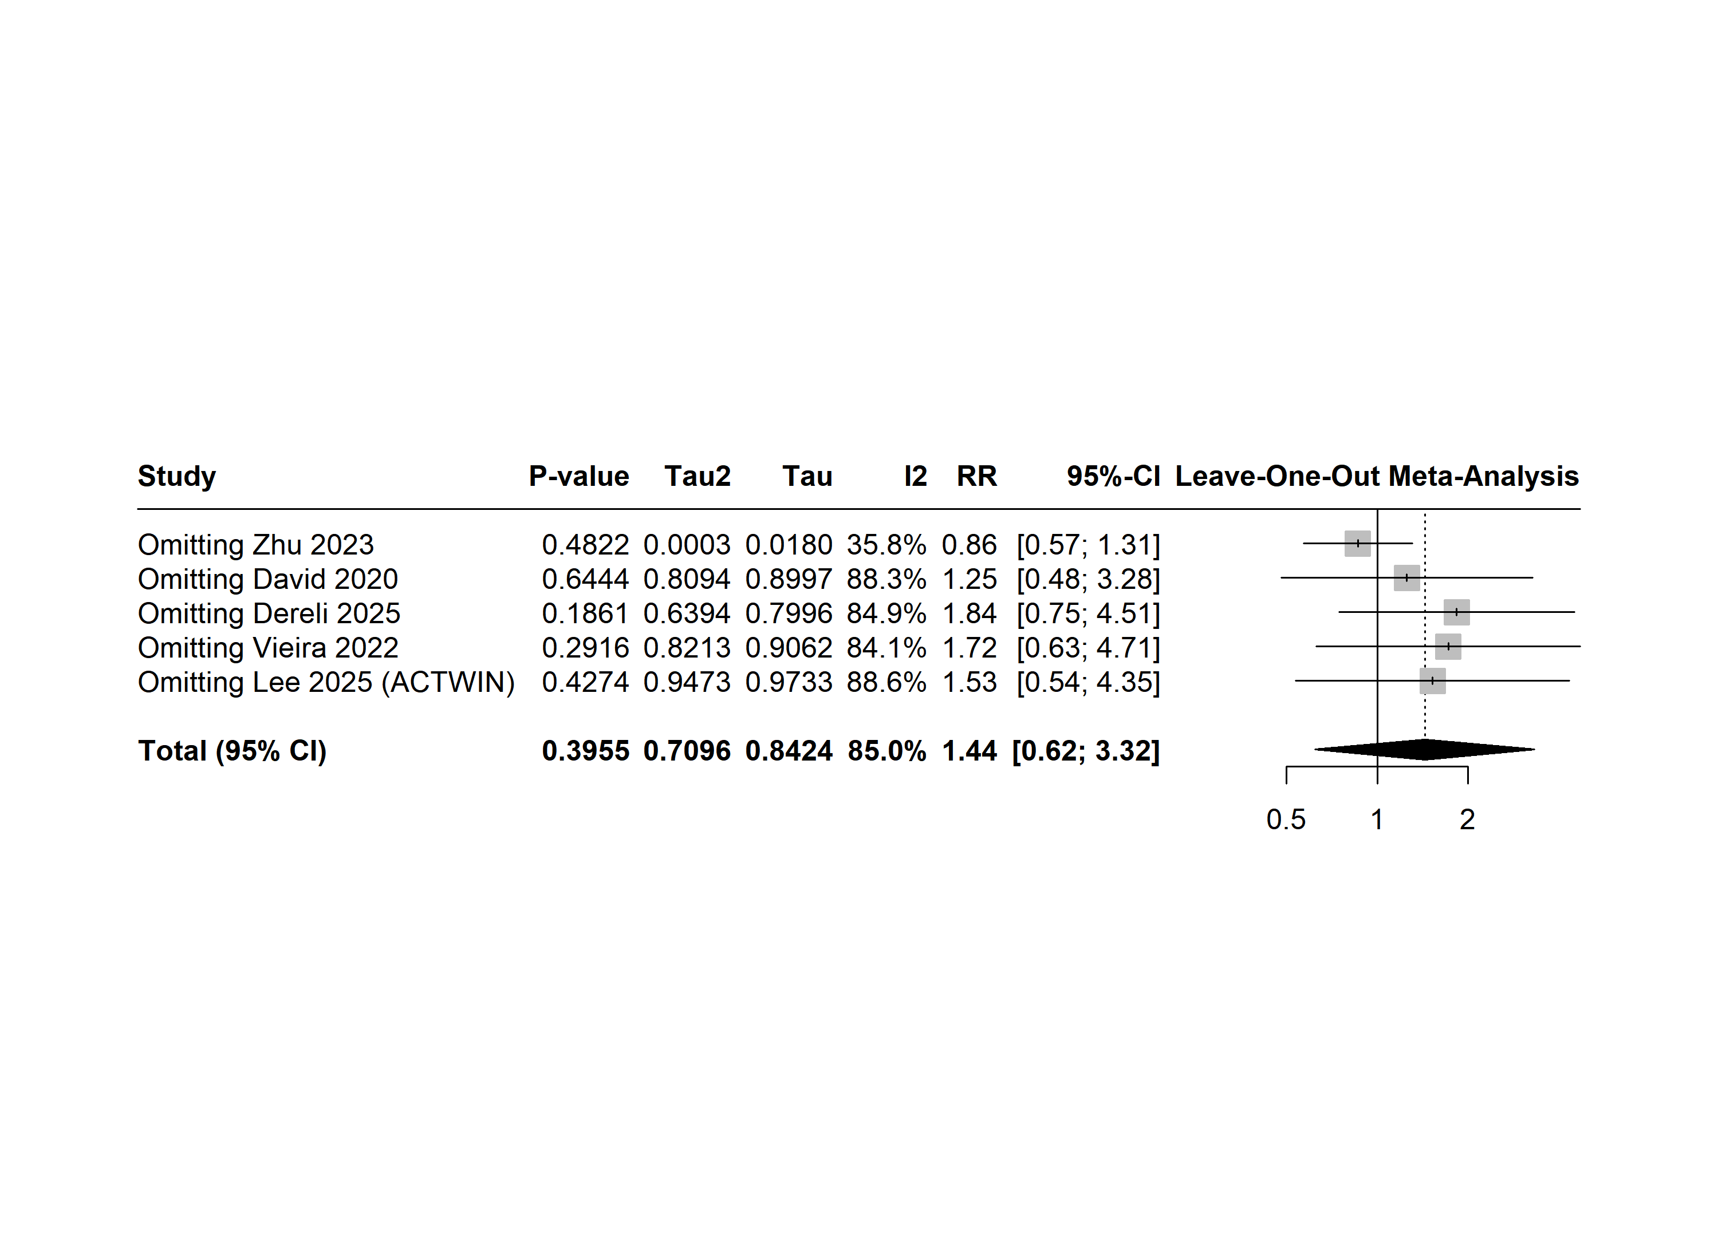

Supplementary Figure 3. Leave-one-out sensitivity analysis demonstrating the impact of omitting individual studies on the pooled effect estimate of Neonatal Hypoglycemia.

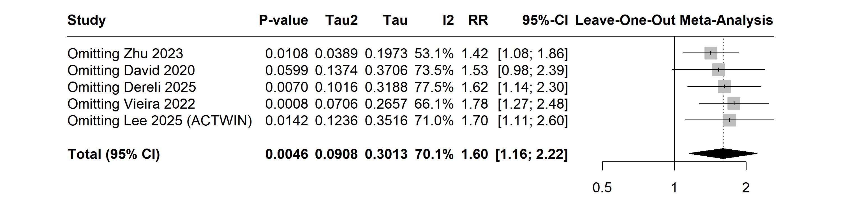

Supplementary Figure 4. Leave-one-out sensitivity analysis demonstrating the impact of omitting individual studies on the pooled effect estimate of Neonatal Jaundice.
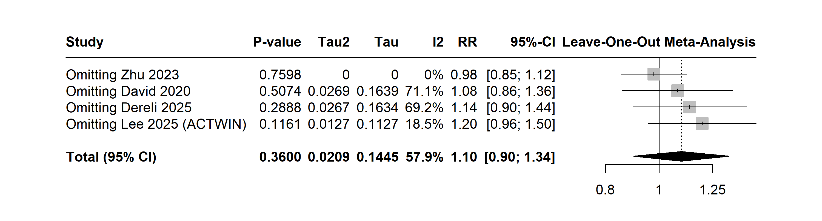

Supplementary Figure 5. Leave-one-out sensitivity analysis demonstrating the impact of omitting individual studies on the pooled effect estimate of NICU Admissions

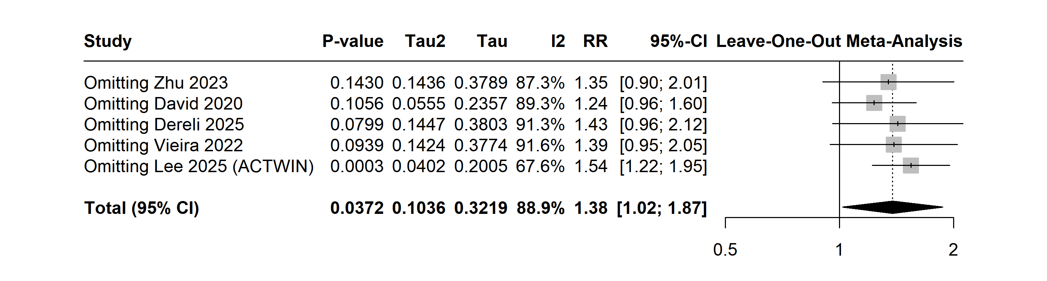

Supplementary Figure 6. Leave-one-out sensitivity analysis demonstrating the impact of omitting individual studies on the pooled effect estimate of Transient Tachypnea of the Newborn

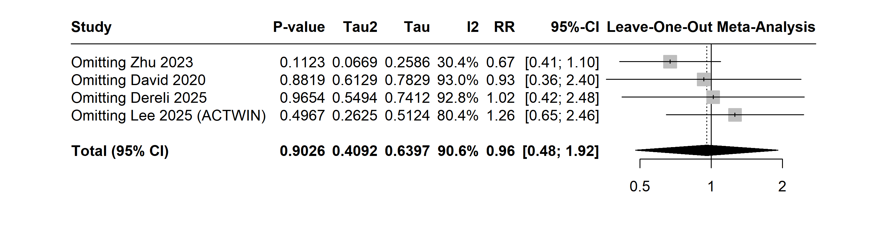

Supplementary Figure 7. Leave-one-out sensitivity analysis demonstrating the impact of omitting individual studies on the pooled effect estimate of Use of Continuous Positive Airway Pressure (CPAP).
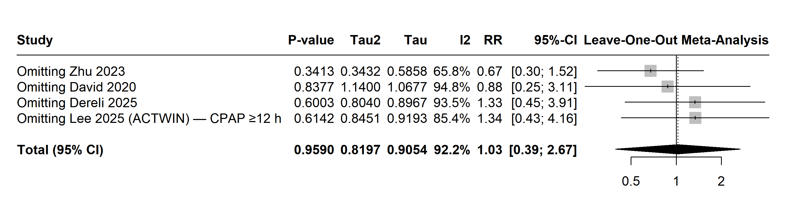

Supplementary Figure 8. Leave-one-out sensitivity analysis demonstrating the impact of omitting individual studies on the pooled effect estimate of Birth Weight

