Freiburg Medical Center
COM-ON
communication skills in oncology

Psychosomatic Medicine and Psychotherapy
Director: Prof. Dr. Michael Wirsching
in Cooperation with the CCCF, Director: Prof. J. Duyster

Klinikum rechts der Isar, TU München

Kommunikative Kompetenzen in der Onkologie
Freiburger Trainingsprogramm

Psychosomatic Medicine and Psychotherapy
Director: Prof. Dr. Peter Henningsen
in Cooperation with the RHCCC,
Director: Prof. P. Herschbach

Contact in Freiburg
Marcelo de Figueiredo, Dipl.-Psychologist
Tel.: +49 761 / 270 68809
E-Mail: marcelo.de.figueiredo@uniklinik-freiburg.de
Johanna Freund, Dipl.-Psychologist
Tel.: +49 761 / 270 68809
E-Mail: johanna.freund@uniklinik-freiburg.de

Contact in Munich
Dr. Alexander Wünsch, Dipl.-Psychologe
Tel.: +49 89 / 4140 4316
E-Mail: a.wuensch@tum.de

ComOn Coaching: Communication in oncology

Self-evaluation of the consultation

Questionnaire for the physician

Dear participant,

on the following page you are asked to answer some questions about the consultation you just conducted.
Please answer the questions thoroughly.

The data will be treated with the utmost discretion, analyzed according to the laws of information privacy and used for scientific purposes only.
Please turn over →
Physician code: |_||_||_||_| |_||_|
Day and month of your birthday Initial letters of the name of your mother
Date |_||_||_||_||_||_| Time |_||_|:|_||_|
Assessment: t |_|

The following example shows you how to answer the questions:

Each affirmation is followed by a 10 cm long line. This line is placed between two poles, e.g. “satisfied” and “unsatisfied”. You answer the question making a stroke in the line: the closer to “satisfied“ you make the stroke, the more satisfied you are; the closer to “unsatisfied” you make the stroke, the more unsatisfied you are. There is no right or wrong: important is your personal opinion.

If you need to correct your answer (e.g. because you made the stroke on the wrong place), please cancel clearly the “wrong” stroke – as in the following example – and make a new one on the correct spot.

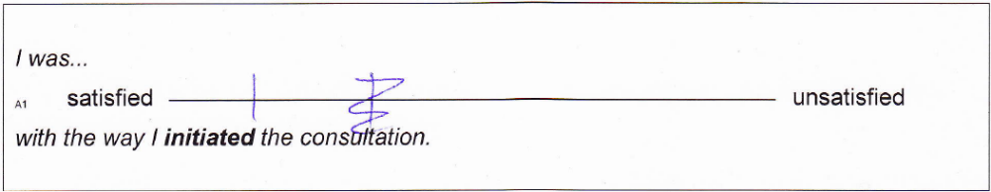

In the example the physician thought, after he made his stroke, that he was more satisfied with the way he began the consultation than he crossed. He then canceled the first stroke and made a new one closer to “satisfied”.

Please turn over →

How did you perceive the consultation you just conducted?

I was...
_{A1} satisfied unsatisfied
with the way I initiated the conversation.

In this consultation I got an idea of the patient’s perspective.
_{A2} agree disagree

I actively structured the consultation and set an agenda of central topics…
_{B1} very well poorly.

I could organize the sub-sections in the course of the conversation…
_{B2} very well poorly.

I was able to recognize the patient’s emotions and name them…
_{C1} very well poorly.

I was able to offer the patient emotional support…
_{C2} agree disagree

I used throughout clear and appropriate words…
_{E1} agree disagree

I used appropriate non-verbal communication…
_{E2} agree disagree

I could adjust my pace when talking and made appropriate pauses…
_{E3} agree disagree

I offered the patient the chance to ask questions.
_{E4} agree disagree

I checked whether the patient had understood the consultation.
_{E5} agree disagree

Please turn over →

I was...
_{D1} satisfied unsatisfied
with the way I summarized the content of consultation and closed it.

The overall quality of this consultation was…
_{F1} very good very bad.

This consultation distressed me emotionally...
_{X} not at all very much.

Before the consultation you were asked about the topics that were important for you. How did you achieve them?
very well poorly

Before the consultation you were asked about the communication skills you wanted to focus on. How did you achieve this?
very well poorly

Thank you for your opinion!

