Freiburg Medical Center
COM-ON
communication skills in oncology

Psychosomatic Medicine and Psychotherapy
Director: Prof. Dr. Michael Wirsching
in Cooperation with the CCCF, Director: Prof. J. Duyster

Klinikum rechts der Isar, TU München

Kommunikative Kompetenzen in der Onkologie
Freiburger Trainingsprogramm

Psychosomatic Medicine and Psychotherapy
Director: Prof. Dr. Peter Henningsen
in Cooperation with the RHCCC,
Director: Prof. P. Herschbach

Contact in Freiburg
Marcelo de Figueiredo, Dipl.-Psychologist
Tel.: +49 761 / 270 68809
E-Mail: marcelo.de.figueiredo@uniklinik-freiburg.de
Johanna Freund, Dipl.-Psychologist
Tel.: +49 761 / 270 68809
E-Mail: johanna.freund@uniklinik-freiburg.de

Contact in Munich
Dr. Alexander Wünsch, Dipl.-Psychologe
Tel.: +49 89 / 4140 4316
E-Mail: a.wuensch@tum.de

ComOn Coaching: Communication in oncology

Evaluation of the consultation

Questionnaire for the patient

Dear patient,

in the following page you are asked to answer some questions about the consultation you just had. We would like to know, how the conversation was for you. There is no right or wrong answers: we are interested in your sincere, personal opinion.
Please answer the questions thoroughly.

The data will be treated with the utmost discretion, analyzed according to the laws of information privacy and used for scientific purposes only.
Please turn over →
Physician code: |_||_||_||_| |_||_|
Day and month of your birthday Initial letters of the name of your mother
Date |_||_||_||_||_||_| Time |_||_|:|_||_|
Assessment: t |_|

The following example shows you how to answer the questions:

Each affirmation is followed by a 10 cm long line. This line is placed between two poles, e.g. “satisfied” and “unsatisfied”. You answer the question making a stroke in the line: the closer to “satisfied” you make the stroke, the more satisfied you are; the closer to “unsatisfied” you make the stroke, the more unsatisfied you are. There is no right or wrong: important is your personal opinion.

If you need to correct your answer (e.g. because you made the stroke on the wrong place), please cancel clearly the “wrong” stroke – as in the following example – and make a new one on the correct spot.

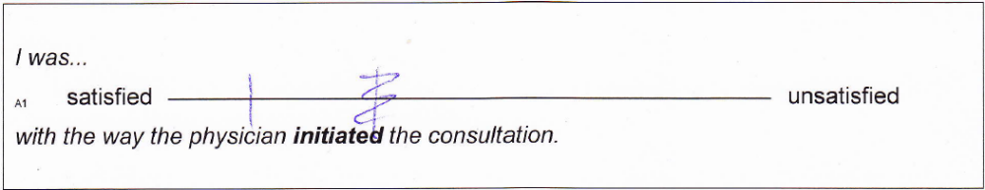

In the example the patient thought, after he made his stroke, that the physician initiated the consultation better than he crossed. She then canceled first stroke and made a new one closer to “satisfied”.

Please turn over →

How was the consultation for you?

I was...
_{A1} satisfied unsatisfied
with the way the physician initiated the conversation.

During this consultation the physician got an idea of how I understand my situation.
_{A2} agree disagree

The physician structured the consultation and set an agenda of central topics …
_{B1} very well poorly.

The physician could organize the subsections in the course of the conversation…
_{B2} very well poorly.

The physician was able to recognize my emotions.
_{C1} very well poorly.

The physician was able to offer me emotional support.
_{C2} agree disagree

The physician used throughout clear and appropriate words.
_{E1} agree disagree

The physician used appropriate non-verbal communication.
_{E2} agree disagree

The physician adjusted his pace when talking and made appropriate pauses.
_{E3} agree disagree

The physician offered me the chance to ask questions.
_{E4} agree disagree

The physician checked wheter I understood the consultation.
_{E5} agree disagree

Please turn over →

I was...
_{D1} satisfied unsatisfied
with the way the physician summarized the consultation and closed it.

The overall quality of this consultation was
_{F1} very good very bad

This consultation distressed me emotionally...
_{X} not at all very much.

Before the consultation you were asked about the topics that were important for you. How were they discussed?
very good poorly

Before the consultation you were asked about your expectations about the way the physician communicates with you. How did she/he achieve this?
very good poorly

Thank you for your opinion!

