- Relative risk estimates of pancreatic cancer for men (alcohol intake versus the lowest alcohol intake).

RR
.3
.5
1
2
Study
RR
(95% CI
)
JACC
1.09 ( 0.74, 1.61)
KIRS and MIHDPS
1.51 ( 0.98, 2.34)
ATBC
0.96 ( 0.75, 1.23)
NLCS
1.01 ( 0.74, 1.37)
NIH−AARP
1.20 ( 1.04, 1.38)
HPFS
0.80 ( 0.64, 1.00)
CPS II
1.18 ( 0.95, 1.45)
TGP
0.76 ( 0.40, 1.43)
NYSC
0.74 ( 0.52, 1.04)
PLCO
1.23 ( 0.84, 1.78)
COSM
1.21 ( 0.76, 1.93)
MCCS
0.68 ( 0.37, 1.26)
Overall
1.03 ( 0.91, 1.17); P=0.664
(I =48.7%; P=0.029)
2
- Relative risk estimates of pancreatic cancer for women (alcohol intake versus the lowest alcohol intake).

RR
.3
.5
1
2
Study
RR
(95% CI)
JACC
1.01 ( 0.53, 1.91)
NLCS
1.26 ( 0.93, 1.72)
NIH−AARP
0.96 ( 0.71, 1.28)
IWHS
1.29 ( 1.00, 1.66)
NHS
1.03 ( 0.82, 1.31)
CPS II
0.87 ( 0.67, 1.14
)
TGP
0.78 ( 0.34, 1.82)
MWS
0.96 ( 0.88, 1.05)
NYSC
1.11 ( 0.61, 2.04
)
BCDDP
1.14 ( 0.82, 1.59)
CTS
1.03 ( 0.78, 1.37)
CNBSS
0.90 ( 0.67, 1.23)
PLCO
1.01 ( 0.64, 1.60)
SMC
0.77 ( 0.47, 1.26)
MCCS
0.80 ( 0.44, 1.48)
Overall
0.99 ( 0.93, 1.06); P=0.806
(I =0.0%; P=0.673)
2
- Relative risk estimates of pancreatic cancer for total cohort (alcohol intake versus the lowest alcohol intake).
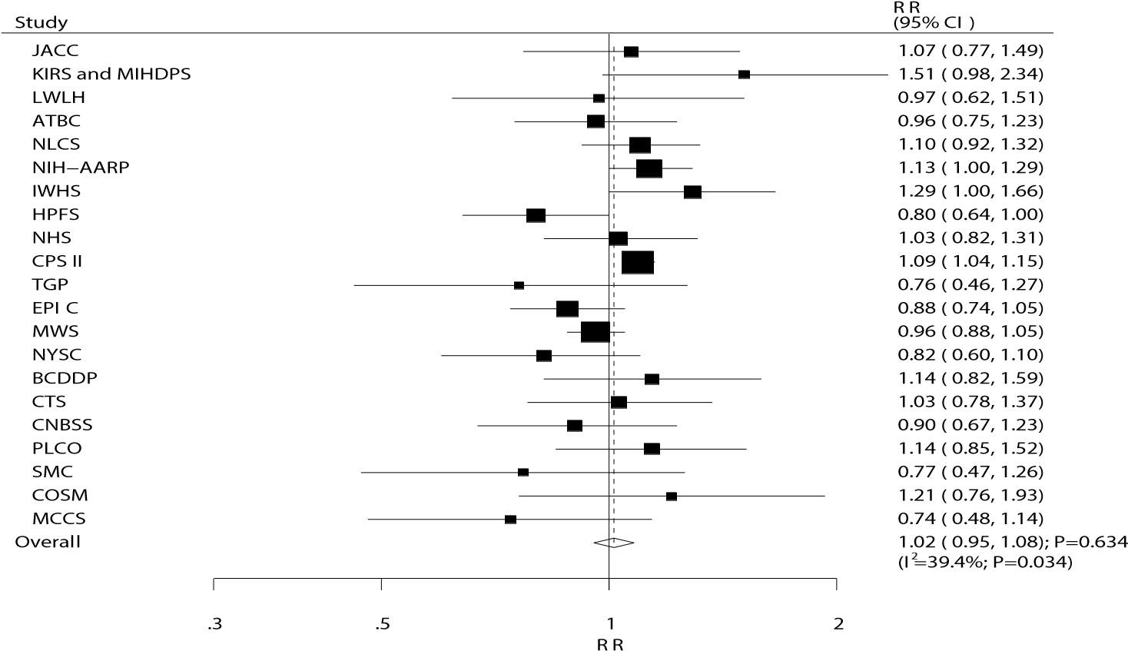
Figure S3. Relative risk estimates of alcohol intake versus the lowest alcohol intake and the risk of pancreatic cancer in men, women, and total cohort.

