Figure S1. Changes in IGF-1 represented as absolute changes (left side) and percentage change from baseline (right side) for the 24, 48, and 72 hour cohorts.

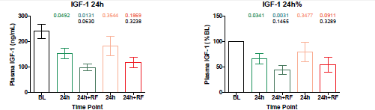

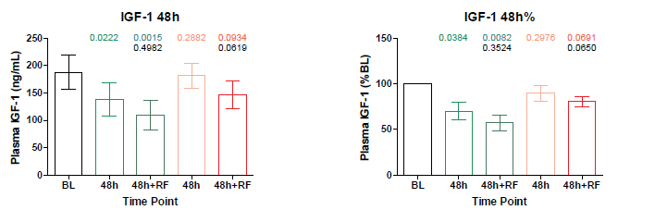

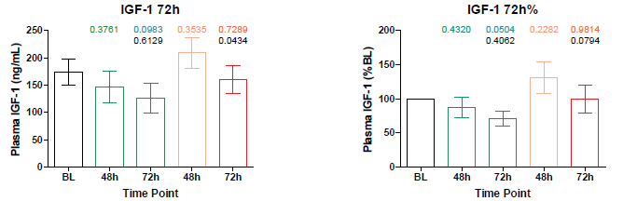

Figure S2. Changes in beta-hydroxybutyrate (ketone) levels in fasting subjects, shown as absolute levels (left column) by cohort, and % changes (right column)
