Supplemental Figure 1. Morphology changed of various treatments of A253 cells. A253-0 cell (A), A253-5 (B), A253-5si (C), A253-5 treated with 5’AZA (D) and A253-5 transfected with miRNA 29b mimic (E). Photographs were taken at 100 X magnificence and mesenchymal type cells were indicated by arrows.

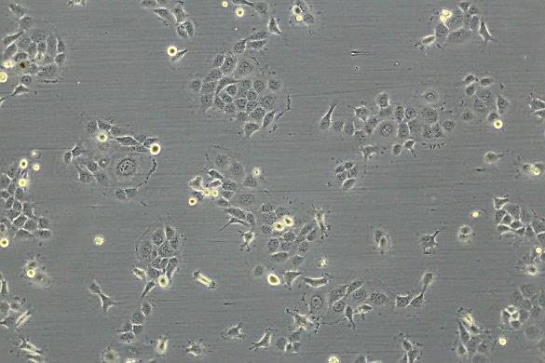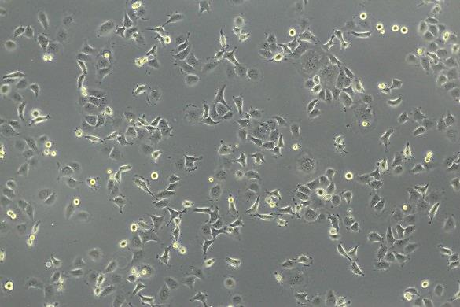
B
A
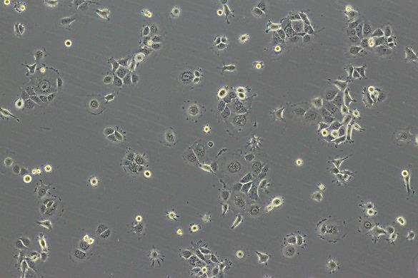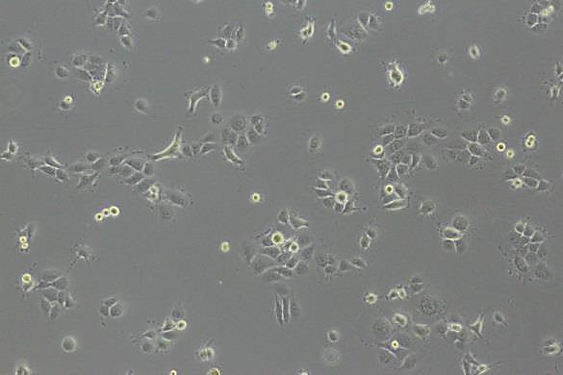
D
C
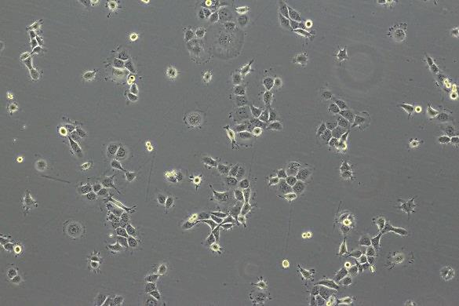
E

