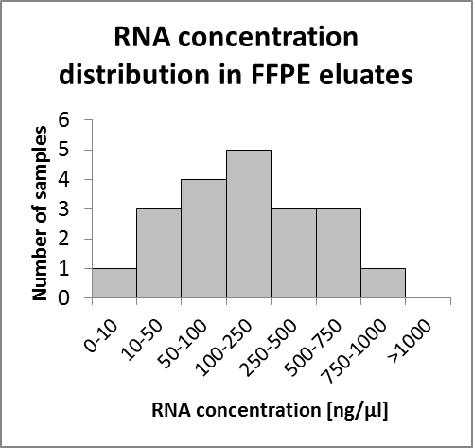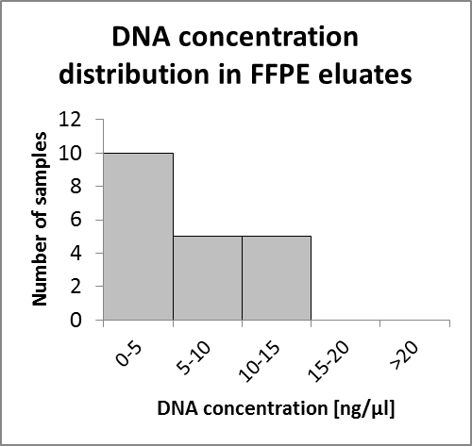
A: RNA and DNA concentration of 20 RNXtract® eluates.

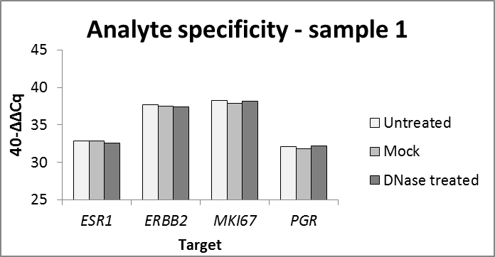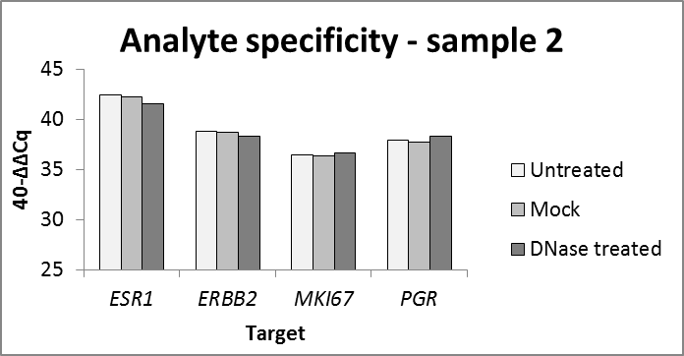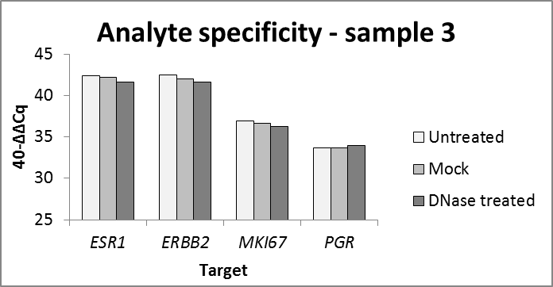
B: Analyte Specificity of MammaTyper tested on 3 independent RNXtract® eluates

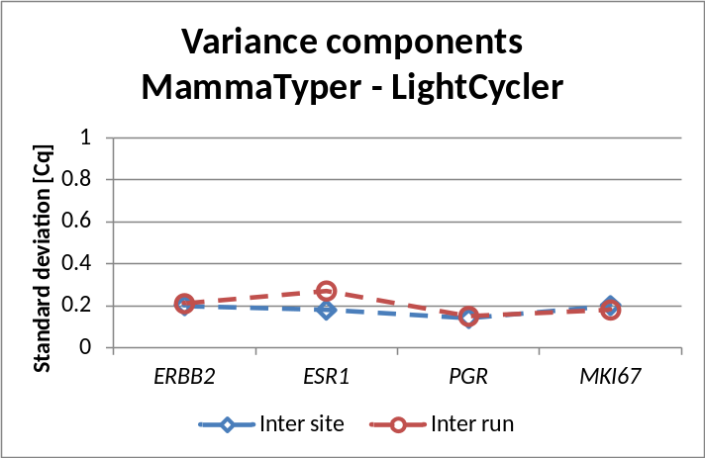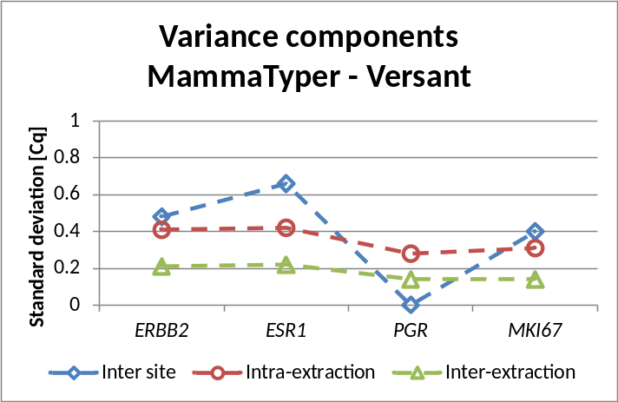
C: Graphical representation of the different sources of variation (variance components) for the MammaTyper assay on the two instruments LightCycler 480 instrument II (Roche) and Versant kPCR (Siemens).

