Assessment of publication bias. Funnel plot for objective response rates, progression-free survival and overall survival in this meta-analysis.

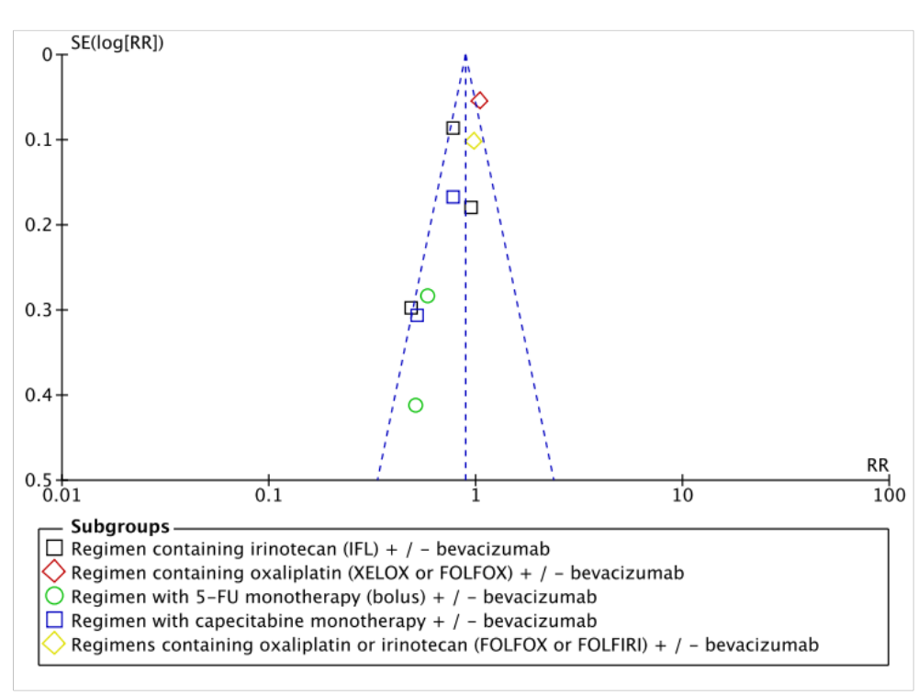
1 - Objective response rates: All studies are evenly distributed on both sides, thus presenting basic symmetry and indicating that there was no publication bias.

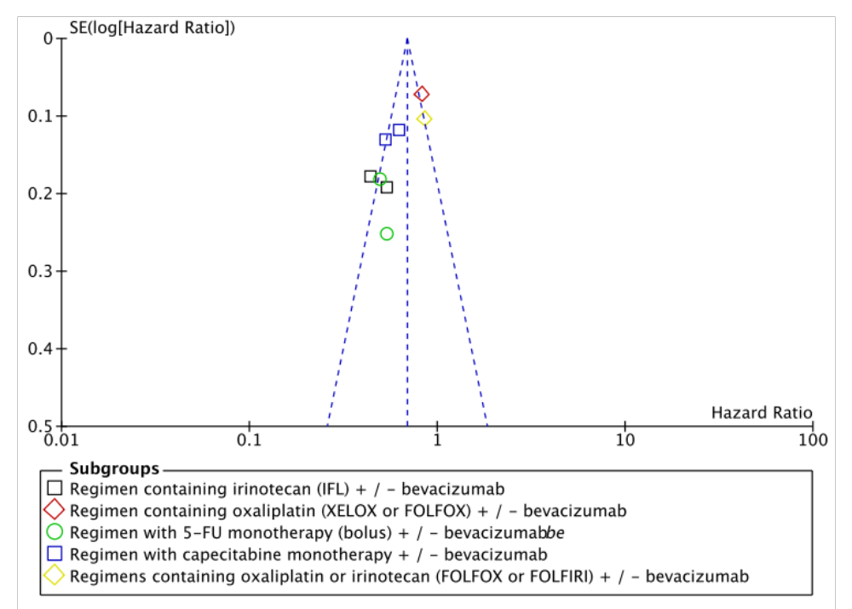
2 - Progression-free survival: All studies are evenly distributed on both sides, thus presenting basic symmetry and indicating that there was no publication bias.

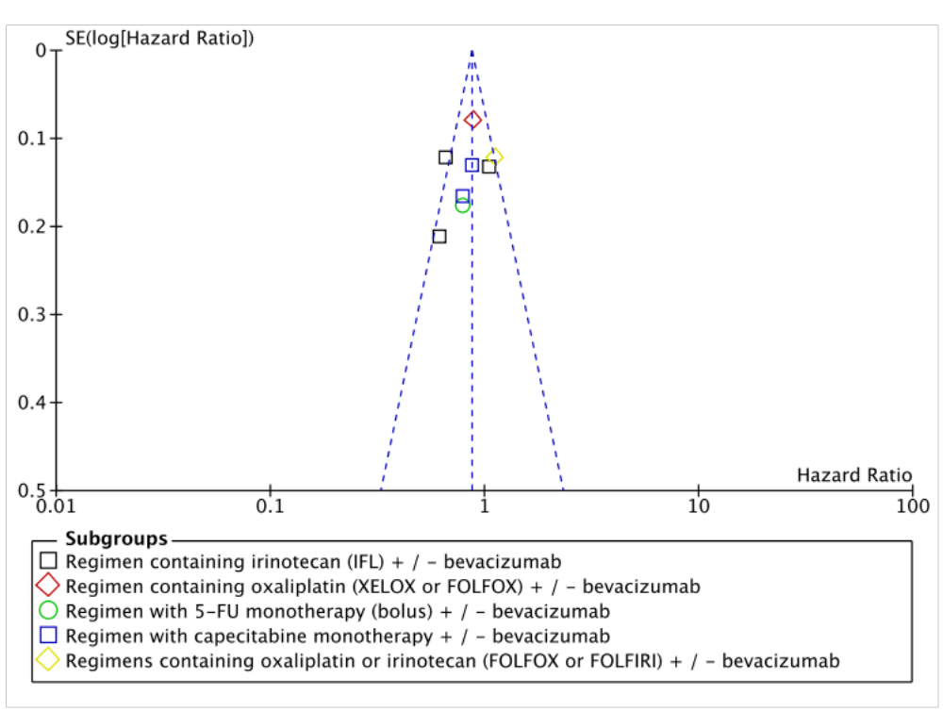
3 - Overall survival: All studies are evenly distributed on both sides, thus presenting basic symmetry and indicating that there was no publication bias.

