Supplementary figure 1. MED15/PCQAP MSP amplicon sequence confirmation.
MED15/PCQAP 3’ Forward sequence
AATGAGATTGCAGTTCTCGGTAGAGATCGATTGGCGGAGTATCGTTTTTCGGTAGAAGTTGGTTAGTTAAATGTGAGTAGTGGTCGGGGTAGGGGGTTGGATTGTGGGATTTTTTTTTTTAGCGTGGCGGGCGAGGTTAGGGTCTAATTAA
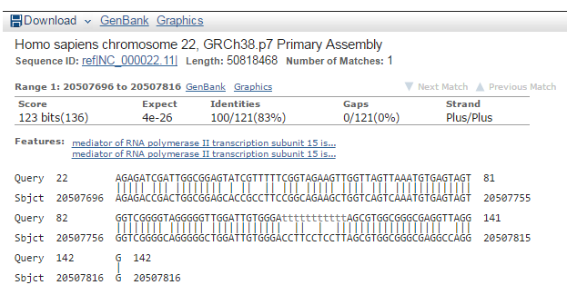
NCBI Basic Local Alignment Search Tool (BLAST) result:

Link:
(http://www.ncbi.nlm.nih.gov/nucleotide/528476531?report=gbwithparts&from=20862710&to=20941712&RID=TX6ZY13G01R)

MED15/PCQAP 5’ Forward sequence
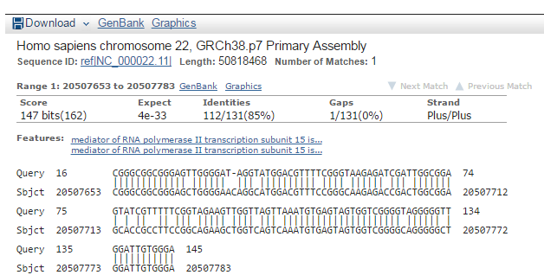
CAGGATCGTAACGGTCGGGCGGCGGGAGTTGGGGATAGGTATGGACGTTTTCGGGTAAGAGATCGATTGGCGGAGTATCGTTTTTCGGTAGAAGTTGGTTAGTTAAATGTGAGTAGTGGTCGGGGTAGGGGGTTGGATTGTGGGATTTTT
NCBI Basic Local Alignment Search Tool (BLAST) result:

Link:
(http://www.ncbi.nlm.nih.gov/nucleotide/528476531?report=gbwithparts&from=20862710&to=20941712&RID=TX7TPC19014)

