Additional File 1
Figure S1. Kaplan-Meier survival curve for patients with SP in various age groups.

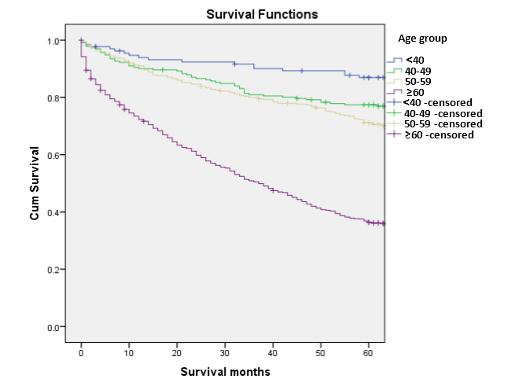

Figure S2. Kaplan-Meier curve for survival rates of males and females.
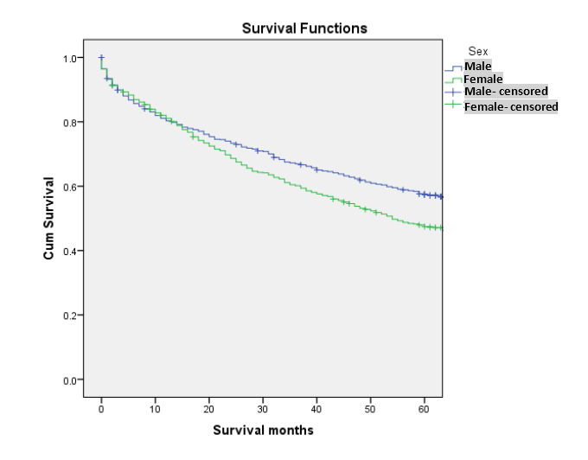

Figure S3: Kaplan-Meier survival curves for patients with plasmacytoma among different races.

