Additional file 1
Table S1. Cox Regression analysis subgroup T1 or T2.
 | Hazard Ratio | 95% CI | p-value
miR-135a high +  T1/2 tumor status | 2.9 | 0.7-12.4 | 0.146
Cox regression analysis on the influence of high expression of miR-135a on the recurrence of HCC in the subgroup of patients with T1 or T2 tumor status, n=16. Abbreviations: CI, Confidence interval.

Table S2. Sequences of target miRNAs used in qPCR analysis.
Target | Sequence | Catalog # (Qiagen)
hsa_miR-21_5p | UAGCUUAUCAGACUGAUGUUGA | MS00009079
hsa_miR-122a_5p | UGGAGUGUGACAAUGGUGUUUG | MS00003416
hsa_miR-125b_5p | UCCCUGAGACCCUAACUUGUGA | MS00006629
hsa_miR-135a_5p | UAUGGCUUUUUAUUCCUAUGUGA | MS00008624

Figure S1. Kaplan-Meier curve subgroup analysis T1 and T2 tumors. Recurrence free survival (RFS) of patients with T1 and T2 tumor status stratified by high vs. low expression of miR-135a in HCC tissue. Cox regression p=0.146, n=16. Abbreviations: HR, hazard ratio; CI, confidence interval.

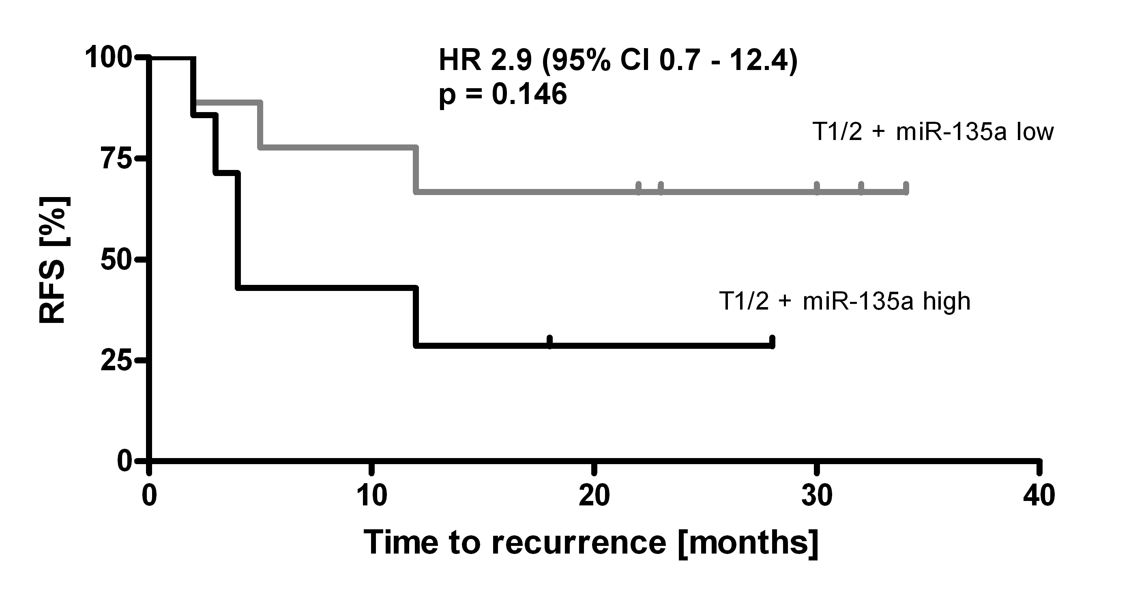
Figure S1.

