Figure S1. Association of BRCA1 and BRCA2 variants with breast cancer risk in all breast cancer cases and healthy controls.

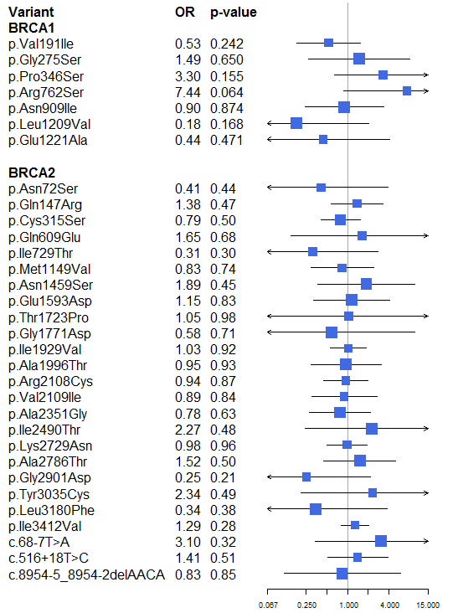

Figure S2. Association of variants with breast cancer risk in ethnicity subgroups: (a) BRCA1 and (b) BRCA2.

(a) (b)
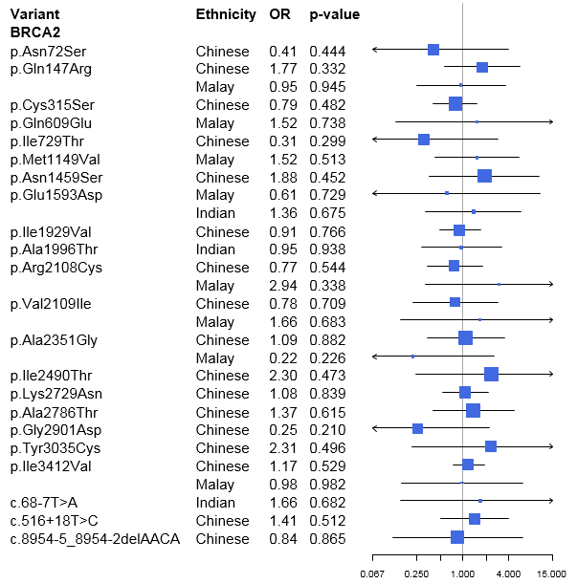
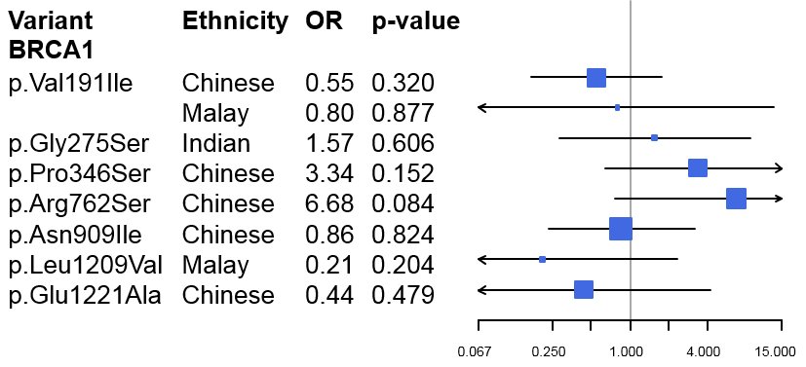

Note: Some variants were only present in certain ethnicity. Only those variants that were present in both breast cancer cases and healthy controls among the same ethnicity were analyzed for association with breast cancer risk.

