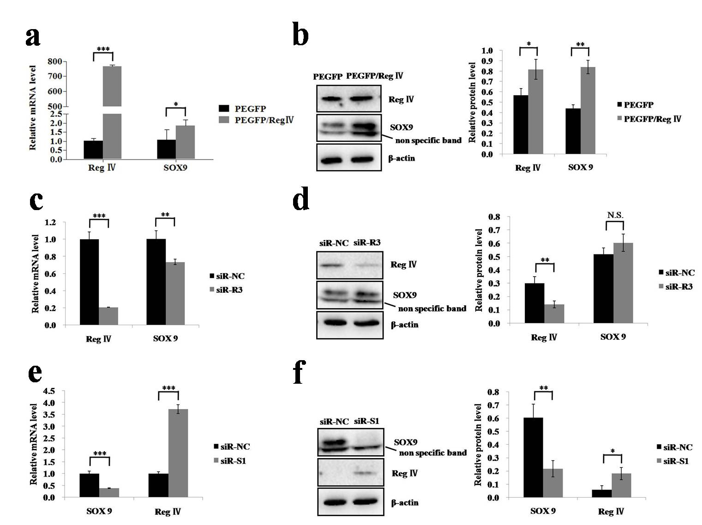
Fig. S2 Regulatory relationship of Reg IV and SOX9 in AGS cells. PEGFP/Reg IV and PEGFP were added to the cells. Cells were harvested after 48 h, total RNA were extracted and converted to cDNA. Real-time PCR (a) was performed to examine the mRNA level of Reg IV and SOX9 in PEGFP/Reg IV and PEGFP treated cells, western blot analysis (b) was done using anti-Reg IV antibody and SOX9 antibody, and bands were visualized (left) and the gray intensity was analyzed (right); after transfection with siR-NC and siR-R3, the mRNA level of Reg IV and SOX9 were examined by real-time PCR (c), and western blot analysis (d) was done; after transfection with siR-NC and siR-S1, the mRNA level of SOX9 and Reg IV (e) were examined by real-time PCR, and western blot analysis (f) was done. The results are shown as Mean ± SD, n=3. * P < 0.05, ** P<0.01, *** P<0.001, N.S. = not significant.

