Supplementary Material

The mathematical representation of our multiplicative linear model predicting neoepitope specific immune response, as described in the “Features associated with immunogenicity” subsection of our results section, is as follows:

Y = -6.6 + 9.4A + 8.6V + 9.3B + 7.0M – 12.3AV + 1.01x10⁻⁵AB - 12.3VB – 9.4TM – 9.1VM – 9.3BM – 1.2x10⁻⁵AVB + 12.4AVM – 1.0x10⁻⁵ABM + 12.3VBM + 1.2x10⁻⁵AVBM

where Y is the neoepitope specific immune response, A is the HLA binding affinity of the neoepitope, V is the peptide sequence similarity of the neoepitope to its closest-matching viral peptide, B is the HLA binding affinity difference between the neoepitope and its closest-matching human peptide, and M is the number of amino acid mismatches between the neoepitope and its paired normal epitope.

Supplemental Figure S1. Total number of patients in each TCGA disease group. A disease abbreviation key is available in Supplementary Table S1.
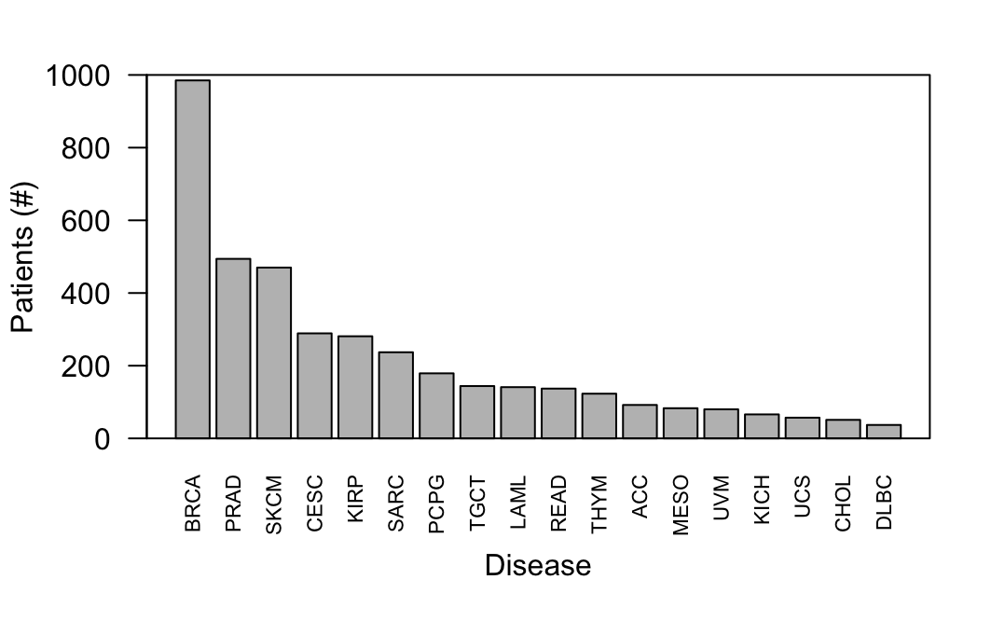

Supplemental Figure S2. Ratio of neoepitopes to somatic missense mutations per patient across disease sites. The total number of neoepitopes predicted across all 145 HLA alleles for each patient was divided by the total number of somatic missense mutations identified for each patient to calculate the ratio.
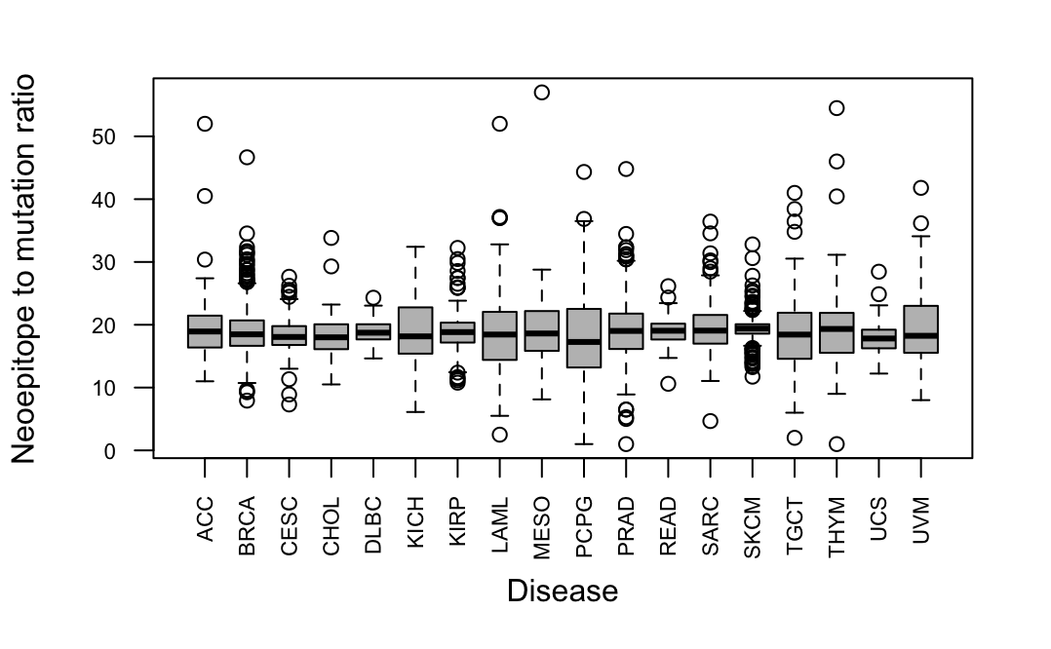

Supplemental Figure S3. Distributions of repeated peptide sequences for TCGA epitopes and randomly simulated epitopes (see Methods). A, percentage of epitope sequences repeated per patient across patients within the same TCGA disease site compared to the percentage of epitope sequences repeated for the same number of random peptides across TCGA. B, percentage of epitope sequences repeated per patient across all patients in TCGA compared to the percentage of epitope sequences repeated for the same number of random peptides across TCGA.
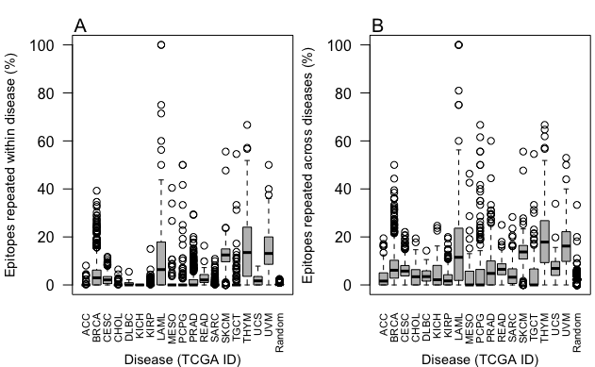

Supplemental Figure S4. Overlap of epitope preference rare across HLA alleles. Using 1000 randomly sampled sets of six HLA alleles (2 HLA-A, 2 HLA-B, 2 HLA-C; see Methods), the instances of shared neoepitope preference were assessed for all neoepitopes predicted across TCGA patients. In most cases (87.898% on average), only one allele from each group bound to a neoepitope, but in some cases (0.00433% on average), all six alleles had a strong binding affinity for the neoepitope. The x axis represents the number of alleles (among a set of six) able to present a given neoepitope. The y axis depicts the number (%) of all neoepitopes with affinity for at least one allele in the set presented by the corresponding number of alleles along the x axis, with the distribution representing a summary across 1000 randomly sampled sets of six HLA alleles.
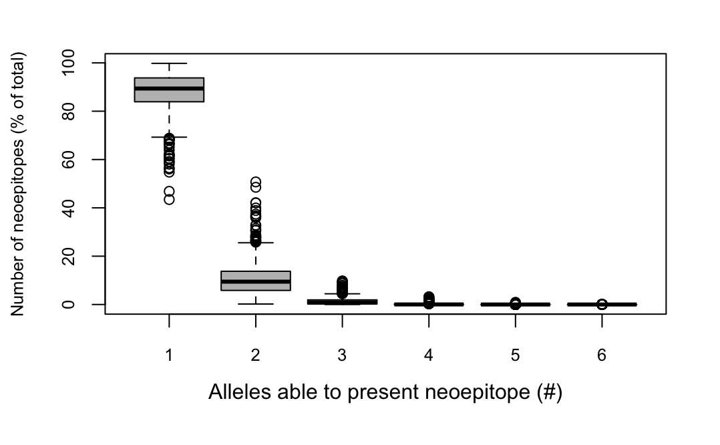

Supplemental Figure S5. Binding affinity difference between paired tumor and normal epitopes in TCGA. Binding affinity difference between paired tumor and normal epitopes was higher for neoepitopes with mutations at anchor residues than those with mutations at non-anchor residues (median 2935.1 nM vs. 28.1 nM, respectively; *p < 2.2x10⁻¹⁶).
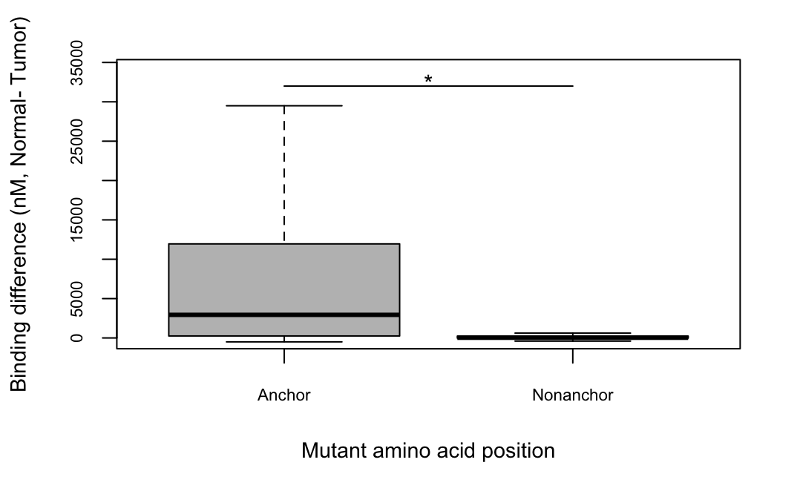

Supplemental Figure S6. Tumor vs. closest microbial peptide sequence similarity of predicted TCGA neoepitopes and randomly simulated peptides. Percent paired sequence similarity (see Methods) of neoepitopes with top bacterial peptide (gray) and viral peptide (white) blastp hits across TCGA disease groups and among 1000 randomly simulated neoepitopes (see Methods) is shown. All TCGA neoepitopes matched with some degree of similarity (76.7% on average) to a viral peptide, while 96.4% of neoepitopes matched with some degree of similarity (91.6% on average) to a bacterial peptide. Vertical lines separate TCGA disease sites. A TCGA disease abbreviation key is available in Supplementary Table S1.
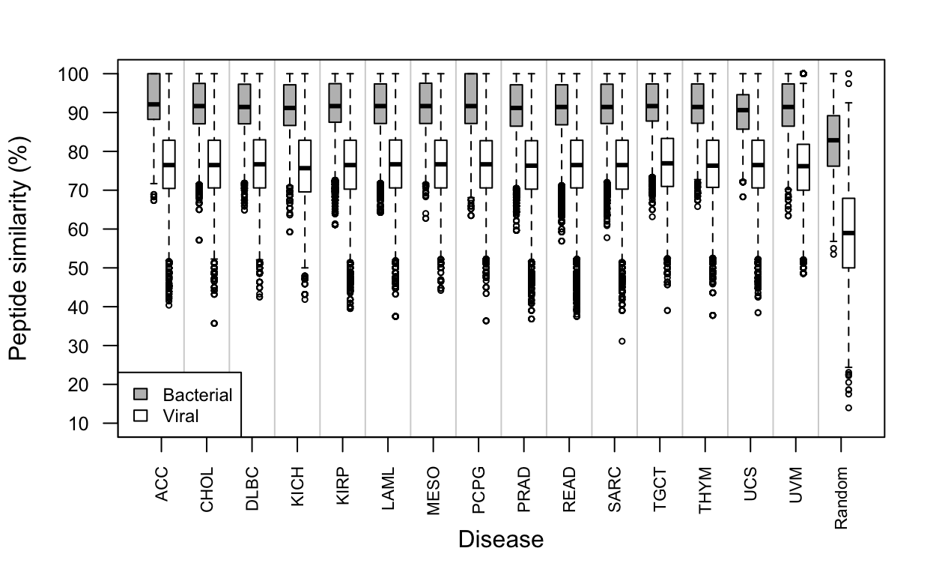

Supplemental Figure S7. ROC curve for prediction of immunogenicity from putatively novel binding status. Within a limited cohort of 419 peptides with paired immune response data, our immunogenic binding criteria was able to predict peptide immunogenicity with an AUC of 0.528.
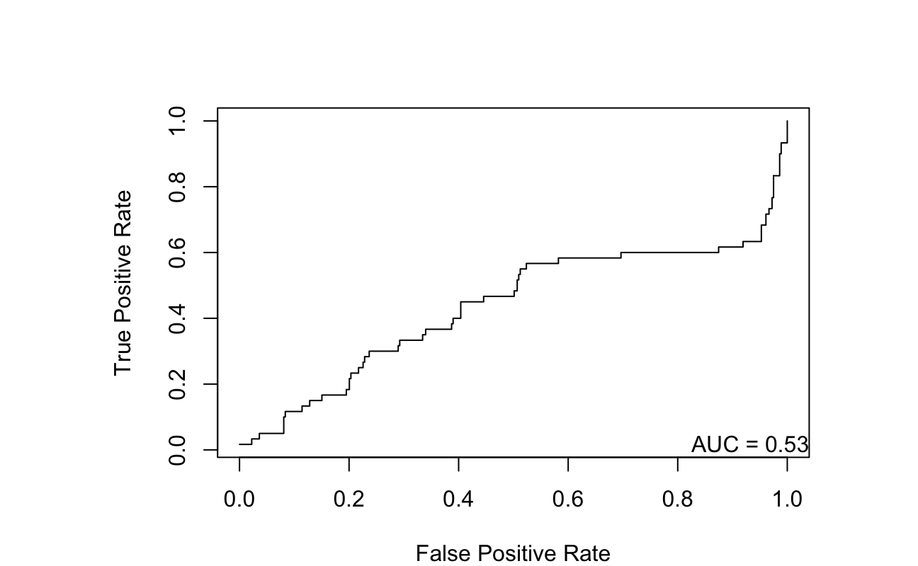

Supplementary Figure S8. ROC curves for the prediction of peptide immunogenicity of peptides using Random Forest, SVM, or multiplicative linear models. Random Forest and SVM models were trained with 10-fold cross validation. All models predict neoepitope-specific immune response from 1) neoepitope binding affinity, 2) paired normal binding affinity, 3) difference in binding affinity between the neoepitope and its paired normal epitope, 4) number of mismatches in amino acid sequence between the neoepitope and its paired normal epitope, 5) difference in binding affinity between the neoepitope and its closest matching human peptide, 6) percent protein sequence similarity between the neoepitope and its paired normal epitope, 7) percent protein sequence similarity between the neoepitope and its closest matching human peptide, 8) percent protein sequence similarity between the neoepitope and its closest matching bacterial peptide, and 9) percent protein sequence similarity between the neoepitope and its closest matching viral peptide. Gray line represents the line y=x for comparison.
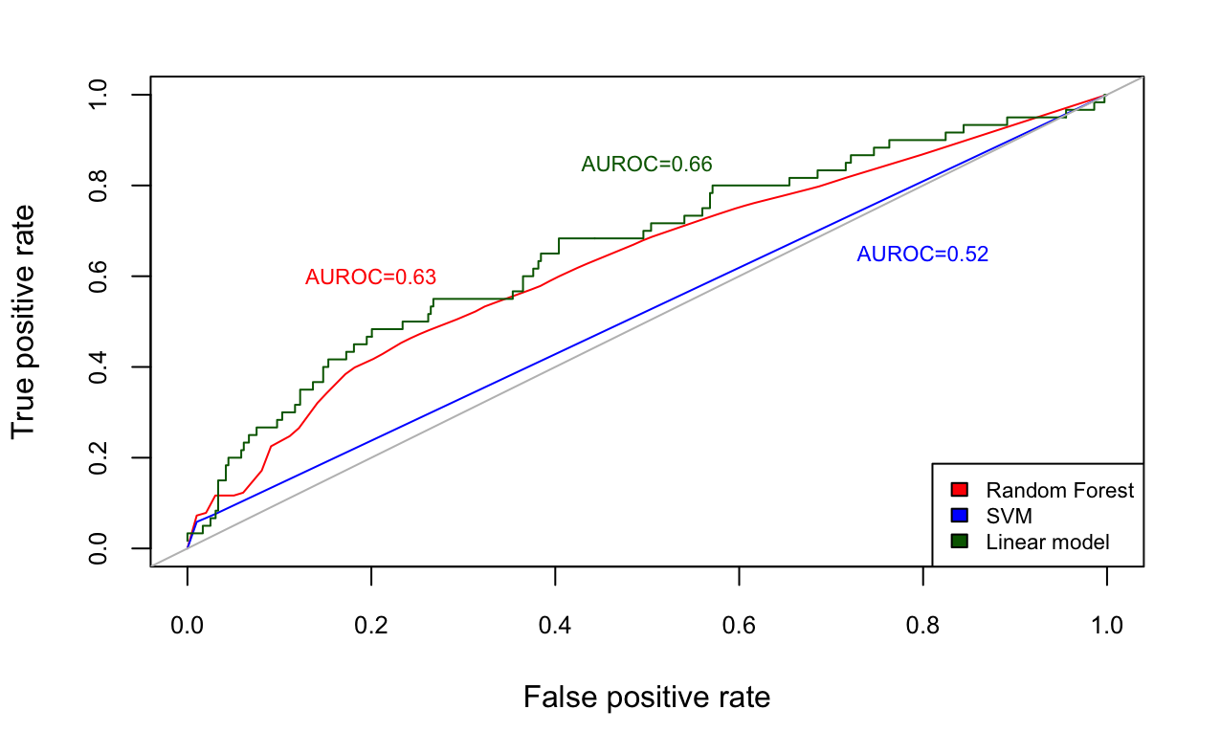

Supplementary Table S1: TCGA cancer data sets used. Disease abbreviations and the number of patients used to generate each data set provided.
TCGA Project Abbreviation | Cancer Type | Number of Cases
ACC | Adrenocortical Carcinoma | 92
BRCA | Breast Invasive Carcinoma | 985
CESC | Cervical Squamous Cell Carcinoma and Endocervical Adenocarcinoma | 289
CHOL | Cholangiocarcinoma | 51
DLBC | Lymphoid Neoplasm Diffuse Large B-cell Lymphoma | 37
KICH | Kidney Chromophobe | 66
KIRP | Kidney Renal Papillary Cell Carcinoma | 281
LAML | Acute Myeloid Leukemia | 141
MESO | Mesothelioma | 83
PCPG | Pheochromocytoma and Paraganglioma | 179
PRAD | Prostate Adenocarcinoma | 494
READ | Rectum Adenocarcinoma | 137
SARC | Sarcoma | 237
SKCM | Skin Cutaneous Melanoma | 470
TGCT | Testicular Germ Cell Tumors | 144
THYM | Thymoma | 123
UCS | Uterine Carcinosarcoma | 57
UVM | Uveal Melanoma | 80

Supplementary Table S2: Top frequency HLA-A alleles (n=38) used for neoepitope prediction from TCGA somatic mutations. Average allele frequencies in the general population are based on those frequencies originating from the Allele Frequency Net Database [1] and summarized for use in the software POLYSOLVER [2] (see Methods).
HLA-A Allele | Average Frequency
HLA-A*02:01 | 0.165735177970068
HLA-A*24:02 | 0.115647218975036
HLA-A*11:01 | 0.0988782090848313
HLA-A*03:01 | 0.072759951608879
HLA-A*01:01 | 0.0677237081068929
HLA-A*23:01 | 0.0473178346593762
HLA-A*33:03 | 0.0393454654639734
HLA-A*30:01 | 0.0318933412012099
HLA-A*26:01 | 0.031566894866778
HLA-A*02:07 | 0.0269360269360269
HLA-A*30:02 | 0.0238301274752413
HLA-A*68:02 | 0.0238287779953814
HLA-A*68:01 | 0.0231422454516778
HLA-A*31:01 | 0.0228448436042297
HLA-A*29:02 | 0.0214702245703172
HLA-A*02:03 | 0.0175084175084175
HLA-A*74:01 | 0.0174565392088051
HLA-A*32:01 | 0.0171012988590301
HLA-A*02:06 | 0.0164949325753346
HLA-A*02:02 | 0.015105065441339
HLA-A*25:01 | 0.0140723759785838
HLA-A*34:02 | 0.0114125511748066
HLA-A*02:05 | 0.0107374789865795
HLA-A*33:01 | 0.0100718736040359
HLA-A*66:01 | 0.00939507878432107
HLA-A*36:01 | 0.00872776099362202
HLA-A*11:02 | 0.00740740740740741
HLA-A*24:07 | 0.003029285808742
HLA-A*29:01 | 0.00302386744263803
HLA-A*66:02 | 0.00234978180597516
HLA-A*80:01 | 0.00234978180597516
HLA-A*30:04 | 0.00201444117246695
HLA-A*01:02 | 0.00201409869083585
HLA-A*34:01 | 0.00168248446194066
HLA-A*26:02 | 0.00134680134680135
HLA-A*26:03 | 0.00134680134680135
HLA-A*24:03 | 0.00134409216374936
HLA-A*03:02 | 0.00134172546232848

Supplementary Table S3: Top frequency HLA-B alleles (n=81) used for neoepitope prediction from TCGA somatic mutations. Average allele frequencies in the general population are based on those frequencies originating from the Allele Frequency Net Database [1] and summarized for use in the software POLYSOLVER [2] (see Methods).
HLA-B Allele | Average Frequency
HLA-B*07:02 | 0.0658965469288718
HLA-B*15:01 | 0.0631742058525538
HLA-B*40:01 | 0.0574267368967641
HLA-B*35:01 | 0.0476382286835008
HLA-B*08:01 | 0.0469771669978825
HLA-B*53:01 | 0.0381638104006582
HLA-B*51:01 | 0.0378425275710676
HLA-B*44:03 | 0.0364888924510866
HLA-B*18:01 | 0.0337932678573997
HLA-B*58:01 | 0.0324242193820546
HLA-B*40:02 | 0.0320892357921403
HLA-B*44:02 | 0.0294062844017529
HLA-B*46:01 | 0.027693346842283
HLA-B*15:03 | 0.0226278332316052
HLA-B*13:02 | 0.0223041527689579
HLA-B*15:02 | 0.022289766970618
HLA-B*45:01 | 0.0192516233688389
HLA-B*42:01 | 0.0192502532928065
HLA-B*52:01 | 0.0182411922949664
HLA-B*27:05 | 0.0165628491553139
HLA-B*58:02 | 0.016548463356974
HLA-B*49:01 | 0.015202363655171
HLA-B*13:01 | 0.0151975683890578
HLA-B*57:01 | 0.0141957002903876
HLA-B*14:02 | 0.0141909050242743
HLA-B*39:01 | 0.0138514686872548
HLA-B*57:03 | 0.0114829497462962
HLA-B*35:03 | 0.0111544740175356
HLA-B*38:01 | 0.0108170927945646
HLA-B*15:10 | 0.00979398851739277
HLA-B*54:01 | 0.00911854103343465
HLA-B*37:01 | 0.00810982255460267
HLA-B*56:01 | 0.00810913751658648
HLA-B*15:18 | 0.00810605484551365
HLA-B*38:02 | 0.00776764606551841
HLA-B*48:01 | 0.00743026484254744
HLA-B*55:02 | 0.00742992232353934
HLA-B*81:01 | 0.00742992232353934
HLA-B*50:01 | 0.00709630880965739
HLA-B*55:01 | 0.0060834801027283
HLA-B*41:02 | 0.0054070050617459
HLA-B*07:05 | 0.0050665411677021
HLA-B*40:06 | 0.00506585612968592
HLA-B*14:01 | 0.00472984498274732
HLA-B*15:25 | 0.00472813238770686
HLA-B*27:02 | 0.004394861392833
HLA-B*15:11 | 0.00439040864572779
HLA-B*15:16 | 0.00439040864572779
HLA-B*35:02 | 0.00405611009382966
HLA-B*27:04 | 0.00405268490374873
HLA-B*41:01 | 0.00371667375681013
HLA-B*78:01 | 0.00371496116176967
HLA-B*15:17 | 0.00304054123483583
HLA-B*44:05 | 0.00202839756592292
HLA-B*15:32 | 0.00202634245187437
HLA-B*35:05 | 0.00202634245187437
HLA-B*42:02 | 0.00202634245187437
HLA-B*57:02 | 0.00202634245187437
HLA-B*35:08 | 0.00169033130493577
HLA-B*39:06 | 0.00168998878592768
HLA-B*47:01 | 0.00168964626691958
HLA-B*15:07 | 0.00168861870989531
HLA-B*39:10 | 0.00168861870989531
HLA-B*51:02 | 0.00168861870989531
HLA-B*15:27 | 0.00135089496791624
HLA-B*27:03 | 0.00135089496791624
HLA-B*67:01 | 0.00135089496791624
HLA-B*18:03 | 0.00101385626395337
HLA-B*14:03 | 0.00101317122593718
HLA-B*44:10 | 0.00101317122593718
HLA-B*59:01 | 0.00101317122593718
HLA-B*07:04 | 0.000676132521974307
HLA-B*51:07 | 0.000675790002966215
HLA-B*15:05 | 0.000675447483958122
HLA-B*15:08 | 0.000675447483958122
HLA-B*40:12 | 0.000675447483958122
HLA-B*47:03 | 0.000675447483958122
HLA-B*48:03 | 0.000675447483958122
HLA-B*57:04 | 0.000675447483958122
HLA-B*82:01 | 0.000675447483958122
HLA-B*51:08 | 0.000338066260987153
Supplementary Table S4: Top frequency HLA-C alleles (n=26) used for neoepitope prediction from TCGA somatic mutations. Average allele frequencies in the general population are based on those frequencies originating from the Allele Frequency Net Database [1] and summarized for use in the software POLYSOLVER [2] (see Methods).
HLA-C Allele | Average Frequency
HLA-C*07:02 | 0.116050870147256
HLA-C*04:01 | 0.114899598393574
HLA-C*07:01 | 0.0978888888888889
HLA-C*06:02 | 0.0861914323962517
HLA-C*03:04 | 0.0815890227576975
HLA-C*01:02 | 0.0689317269076305
HLA-C*02:02 | 0.0464230254350736
HLA-C*03:03 | 0.0441619812583668
HLA-C*16:01 | 0.0390281124497992
HLA-C*12:03 | 0.0381298527443106
HLA-C*08:01 | 0.0361419009370817
HLA-C*05:01 | 0.0297510040160643
HLA-C*17:01 | 0.0293507362784471
HLA-C*03:02 | 0.0274163319946452
HLA-C*08:02 | 0.0213668005354752
HLA-C*12:02 | 0.0210816599732262
HLA-C*14:02 | 0.0207336010709505
HLA-C*15:02 | 0.0177309236947791
HLA-C*07:04 | 0.0160441767068273
HLA-C*18:01 | 0.01
HLA-C*14:03 | 0.00769210174029451
HLA-C*04:03 | 0.00602409638554217
HLA-C*15:05 | 0.00600937081659973
HLA-C*08:04 | 0.00333333333333333
HLA-C*02:10 | 0.003
HLA-C*08:03 | 0.00234270414993307

Supplementary Table S6. Neoepitope sequence repetition within and across disease sites for real and simulated neoepitopes. Neoepitopes were randomly simulated for each disease site (see Methods), and the percentage of true versus randomly simulated neoepitope sequences repeated both within and across disease sites were compared. Significance of the difference in repetition between true and randomly simulated neoepitopes was tested using a Welch Two Sample t-test. For KICH, no epitope sequences were repeated within the disease site for either true or randomly simulated neoepitopes.
Disease Site (TCGA ID) | Mean % true epitopes repeated within site | Mean % random epitopes repeated within site | Significance of difference (p value) | Mean % true epitopes repeated across TCGA | Mean % random epitopes repeated across TCGA | Significance of difference (p value)
ACC | 0.38 | 0.027 | 0.0096 | 3.3 | 2.3 | 0.049
BRCA | 4.5 | 0.34 | < 2.2x10⁻¹⁶ | 7.5 | 2.2 | < 2.2x10⁻¹⁶
CESC | 2.5 | 0.025 | < 2.2x10⁻¹⁶ | 6.4 | 2.3 | < 2.2x10⁻¹⁶
CHOL | 0.48 | 0.0016 | 0.0094 | 4.4 | 2.3 | 0.0024
DLBC | 0.54 | 0.016 | 0.0044 | 4.2 | 2.3 | 0.0016
KICH | 0 | 0 | NA | 4.9 | 2.4 | 0.0026
KIRP | 0.41 | 0.083 | 1.2x10⁻⁵ | 2.9 | 2.3 | 0.0059
LAML | 12.4 | 0.026 | 2.4x10⁻¹³ | 17.0 | 2.5 | 4.8x10⁻¹⁴
MESO | 2.1 | 0.013 | 0.0064 | 4.4 | 2.3 | 0.024
PCPG | 2.0 | 0.0084 | 0.00032 | 6.4 | 2.3 | 6.9x10⁻⁵
PRAD | 1.9 | 0.11 | < 2.2x10⁻¹⁶ | 6.5 | 2.3 | < 2.2x10⁻¹⁶
READ | 2.8 | 0.2 | < 2.2x10⁻¹⁶ | 7.1 | 2.3 | < 2.2x10⁻¹⁶
SARC | 0.60 | 0.078 | 1.8x10⁻⁶ | 4.4 | 2.3 | 3.2x10⁻¹¹
SKCM | 12.1 | 1.2 | < 2.2x10⁻¹⁶ | 13.4 | 2.3 | < 2.2x10⁻¹⁶
TGCT | 2.0 | 0.025 | 0.00042 | 4.5 | 2.4 | 0.0023
THYM | 16.4 | 0.0043 | < 2.2x10⁻¹⁶ | 19.7 | 2.2 | < 2.2x10⁻¹⁶
UCS | 2.2 | 0.022 | 2.9x10⁻¹⁰ | 7.5 | 2.3 | 2.5x10⁻⁹
UVM | 14.9 | 0.0 | < 2.2x10⁻¹⁶ | 17.7 | 2.6 | < 2.2x10⁻¹⁶

Supplementary Table S7: Significance of difference in tumor vs. paired normal peptide sequence similarity for neoepitopes with non-anchor-position mutations with vs. without a putatively novel binding change. Across five neoepitope binding affinity windows, the significance of the difference in tumor vs. paired normal peptide sequence similarity between neoepitopes with and without a putatively novel binding affinity difference (see Methods) was tested with a Wilcoxon rank sum test.
Neoepitope binding affinity (nM) | # neoepitopes with novel binding change | Median peptide sequence similarity for neoepitopes with novel binding change | # neoepitopes without novel binding change | Median peptide sequence similarity for neoepitopes without novel binding change | Significance of difference in peptide sequence similarity score between groups (p value)
< 100 | 140884 | 82.1% | 2098365 | 84.4% | < 2.2x10⁻¹⁶
> 100 and < 200 | 172779 | 82.4% | 1240385 | 84.6% | < 2.2x10⁻¹⁶
> 200 and < 300 | 126533 | 82.4% | 991259 | 84.6% | < 2.2x10⁻¹⁶
> 300 and < 400 | 101427 | 82.4% | 857704 | 84.6% | < 2.2x10⁻¹⁶
> 400 and < 500 | 85149 | 82.1% | 774308 | 84.6% | < 2.2x10⁻¹⁶

References

- Gonzalez-Galarza FF, Christmas S, Middleton D, Jones AR. Allele frequency net: a database and online repository for immune gene frequencies in worldwide populations. Nucleic Acids Res. 2011;39:D913-9.
- Shukla SA, Rooney MS, Rajasagi M, Tiao G, Dixon PM, Lawrence MS, et al. Comprehensive analysis of cancer-associated somatic mutations in class I HLA genes. Nat Biotechnol. 2015;33(11):1152-8.

