Additional file 1

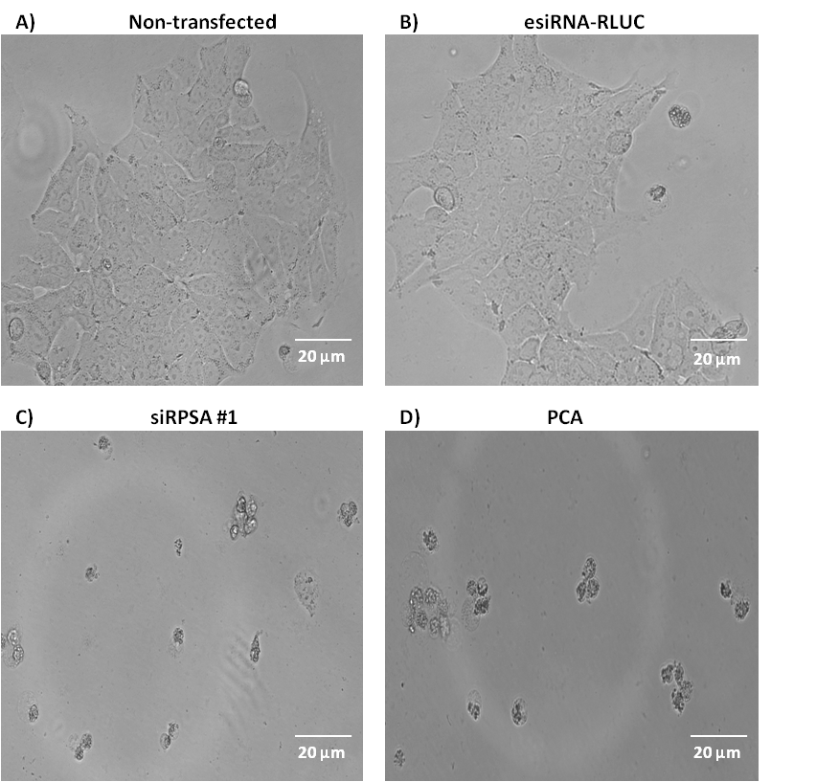
Figure S1: Late stage (DLD-1) colorectal cancer cells show membrane blebbing and reduced nuclei post transfection with siRPSA #1 using bright field microscopy. A) and B) Non-transfected and esiRNA-RLUC (negative control) transfected cells are found to be large with uncompromised membrane integrity. C) and B) siRPSA #1-transfected and PCA (positive control) treated cells are found to have a reduced size together with compromised membrane integrity i.e. membrane blebbing and condensed nuclei – all indicative of apoptosis occurring. Images were obtained at 200X magnification. Scale bars are indicative of 20 µm.

Table S1: Sequence of Human-RPSA, esiRNA-RPSA and control siRNA-RLUC used for down-regulation of LRP/LR.
siRNA | Sequence | Transfection reagent
ON-TARGETplus SMARTpool human-RPSA | 4 RPSA siRNA pooled together (targets 4 regions of LRP/LR):  Target sequence 1:  CGACAUGAGUUGUACUUCU  Target sequence 2:  GAUUGCAUAUCAAAGCAUA  Target sequence 3:  GGUCAUGCCUGAUCUGUAC  Target sequence 4:  UAUCAUAAAUCUCAAGAGG | DharmaFect1
esiRNA-RPSA | CCTCTCACGGAGGCATCTTATGTTAACCTACCTACCATTGCGC  TGTGTAACACAGATTCTCCTCTGCGCTATGTGGACATTGCCAT  CCCATGCAACAACAAGGGAGCTCACTCAGTGGGTTTGATGTGG  TGGATGCTGGCTCGGGAAGTTCTGCGCATGCGTGGCACCATTT  CCCGTGAACACCCATGGGAGGTCATGCCTGATCTGTACTTCTA  CAGAGATCCTGAAGAGATTGAAAAAGAAGAGCAGGCTGCTGCT  GAGAAGGCAGTGACCAAGGAGGAATTTCAGGGTGAATGGACT  GCTCCCGCTCCTGAGTTCACTGCTACTCAGCCTGAGGTTGCAG  ACTGGTCTGAAGGTGTACAGGTGCCCTCTGTGCCTATTCAGCA  ATTCCCTACTGAAGACTGGAGCG | Mission transfection reagent
esiRNA-RLUC | GATAACTGGTCCGCAGTGGTGGGCCAGATGTAAACAAATGAAT  GTTCTTGATTCATTTATTAATTATTATGATTCAGAAAAACATGC  AGAAAATGCTGTTATTTTTTTACATGGTAACGCGGCCTCTTCT  TATTTATGGCGACATGTTGTGCCACATATTGAGCCAGTAGCGC  GGTGTATTATACCAGACCTTATTGGTATGGGCAAATCAGGCAA  ATCTGGTAATGGTTCTTATAGGTTACTTGATCATTACAAATAT  CTTACTGCATGGTTTGAACTTCTTAATTTACCAAAGAAGATCAT  TTTTGTCGGCCATGATTGGGGTGCTTGTTTGGCATTTCATTAT  AGCTATGAGCATCAAGATAAGATCAAAGCAATAGTTCACGCTG  AAAGTGTAGTAGATGTGATTGAATCATGGGATGAATGG | Mission transfection reagent

Table S2: Pearson’s correlation co-efficients (R) between total LRP levels prior to and post transfection with esiRNA-RPSA.
Cell line | Correlation between total LRP levels prior to and post esiRNA-RPSA transfection (R-value)
SW-480 | 0.98
DLD-1 | 0.99

Transfection procedure using Human-RPSA:

Lyophilized Human-RPSA (5nmol/20nmol) was reconstituted in 100µl or 250μl of 1X RNAse free siRNA buffer, respectively, before use in order to make a 20 μM stock. The table below shows amounts of siRNA and corresponding components used for transfections of a 6-well plate.
Reagent | Volume (μl)
Opti-MEM media – for addition of esiRNA | 190
Human-RPSA | 10
Opti-MEM media – for addition of transfection reagent | 190
DharmaFect transfection reagent | 10

Transfection procedure:
Reconstituted Human-RPSA was added to the corresponding volume of Opti-MEM media in a micro centrifuge tube. In a second tube, transfection reagent was added to the corresponding volume of Opti-MEM media. Both tubes were incubated for 5 minutes at room temperature and mixed together. The resultant siRNA solution was further incubated for 20 minutes at room temperature.
Transfection procedure using esiRNA-RPSA and esiRNA-RLUC:

esiRNA-RPSA and esiRNA-RLUC are purchased reconstituted. The table below shows volumes of esiRNA and corresponding components used for transfections of a 6-well plate.
Reagent | Volume (μl)
Opti-MEM media – for addition of esiRNA | 250
esiRNA-RPSA or esiRNA-RLUC | 5
Opti-MEM media – for addition of transfection reagent | 250
Mission transfection reagent | 5

Transfection procedure:
esiRNA-RPSA or esiRNA-RLUC was added to the corresponding volume of Opti-MEM media in a micro centrifuge tube. In a second tube, transfection reagent was added to the corresponding volume of Opti-MEM media. Both tubes were incubated for 5 minutes at room temperature and the contents of both tubes were mixed together.
Antibodies and siRNAs – Suppliers list:
- IgG1-iS18 – Affimed Therapeutics
- Anti-human IgG-HRP, anti-human PE, anti-rabbit APC– Abcam
- Anti-β actin peroxidase, esiRNA-RPSA (200ng/ul), esiRNA-RLUC (200 ng/ul) – Sigma
- Human-RPSA siRNA(5 nmol/20nmol) and DharmaFect1 transfection reagent – GE Dharmacon

Kits – suppliers list:
- Annexin V-FITC/ PI kit – BD Biosciences
- Caspase 3,-8 and -9 kits and cell cycle kit – Merck Millipore

Equipment list:
- Flow cytometer – BD Accuri C6
- Confocal microscope – Zeiss LSM 710 3-channel (images were captured using the blue laser, 63X magnification, and using Zen 2011 software).
- Bright field microscope – Floid cell imaging station
- Laminar flow – Labotec
- ELISA reader – Tecan (using Magellan software)
- Centrifuge – Eppendorf 5417C
- Pipettes and micropipettes – Eppendorf research
- TC20 cell counter, gel casting and running apparatus – Biorad

