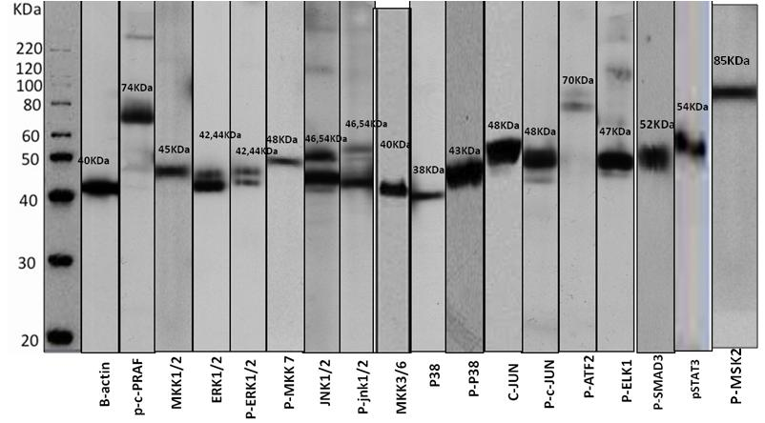
Figure S1 Western blotting results of pan-P38 and p-P38 expression in MCF-7 cell line lysate.

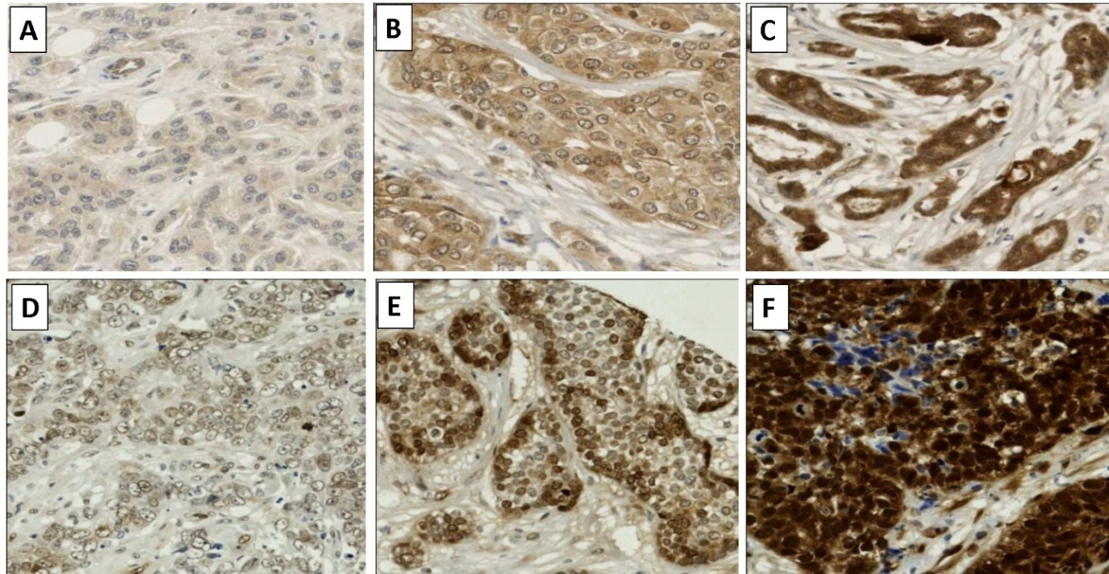
Figure S2 Pan-P38 and p-P38 staining in breast cancer; Different intensities of staining were observed across samples. Representative images of weak, moderate and strong pan-P38 (A-C) and p-P38 (D-F), respectively, are shown. Photomicrograph magnification x200.

