Additional file 3: Figure S2 ROC curves of our models.
2A: ROC curves of predictive LN Involvement – Pathologic model.
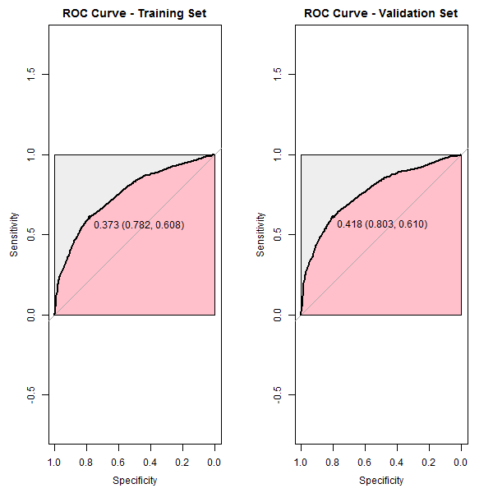

2B: ROC curves of predictive LN macro metastases – Pathologic model.
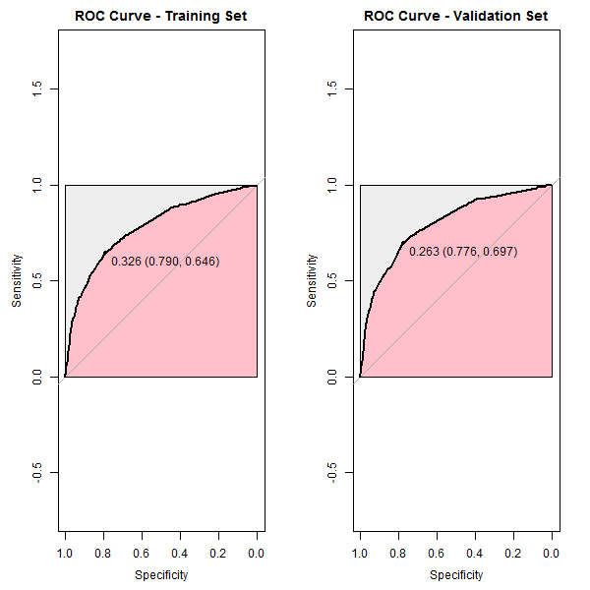

2C: ROC curves of predictive LN Involvement – Clinical model.
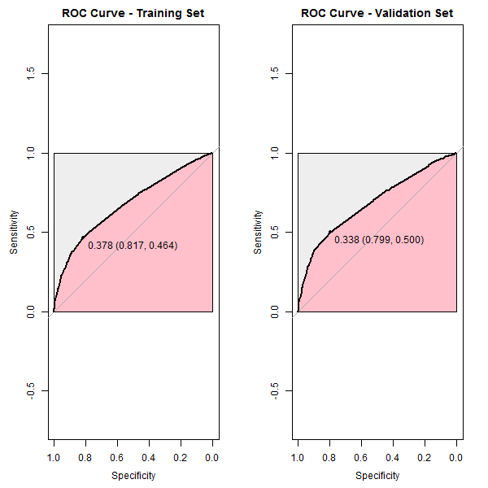

2D: ROC curves of predictive LN macro metastases – Clinical model.
