A
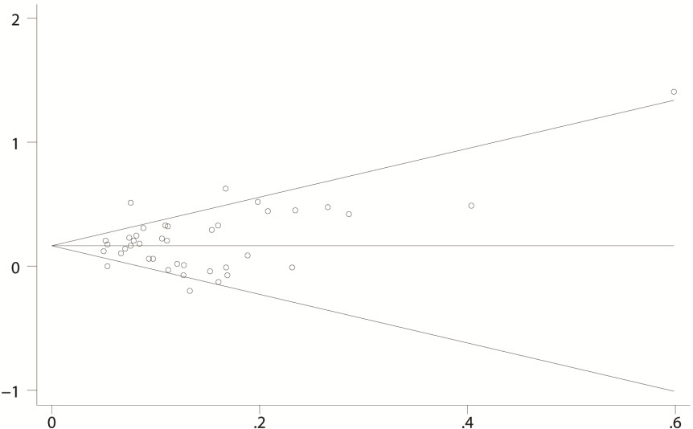
Log-transformed OR
Standard error of log-transformed OR

B
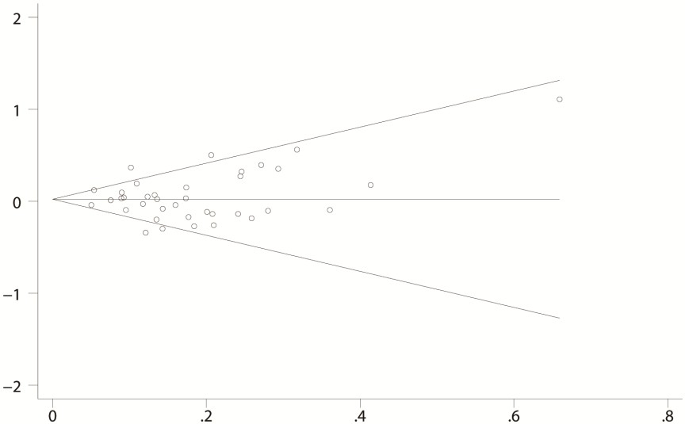
Log-transformed OR
Standard error of log-transformed OR

C
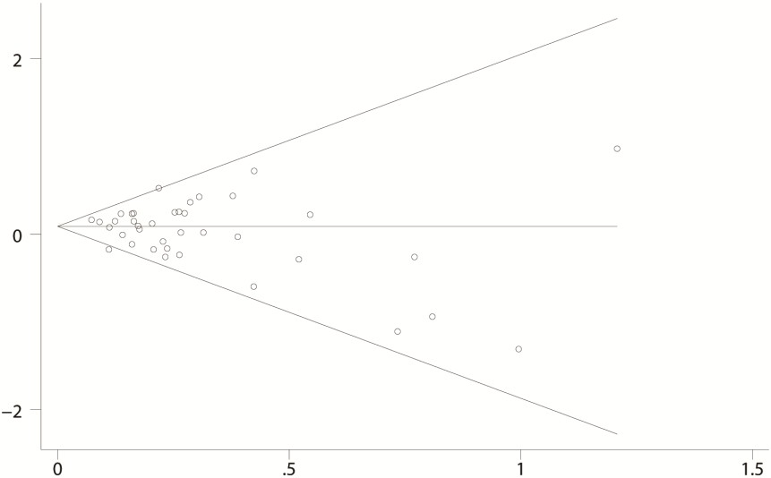
Standard error of log-transformed OR
Log-transformed OR

Additional file 5: Figure S2. Begg’s funnel plots for ABO blood group and gastric cancer risk. Figures A-C are funnel plots for blood group A (A), B (B), AB (C) verse group O. The vertical axis represents the log-transformed odds ratios (ORs). The horizontal axis represents the standard errors (SEs) of log-transformed ORs. The funnel plots are drawn with 95% confidence intervals.

