Supplementary Tables
Additional file 1: Table S1. Cell cultivation conditions
 | Culture medium | Supplementary ingredients
SAS | DMEM | 10% FBS +1% pen-strep-ampho + 2 mM L-glutamine
FaDu | MEM | 10% FBS +1% pen-strep-ampho +2 mM L-glutamine
MOC-L1~4 | DMEM | 10% FBS +1% pen-strep-ampho + 2 mM L-glutamine
293T | DMEM | 10% FBS +1% pen-strep-ampho

Additional file 1: Table S2. Primers used in the present study
Gene or construct | Direction | Sequences (5’ - 3’) | Amplicon (bps)
p53 Exon 1-5 | Forward | CTAGCATTCAGGCCCTCATC | 565
p53 Exon 1-5 | Reverse | CTCCGTCATGTGCTGTGACT | 565
p53 Exon 5-9 | Forward | TCCCCTCAATAAGCTATTCTGC | 576
p53 Exon 5-9 | Reverse | TTCTTTTGCGGGGGAGAG | 576
p53 Exon 8-11 | Forward | CAGGGAGCGCAAAGAGAG | 433 or 529
p53 Exon 8-11 | Reverse | GGCCAGGAACCACTACTCAG | 433 or 529
Human PTGER2 | Forward | GCTGCTTCTCATTGTCTCGG | 189
Human PTGER2 | Reverse | GCCAGGAGAATGAGGTGGTC | 189
Mouse PTGER2 | Forward | CCTGCTGCTTATCGTGGCTG | 189
Mouse PTGER2 | Reverse | GCCAGGAGAATGAGGTGGTC | 189
Human and mouse PTGER2 | Forward | TACCTGCAGCTGTACGCCAC | 215
Human and mouse PTGER2 | Reverse | GCCAGGAGAATGAGGTGGTC | 215

Additional file 1: Table S3. Primary antibodies or associated reagents used in the present study
Antibody | MW (kDa) | Host | Dilution | Supplier | Cat. No.
GFP | 27 | mouse | 1:1000  1:500# | Clontech | 632381
Ki67 | 345,395 | rabbit | 1:500 | Santa Cruz Biotech | sc7846
PCNA | 34 | mouse | 1:1000 | Santa Cruz Biotech | sc25280
p53 | 53 | rabbit | 1:1000 | Abcam | ab131442
ΒΝC1 | 120 | mouse | 1:1000 | Santa Cruz Biotech | sc517114
Involucrin | 120 | mouse | 1:1000 | Sigma-Aldrich | I9018
TGM1 | 90 | goat | 1:500 | Santa Cruz Biotech | sc18129
K6 | 56 | mouse | 1:1000 | MDBio | LVMS766p0
K14 | 55 | mouse | 1:1000 | Abcam | ab7800
K18 | 45 | mouse | 1:1000 | Santa Cruz Biotech | sc32329
K19 | 40 | mouse | 1:1000 | Santa Cruz Biotech | sc376126
E-cadherin | 120 | mouse | 1:1000 | BD | 610182
Vimentin | 57 | rabbit | 1:1000 | Cell Signaling | 5741
Fibronectin | 240 | mouse | 1:1000 | BD | 610078
Twist | 17,26 | rabbit | 1:1000 | Santa Cruz Biotech | sc15393
ZEB1 | 200 | rabbit | 1:1000 | Cell Signaling | 3396S
αγSMA | 43 | mouse | 1:1000 | Santa Cruz Biotech | sc53015
αV Integrin | 135,140 | rabbit | 1:1000 | Cell Signaling | 4711
MMP2 | 63,72,89 | mouse | 1:1000 | Santa Cruz Biotech | sc13595
MMP9 | 105 | rabbit | 1:1000 | Sigma-Aldrich | M9555
SOX2 | 35 | rabbit | 1:1000 | Cell Signaling | 3579S
Nanog | 42 | rabbit | 1:1000 | Cell Signaling | 3580S
Oct4 | 45 | rabbit | 1:1000 | Cell Signaling | 2750S
GAPDH | 36 | mouse | 1:10000 | Santa Cruz Biotech | sc32233
#, concentration used for IHC

Additional file 1: Table S4. TaqMan® assay probes
Gene and miRNA | Cat. No.
mmu-miR-31 | 000185
miR-16 | 000391
miR-19a | 000395
miR-21 | 000397
miR-24 | 000402
miR-27a | 000408
miR-27b | 000409
miR-34c | 000428
miR-103 | 000439
miR-107 | 000443
miR-125b | 000449
miR-132 | 000457
miR-134 | 000459
miR-146a | 000468
miR-181a | 000480
miR-181c | 000482
miR-184 | 000485
miR-194 | 000493
miR-210 | 000512
miR-221 | 000524
miR-20a | 000580
mmu-miR-211 | 001199
U6 snRNA | 001973
miR-29a | 002112
miR-196b | 002215
miR-149 | 002255
miR-370 | 002275
miR-145 | 002278
miR-200c | 002300
miR-17 | 002308
miR-543 | 002376
miR-144 | 002676

Supplementary Figures

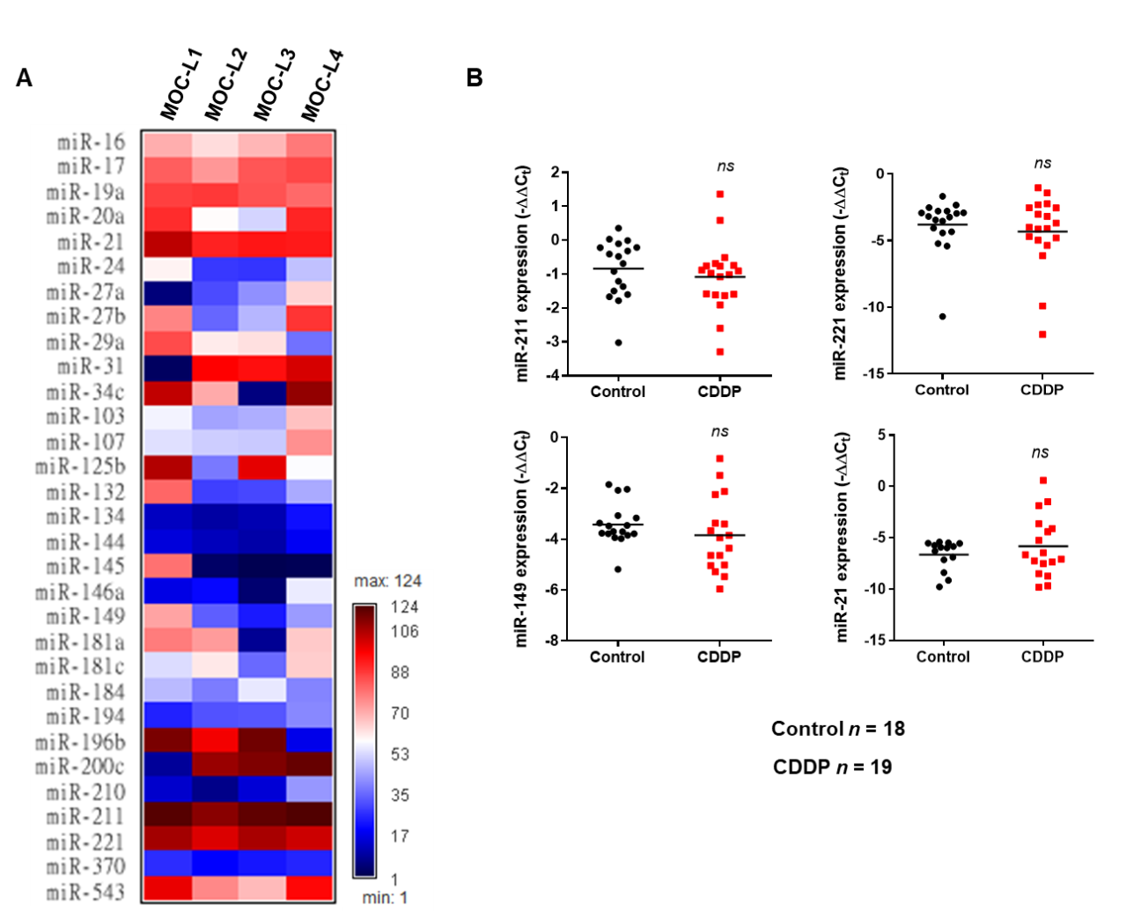
Additional file 1: Figure S1. miRNA expression in the MOC cell lines. (A) An algorithm showing the miRNA expression profiles of MOC-L1 to MOC-L4 cells compared to SAS cells. (B) A comparison of the expression levels of miR-211, miR-196b, miR-221, miR-149 and miR-21 between the control tumors and the CDDP treated tumors. ns, not significant, **, p < 0.01.

