Additional file 6: Figure S4.
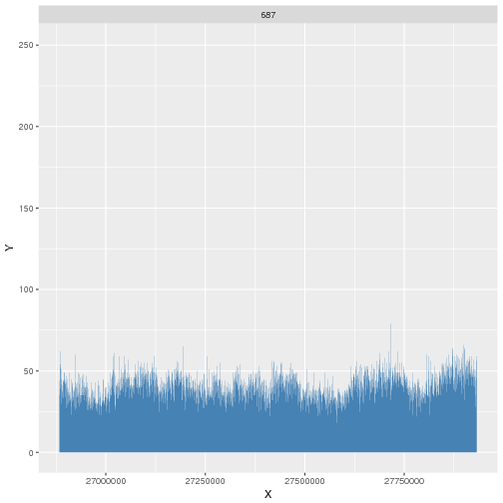
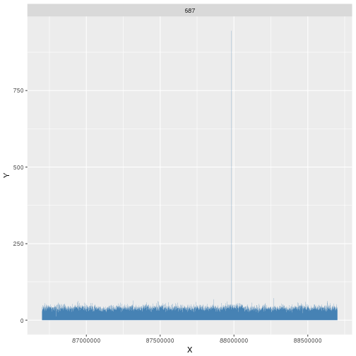
Chromosome 4q22.1
Chromosome 1p36.11
Tumor 687
Tumor 687

