Supplement figures:
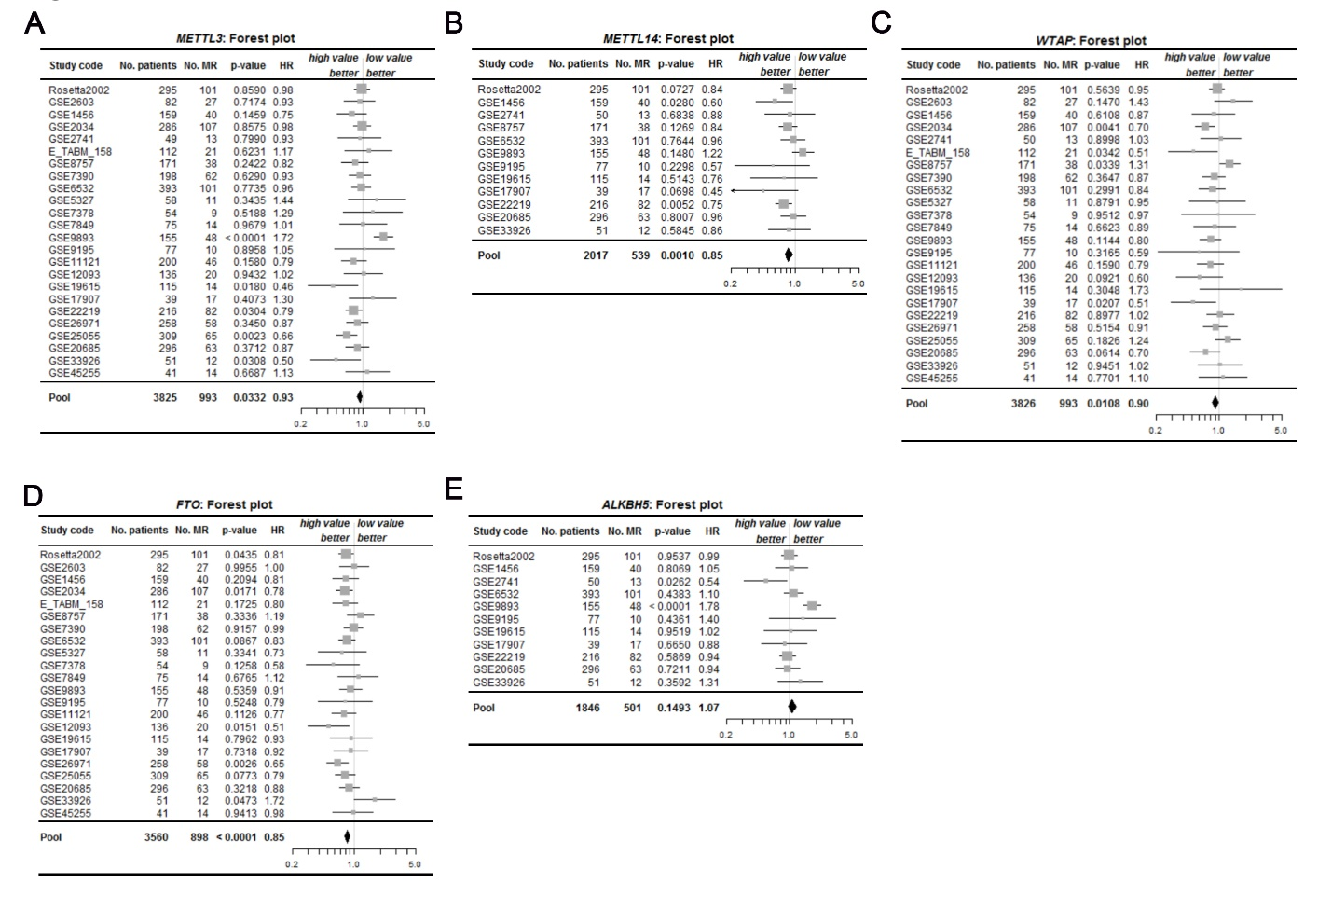

Figure S1: Forest plot of mRNA expression of m6A enzymes for metastasis relapse (MR)-free survival in all BC patients by meta-analysis according bc-GenExMiner v4.0 database.

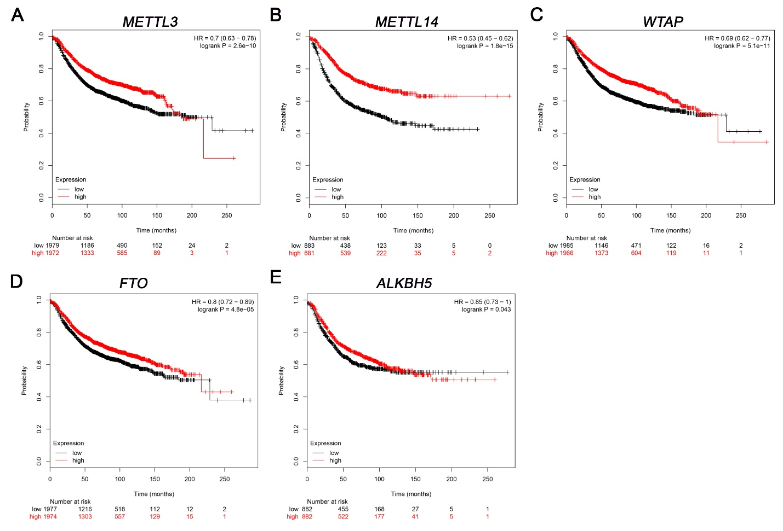
Figure S2: The prognostic value of mRNA level of m6A-enzymes in BC patients (RFS in Kaplan-Meier plotter). Reduced METTL3 (A), METTL14(B), WTAP(C), FTO (E) and ALKBH5 (F) but not KIAA1429 (D) and mRNA level was significantly associated with poor overall survival (OS) in all BC patients.

Supplement tables:
Table S1. List of primers used in qRT-PCR assays.

Assay | Primer sequence (sense 5’-3’) | Primer sequence (anti-sense 5’-3’) | Size (bp)
METTL3 | TTGTCTCCAACCTTCCGTAGT | CCAGATCAGAGAGGTGGTGTAG | 145
METTL14 | AGTGCCGACAGCATTGGTG | GGAGCAGAGGTATCATAGGAAGC | 101
WTAP | TTGTAATGCGACTAGCAACCAA | GCTGGGTCTACCATTGTTGATCT | 121
KIAA1429 | TACTTTGAGCCCATTTCTCCTGA | GGAATACTGTCTACTGTTCGTCG | 176
FTO | ACTTGGCTCCCTTATCTGACC | TGTGCAGTGTGAGAAAGGCTT | 145
ALKBH5 | CGGCGAAGGCTACACTTACG | CCACCAGCTTTTGGATCACCA | 128
β-ACTIN | TTAGTTGCGTTACACCCTTTC | GCTGTCACCTTCACCGTTC | 156

Table S2. Univariate Cox analysis of METTL3 for clinical survival of breast cancer patients. (Data from bc-GenExMiner v4.0).
Cohort | References | No. patients | No. MR | HR | 95% CI | p-value
Rosetta2002 | Van de Vijver et al., 2002 | 295 | 101 | 0.98 | 0.81–1.20 | 0.859
GSE2603 | Minn et al., 2005 | 82 | 27 | 0.93 | 0.62–1.39 | 0.7174
GSE1456 | Pawitan et al., 2005 | 159 | 40 | 0.75 | 0.51–1.11 | 0.1459
GSE2034 | Wang et al., 2005 | 286 | 107 | 0.98 | 0.78–1.23 | 0.8575
GSE2741 | Weigelt et al., 2005 | 49 | 13 | 0.93 | 0.53–1.62 | 0.799
E_TABM_158 | Chin et al., 2006 | 112 | 21 | 1.17 | 0.63–2.14 | 0.6231
GSE8757 | Chin et al., 2007 | 171 | 38 | 0.82 | 0.58–1.15 | 0.2422
GSE7390 | Desmedt et al., 2007 | 198 | 62 | 0.93 | 0.70–1.24 | 0.629
GSE6532 | Loi et al., 2007 | 393 | 101 | 0.96 | 0.75–1.24 | 0.7735
GSE5327 | Minn et al., 2007 | 58 | 11 | 1.44 | 0.68–3.04 | 0.3435
GSE7378 | Zhou et al., 2007 | 54 | 9 | 1.29 | 0.60–2.78 | 0.5188
GSE7849 | Anders et al., 2008 | 75 | 14 | 1.01 | 0.55–1.86 | 0.9679
GSE9893 | Chanrion et al., 2008 | 155 | 48 | 1.72 | 1.35–2.18 | < 0.0001
GSE9195 | Loi et al., 2008 | 77 | 10 | 1.05 | 0.48–2.31 | 0.8958
GSE11121 | Schmidt et al., 2008 | 200 | 46 | 0.79 | 0.57–1.09 | 0.158
GSE12093 | Zhang et al., 2009 | 136 | 20 | 1.02 | 0.61–1.70 | 0.9432
GSE19615 | Li et al., 2010 | 115 | 14 | 0.46 | 0.24–0.88 | 0.018
GSE17907 | Sircoulomb et al., 2010 | 39 | 17 | 1.3 | 0.70–2.39 | 0.4073
GSE22219 | Buffa et al., 2011 | 216 | 82 | 0.79 | 0.64–0.98 | 0.0304
GSE26971 | Filipits et al., 2011 | 258 | 58 | 0.87 | 0.66–1.16 | 0.345
GSE25055 | Hatzis et al., 2011 | 309 | 65 | 0.66 | 0.50–0.86 | 0.0023
GSE20685 | Kao et al., 2011 | 296 | 63 | 0.87 | 0.65–1.18 | 0.3712
GSE33926 | Kuo et al., 2012 | 51 | 12 | 0.5 | 0.26–0.94 | 0.0308
GSE45255 | Nagalla et al., 2013 | 41 | 14 | 1.13 | 0.64–2.02 | 0.6687
 | Pool | 3825 | 993 | 0.93 | 0.86–0.99 | 0.0332
HR: hazard ratio; 95% CI: 95% confidence interval

Table S3. Univariate Cox analysis of METTL14 for clinical survival of breast cancer patients. (Data from bc-GenExMiner v4.0).
Cohort | References | No. patients | No. MR | HR | 95% CI | p-value
Rosetta2002 | Van de Vijver et al., 2002 | 295 | 101 | 0.84 | 0.70–1.02 | 0.0727
GSE1456 | Pawitan et al., 2005 | 159 | 40 | 0.6 | 0.38–0.95 | 0.028
GSE2741 | Weigelt et al., 2005 | 50 | 13 | 0.88 | 0.47–1.65 | 0.6838
GSE8757 | Chin et al., 2007 | 171 | 38 | 0.84 | 0.67–1.05 | 0.1269
GSE6532 | Loi et al., 2007 | 393 | 101 | 0.96 | 0.71–1.29 | 0.7644
GSE9893 | Chanrion et al., 2008 | 155 | 48 | 1.22 | 0.93–1.60 | 0.148
GSE9195 | Loi et al., 2008 | 77 | 10 | 0.57 | 0.22–1.43 | 0.2298
GSE19615 | Li et al., 2010 | 115 | 14 | 0.76 | 0.33–1.74 | 0.5143
GSE17907 | Sircoulomb et al., 2010 | 39 | 17 | 0.45 | 0.19–1.07 | 0.0698
GSE22219 | Buffa et al., 2011 | 216 | 82 | 0.75 | 0.61–0.92 | 0.0052
GSE20685 | Kao et al., 2011 | 296 | 63 | 0.96 | 0.70–1.31 | 0.8007
GSE33926 | Kuo et al., 2012 | 51 | 12 | 0.86 | 0.51–1.47 | 0.5845
 | Pool | 2017 | 539 | 0.85 | 0.78–0.94 | 0.001

Table S4. Univariate Cox analysis of WTAP for clinical survival of breast cancer patients. (Data from bc-GenExMiner v4.0).
Cohort | Reference | No. patients | No. MR | HR | 95% CI | p-value
Rosetta2002 | Van de Vijver et al., 2002 | 295 | 101 | 0.95 | 0.78–1.14 | 0.5639
GSE2603 | Minn et al., 2005 | 82 | 27 | 1.43 | 0.88–2.32 | 0.147
GSE1456 | Pawitan et al., 2005 | 159 | 40 | 0.87 | 0.50–1.50 | 0.6108
GSE2034 | Wang et al., 2005 | 286 | 107 | 0.7 | 0.54–0.89 | 0.0041
GSE2741 | Weigelt et al., 2005 | 50 | 13 | 1.03 | 0.62–1.73 | 0.8998
E_TABM_158 | Chin et al., 2006 | 112 | 21 | 0.51 | 0.27–0.95 | 0.0342
GSE8757 | Chin et al., 2007 | 171 | 38 | 1.31 | 1.02–1.69 | 0.0339
GSE7390 | Desmedt et al., 2007 | 198 | 62 | 0.87 | 0.65–1.17 | 0.3647
GSE6532 | Loi et al., 2007 | 393 | 101 | 0.84 | 0.60–1.17 | 0.2991
GSE5327 | Minn et al., 2007 | 58 | 11 | 0.95 | 0.46–1.93 | 0.8791
GSE7378 | Zhou et al., 2007 | 54 | 9 | 0.97 | 0.38–2.50 | 0.9512
GSE7849 | Anders et al., 2008 | 75 | 14 | 0.89 | 0.52–1.51 | 0.6623
GSE9893 | Chanrion et al., 2008 | 155 | 48 | 0.8 | 0.61–1.05 | 0.1144
GSE9195 | Loi et al., 2008 | 77 | 10 | 0.59 | 0.21–1.66 | 0.3165
GSE11121 | Schmidt et al., 2008 | 200 | 46 | 0.79 | 0.57–1.10 | 0.159
GSE12093 | Zhang et al., 2009 | 136 | 20 | 0.6 | 0.33–1.09 | 0.0921
GSE19615 | Li et al., 2010 | 115 | 14 | 1.73 | 0.61–4.95 | 0.3048
GSE17907 | Sircoulomb et al., 2010 | 39 | 17 | 0.51 | 0.29–0.90 | 0.0207
GSE22219 | Buffa et al., 2011 | 216 | 82 | 1.02 | 0.72–1.46 | 0.8977
GSE26971 | Filipits et al., 2011 | 258 | 58 | 0.91 | 0.67–1.22 | 0.5154
GSE25055 | Hatzis et al., 2011 | 309 | 65 | 1.24 | 0.91–1.69 | 0.1826
GSE20685 | Kao et al., 2011 | 296 | 63 | 0.7 | 0.48–1.02 | 0.0614
GSE33926 | Kuo et al., 2012 | 51 | 12 | 1.02 | 0.58–1.78 | 0.9451
GSE45255 | Nagalla et al., 2013 | 41 | 14 | 1.1 | 0.59–2.03 | 0.7701
 | Pool | 3826 | 993 | 0.9 | 0.84–0.98 | 0.0108

Table S5. Univariate Cox analysis of KIAA1429 for clinical survival of breast cancer patients. (Data from bc-GenExMiner v4.0).
Cohort | Reference | No. patients | No. MR | HR | 95% CI | p-value
GSE1456 | Pawitan et al., 2005 | 159 | 40 | 0.97 | 0.63–1.49 | 0.8865
GSE6532 | Loi et al., 2007 | 393 | 101 | 1.17 | 0.91–1.49 | 0.224
GSE9195 | Loi et al., 2008 | 77 | 10 | 0.72 | 0.33–1.56 | 0.3981
GSE19615 | Li et al., 2010 | 115 | 14 | 1.46 | 0.68–3.15 | 0.3323
GSE17907 | Sircoulomb et al., 2010 | 39 | 17 | 0.77 | 0.43–1.37 | 0.3724
GSE20685 | Kao et al., 2011 | 296 | 63 | 1.04 | 0.79–1.37 | 0.7803
 | Pool | 1079 | 245 | 1.05 | 0.90–1.23 | 0.5406

Table S6. Univariate Cox analysis of FTO for clinical survival of breast cancer patients. (Data from bc-GenExMiner v4.0).
Cohort | Reference | No. patients | No. MR | HR | 95% CI | p-value
Rosetta2002 | Van de Vijver et al., 2002 | 295 | 101 | 0.81 | 0.67–0.99 | 0.0435
GSE2603 | Minn et al., 2005 | 82 | 27 | 1 | 0.68–1.46 | 0.9955
GSE1456 | Pawitan et al., 2005 | 159 | 40 | 0.81 | 0.58–1.13 | 0.2094
GSE2034 | Wang et al., 2005 | 286 | 107 | 0.78 | 0.63–0.96 | 0.0171
E_TABM_158 | Chin et al., 2006 | 112 | 21 | 0.8 | 0.57–1.11 | 0.1725
GSE8757 | Chin et al., 2007 | 171 | 38 | 1.19 | 0.84–1.67 | 0.3336
GSE7390 | Desmedt et al., 2007 | 198 | 62 | 0.99 | 0.77–1.26 | 0.9157
GSE6532 | Loi et al., 2007 | 393 | 101 | 0.83 | 0.67–1.03 | 0.0867
GSE5327 | Minn et al., 2007 | 58 | 11 | 0.73 | 0.39–1.38 | 0.3341
GSE7378 | Zhou et al., 2007 | 54 | 9 | 0.58 | 0.29–1.16 | 0.1258
GSE7849 | Anders et al., 2008 | 75 | 14 | 1.12 | 0.66–1.89 | 0.6765
GSE9893 | Chanrion et al., 2008 | 155 | 48 | 0.91 | 0.68–1.22 | 0.5359
GSE9195 | Loi et al., 2008 | 77 | 10 | 0.79 | 0.39–1.62 | 0.5248
GSE11121 | Schmidt et al., 2008 | 200 | 46 | 0.77 | 0.56–1.06 | 0.1126
GSE12093 | Zhang et al., 2009 | 136 | 20 | 0.51 | 0.30–0.88 | 0.0151
GSE19615 | Li et al., 2010 | 115 | 14 | 0.93 | 0.54–1.60 | 0.7962
GSE17907 | Sircoulomb et al., 2010 | 39 | 17 | 0.92 | 0.59–1.45 | 0.7318
GSE26971 | Filipits et al., 2011 | 258 | 58 | 0.65 | 0.49–0.86 | 0.0026
GSE25055 | Hatzis et al., 2011 | 309 | 65 | 0.79 | 0.61–1.03 | 0.0773
GSE20685 | Kao et al., 2011 | 296 | 63 | 0.88 | 0.68–1.14 | 0.3218
GSE33926 | Kuo et al., 2012 | 51 | 12 | 1.72 | 1.01–2.94 | 0.0473
GSE45255 | Nagalla et al., 2013 | 41 | 14 | 0.98 | 0.58–1.65 | 0.9413
 | Pool | 3560 | 898 | 0.85 | 0.79–0.90 | < 0.0001

Table S7. Univariate Cox analysis of ALKBH5 for clinical survival of breast cancer patients. (Data from bc-GenExMiner v4.0).
Cohort | Reference | No. patients | No. MR | HR | 95% CI | p-value
Rosetta2002 | Van de Vijver et al., 2002 | 295 | 101 | 0.99 | 0.82–1.21 | 0.9537
GSE1456 | Pawitan et al., 2005 | 159 | 40 | 1.05 | 0.70–1.59 | 0.8069
GSE2741 | Weigelt et al., 2005 | 50 | 13 | 0.54 | 0.31–0.93 | 0.0262
GSE6532 | Loi et al., 2007 | 393 | 101 | 1.1 | 0.86–1.41 | 0.4383
GSE9893 | Chanrion et al., 2008 | 155 | 48 | 1.78 | 1.42–2.22 | < 0.0001
GSE9195 | Loi et al., 2008 | 77 | 10 | 1.4 | 0.60–3.23 | 0.4361
GSE19615 | Li et al., 2010 | 115 | 14 | 1.02 | 0.52–1.99 | 0.9519
GSE17907 | Sircoulomb et al., 2010 | 39 | 17 | 0.88 | 0.49–1.57 | 0.665
GSE22219 | Buffa et al., 2011 | 216 | 82 | 0.94 | 0.77–1.16 | 0.5869
GSE20685 | Kao et al., 2011 | 296 | 63 | 0.94 | 0.69–1.29 | 0.7211
GSE33926 | Kuo et al., 2012 | 51 | 12 | 1.31 | 0.74–2.33 | 0.3592
 | Pool | 1846 | 501 | 1.07 | 0.97–1.18 | 0.1493

Table S8. Univariate Cox analysis of the prognostic value of METTL3 in breast cancer by clinicopathological factors
Event criteria |  |  | p value | HR | 95% CI | No. patients | No. events
N- | ERm | MR | 0.0199 | 0.88 | 0.80–0.98 | 1 886 | 454
N- | ER- | MR | 0.0246 | 0.82 | 0.68–0.97 | 478 | 140
Nm | ER- | MR | 0.029 | 0.88 | 0.78–0.99 | 1 038 | 330
Nm | ERm | MR | 0.0332 | 0.93 | 0.86–0.99 | 3 825 | 993
N- | ERm | AE | 0.1452 | 0.94 | 0.86–1.02 | 2 360 | 719
Nm | ERm | AE | 0.1592 | 0.96 | 0.91–1.01 | 5 291 | 1 804
N+ | ER+ | MR | 0.2169 | 1.1 | 0.95–1.27 | 677 | 202
N- | ER- | AE | 0.3305 | 0.93 | 0.80–1.08 | 611 | 211
Nm | ER- | AE | 0.493 | 0.97 | 0.89–1.06 | 1 476 | 578
N+ | ER+ | AE | 0.6665 | 1.02 | 0.92–1.14 | 983 | 397
N+ | ERm | MR | 0.6862 | 1.02 | 0.91–1.15 | 980 | 322
N+ | ER- | MR | 0.7646 | 0.97 | 0.78–1.20 | 295 | 119
N- | ER+ | MR | 0.7959 | 0.98 | 0.86–1.12 | 1 389 | 312
Nm | ER+ | AE | 0.8628 | 0.99 | 0.93–1.06 | 3 766 | 1 215
N+ | ER- | AE | 0.8687 | 0.99 | 0.84–1.16 | 426 | 210
N+ | ERm | AE | 0.8818 | 1.01 | 0.92–1.10 | 1 418 | 608
Nm | ER+ | MR | 0.9086 | 1.01 | 0.92–1.10 | 2 757 | 658
N- | ER+ | AE | 0.9257 | 0.99 | 0.89–1.11 | 1 724 | 503
AE: any event; ER (+,-,m): oestrogen receptor status (+: positive, -: negative, m: mixed); HR: hazard ratio; MR: metastatic relapse; N (+,-,m): nodal status (+: positive, -: negative, m: mixed)

Table S9. Univariate Cox analysis of the prognostic value of METTL14 in breast cancer by clinicopathological factors.
Event criteria |  |  | p value | HR | 95% CI | No. patients | No. events
N- | ERm | MR | 0.0007 | 0.75 | 0.64–0.89 | 762 | 167
Nm | ERm | MR | 0.001 | 0.85 | 0.78–0.94 | 2 017 | 539
N- | ER+ | MR | 0.0014 | 0.72 | 0.59–0.88 | 542 | 113
N+ | ERm | AE | 0.0055 | 0.86 | 0.77–0.96 | 1 050 | 497
N- | ERm | AE | 0.0086 | 0.86 | 0.77–0.96 | 1 236 | 395
N- | ER+ | AE | 0.0096 | 0.82 | 0.71–0.95 | 877 | 276
Nm | ERm | AE | 0.0142 | 0.92 | 0.86–0.98 | 3 325 | 1 250
Nm | ER+ | MR | 0.0327 | 0.88 | 0.78–0.99 | 1 450 | 355
N+ | ER- | AE | 0.0791 | 0.83 | 0.68–1.02 | 266 | 153
N+ | ER- | MR | 0.1275 | 0.79 | 0.58–1.07 | 135 | 68
N+ | ERm | MR | 0.1861 | 0.9 | 0.77–1.05 | 612 | 224
Nm | ER+ | AE | 0.2018 | 0.95 | 0.87–1.03 | 2 349 | 840
Nm | ER- | MR | 0.2928 | 0.91 | 0.77–1.08 | 547 | 181
N- | ER- | MR | 0.2993 | 0.86 | 0.65–1.14 | 205 | 53
N+ | ER+ | AE | 0.4092 | 0.94 | 0.82–1.08 | 781 | 344
N- | ER- | AE | 0.5471 | 0.94 | 0.77–1.15 | 338 | 115
N+ | ER+ | MR | 0.7023 | 1.04 | 0.86–1.25 | 475 | 156
Nm | ER- | AE | 0.999 | 1 | 0.89–1.12 | 937 | 401

Table S10. Univariate Cox analysis of the prognostic value of WTAP in breast cancer by clinicopathological factors.
Event criteria |  |  | p value | HR | 95% CI | No. patients | No. events
N- | ER+ | MR | 0.0001 | 0.77 | 0.67–0.88 | 1 389 | 312
N- | ER+ | AE | 0.0005 | 0.82 | 0.73–0.92 | 1 724 | 503
Nm | ER+ | MR | 0.0006 | 0.84 | 0.77–0.93 | 2 757 | 658
Nm | ER+ | AE | 0.0024 | 0.89 | 0.82–0.96 | 3 547 | 1 123
N- | ERm | MR | 0.0033 | 0.85 | 0.76–0.95 | 1 887 | 454
Nm | ERm | MR | 0.0108 | 0.9 | 0.84–0.98 | 3 826 | 993
N- | ERm | AE | 0.0121 | 0.89 | 0.81–0.97 | 2 361 | 719
Nm | ERm | AE | 0.0314 | 0.93 | 0.88–0.99 | 4 953 | 1 653
Nm | ER- | MR | 0.2889 | 0.93 | 0.82–1.06 | 1 039 | 330
N+ | ER+ | MR | 0.2929 | 0.91 | 0.76–1.09 | 677 | 202
Nm | ER- | AE | 0.3701 | 0.95 | 0.86–1.06 | 1 365 | 520
N+ | ER+ | AE | 0.4229 | 0.94 | 0.82–1.09 | 983 | 397
N- | ER- | MR | 0.4418 | 0.93 | 0.77–1.12 | 479 | 140
N- | ER- | AE | 0.4846 | 0.95 | 0.81–1.10 | 612 | 211
N+ | ERm | MR | 0.6141 | 0.96 | 0.84–1.11 | 980 | 322
N+ | ERm | AE | 0.7846 | 0.98 | 0.88–1.10 | 1 418 | 608
N+ | ER- | MR | 0.8494 | 0.98 | 0.79–1.22 | 295 | 119
N+ | ER- | AE | 0.9107 | 0.99 | 0.83–1.18 | 426 | 210

Table S11. Univariate Cox analysis of the prognostic value of KIAA1429 in breast cancer by clinicopathological factors.
Event criteria |  |  | p value | HR | 95% CI | No. patients | No. events
N- | ER+ | AE | 0.0027 | 1.35 | 1.11–1.63 | 506 | 153
N- | ERm | AE | 0.0052 | 1.28 | 1.08–1.52 | 683 | 206
N- | ER+ | MR | 0.0824 | 1.43 | 0.95–2.15 | 277 | 47
Nm | ER+ | MR | 0.0834 | 1.18 | 0.98–1.41 | 816 | 167
Nm | ER+ | AE | 0.0969 | 1.1 | 0.98–1.23 | 1 263 | 400
N+ | ERm | AE | 0.176 | 0.9 | 0.78–1.05 | 558 | 235
N+ | ER- | AE | 0.1911 | 0.74 | 0.47–1.16 | 123 | 65
N- | ERm | MR | 0.2516 | 1.23 | 0.86–1.75 | 357 | 63
N+ | ER- | MR | 0.3558 | 0.59 | 0.19–1.80 | 33 | 18
N+ | ER+ | MR | 0.5358 | 1.1 | 0.82–1.47 | 222 | 58
Nm | ERm | MR | 0.5406 | 1.05 | 0.90–1.23 | 1 079 | 245
Nm | ERm | AE | 0.5476 | 1.03 | 0.93–1.14 | 1 720 | 569
Nm | ER- | AE | 0.6404 | 0.95 | 0.76–1.19 | 443 | 167
Nm | ER- | MR | 0.7332 | 0.94 | 0.67–1.32 | 256 | 77
N+ | ER+ | AE | 0.7377 | 0.97 | 0.83–1.15 | 434 | 170
N- | ER- | AE | 0.7469 | 1.07 | 0.72–1.57 | 166 | 51
N- | ER- | MR | 0.8775 | 0.94 | 0.45–1.98 | 73 | 15
N+ | ERm | MR | 0.9073 | 0.98 | 0.75–1.29 | 255 | 76

Table S12. Univariate Cox analysis of the prognostic value of FTO in breast cancer by clinicopathological factors.
Event criteria |  |  | p value | HR | 95% CI | No. patients | No. events
Nm | ER+ | MR | < 0.0001 | 0.81 | 0.75–0.88 | 2 597 | 606
Nm | ERm | MR | < 0.0001 | 0.85 | 0.79–0.90 | 3 560 | 898
Nm | ER+ | AE | < 0.0001 | 0.87 | 0.82–0.92 | 3 606 | 1 163
N- | ER+ | MR | < 0.0001 | 0.74 | 0.65–0.84 | 1 300 | 290
Nm | ERm | AE | < 0.0001 | 0.9 | 0.86–0.94 | 5 026 | 1 709
N- | ERm | MR | < 0.0001 | 0.8 | 0.72–0.89 | 1 741 | 417
N- | ER+ | AE | 0.0016 | 0.86 | 0.78–0.94 | 1 635 | 481
N- | ERm | AE | 0.0028 | 0.89 | 0.82–0.96 | 2 215 | 682
N+ | ERm | MR | 0.2804 | 0.94 | 0.83–1.05 | 860 | 264
N+ | ER+ | MR | 0.4209 | 0.94 | 0.82–1.09 | 606 | 172
Nm | ER- | AE | 0.5823 | 1.03 | 0.93–1.13 | 1 371 | 535
N+ | ER- | MR | 0.5913 | 0.94 | 0.75–1.18 | 246 | 91
N+ | ER+ | AE | 0.6292 | 0.98 | 0.88–1.08 | 912 | 367
N- | ER- | AE | 0.6877 | 1.03 | 0.89–1.20 | 555 | 196
N+ | ERm | AE | 0.7346 | 0.99 | 0.91–1.07 | 1 298 | 550
Nm | ER- | MR | 0.7446 | 0.98 | 0.86–1.11 | 933 | 287
N- | ER- | MR | 0.9633 | 1 | 0.82–1.23 | 422 | 125
N+ | ER- | AE | 0.9936 | 1 | 0.85–1.18 | 377 | 182

Table S13. Univariate Cox analysis of the prognostic value of ALKBH5 in breast cancer by clinicopathological factors.
Event criteria |  |  | p value | HR | 95% CI | No. patients | No. events
N+ | ER+ | MR | 0.0664 | 1.18 | 0.99–1.40 | 475 | 156
Nm | ERm | MR | 0.1493 | 1.07 | 0.97–1.18 | 1 846 | 501
N- | ER- | MR | 0.1684 | 1.21 | 0.92–1.58 | 205 | 53
Nm | ER+ | MR | 0.1819 | 1.09 | 0.96–1.22 | 1 337 | 333
Nm | ER+ | AE | 0.3185 | 1.04 | 0.96–1.13 | 2 236 | 804
N+ | ERm | MR | 0.3416 | 1.07 | 0.93–1.24 | 612 | 224
N+ | ER- | MR | 0.4054 | 0.89 | 0.68–1.17 | 135 | 68
N+ | ER+ | AE | 0.4447 | 1.05 | 0.93–1.19 | 781 | 344
Nm | ER- | MR | 0.545 | 1.05 | 0.89–1.25 | 490 | 165
N- | ER+ | MR | 0.63 | 0.95 | 0.79–1.15 | 542 | 113
N- | ER- | AE | 0.6407 | 1.05 | 0.86–1.28 | 338 | 115
N- | ERm | MR | 0.6537 | 1.04 | 0.88–1.22 | 762 | 167
Nm | ERm | AE | 0.6869 | 1.01 | 0.95–1.08 | 3 154 | 1 194
N+ | ER- | AE | 0.7827 | 0.97 | 0.81–1.17 | 266 | 153
N+ | ERm | AE | 0.8112 | 1.01 | 0.91–1.12 | 1 050 | 497
N- | ERm | AE | 0.8167 | 0.99 | 0.88–1.10 | 1 236 | 395
Nm | ER- | AE | 0.9022 | 1.01 | 0.90–1.13 | 880 | 382
N- | ER+ | AE | 0.9854 | 1 | 0.87–1.15 | 877 | 276

