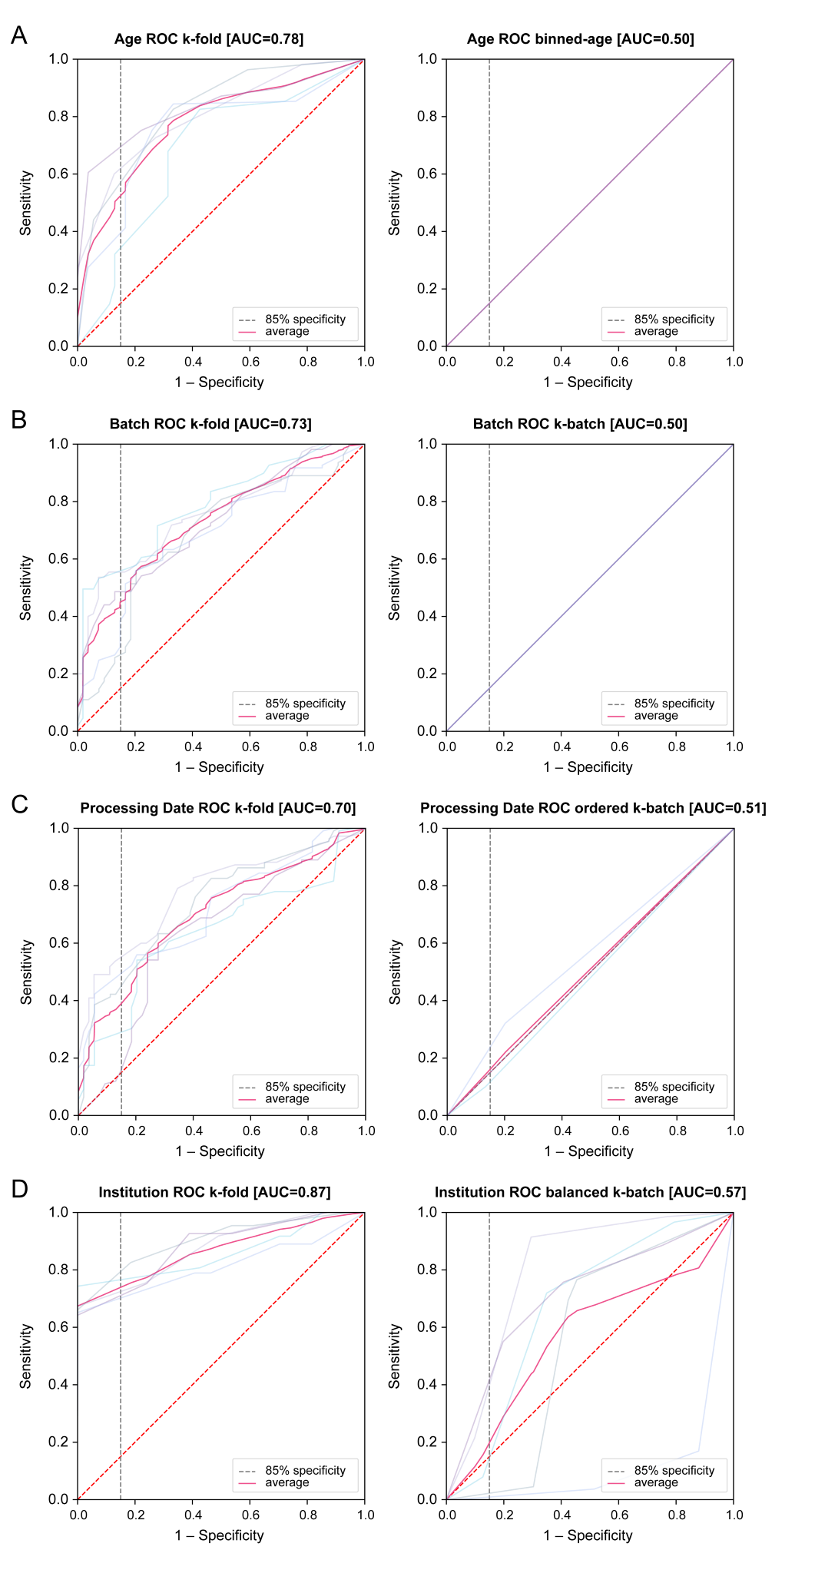
Figure S1 Performance of confounding variable in k-fold and target CV procedure (ROC curves) for:
a Age and binned-age CV b Batch and k-batch CV c Processing date and ordered k-batch CV d Institution and balanced k-batch CV
Note that stratification CVs (i.e., binned-age, k-batch, and ordered k-batch) perform at chance (mean AUC of 0.50) when the distribution of labels in the test covariate is even and would result in an ROC that is just a diagonal line. The variance seen in some of the target procedures is due to class imbalance in the test data.

