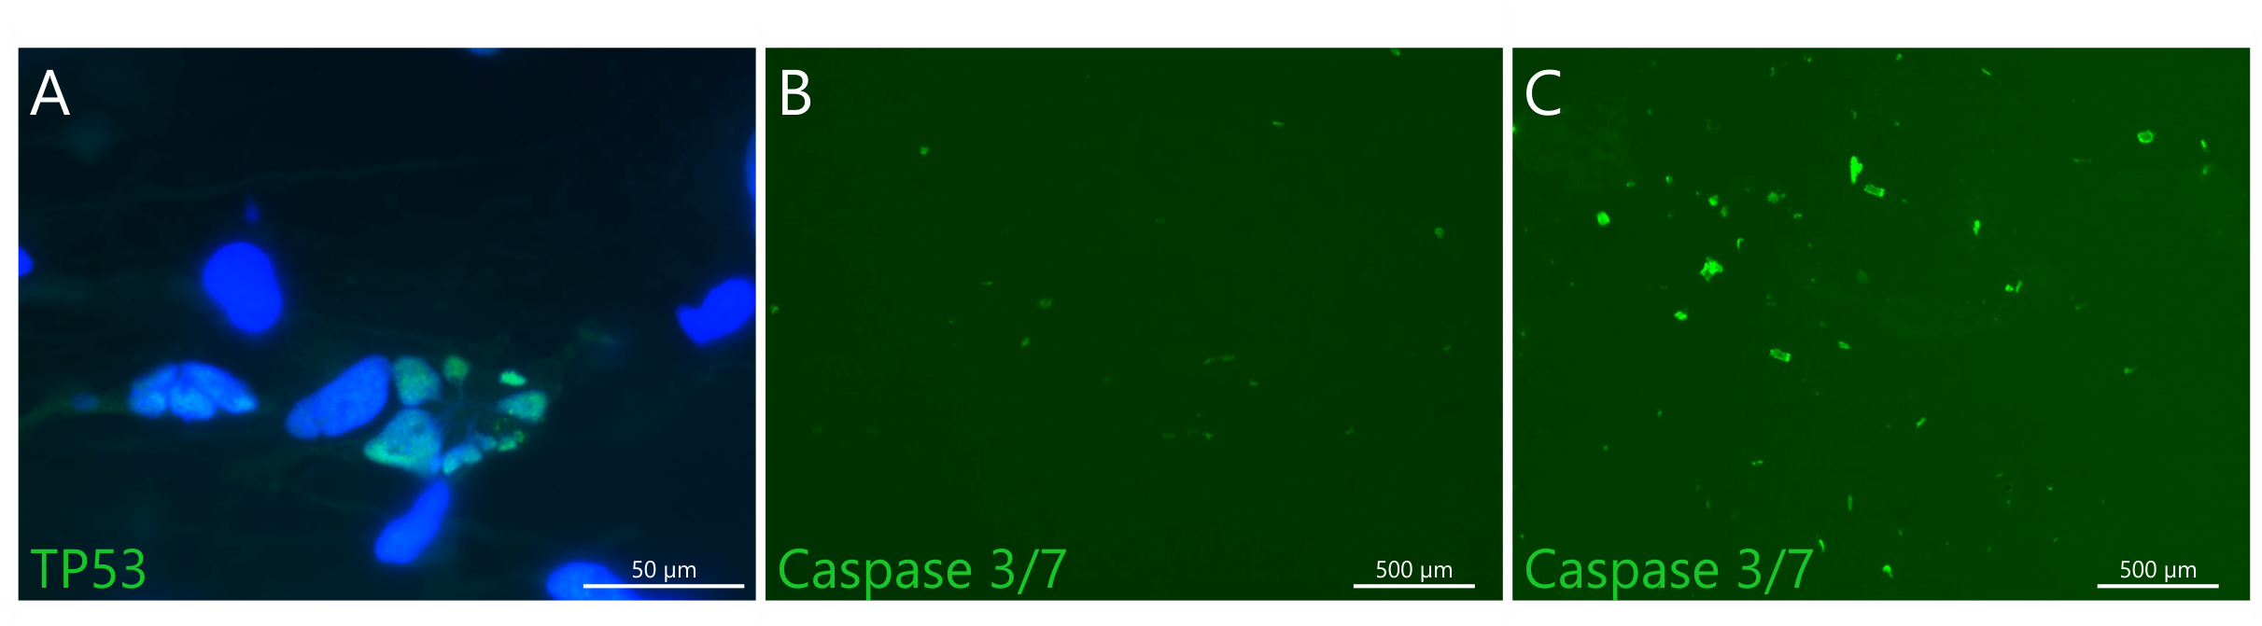
Figure S1. Apoptosis of glioblastoma cells. Representative images showing classical apoptotic nuclei with TP53 accumulation (A) as well as activity of the synthetic Caspase 3/7 reporter in early passages of GB9. The number of Caspase 3/7 positive cells was higher in NSC-like conditions (C) than in monolayer (B) (quantitative data are shown in Figure 3G-K and Suppl. Tab. 4).

